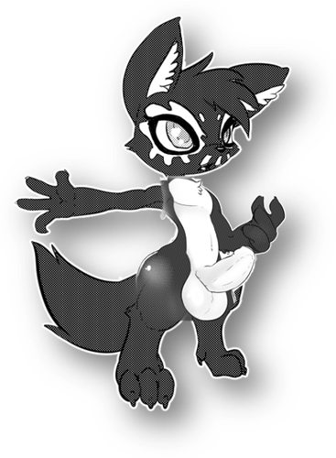
Under the pale moon light.
"Mmmmmnnyyyaaaaaaah"
Yakkaina stretched and yawned as he had hung his jacket and hat on the coat rack.
Falokar had sent his uniform to be cleaned and was currently in the shower.

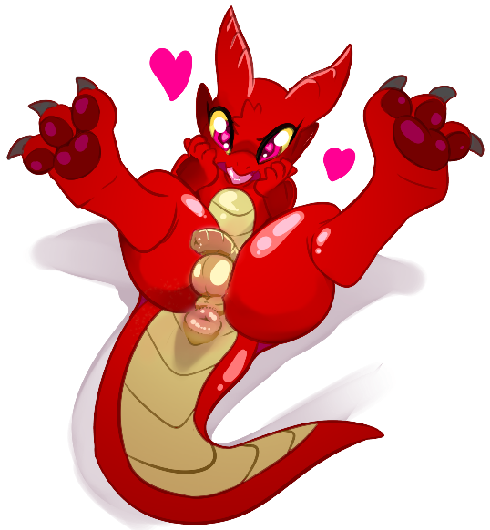
The black furred lycan sniffed around the room a few times, they had only been here a few hours but the room was already starting to pick up on Falokar's scent. There was a Bureau nearby which Yakkaina used to take off his cufflinks and lace collared broach, setting them away, unlike Falokar's which were inlaid with rubies, his had sapphires in them.

Yakkaina took to stripping off their clothes as well, freeing himself from the constraining uniform of a blood hunter, once naked it was plain to see that he was absolutely adorable, and that much like Falokar, he for some reason had glowing magenta hued eyes.
the wolf climbed onto the bed and spread out rubbing himself along the sheets and the comfortable mattress as he pulled the downy soft pillows and snuggled one.
The bathroom door opened with a soft click as a faint steamy fog exited the bathroom, a breeze from the door opening blew out the candles in the room leaving it in darkness save for the pale light of the moon through the window.
Yakkaina yipped softly taken by surprise, looking towards the bathroom as he spotted Falokar's eyes staring him down from the distance.

"So, making yourself comfortable in my bed huh?"
"I figured you wouldn't mind...."
"How cheeky of you."

Yakkaina blushed a little as he could feel Falokar clambering onto the bed over him, as the two stared each other down, their eyes locked and glowing gently, only faint lighting to show their details. Despite this the two had Darkvision which meant they could see each other perfectly.
Falokar moved in kissing the wolf upon the muzzle, their hands clasped into one anothers, their fingers laced across the others knuckles. The kobold gently pushed his frame to the lycan's as their chests rubbed, scale to fur, then mid torsos, their dicks gently rubbed one another and at last their balls.

It could easily be noted that of the two, Yakkaina was the better hung, in that his dick was bigger and thicker, and his balls were larger as well, though still coinpursed, they acted as a cradle here for Falokar's own pair.

As Falokar broke the kiss, Yakkaina would exhale frost through his nose and shudder.
"I keep forgetting that your blood rite is the freezing kind."
Falokar giggled a little, "But it compliment's your own so well, the rite of flame."
Falokar gripped into the bedsheets, placing the pillow that Yakkaina had been cuddling behind the lycan's head for now as he began thrusting himself upon Yakkaina, gently at first. Soft waving bodily motions from the chest to the groin, froting their cocks together, both had some amount of thickness to them but neither really had much by way of length, though again Yakkaina was longer, by a solid two inches at least.

Yakkaina moaned softly, his arms wrapping around to Falokar's back, and his legs pulling up, hooking around the inside of Falokar's thighs.
Falokar continued his gentle thrusting, the bed rocking ever so slightly, their breath quickening only a little, by now the two were very hard, with Falokar sporting a 5-inch-long, 2-inch-thick cock, and Yakkaina with 7.5 inches in length and 2.5 inches in thickness.

Yakkaina would lean up licking Falokar acros the muzzle, narrowing his eyes as he stared at the kobold in a loving, seductive manner.
"Pitcher?" he asked in a manner that was more or less a curiosity.
Falokar shook their head, "Catcher" they responded with a gentle smirk.
Yakkaina giggled, "Of course, It has been a while hasn't it?"
The two rolled on the bed, which was easily large enough to comfortably fit two giants on the bed, thus they had plenty of space to move about, as now Falokar was on the bottom.

Yakkaina smirked, their ears lifting into an alert position as he twisted his body, turning around, and promptly sat his butt down on Falokar's face, their tailhole to the kobold's nose, and his balls resting on Falokar's lips. From here the wolf had a great view of Falokar's bits, as he slowly leaned forward and began licking along the length of Falokar's dick.
Falokar inhaled Yakkaina's scent, then opened his mouth as he used his tongue to pull the lycan's balls into his mouth and gently started sucking on them. One hand moved up to massage Yakkaina's fluffy ass, while the other would gently stroke the werewolf's dick teasingly.
Yakkaina panted heavier now, Falokar's cold breath was making his balls shrink towards his body tightly, with a gentle tug he'd pull away before lining his dick up and then thrusting down into the kobold's mouth, his balls now gently slapping against Falokar's muzzle as Yakkaina began a soft rhythmic thrusting.
in return to this Falokar used his legs to pull Yakkaina into a head lock, pushing his own dick into their mouth, as he began a slightly faster paced thrusting as the two began a counter pointed dance of sixty-nine positioned face fucking.
Falokar sucked lightly, using his tongue to work the shaft and head, taking in the texture, heat, flavor, it might be an odd detail but it was to be noted that Falokar enjoyed the mixed salty but sweet taste of Yakkaina's dick. Of course, being a blood hunter was no help to the matter being so close to a large source of blood in the mouth and yet not being able to access it drove him to lust, as was often the case when the kobold engaged in sex.

Yakkaina meanwhile was using his tongue to enjoy the texture, Falokar being a kobold, and thusly a scalie, had a ribbed foreskin around his dick similar to his underbelly's texture, there was a sort of natural salt about it, and well, the kobold had recently bathed just minutes ago, so they now also had a fragrance of lavender.
The werewolf took to thrusting faster and harder, the rhythmic plaps of his balls and thighs gently slapping Falokar in the face becoming only slightly louder and more consistent.
Falokar moaned softly smiling as he continued to suck and lick the cock in his mouth enjoying the sensations of flavor, the fact that Yakkaina's dick could push its way into his throat, he swallowed around it as if trying to massage the dick.

Yakkaina meanwhile had taken his mouth away from Falokar's cock, pulling himself forward just a little as he nosed past the kobold's balls and began licking at their tailhole instead, placing his mouth around the small donut of a pucker that it was, as he sucked and licked at it gently, using his saliva to lubricate Falokar's ass. Falokar had wanted to be the catcher tonight, this was a natural part of the process considering the distinctive lack of oils in their room at the moment. Yakkaina would have to fix that later.
Yakkaina feeling properly lubricated himself, would use his feet to lift his haunches off of Falokar's face and pull his dick out of their mouth with a soft suckling pop sound, strings of saliva still connecting the two for the second, as he used his fluffy paw like hands to grasp into Falokar's ass cheeks spreading them as he dug his tongue into the kobold's ass a few seconds more. Pulling away as he licked his lips, Falokar was always such a good and thorough cleaner when it came to their own body.

"You ready?"
Yakkaina looked down between his legs at Falokar who nodded gently.
The lycan smiled a little as he changed his position again, straddling Falokar's tail as he lined his dick up, then, with the head of his cock kissing into the kobold's ass, he leaned forward, hoisting Falokar's legs up around his hips as he kissed Falokar deeply and thrust in, all at once.

Falokar let out a muffled moan that would have certainly been close to screaming had he not been silenced by Yakkaina's kiss, the whole cock at once was a lot to take in for someone as small bodied as Falokar was.

He was hoping he'd have a second to adjust, yet no such respite came, rather Yakkaina began hard, fast and deep almost instantly, hosting Falokar's ass up as he took to roughly fucking the kobold. The floor creaked from their motions and were Falokar free to talk they'd probably be moaning as loudly as any experienced whore would, yet Yakkaina wasn't giving him such an opportunity, as the rough pounding continued, it was now Falokar's turn to hug the pillowbetween himself and his half-brother. It had stung, intensely at first but by now it was far beyond that point and well into the range of feeling so good that it was driving the kobold's senses wild.
Yakkaina finally let the kiss go, when he knew Falokar would be quiet enough to not scream out from the penetration.

Though there were still audible moans and pants in the form of Falokar's adorably pitched voice.
"Aaahn"
"Hnyah"
"Nnngh"
"Aaaah"
"Y...ya...Yaaahnnngh...."
Yakkaina hadn't eased up the entire time as of yet, but was instead picking up pace, drilling his dick ever deeper into Falokar's tight little ass, now stretched around the lycan's dick, yet still feeling tight enough that Yakkaina had the sensation that the kobold's ass was trying to suck him in, it wouldn't seem to let him go, as if trying to milk him of his seed.
"I... I'm getting close Fally..."

Falokar blushed a little, literally no one else knew about their pet names for one another, it was an intimidate part of their relationship.

And cum he did, as Yakkaina unloaded all he could muster into Falokar's ass, having not done anything sexual for nearing a month to say that he was pent up was an understatement, he in fact came in such volume that there was an overflow of cum gushing out of Falokar's now well used asshole just from one round.

Falokar laid there panting heavily, their tailhole gaping like a well used glazed donut.
Yakkaina shuddered and sighed leaning in to kiss Falokar again, only to feel a wetness to his midsection as he looked down and realized that Falokar had cum as well, multiple times from the looks of it as there was a pool of cum on their tummy, and strings of cum connecting their torsos together.
Falokar leaned in wrapping his arms around Yakkaina's neck and kissed him before pulling away and smiling in a loving manner. "Put it back in... I wanna sleep with you in my tonight."

Yakkaina giggled and nodded slipping his still hard dick back into Falokar's ass, which glided in much easier this time as Falokar bit his lower lip and hugged the lycan close cuddling him.
there were no blankets this night their bodies keeping the other warm as they laid there illuminated by the pale moon light, sleeping in each others arms.

