Schooling For Chus The Series (By Littilwood)
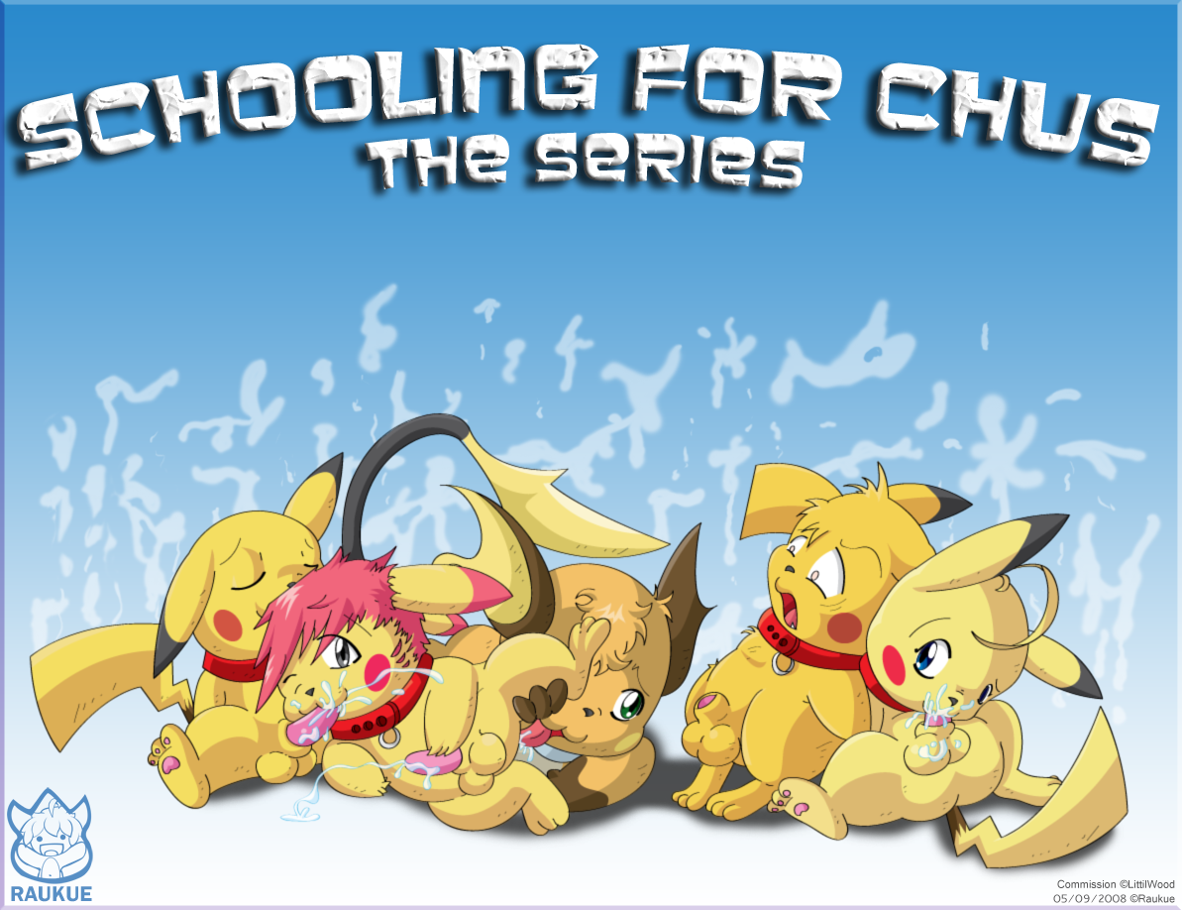
(This picture is copyright ©) Raukue, Littilwood

(Chapter Four) PART TWO

Pikachu sat on the swing set sadly… finally, a break from school, and yet, he didn’t seem to be enjoying himself… he spent most of his time hiding in fear, away from people because he was afraid he would really hurt somebody if Darkchu took over his mind again. One thing he couldn’t seem to get out of his head was the simple question he had always asked himself… “What is he after? Why is hunting me down?” He sighed and looked down at his amulet, the only thing that was temporarily shielding his mind against the evil chu. He took it in his palm, being very careful not to damage it in fear that if it got even the slightest scratch on its surface, it would no longer be protective. He didn’t want to be chased down by some evil pikachu, that wasn’t what he wanted when he decided to go to this school…

He dropped the amulet, which quickly fell swinging until it settled back in the center of his upper chest. He wanted so bad to just take it off, but he feared for his friends. That night back at the school… he had been so violent. He nearly killed a teacher, let alone his friends. He felt bad. He didn’t want to be around anyone, especially his friends. He laughed pitifully to himself, unsure if his friends even wanted to be with him anymore.

He sighed once again, and started for home. Images of that event kept flashing through his mind, and they grew even more terrible. He saw horrible things, his mind being controlled once again, and it escalated all the way up to where he saw himself, moving in on his friends, and then they were dead… He quickly shook his head, shaking any and all of the negatives off.

“I have to learn how to keep him out of my head” he said softly but sadly to himself.

He continued walking along the road, thinking of anything good. He missed William. His mate didn’t live that far away, but far enough that it would take a good while just to get to him. For this reason, he would only be able to see him every once in a while, at least until school started back up. That was another thought that raced through his mind, a good thought. The school… He loved what the school had taught him, and how gifted he was at it too. He wanted to lay back and suck himself like he had done back in Mottley’s class, but he wasn’t quite ready for anyone in this area to find out about him… even though he himself didn’t mind how he was, other people were stubborn and ignorant, and they would surely ridicule anyone who they figured out was that way… some of the chus were actually proud of how they were. They had mates who were guys waiting at home. They didn’t care what other people thought and they were more than willing to deal with whatever they had to for their mates… Pikachu head a noise…

“Hey look who it is! Where’s your boyfriend?!”

His attention became focused on three pokemon in the distance. Two of them, a charmeleon and a wartortle were picking on a chu that was no bigger than Pikachu himself. He knew this pikachu. He was in Zaush house back at AGNPH as well… he knew about this Pikachu… he was one of the ones who really was proud of the fact that he wasn’t exactly straight… in fact, he did have a mate at home, a mate who really wouldn’t be happy if he saw his chu love had been ridiculed or hurt physically. He quickly marched over to the scene before anything could get out of control.

“HEY!” He said as he strode over angrily

“Oh look!” laughed the charmeleon, “another one!”

The two bullies fell backward in laughter, which seemed a bit ironic and made them seem a bit too cocky especially since they weren’t much bigger than the two chus.

“Leave him alone…” Pikachu said trough gritted teeth”

“It’s fine Pikachu,” the other Zaush member said, “I’ve taken care of these two before and I can do it again…”

“Well if things start to get ugly I don’t want to miss out…” Pikachu smiled smugly at the other chu, who grinned back, looking cautiously at the amulet around his neck*

They quickly turned back as the other two pokemon jumped back up and got into a fighting stance.

“Oh, but see, what you don’t realize is that we brought friends…, and you both just put yourselves in a bad situation!” They both laughed again, and at that time, three other pokemon jumped out of the bushes, an ivysaur, an umbreon, and a second charmeleon.

Both chus were quickly seized by the other pokemon. The second charmeleon grabbed Pikachu, while the other was gripped by the umbreon. They bother struggled to get free again as the other pokemon laughed and the original two spoke up.

“Alright, it’s time the two of you got what was comin’ to you” The wartortle punched the first Chu in the stomach, and Pikachu watched as he folded over in pain, still being held up by the umbreon. Pikachu was next, also being punched in the stomach but by the other charmeleon, and he too, doubled over in pain.

“Oh, look! “What a pretty necklace! Said the charmeleon as he stopped himself from a second punch, and eyeing the amulet that hung from the chus neck. “I think I’ll take it…” He quickly snatched the amulet from around his neck, and put it on himself. Pikachu tried to protest, but was still winded from the blow he’d just received.

“No…” he said very quietly, despite his effort to scream it.”

WHAT?! Did you just speak without my permission?! The charmeleon spun around angrily and landed another blow to his stomache, and the second charmeleon dropped him, laughing as he fell to the ground, the other chu screaming as he watched his friend getting hurt.”

Pikachu began to get a weird feeling in is mind… Darkchu was doing it again… He grabbed his head trying to fight the word that the evil chu began speaking to him, “kill them!” Make them pay for what they just did to you!”

“NO! PLEASE!!! GIVE THE NECKLACE BACK!! I NEED IT!!” He yelled at the other pokemon, his body shaking…

Another blow was landed to his body and he fell to the ground again, still gripping his head!

“NO!!! STOP!!!! PLEASE!!!!”

“Aw, look…” said the charmeleon who was still wearing Pikachu’s necklace, “he’s gonna cry now!” all the pokemon burst into laughter…

They dropped the other chu right next to him, who quickly crawled over to check on Pikachu…

“Aww I’m sorry, is this another one of your boyfriends?!

The chu stared at the charmeleon angrily, electric sparks shooting out of his cheeks…

“Well then, let’s help you two lovers get better acquainted,” he grinned as he ordered the ivysaur to pick them both up and ‘help them along…’ The ivysaur grabbed the chus with his vines and brought them close together wrapping the vines around the two of them, pressing their bodies together… both chus struggled to get free, but the vines were holding them securely. Pikachu was still shaking and looking nto the other chu’s eyes, tears filling his own…

“Run…” he whispered desperately to his friend… and then his expression was lost… he closed his eyes, as though he’d lost consciousness…

“Now both of you… KISS” the charmeleon ordered them, and the group once again started to laugh.

Pikachu’s eyes shot back open, and they were now a scarlet red in colour, and the threatening eyes quickly focused on the ivysaur…

“Chudeat Skele!” And the spell flew very quickly at the ivysaur who quickly released the two from his grip, and went into immediate shock, his facial expression showing complete and udder fear.

The spell was quickly deflected and standing on the ground right beside pikachu, with a horrified expression on his face, was the other chu, his hands extended in front of his body… He had blocked the curse just in time…

“GIVE HIM HIS FUCKING NECKLACE BACK!!!” HE’S DANGEROUS WITHOUT IT!!” he shouted to the charmeleon, who wasn’t buying into the bull…

“NO! IT’S MINE NOW! I HOPE YOUR FRIEND KILLS YOU!” and the group took off running, both chu’s behind the charmeleon. The sky was getting darker, as though a large storm were approaching, and the grayish-black clouds began to spiral…The wind began to blow uncontrollably, a sign that an evil presence was in the area. People rushed from their houses to see what was going on, and they stumbled upon the sounds and the spells flying through the air. A lot of them took cover, while others ran to help.

As they got closer, they noticed Pikachu, his demonic voice shouting to the others, and the familiar killing curse that Darkchu used on his victims…

“WHERE’S HIS AMULET?!!” they shouted loudly, and their attention quickly focused on the charmeleon who was being chased by the one chu, who was firing stunning curses, but none deadly… at the same time, he was trying to deflect the curses Pikachu was throwing at them both.

“Styullious!” the one chu yelled and a spell flew at his target, hitting the charmander and throwing him to the ground… the amulet flew off of his person and landed several feet in front of him, and the chu quickly retrieved the necklace…

“Chudeat Skele!” Pikachu yelled again and another curse flew from his fingertips, this time, hitting the frozen charmeleon. The pikachu laughed in Darkchu’s demonic voice.

The chu screamed as he turned and saw several skeletons emerge from the ground and grab hold of the charmeleon who’s ear-shattering screams could be heard throughout the area. The chu, making a desperate attempt, quickly seized hold of the charmeleon and pried him away from the skeletons, as thei attempted to enter the fiery pokemon’s private areas. The bones broke and the charmeleon and the chu went flying onto the ground, jumping back up very rapidly. The ground below them broke open again, and both of the pokemon quickly dove out of the way again, hitting the ground hard, and rolling to safety. The skeletons kept coming after them. They were screwed!

The ground broke open one last time, and making one last attempt at safety, the exausted chu grabbed hold of the charmeleon, who was still literally frozen with fear, and threw them both out of the way, dropping the amulet in the process which was quickly seized by the skeletons and drug down, raped as though it were the spell’s victim…
This time, however, the skeletons did not return…

“That was it! That’s the trick on how to stop the killing curse if it hits you! Throw something else at it! Give it something else to drag down!” He laughed relaxing a bit, knowing he had just survived the killing curse and saved someone else in the process… but now the amulet was gone…

“IT’S GONE!” he quickly thought to himself… “AND PIKACHU IS STILL BEING CONTROLLED!” He turned to look at the chu who was grinning evilly at the two of them, ready to throw another curse at them… the chu couldn’t get up in time to stop the next curse… he sat by the charmeleon, eyes closed tightly, waiting to be killed for trying to stop Pikachu from killing the charmeleon…

“Chudeat Ske…” Darkchu stopped speaking through Pikachu, and sounds of a struggle could be heard, as another chu came up behind Pikachu, and grabbed him, holding him closely and bringing him carefully down to the ground in his grasp, refusing to let the chu go…

“PIKACHU STOP!” the crying voice of his mate William could be heard… “PLEASE!! STOP!!! THAT’S YOUR FRIEND OVER THERE!!”

More people came running over… a black squirrel and a copper wolf with a pink muzzle ran over to the chu and the charmeleon, the squirrel grabbing hold of the chu, while the wolf grabbed the charmeleon… They watched in fear as the struggle continued…

William held Pikachu tightly, who continued his struggle to break free, but Darkchu’s hold was somehow getting weaker…

“PLEASE!! FIGHT IT!! YOU CANT KEEP HIM OUT OF YOU MIND!! DON’T LET HIM DO THIS TO YOU!”

Pikachu’s expression was changing, his eyes flickereing from the red to their normal colour… His eyes finally fixed back to their normal traits, and Darkchu was gone. He sat there in Williams arms crying into his chest as his mate held him closely, tears falling from his own eyes…

The wolf led the chus back to the house, where they could rest. William held on to the sobbing pikachu, hugging and kissing him as he helped his mate along, while the squirrel and the other chu grinned at one another, happy to see each other again, as they drug the charmeleon along…

“You know Pikachu,” the wolf said… you should really learn to control that little problem…

“It’s not a problem” the other chu said, as he and the squirrel held onto the charmeleon.… some evil pikachu has been trying to take control of his mind… and well… it’s clear, he’s been very successful…”

“What was going on over there anyway Stewie?” asked his squirrely lover. The pikachu looked at his mate…

Stewie was like the other chus when it came to appearance, only there was a slight difference in the ears and the tail… the black tips of the ears were jagged at the bottom, and the tail had a slight nick on the tip… He was finally happy that he was home… he’d missed his mate, Littilwood, while he was away at school. Littilwood was a black squirrel, who’s origin wasn’t realy known… his mother was believed to be an angel and his father quite the opposite, a demon… because of this, the squirrel has always had the ability to change from, into either an angel or a demon, but he hadn’t figured that out until recently. Littilwood’s master, Rune, was a copper wolf with a pink muzzle… he took Littilwood in when his previous master had basically abandoned him… Rune was quite gifted with magic, particularly when it came to controlling of the mind or the body… he was very kind and loving for a wolf, and did what he could for other people…

“Just him and his friend again,” he said pointing to the charmander who could still barely walk… “Only this time he brought more… Pikachu tried to help, and well… they took his amulet…

“What amulet?” Rune asked…

“Master’s right…” Littilwood replied, puzzled… I don’t see any amulet, Stew…

“Oh, umm… the skeletons took it down… it was the only way I could save myself… and this moron… from getting pulled under…”

“I’m really, really sorry!!” Pikachu cried to Stewie

Stew flashed a reassuring smile toward Pikachu, who was still clinging tightly to William.

“It’s alright… at least you scarlet the living shit out of this idiot… he took your necklace in the first place…” He giggled, “I’ll bet he and his other friends wont mess with us anymore…”

They finally reached the house and Rune walked up and unlocked the door. It swung open and they all headed inside, the door closing and locking behind them. They settled in a large living room area… Rune headed into the kitchen and brought back several cups of tea on a tray…

“Hey pet,” he smiled at the squirrel… would you mind helping me with these?”

“Of course I’ll help master,” Littilwood smiled and grabbed single cups at a time, passing them off to everyone, while Rune held the large tray.

The wolf set the tray on the table and grabbed the last two cups, handing one to his pet, and taking the remaining cup for himself. He sipped at the tea before he spoke…

“You should be safe here…”

“No,” Pikachu protested, “Not with him trying to get into my head… I’m too dangerous…” He lay sadly against William, who kissed him and hugged him, pulling him closer

“You’ll be fine love… Don’t worry. We wont let him keep doing this to you…” His mate said, nuzzling up against him. He wanted to make his mate feel comfortable. He glanced at the chu’s naked body, eyeing his nether regions, and keeping aware that this was Rune’s home, he turned to Rune, who nodded, granting permission for the event to take place… It wasn’t anything much, but it was enough to take Pikachu’s mind away from the sorrow he felt, as William began rubbing his mate’s sack lightly, getting a slight moan in return…

Rune giggled softly and looked down at his own member, which was beginning to get hard… He smiled before saying “Hey pet…” to which the little squirrel turned to face his master, ears perked… “Do you think you could help me with this sweety?”

He looked at Stewie who ushered him to help his master out with his ‘problem’.

“Yes master…” he said, turning and kissing Stewie before he hopped up and moved over to his master, climbing up on his lap, Rune’s cock between his legs. He faced his master who smiled, giving him the okay to begin… He took the wolf’s cock in hand and began rubbing it up and down, instantly getting in return a full on erection. He massaged his master’s large orbs, receiving several moans, and then he started to lick at the large member in front of him before going down on it completely, taking what he could into his muzzle…

By that time, William had Pikachu on his own lap, his member deep in Pikachu’s tight hole, bouncing the chu up and down, thrusting in and pulling out quickly… they were completely into it now, and William was kind of happy he got permission as he noticed a pool of pre collecting on the sofa where the two were playing…

Stewie watched and played with his own hard on while the two shows were going on… it was hard to choose which one to watch, the chu on his left getting it up the rear by his mate, who had jut so recently been completely opposed to being gay in any way, or his mate suckling on his master’s cock, while loads of pre dripped down from his muzzle… He closed his eyes and listened to the sounds as he continued fapping… he thought about being able to suck himself, but knew good and well he was unable to reach himself, but he didn’t let that stop him… oddly enough, he was the closest one to going over the edge, and his kawk began twitching madly at each and every sound that entered the chu’s ears, each and every stroke that was made against his own member, his fingers tickling it into submission, and the pleasure received from everything that was going on at the time… his member couldn’t take it anymore, and was too sensitive from each stroke… finally his climax came. He opened his muzzle just in time, and his dick fired several large spurts at its target… the chu gulped down his prize and opened up for the last of what his kawk had to offer before it finally twitched its few last times and stopped spraying altogether.

Loud moans could be heard to Stewie’s left, and he turned, almost feeling that the two chus over on the other end of the sofa were getting ready to climax as well… William panted heavily as Pikachu continued bounching up and down on his member, moaning loudly while his mate groped at his dick jerking him off, while hisown member was drilling the insides of Pikachu’s ass… William finally slowed his pace to a complete stop, moaning loualdy before releasing his load in large spurts into his lover’s tail. Pikachu, unable to take both the groping and the seed being fired into his tail, groaned as his own member twitched and began shooting cum all over his belly, after which his mate happily lapped at it, cleaning the mess…

Everyone’s attention finally turned to the last remaining contestants in the large armchair, Littilwood was finishing up on his master, who’s lap was now soaked in pre, as was the squirrel’s furry chest. Rune kicked his foot panting heavily as the squirrel suckled a few last times, driving his master over the edge… the wolf, feeling his kawk twitch, carefully put his hand on his pets head, signaling him to stop and pull off. The squirrel being led by the wolf’s hand, removed Rune’s member from his muzzle. He looked quickly at his master who smiled and then focused the squirrel’s attention once again at his large member, which began firing cum straight onto the tiny mammal’s face, completely covering it with his master’s seed as well as his small tummy and chest. Littilwood held very still, remaining as his master had positioned, while the last few spurts of Rune’s seed coated his small face… When Rune stopped, Littilwood looked back up at his master, who was now giggling at the sight of his pet’s spoogy face… Littilwood reached his paw up to wiped the mess off his face, but his arm was quickly but gently seized by his master…

“Leave it, sweety, I told you before… you look cute with a cummy face.”

Everyone giggled before Rune let Littilwood down off of his lap, his face still covered in wolf seed and remaining untouched as his master had ordered it… The squirrel walked back over to the sofa, his own cock still fully erect and unsatisfied… He climbed back up, making a mess of the couch as he did so, and sat next to his mate, who, mouth still full of his own seed, pulled the swuirrel into a deep kiss, sharing what he had to offer… The taste of his mate’s cum in his maw, drove Littilwood over the edge and he fired his load all over himself and his mate, who proceeded to pick it up and play with it in his paws before finally licking it off and swallowing it down, savoring the taste… They both giggled and then, everyone having been relieved sexually, the focus of the room went back to the issue… Darkchu controlling Pikachu…

Litilwood cuddled against Stewie and then turned to his master…

“Master… do you think you have anything in your spell book that could help Pikachu?”

“Hmmm… I could definitely check, sweety.” He smiled and walked up to a large bookcase and pulled out a slightly large book with odd markings on it… He brought it back to the group, sat down in a large armchair and began looking through the pages.

“Hey... I… I have a book just like that…” Pikachu said suddenly, eyeing the cover…

“That’s impossible, sweety… there are only three of these books in existence… the book of mind, the book of spirit, and the book of body, which is the one I have here…” These books weren’t just written; they were created by gods… they contained an impressive amount of power… they actually started as one book, the book of mind, body, and spirit. When evil came upon this book, it split into three separate parts, lost forever… It was miraculous that I came upon this book, but the odds of two of them winding up in the same area is very unlikely sweety…

“No… I have the book of spirit…” Pikachu protested… I just thought it was a bunch of writing, nothing more…”

William jumped in, “Could that book be the reason Darkchu is after you then?” He looked seriously at Pikachu and then at Rune, “What if he has the other book… the book of mind?”

“The book of mind is very powerful,” Rune said in response, “It allows its owner to view things through another’s mind, see their thoughts, and even possess them… That could be how he was talking through Pikachu… These books are all very difficult… only the owner can read what it says… It’s different in Darkchu’s case because he stole it… he can still read it, but he can’t really master anything in that book… If he combines them, however…” He started past everyone in the room and sighed deeply, “If he combines them, whether he could master the contents of the book or not, he would still be nearly unstoppable… He can do anything… The books combine in different ways, which create different spells altogether… body and spirit combined could create a living thing, but without mind, it could not think, it could only be controlled, all three however, could bring a dead person back to life, and they would be just as normal and be able to think like they had never died… that’s how complicated these books are… if he has just to of them, he would be very difficult to challenge…”

The group looked at each other, and then at Pikachu…

“I… I don’t have the book on me… it’s at my house, not far from here...”

“Well then love, we’ll just have to go get it won’t we?” William said smiling as he hugged his mate.

“No… it’s too dangerous…”

We can all go… if you Darkchu tries to take over your mind again, we’ll be there to help you through it… we’re your friends… friendship is stronger than the evil he’s trying to drill into your brain… we know you wouldn’t attack us…”

“But I almost did…” Pikachu said nearly shouting, looking in Stewie’s direction.

“Whether or not Darkchu attempts to take over his mind, we have to get that book to a safe place… I can keep the books here, but Pikachu’s book is useless to me… you should take it with you when you head back to school… learn how to use it… you’ll need to… it’s the only way we can defeat him if he’s using more than ordinary magic…”
“Lets go then…” Stewie said, hopping up off the seat and helping his mate up…

“Woah, woah, woah!” William said still holding his lover in a hug on the couch, “We just got back, after what just happened, we should rest… We can get it tomorrow.” He laughed, “It’s not like he’s on his way to get it, now is it?”

“We have no idea where he is at the moment, but we should best be safe about it, and get it while we can… while it’s still safe out there…” Rune said, urging the others to get ready to go

“No…” Pikachu said blankly… “It’s not safe out there anymore…”

The group just stared at him, slightly frightened at the words he just spoke. Pikachu continued with one last sentence…

“He’s coming… He knows where we are…”

(END OF PART TWO)

Credits/Acknowledgements/Rights:

“Pokemon” and “Pokemon Characters” (Pikachu, Sparky, etc) are copyright/trademark of The Pokemon Company, Pokemon USA Inc, Pokemon.com any and all subsidiaries and legally associated companies, their products, services, and licenses.

Art (shown above), is copyright of Lando

Name “Darkchu” is copyright Darkchu
Character “Riiko” is copyright his owner
Character “Croix Tehweenus” is copyright Tehweenus
Character “Raischade” is copyright Raischade

“Schooling For Chus the series” is copyright Littilwood

“AGNPH” belongs to AGNPH.com

“Hogwarts” and Harry Potter themes” are copyright JK Rowling

House names: “Zaush, Arcc, Athus, Nek0gami, and Furfragged” are copyright themselves

