Schooling For Chus The Series (By Littilwood)
Starring Riiko and Pikachu

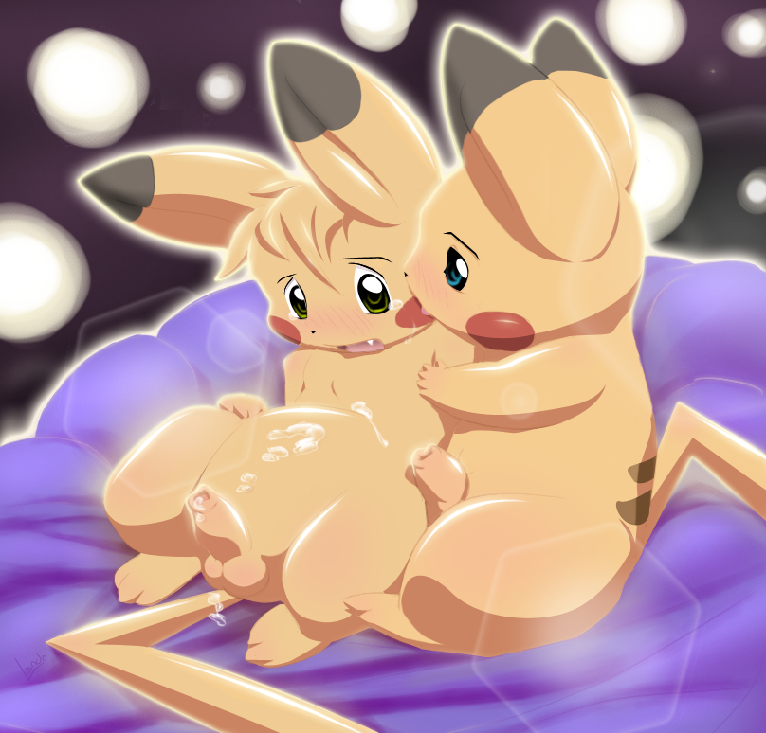
(This picture is copyright © Lando)

(Chapter Two)

It was dark outside, and the train was just pulling into and empty station near the school. As the train came to stop, a few of the train’s workers hopped off to begin pulling out luggage and helping students off the train. There were also a few people waiting to take the new students to where they needed to be. There was plenty of people to help keep things under control, and also to help guide the students. The train pulled to a complete stop, and as soon as they were given the go ahead, students began pouring off the train. Ethan and Sam hopped off the train, followed by Sparky and Will, with Pikachu, still red-faced, trailing just behind them. He did not say a word the whole time.

Students were now all over the train station, many looking for their luggage, which wasn’t a problem, as it was handed right to them, while other students, mainly the new ones gazed at the sight of the school- it was just like Hogwarts! There was a huge castle dead ahead of them, and it was the school!! They climbed into some old looking boats, and were taken directly across the huge lake to the boating house, and they walked the rest of the way to the school.

Once inside, the new students all gathered around on a large staircase, while the newer students headed up and directly to their dorms, dropped their things, and headed back down to the great hall. A teacher came out from the two huge doors leading into the great hall and stopped in front of the students. She looked rather serious.

“Welcome,” She said, “to the AGNPH School For Chus.” In a moment, you will enter through these doors and join your classmates. But… you must first me sorted into your houses; they are- Zaush, Arcc, Athus, and Nek0gami. Now, I will be back when we’re ready.”

She disappeared for several moments, during which, a lot of the students talked and laughed, and messed around. Then, she finally returned

We’re ready for you.”

And with that, she led all of the students through the large doors and into the great hall. The students all looked around the huge room with large windows surrounding it, the huge ceilings were phenomenal, and the overall area of the room was enormous!! They looked at students who were watching them, smiling and waving as they walked by. The odd thing- the one thing that caught their attention- absolutely none of the students sitting at the tables were wearing any clothing. They were completely exposed, chu-kawks and everything. The one thing that was distinctive- the thing that told everyone which house they were in was a simple collar that hung around their necks- red for Zaush, blue for Arcc, yellow for Athus, and green for Nek0gami. That was all the students wore.

The students all focused their attention up front where the woman that led them into the huge room stood. She spoke again

“This,” she said holding up a white collar, “This is the magic collar that will decide what house you are in.”

The students watched as something the same color as the color trickled down her fingers.

She held up a scroll. “Now, when I call your name, you will come up and be sorted into your houses.”

She began reading names off the list. The third name on the list was William. Hesitantly, he stepped forward, and slowly began walking up to the spot where the teacher was standing. She placed the color around his neck and fastened it. His nostrils were filled with a strong scent. He had smelled this before. His neck felt wet, and he felt the wetness of the color begin to run down his neck. He immediately recognized the smell, and stood there petrified. The collar was soaked with cum. That’s what the smell was; he remembered it from the train. The collar spoke up…
“Zaush!” it shouted, and the room was filled with clapping and applause, particularly from the Zaush house. She removed the collar from around his neck, and he began to walk toward his house table, but was stopped.

“You may now put on this red collar” she said putting the collar on him, “and remove your clothing.”

Apparently Will, Pikachu, and Sparky hadn’t been paying attention to the first 3 students who were called up because they hadn’t remembered her telling them to remove their clothing. Will’s face went bright red. He didn’t want to expose himself to all those other students. He didn’t want them all staring at his privates. But the teacher stared at him with her hand held out, ready to receive the clothes. His member began to get hard. He was definitely embarrassed by now. He carefully removed his clothing; all eyes were on him. He finally got down to his underwear after what seemed like hours, and he pulled them down, revealing his mass erection. Everyone clapped and cheered as he took off the last of his clothing. He then handed his clothes to the teacher and headed for the table. His face still red, he sat down next to someone he was quite familiar with- Ethan, who surprised him by quickly reaching over and squeezing Will’s cock, causing him to shriek lightly and spray all over the underside of the table, the juices dripped from the table and back down into his lap. Now William was embarrassed.

Finally, the teacher got to Sparky. Same procedure and all, Sparky sat down, the collar was placed around his neck and after a minute of feeling the wet collar around his neck, Sparky listened as the collar shouted “ZAUSH!” and everyone cheered for their new classmate.

“Pikachu.” The teacher’s voice called out the name as she read it off the scroll. Pikachu was most nervous- he’d already done something with another student and yet he wasn’t even a student yet. He carefully walked up and stood next to the teacher. She placed the white collar around his neck, and the collar spoke to him.

“Yes, I see you have true potential, I know what house that will come in handy with,” and the collar heard Pikachu saying “Not Nek0gami, anything but Nek0gami”

“Are you sure?” the collar spoke up again, “You have remarkable potential, and Nek0gami will help you along the way! In that case, it had better be… “Zaush!”

The room went up in an uproar of cheering. Everyone stood clapping and whistling, and Pikachu went red again, but he couldn’t help but smile. He would be in a house with all his friends, and that made him most happy! He said the name of the house to himself: “Zaush…” and he smiled thinking “Greatness…” He removed his clothing as the collar was placed around his neck and then he headed for the Zaush table.

Then the headmaster came up to the podium. Everyone knew exactly who he was. He was only the greatest headmaster that AGNPH has ever seen. He was Riiko!

“Welcome to AGNPH!” He said with a smile. “Before we begin our feast, I would like to go over a few rules. The forest is off limits to all students. Also, our caretaker, Mr. Narse, has asked me to remind you that the 5th floor corridor, just near the library, is off limits to those who do not wish to die a most painful death.”

He went over a few more rules and welcomed some teachers, and finally finished the speech with a “let the feast begin!”

He waved his hands and a huge assortment of foods appeared on the table in front of the students. They all dined!

Later, after the feast, the students all headed up to the dorm rooms, the students who had been there longer, leading the way for the new students. “Pikachu spoke up to Sparky and William, “Hey guys,” he said, his face turning red again. He hesitated, “Listen… I’m sorry about earlier, on the train I mean… I don’t know what’s going on… Sam was right, It’s some kind of will power that all Pikachus have, they just cant take it, and eventually, they end up doing what I did. I guess that’s why they have this school, and only for Pikachus- because no other pokemon are like this... I mean…”

“It’s okay, Pika” said Sparky, “I mean, this is what this school teaches, right?”

“Yeah,” agreed Will, “You’ll probably ace every class!”

They smiled and kept walking…

Later on that, while all the students sat in their dorm rooms, Pikachu set off to go take a shower. “After all the fun I had on the train, I think I need a shower,” he thought to himself, smiling as he walked along. The corridors were pretty dark at night, except for a dim light that came from the torches lined up along the walls.

He went to round a corner, and just as he turned, something hit him hard, and he fell to the ground. He quickly looked up. He was surrounded by four other pikachus. Sparks shot from their cheeks and hands, and Pikachu could just barely see the green collars they had around their necks. He looked up at their faces- and they were pissed!

They were all very large pikachus, and the largest one grabbed him while saying

“What the hell is wrong with Nek0gami house, kid?!” This house is way better than all your pathetic houses!”

Pikachu struggled to get away, as he was carried down the corridor and up to the Nek0gami dorm room. He was carried inside, and the door was closed and locked behind them. All the while another 3 Nek0gami students sat there on the couch smiling evilly at the little Chu. Pikachu struggled once again to get away, attempting to shock the other pikachus in order to do so, but it didn’t work, they merely absorbed the electricity. He bit the large one’s arm and he was dropped.

“You little bitch! So you like to bite things, eh?! Well don’t you worry about that!”

Another large Chu grabbed him from behind. He tried yet again to get away, but this time, his hands were tied behind his back. He was stuck there. The pikachu holding him from behind pushed him down onto his knees. And Pikachu watched as the other one (the one he bit) stood smiling in front of him. Pikachu’s muzzle was immediately greeted by a huge cock as the largest one thrust right into the little chu’s mouth, and began fucking him, sending his cock all the way into the back of his throat! Pikachu felt something huge penetrate his ass and screamed at the pain as the other large Chu stuffed his hard-on right into his tail hole. This was nothing as the rest of the crowd joined in.

There were seven of them total, and Pikachu screamed even louder as another huge cock penetrated his ass right along side the other one. Both cocks’s thrust in and out of his ass, while the one in his mouth continually gagged him. He tried again to shock the other pikachus but nothing worked. They just kept absorbing his electricity. He watched with tears in his eyes as some of the remaining four Chus just pointed and laughed, while the others joined in, masturbating themselves and spraying right onto the poor little Chu. Over and over again, Pikachu was thrust into from both ends, and over and over again, the remaining Chus sprayed their seed all over him until he was soaked, and more and more pikachus kept coming some trading off with the large Chus so they could get some of their juices inside the helpless mouse. Several of them moved in front of Pikachu and emptied themselves into the back of his throat and directly into his tummy, while the rest did the same to the other end. It was the worst when pikachu got three large cocks stuffed into his ass at one time and another two or three working at his mouth at one time.

He was sore, but these Chus were far from over. Some of them climbed on top of him and rode on his back like he was a horse, while others had attached a leash to his collar and were tugging at it for fun. One pikachu had managed to get hold of a nice willow branch, which he used over and over again across the pikachu’s ass. One pikachu had taken a string and had tied it around Pikachu’s cock and he had another group of people playing tug of war with the other end of the rope. Anything cruel and unusual that would cause this Chu pain was done to him, and the torment lasted for hours. The pikachus that were on his back were spraying all over his head and face, and now he was laying in a huge puddle of cum, but he wasn’t face down in it because his head was being held up by the collar and the leash while his mouth was now being pried by the sixty-seventh Nek0gami student to arrive, and some were even coming back for a second turn.

His belly was full to bursting with Chu cum, and his mouth was still being filled with the cream, and he wished it all just stopped. He didn’t think there was anyway he was going to get out of this. Another branch was taken across his ass, and another huge tug at his swollen chu-kawk. He couldn’t cum anymore; it was too painful. Then, out of nowhere, the branch was shoved deep into his ass and he yelled so loud that it seemed like anyone within a five-mile radius could hear him, but nobody did hear him, and nobody came to help him. He was nearly out, the room started to get darker and darker, then his head was dropped as the Nek0gami house pikachus began shoving his face down into the pool of cum. Pikachu fought and fought for air, they were drowning him in cum. He chocked and coughed and sputtered, and there were more whacks at his ass and more Chus adding to the pool of cum. They were going to kill him; he just knew it. A few for gasps for air, and the Chu faded into darkness, and this time, the light of the room didn’t come back. The last thing he heard was loud bang and a commotion. That was all.

He woke up in the hospital wing later on the next day. He squinted from the light.
Where… where am I he asked weakly, his body was still in pain? “What happened?”

The voice of his friend Sparky spoke up. “You’re in the hospital wing… you were almost killed by those angry Nek0gamis.”

“How did you guys find me?” he said, his voice still weak.

“Well,” William began, “When you didn’t come back from the shower, we figured something was up, and so we went looking for you.”

“You weren’t in the bathroom,” Sparky began again, “so were went looking. We heard a huge commotion and screaming coming from the Nek0gami dormitories, and so we figured your were in there.”

“Yeah, so we went and got these two,” Sparky said, pointing to Sam and Ethan who were sitting there listening to the story, “and they helped us storm the room and get you out. Sam and Ethan sure can take out those Chus, they took out nearly all of them.”

“Yeah,” said Ethan, “They’re afraid of us! We know how to set em straight! They wont ever mess with you again! And if they ever try to, you’ll be ready. We’re gonna show you how to defend yourself against them!”

“Thanks guys…” Pikachu said

“Yeah well, you owe all four of use a blow job, and a good rim job; just remember that!” Ethan said entertainingly. They all laughed.

A couple days later, when Pikachu was able to get around again, daily activities resumed like normal. Everyone was finally settled in and classes would start in another week, so basically, students just hung around and got to know other students in their houses. Pikachu got to know many people from his house, and he got along with all of them really well. He remembered asking Ethan about the Nek0gami house, and he remembered Ethan telling him, “Nek0gamis always grow up to be bad, they rape people mainly, like what they did to you, or at least it’s what they tried to do… You’re lucky the collar didn’t put you in that house, or you could’ve grown up to be like them. It was a nice idea telling the collar not to put you in Nek0gami.”

But Ethan and Sam showed Pikachu some of the ropes on defending himself from the Nek0gami students, and after all that was over, they would all go back inside the castle and head up to their dorms after supper, where they would just hand out for the rest of the night. One night, while everyone was asleep, pikachu sat out on the couch, thinking to himself. He heard the sound of footsteps on the staircase, even though whoever was coming down was trying to keep the noise down. It was Sparky.

“Hey, what are you still doing up?” he asked Pikachu.
“Just thinking, Spark, that’s all!” he replied softly. “Listen, Spark, I want to thank you again for what you did the other day.”

“Oh, it was nothing,” he said as he sat next to Pikachu on the couch
“Spark, they could’ve killed me… you saved me.”

Sparky just gazed ahead while he thought about what Pikachu said. It really was nothing… he had just gone and gotten Sam and Ethan. Had they not done that, they would’ve found themselves in the same situation.

He continued thinking about the matter, not even paying attention to Pikachu or anything else for that matter. He was deep in thought- lost in his thoughts. Then, he felt something warm and wet on his cock. Shocked, he looked down. Pikachu was now sucking on his cock.

“Wh-what are you doing?!” he said still disturbed.

“I believe I owe you one blowjob,” he said with a sot, smooth, and sexy tone to his voice”

“Seriously, you don’t have to do this. Ethan was just joking-“

“I want to… I owe it to you; besides, you have no idea how long I’ve wanted to do this…”

He smiled and continued his work, suckling greedily at the chu-kawk.” Sparky just sat there, until the will to cum began to hit him. He then started to go along with the motions. He moaned to show his enjoyment, even though he was still quite shocked at the fact that his best friend was now eating his cock, waiting for something to swallow, but he convinced himself that it was okay because of the plain and simple reason that “this is what this school taught,” so he continued to go along with it. Eventually the knowledge of what was going on hit him- it was his best friend…. And he was giving him a blowjob. He had known this already, but just thinking about it over and over again, brought him closer to going over the edge, and he began bucking his hips into Pikachu’s face, who simply grinned knowing what was coming. Then, with very little warning, Sparky shot his load and Pikachu kept his lips sealed around the cock so he wouldn’t miss a drop of what his friend was giving him.

He swallowed every bit of the white Chu-cream that was sprayed into his muzzle. His friend sighed with relief, but was interrupted with “It’s not over yet, Spark…” Pikachu rolled him onto his belly exposing his backside. He moved his head in towards his hole, and took a few licks. The papery tongue against his ass made Sparky shiver with delight, and he refused to fight what Pikachu was about to do. “After all,” he thought to himself, “he owes it to me.” Pikachu took a few more lips of the tight pink pucker before moving completely in and driving his tongue deep inside his friends tail hole, slurping along the walls, and sucking anything and everything out and into his awaiting muzzle.

He got plenty of juices to drink down, but that was all it, and eventually, he was stopped by Sparky, who had other ideas in mind. He smiled at Pikachu and said “get up here…” and Pikachu knew what he wanted. Smiling back, the chu climbed up onto his master’s lap and waited anxiously for Sparky’s hard member to penetrate his ass. He wanted Sparky to fill him up, and that’s what Sparky planned to do. Sparky lowered his temporary slave down onto his lap, and carefully pushed in until Pikachu was flat onto his lap. Then he began his work, moving in and out of the tail hole, and Pikachu just moaned with pleasure. His cock was stiff too, and soon he would go over the edge.

He was sitting facing Sparky while Sparky was thrusting in and out and an increasingly fast rate, and he began to drive himself to the point of no return. “You owed me a rim job and a blowjob, that was it. This is extra, so I’ll return the favor. He smiled and bent down and began licking at the tip of Pikachu’s member, which drove him even closer to his climax, and Sparky was also reaching his too, as once again, he began bucking his hips, holding Pikachu down, and eventually, he let loose, coating the inside of his hole with chu-cream, and in response to the feeling of cum jetting into his ass, Pikachu also let loose, spraying a huge load of cum into the face and muzzle of his friend, who gladly drank it up.

With one last moan, Pikachu finished his load, and then he climbed off of his friend. The couch was covered in cum, and so was his friend, and he himself was covered too. That must’ve been a pretty large load. But Sparky was already cleaning him up with his tongue, and Pikachu decided, once more, to return the favor, and he began licking his friend clean as well. They were both exhausted from their activity, and without even realizing it, before they were even able to finish cleaning up the mess; they both cuddled together and fell asleep.

(END OF CHAPTER TWO)

Credits/Acknowledgements/Rights:

“Pokemon” and “Pokemon Characters” (Pikachu, Sparky, etc) are copyright/trademark of The Pokemon Company, Pokemon USA Inc, Pokemon.com any and all subsidiaries and legally associated companies, their products, services, and licenses.

Art (shown above), is copyright of Lando

Character “Riiko” is copyright his owner

“Schooling For Chus the series” is copyright Littilwood

“AGNPH” belongs to AGNPH.com

“Hogwarts” and Harry Potter” are copyright JK Rowling

House names: “Zaush, Arcc, Athus, and Nek0gami” are copyright themselves

