Schooling For Chus The Series (By Littilwood)
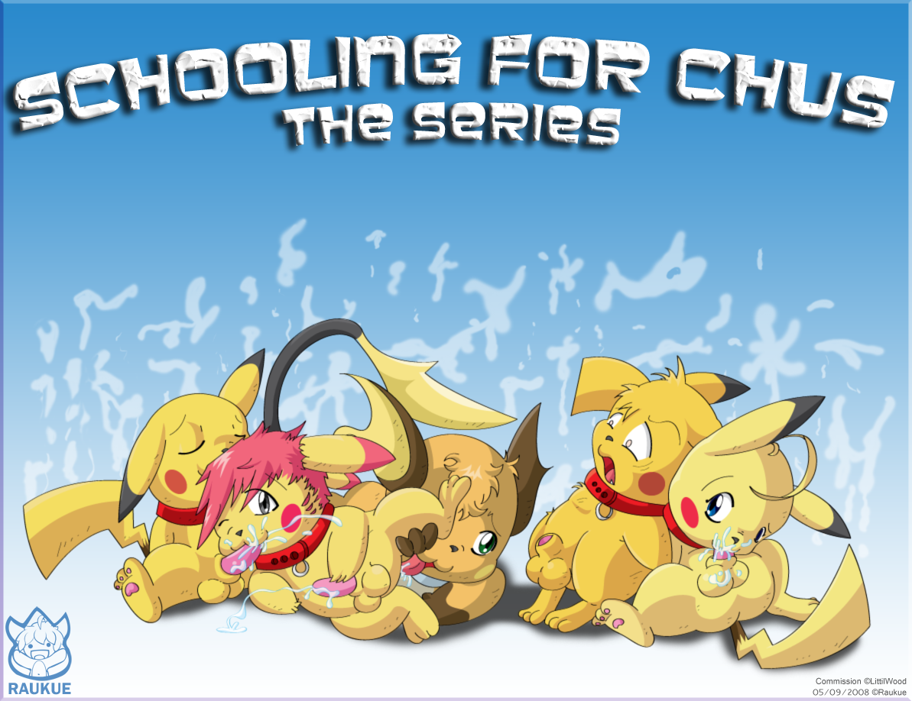

Chapter Five

A harsh wind started to blow outside, pounding the windows as thunder bellowed in the distance. The trees swayed slightly at first, but became more violent as the wind picked up speed. The sky grew darker as black clouds passed overhead, completely blocking out the sun. Rain started to pour onto the ground, quickly soaking it.

“We have to hurry!” Pikachu said, as they moved toward the curtains, taking a precautionary glimpse through the water-soaked window.

The group headed for the door, prying it open. Pikachu, with William right behind him, dashed out onto the lawn.

Rune grabbed his book, hiding it under his long cloak. “Come on, pet,” he ushered the innocent-looking squirrel through the door, who fell into place right beside Stewie.

The streets seemed empty, as if everyone had gotten confused between daytime and nighttime and had gone to bed.

Pikachu was a ways up the street before he heard sounds of screaming, a house right beside him, which had once been dark, burst into flames, only inches away from him.

“Chudeat Skele!” He heard a thud inside the house

“No!” he said to himself rather quietly, his eyes wide with tears.

“THERE!” he heard a demoic voice right behind him, and quickly ducked as a spell flew right by his face, this time on his opposite side

A window shattered revealing the inside of another house, as a demon-like creature hopped out onto the lawn, grinning evilly at the chu. He raised his wand.

“CHUDEAT SKELE!”

The demon fell onto the ground, and Pikachu stared astonished. That spell… he heard it… he thought it was headed for him. He glanced over, only to see his mate with his wand extended, sparks, flittering off the end.

He sat, rendering the situation in his mind before he shouted, “COME ON!”

Everywhere they looked, they could now see visible spells, flying from families trying to defend themselves from the demons attacking the town.

“KILL THEM ALL!” a voice echoed through the land. “LEAVE NO SURVIVORS!!”

Pikachu, fell onto his knees, and gripped his head, wincing in pain.

Rune ran up behind him, his book open in his arms. He raised his hand and uttered one of the incantations from his book, and a beam of blue light, rose from the ground, just under a group of enemies in the distance, completely disintegrating them.

The squirrel trailed not far behind his master, his mate beside him, flinging spells to protect the two of them.

“Fight it sweety.” Rune said, kneeling down beside the Chu, his paw on his shoulder. “He’s close now, it’s going to be harder to fight the power of the book”

After a brief struggle to ignore the voice and regain self-control, Pikachu stood up, slightly dizzied. He continued for his house, the group staying close.

“CHUDEAT SKELE!” He shouted, hesitantly, his wand pointed at a group of demons, all but one, just barely dodging it, the last, falling to the ground, and shattering into a pile of corpse dust.

“THERE!” He pointed out into the distance, revealing a house that was so far away, it was barely visible. It was untouched.

“WE HAVE TO HURRY!”

He bolted through the wet grass, jumping down quickly to avoid a spell. He hoped the demons weren’t headed for the same house, but if they were after him, they might as well be.

He tore through the bushes, hopping any fence he could, completely breaking free from sight of his friends. His one goal was to get that book, no matter what it took; he HAD to get it before Darkchu did.

Thoughts pounded through his mind, more and more coming and going, as he got closer to the house. He started to see visions, a Pikachu, much like himself, a sneaky little bustard, and a worried look on his face. The Pikachu approached a shelf and pulled a book, the wall turning. Then another flash, a blue light surrounding a book. The Pikachu reached through the light, gripping the book in his tiny paws. And then, all of a sudden, the light turned red, he tugged at the book and it came through the protective barrier. Power rushing through his body. The Pikachu grinned evilly, and then looked up right into the eyes of Pikachu.

Pikachu shook his head, pulling himself upward, as though trying to wake himself up from a very bad nightmare. He was soaked with rain, and the group was still behind him, battling. He found himself kneeling on the ground again. He stood up, regaining his footing. His house was only just ahead. He looked around, but saw nothing. Nobody else was in the area. His eyes focused on the door to his house. The door was slightly open.

His heart sunk. He was too late… they got inside while he was daydreaming!

He rushed for the door, throwing it open, seeing two demons inside on of the rooms.

“CHUDEAT SKELE!” he shouted, blasting them both through the wall into another room.

He snuck quietly through the house, his wand out in front of him, a soft green glow at the tip.

He snuck up the steps, quietly, trying to prevent any noises. The floor didn’t make much noise, and he was careful with his footing, and knowing his house, stepped only in the spots that made no noise. He got to the staircase. The book was upstairs in his room.

He started quietly up the stairs, almost sidestepping, in case someone was around the corner. He almost lost his footing, as the creaking of one step scared the hell out of him. He was shaky, but tried to remain calm. He was alone, and he didn’t want to wind up surrounded by a group of demons he wouldn’t be able to take on his own.

