Dancing With Dragons- A Story About Ron Stoppable and Jake Long
Written By: Littilwood
Artwork and Icon © Serge Stiles
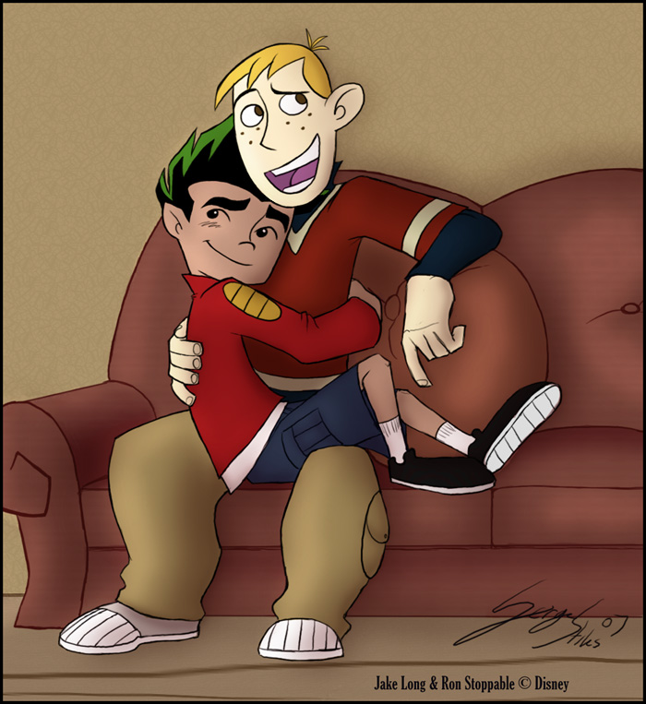
Characters © Disney

It was 5-o-clock, and Ron had just jumped out of the shower. He quickly dried himself off, and dressed up nicely- nothing big like a tux or anything, just a nice pair of pants and a decent-looking shirt. He had to hurry up, or he would be late, his date would arrive at quarter after. He quickly buttoned up his white silky-smooth shirt, and took one final glance in the mirror.

“Perfect!” he said to himself, as he turned away and rushed out the door and into the hallway.

It was going to be a long week- Ron’s parents were away, and he planned to spend every sweet moment with his true love, even if the relationship did seem a little weird.

There was a knock at the door, and Ron ran as fast as he could jumping over furniture to get to the door. He stopped abruptly in front of the door, and very swiftly, very smoothly; he turned the knob, and pulled the door open.

“Hey! A very familiar voice said softly, but lovingly. It was the familiar voice of Jake Long.

“Hi,” Ron said just as sweetly, reaching out and pulling his lover into a big hug.

Jake looked just as nice as Ron did. He didn’t overdue the dress-up thing, and instead, like Ron, he also wore just a decent shirt and a nice pair of pants. It didn’t matter though, because in Ron’s eyes, Jake long looked amazing, no matter what he was wearing.

The sun was setting in the background as Ron, shut the door and lead Jake into the family room. They were just going to watch a couple of movies. They both sat on the sofa.

“So, which movie is it going to be?” Ron asked coolly. “I’ve got Bay Creek, Night of the Wolves, and The Secret Door.”

“Hmmm… Night of the Wolves sounds like a nice movie,” Jake said serenely.

Then Night of the Wolves it is, Ron said as he popped in the disc.

They both cuddled up on the couch as the movie played on, Jake in Ron’s arms…

“Hey,” Ron said quietly to Jake, halfway through the movie, “do you want something to eat?”

Sure, Jake said putting the movie on pause.

Ron got up and headed for the kitchen, which was pretty much attached to the family room. It wasn’t one of those separate rooms, and the counter was right there. He opened the fridge and grabbed a bottle of soda. Then he reached over o the cabinet and reached for two glasses, but his hand slipped, knocking a few onto the floor, which luckily, didn’t break. Embarrassed, he bent down and picked them up- he knew Jake was watching, so he tried to be cool about it.

“Do you need some help?” Jake asked as Ron finally got two clean glasses and set them on the counter.

“No, I’m good, I got it…” he said as he began pouring the soda into the glasses, which splashed, and some got on his white shirt.

“Oh, man, I got some soda on my shirt.” He said, his face was now red with embarrassment. He simply finished pouring the soda, threw some popcorn in the microwave, and then into a bowl, and then he removed his shirt, and threw it on top of the washer. He wasn’t worried- after all the stain would come out. When he returned from the laundry room, he grabbed the drinks, and took them both over to the couch where Jake took them and set them gently down on the coffee table, while Ron headed back for the popcorn. As he headed back toward the couch with the popcorn, his nice dress pants, caught hold of the corner of the counter and ripped wide open. Ron was now completely embarrassed. The only one who had ever seen his boxer shorts was Kim.

“Awwww maaan!” he spoke out loud, while Jake, who had seen the whole thing was now on the couch laughing. Ron began to leave to go grab another pair of pants

“It’s okay, Ron; keep them off. You’re boxers are nice.

And so Ron, still embarrassed, took off the torn pants, threw them away, and returned to the couch, in nothing but his boxers, and Jake, who felt bad about seeing Ron in his boxers, had stripped down to his boxers to make Ron feel more comfortable about the situation.

Ron returned to the couch, and just seeing Jake in his boxers began to give him a hard on. He tried to ignore it and sat back down on the couch, and Jake laid himself down across his lap. He felt something against his head, and Ron knew what it was, hoping the hard on would go away and fast, but it didn’t. As Jake lifted himself up to see what he had laid on, he noticed Ron’s erection, and it was poking through the crotch-hole in his boxers.

Both of their faces went red, but the redness on Jake’s face wasn’t even comparable to the embarrassment shown in Ron’s face. He couldn’t even speak…

Jake simply smiled, and began pulling down Ron’s boxer shorts, revealing the full thing, sack and everything, still completely hard, now with a little pre cum on oozing out of the tip. He then removed his own boxers, as Ron just sat there, still unable to speak, but in total disbelief at what he was watching. Jake opened his mouth, and revealed his dragon tongue, which was very long in comparison to his human tongue. He wrapped the thing around Ron’s cock twice, and with the remainder of his tongue, headed up for the tip of the dripping member. He licked at the tip, collecting the pre cum on his tongue, while using the rest of his tongue, to masturbate Ron’s cock. Ron simply stared at his lover, who grinned back at him and continued his work. Now with a completely different idea in his head, he unwrapped his tongue from around Ron’s cock, and put his whole mouth over it and began to suck hard at it, while his tongue began doing a different job. He sent his tongue down under Ron’s sack, and up his backside, and felt for the opening of Ron’s hole. Ron simply moaned at the feeling of both Jake eating his cock, and also at the feeling of Jake’s slippery wet tongue feeling around his ass. Jake finally found the hole, and shot his tongue into the opening, and began licking the inside for anything tasty. Ron, who couldn’t quite handle the sudden thrust of Jake’s tongue in his ass shot a jet of pre into the back of Jake’s throat, who quickly swallowed it like he had been starved for a while. Ron loved the feeling of Jake on his cock, it felt nice, because not only was he enjoying the licking and sucking sensations, but he also loved the feeling of Jake’s fiery, warm dragon breath on his cock. He could also see steam coming out of Jake’s nose.

Jake’s cock was now also erect, and he continued hungrily at his work, and to add a little more fun to the situation, he changed into his complete dragon form. Ron was completely surprised by this, not because Jake was a dragon (because he’d known about that), but because never before had he seen Jake in his boxer shorts, let alone naked, but now that he was in dragon form, his cock was now 5 times it’s original size, it was like 8 inches long and dripping with pre. Jake simply grinned at Ron’s surprise, and kept going, even harder and harder than before- he wanted what Ron’s cock was offering, and he wanted it bad, he suckled harder and faster, and Ron was drawing closer to his breaking point. Just a few more pumps, and he would be finished. Ron began bucking his hips, thrusting his cock uncontrollably into Jake’s dragon muzzle, and finally with one final hard thrust into Jake, and Jake with one final suck and thrust of his tongue into Ron’s hole, Ron let it all go- spraying into the back of Jake’s awaiting mouth. Jake moved his mouth away from Ron’s cock and removed his tongue from Ron’s ass, as he groaned and continued spraying his seed onto Jake’s face- in his hair and onto his ears and nose, and Jake using his tongue to clean himself off, got himself ready for the next round, as Ron finished up.

“Okay,” Jake said with an evil grin, “Now it’s your turn!” Jake, still in his dragon form, laid back onto the ground with his completely erect eight inch member pointing straight into the air.

“Uhh, do I really have to?” Ron asked nervously. He wouldn’t have minded sucking Jake’s regular cock, but he was completely shocked at the fact that Jake wanted him to eat this huge cock. He probably couldn’t even fit it in his mouth!

“It’s either your face or your ass,” he said, the evil smile still across his face.

Ron got up off the couch and got down onto the floor on his knees, and moved closer to Jake’s large dragon member.

“Go On, Ron-“ Jake ushered.

With a sigh, Ron moved in closer and sticking his tongue out, licked the tip of the huge hard on, causing Jake to moan, and a small spurt of pre to come oozing down onto Ron’s face. For a dragon, that was a lot, so much in fact, that single spurt of pre could’ve filled half of one of those glasses sitting on the coffee table. The quick spurt oozed onto Ron’s tongue. He tasted the pre- it wasn’t bad- it was slightly salty actually, not bitter, and it had a smoky flavor that resembled beef jerky- this must’ve been because of the fact that Jake was a dragon, and a fire-breathing dragon at that! It was delicious!

Ron quickly began working on the cock, licking the whole thing over, from the base to the tip, while Jake just laid back and moaned, steam still coming from his nose, and his mouth too. Ron finally, grabbed the whole thing, and holding it steady with both hands, thrust the huge member into his mouth, and an explosion of pre flowed into his cheeks. Ron quickly swallowed the mouthful, and kept going. It was suck as large cock, and the only thing Ron could do is bob is head up and down, and use his tongue as a tool to help pleasure the dragon. Pre cum ran down from the tip of Jake’s cock and all over Ron’s hands. It was a lot, more than Ron could swallow. That is what Jake loved about his dragon form; his cock was larger and there was so much more hat came from it than did in human form.

Ron kept up the work quietly as Jake moaned and gave a few thrusts to help Ron out. He loved it. There was so much pre flowing from his cock- his cock could’ve literally eaten Ron. He imagined it, and smiled at the thought. He wanted to stuff Ron up his ass, and not just his cock either- he could literally fit Ron’s whole body in his ass! These thoughts drove him over the edge, and, like Ron, he bucked hard, gagging his friend in the process, and finally exploded, spraying buckets and buckets of cum at Ron, who could only take so much in his mouth. It ended up literally soaking Ron in dragon seed, and now it was all over the floor too. Ron swallowed the delicious drink, and began licking the floor for more, while Jake continued spraying, in fact, Jake had sprayed so much, if he had sprayed into one of those small kiddy-pools, he’d have filled it to the rim with cum- that’s how much was all over the floor, all over Ron, and all over himself.

The hungry dragon couldn’t stop himself now, and he quickly grabbed Ron by his waist, lifted his dragon legs up, and began to shove Ron, who was still completely covered in cum and now completely shocked at what was about to happen, head first into his dragon hole. His tight hole stretched to its limits, as first, Ron’s head disappeared, followed by his upper body, then his cock, his ass, and his legs- and finally his feet, which all completely vanished into Jake’s ass.

Jake licked his lips, enjoying the feeling of his ass, which had completely devoured his lover. There was no way he was going to let this end…

The final words Jake spoke to his boyfriend in this story were- “I hope you like it in there, because that’s where you’re going to be for the rest of the week!” He smiled evilly, and just laid back into the puddle of dragon seed on the floor, licking the cum off his claws and enjoying the moment. Then he fell asleep…

