Until I Met Him
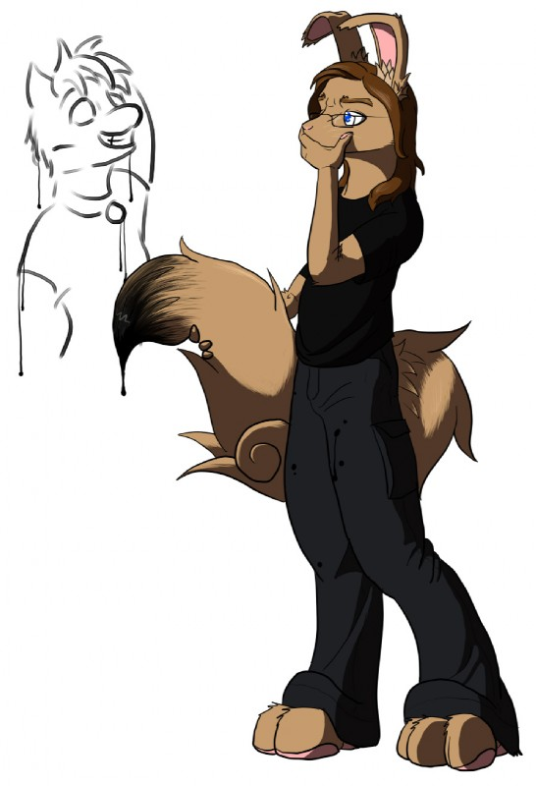
The teenage kit woke up to a beautiful sight of light beams flickering about the room. Light reflecting off particles of dust created the illusion of tiny fairies dancing with the gentle breeze flowing through the room. A delicious aroma caught the attention of the kit's keen little nose and at that moment he knew it was time to get up. As the kit padded sleepily down the hall towards the smell which was coming from the kitchen, he heard the beautiful sound of a joyful tune which he knew was coming from his mother. Seeing his mother out of bed for the first time in months shocked him. His mother, a short little rabbit with long floppy ears, had been battling cancer and had not been able to get out of bed. This day was going to be different.
"Morning Immy, I knew this would get you out of bed," said the bunny with a smile. "Morning mom, Im glad to see you out of bed. Whats the occasion?", "Im going back to work today!" said the excited rabbit, ears twitching happily. "Anyways, howd you sleep sweetie?", "Ehhh... slept wrong on my tail and now its really sore", said the kit swishing his tail around to work out the soreness. "You have no idea how annoying having a tail this big can be!" Unexpectedly the kit's mother burst out with "I always thought everyone in your dads family had big tails but yours is ridiculously huge compared to theirs! Its weird how your half rabbit and its still so big. Well, thats genetics for ya" "Well I did inherit your floppy ears!", said Immy while separating his long headfur from his floppy ears. "What are you going to do today while im at work, son?" said the mother bunny while frying a pan-full of bacon. After all, bacon was the best way to start the day. The still tired kit said with a slightly sad tone, "Im not sure. I guess ill sit here by myself like usual." "I know you will find something to occupy yourself. Maybe you can have a friend from school over." said the kit's mom in a strange tone. The bunny turned to her son as she finished cooking to see him glaring at her, eyes narrowed. She gasped only to see her sons evil look turn to tears. "I havent gone to school all week." said the kit, hanging his head and barely audible. The kits mother interrupted "I know. I heard about what happened. Why do you try to keep things like this from me?" The previous week, the kit had a fight with the whole football team and it ended with 23 pissed off football players and 1 terrified little kit in the locker room. "I was hoping they wouldnt tell anyone and I thought that if I told you, you would go to the school and make a big deal out of it and everybody would definatly hear about it then. Plus, you have enough to be worried about and you dont need to worry about me. Im perfectly fine having not having many friends. I like it like that!" growled the kit. "Well if you dont want me to help then so be it but your going to school tomorrow. You need to make up all that work you missed." said the rabbit with a motherly tone. "and Immy," the kit looked at his mother, "try to be friendly. Dont go wander off away from the other students. They can sense your fear when you do that." Said the kits mother as she finished washing her plate. "Im going to get ready for work. Love you!" The rabbit walked out of the kitchen towards her bedroom and shut the door leaving the kit staring at his untouched food. He noticed his mothers blatant disconcern on the subject and knew that she was hiding her true feelings. "Shit..."
The next morning, Immy reluctlantly got up and got himself ready for school. His mother returned from work just in time to drop him off at school with a smile and a kiss. She was acting weird and Immy could tell. The kit padded up to school's main courtyard and to his surprise, no dirty looks! It seems like nobody knows what happened. It was obvious that something happened. They have to know but why are they being so nice? “Morning Immy!” The kit looked around for the familier voice. He then saw one of his only friends, a slender tabby cat, standing among a crowd of aquaintances. “Hey, Ashley. Sorry to be this way this early in the morning but why does something feel off,” questioned the kit. “What do you mean? Hehe...” stammered the cat nervously. “You know, dont you?” “Everybody knows, Immy. They arent saying anything because... well...” “Well what?!?,” growled the kit. “Your mom kinda came to school yesterday and beat the ever living crap out of LaDerick Johnson” The young bunny/fox's eyes got huge, “the starting quarter back!?!” “yep. The good thing is that she cant go to jail because hes over 18.” “ Im not worried about her going to jail, Im worried about what she did to him. Can he breath on his own?,” “The principal said that he will take no further actions against your mom for some reason.” The kit was sorta proud and sorta embarrased by his mothers actions. Must she always fight her sons battles? Ashley speaks up, “did you hear about the new student? They say that he was rescued from some sick bio-medical association. They said that they kidnapped him and used him for weird experiments... Ironically he's a lab rat.”

