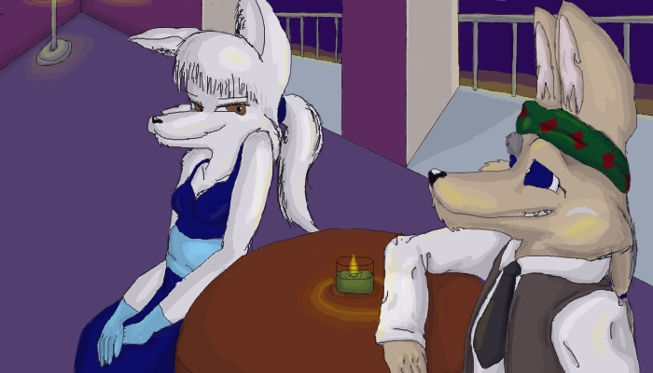
Clyde watched with a huge grin as Jacqueline bared her shoulder to him, batting her eyelashes painted dark brown for just this occasion.
The arctic vixen was graceful and elegant in her navy blue spaghetti-strap dress and the baby blue sash around her waist. Her hands were bedecked by elegant gloves of the same blue color as her sash. The cold colors seemed to indicate her progression from a harsh, arctic climate to the high-society life she now lived more than even her pure, white fur could signify.
Clyde, for his part, wasn’t too shabby either, sporting a waistcoat, a fine white undershirt, a black tie, and some spiffy black slacks. He normally didn’t like to dress up, but this date was special. Across from him was a famous musician and comedian named Jacqueline Iris, and she had specifically picked him out of the crowd and asked him to come backstage. Not used to commiserating with celebrities, Clyde couldn’t but find himself a little giddy at the prospect of meeting one in person and behind the scenes. And now here he was: on a date with Miss Iris, watching her obvious flirtation in full bloom. Sure, it was probably going to be a one-night stand, but he could dig that just fine.
“So, tell me a little about yourself,” the vixen crooned, her voice clenching the jackal’s diaphragm as would a fist.
“Well,” he began, acting cool despite his racing heart, “I do various odd jobs here and there. Like you, I travel a lot. Came from the desert, as you might imagine from my fur color and race.” He left out that the “odd jobs” were often criminal, and the reason he traveled a lot was because he was often on the run from the law. Figured she might not need to know that.
“Ahhhh,” Jacqueline replied. “I like a well-traveled man. So many people I meet are insulated and narrow-minded. Not very adventurous at all, you know?” She decided that now was a good time to rest her elbows on the table and her cheeks on her hands, revealing just how loose and low-cut her dress happened to be.
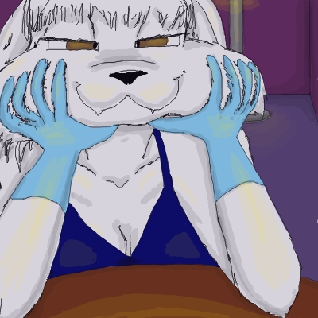
Clyde smirked, couldn’t help himself, and continued talking despite the obvious game his date was playing. “You seem like a person who can read others pretty well,” he said, making almost no effort to hide where his eyes were drawn. “You have to be, being a comedian. After all, your profession is to notice things others only know subconsciously and point them out in hilarious ways. That said, why’d you choose me out of the crowd to go on a date with?”
“Oh, quite to-the-point, aren’t you?” she asked, leaning back and twirling a lock of her long, white hair that had fallen over her shoulder. “Then I will be too. You looked the most cynical and experienced of all the people I’d seen in the crowd. I like people like that, and I’m not above using my influence to meet them. After all, what if I find ‘Mr. Right?’” She left out the fact that she liked to, as she called it, “collect” people in each place she visited. At least one person per place, but if she could get more, it increased the thrill. The real reason she chose Clyde is because she thought he looked like a bum and no one would miss him. She was a bit surprised he was dressed so nicely this night, to tell the truth.
Her date laughed a bit at that last statement. “Pardon me,” he said, placing his hand in front of his smiling face, “but you don’t really strike me as the type who would want to ‘settle down’ anytime soon.”
She grinned as well, showing off her sharp, pearly-white teeth. Clearly she cared about her appearance; even her teeth were immaculate, and if Clyde were to venture a guess, he imagined her breath probably smelled somewhat sweet as well, despite her carnivorous species. What he didn’t know was that, if Jacqueline had her way, he’d get to smell it more than he could possibly want.

Dinner arrived shortly after, and Jacqueline ate her shrimp platter as tantalizingly as she possibly could, accentuating every movement, from stabbing the small shellfish, to wrapping her tongue around them as she placed the fork in her mouth, to removing the bare fork with a small sucking noise and a light Mmmm...followed by a tilt of her head and a small ripple beginning just beneath her jaw and running down the center of her bare neck until it disappeared behind her collarbone. Clyde couldn’t help but stare at the pink cheeks, immaculate teeth, and luscious tongue as she smacked her white lips and said, “Ahhh…delicious.”
While gawking, the jackal ate his steak, peas, and potatoes with far less grace, barely noticing the taste, which itself was juicy and exquisite. After all, as good as the dinner was, the company was far more memorable, and he wanted to take in every detail he could.
The two talked until the restaurant closed, discussing personal philosophies, past relationships, and life’s experiences. They appeared to have hit it off pretty well, finding many things in common. In particular, their conversation about past relationships aroused a lot of interest in both parties.
“…Then the guy got a real shitty attitude and the relationship went down the toilet. I only saw him once after the breakup, but barely recognized him, not that it mattered at that point,” Jacqueline finished talking about her last boyfriend with a small shrug and a smile. She had stopped her fake flirting by this point, seeing no need to continue.
“Sounds like you’ve been the dumpER in most of your relationships. Doesn’t surprise me too much. You’re real strong-willed and self-sufficient. I can’t imagine you get too attached to people either, since you’re clearly not attached to any one place.”
Jacqueline laughed. “Ha! Yeah, that’s true. You’re good. So how about you? Which kinds of relationships have you had in the past?”
Clyde leaned back, one arm over the back of his chair, far more relaxed than when the date started. “Most people would shy away from this topic, I’d think. It’s a strange thing to talk about on a first date, either way. Pretty cool to be able to just let loose and spill all this stuff with someone who’s basically a stranger.”
“True. True. You gonna answer the question, though, or are you dodging it?” The vixen smiled sardonically, showing just a hint of her sharp teeth.
Chuckling a bit, Clyde waved his hand in a dismissive gesture. “Yeah, yeah. Just makin’ an observation.” He fluttered his free hand about a bit, open-palmed; flicked his tongue across his lips to wet them; and started talking.
“As you may imagine, I’ve been through a lot, and that means a lot of weird relationships too. Like you, I’ve done most of the breaking up myself. I get bored, see, so I move on after a time. I’ve tried a whole buncha different things, including dating men, but I’ve since decided that ain’t my cup of tea. Women are more my thing. Usually when I’m finished with a relationship, though, I just kinda leave and move on. Got no kids that I know of, and I don’t really care to know either.”
Jacqueline chuckled at that. “Hey, me neither. I’d probably know, though,” she laughed, “so I guess I’m good. So what was your last girlfriend like, anyway?”
Clyde’s brow dropped a bit and he lost his grin. “Well, last time was strange. This time, it was her who disappeared on me. I was dating a white rabbit back in the city of Pardle. Had a coupla dark marks under her eyes. Hair covering her right eye most of the time. Best goddamn dresser I’ve ever seen. You wouldn’t believe how many wardrobe malfunctions she had.” At this, Clyde rubbed his chin in delighted remembrance, grinning.
Jacqueline’s adrenaline surged a bit. She actually knew the rabbit he was talking about, or thought she did. The rabbit was the last person she had “collected,” back in the city of Pardle. However, the vixen remained in the same position with the same expression, as if she weren’t affected at all, even if she was almost giddy to hear more.
Clyde continued: “She was real nice, but a bit vapid. Tried teaching her some stuff, and some of it got through. I actually still liked that relationship for the most part, but then one day I went to her place and she wasn’t there. Figured she was out or something, so I came back later. Well, obviously I haven’t seen her since. Real mysterious and such, but I guess I won’t worry about it too much. She was a good dancer, but it’s not like there was a lot else she contributed to society.” He shrugged a bit, a tired smile on his face.
Jacqueline’s stomach felt like it was twisted in knots now. Yeah, that’s exactly the girl she’d “collected” a little while back. Same location, same description, right down to the revelatory attire. Now the vixen was certain she’d have to “collect” Clyde, because to pass up on this would ruin such an ironic situation. She smiled sympathetically and leaned forward, touching the jackal’s chest. “I’m really sorry to hear that. What say you come back to my place and I ‘console’ you?” She winked.
“Was hoping you’d say that,” he replied, grinning mischievously.
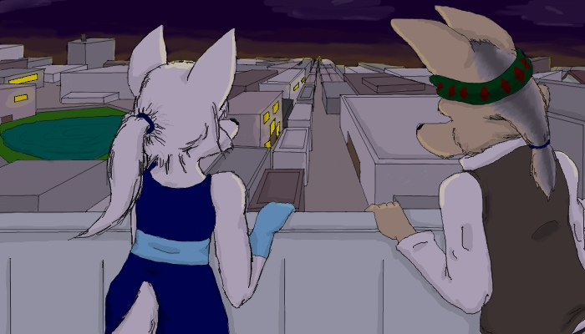
Jacqueline’s “place” was a very posh hotel suite on a hill with a balcony view of most of the city. Though usually cheap, Clyde could see why someone with money might want to spend it for something like this. Sure it wasn’t practical, but man did it feel good to look out over everyone else. Gave a sense of power, not to mention the beauty of a modern city’s lights. Whoever said that the only worthwhile things were in nature was an asshole.
“Ever see anything like it?” Jacqueline’s voice came from behind him.
Clyde turned to her and smiled. “Yes, but usually not without any sense of urgency. My view at this very moment, though? Can’t say I have seen anything like it before.” The jackal held out his hand, which his vixen companion took with a coy smile. The two then left the balcony and flirtatiously made their way to Jacqueline’s apartment’s living room.
Jacqueline was the first to make a move, wrapping one arm around Clyde’s neck, staring into his deep blue eyes and giggling, and then slowly licking his cheek. She smacked her lips and said, “Mmm…tasty. Just the way I like my men.”
This hit a particular nerve with the jackal, accessing his libido in a way no other teasing could. He visibly shivered, shutting his eyes tightly and grinning. When he opened his eyes again, he realized she had taken his hand and placed it upon her chest.
“Liked that, did you?” she crooned, licking him again.
Smiling very widely, he replied, “I did. And perhaps you would like it as well.” He likewise ran his tongue along her silky neck. She giggled a bit and pressed the side of her face against his chest, beginning to hum a small tune.
The whole experience seemed dreamlike to the jackal. Sure, he’d had plenty of other girlfriends, but none seemed as special, as…transformational as this current one. Part of it was her celebrity, of course, but there just appeared to be a mystical quality about her. Why, he felt as though he ought to just give himself up entirely to her, as though she were larger than he could ever be and yet utterly benevolent. He closed his eyes again and had the sensation of losing himself. Losing mass. Shrinki—oh fuck. She was a bard.
He opened his eyes again and realized he was about a foot shorter than he had previously been, and although staring at her knockers was pleasant enough, he didn’t particularly want to continue shrinking. With a grunt, he steeled his will against her spell, staring daggers into her sly eyes. She cocked an eyebrow, realizing that he knew what she was doing, so she crescendoed her hum from soft to nearly operatic in scale. The walls reverberated with her voice, and Clyde found his mind fogging over again.
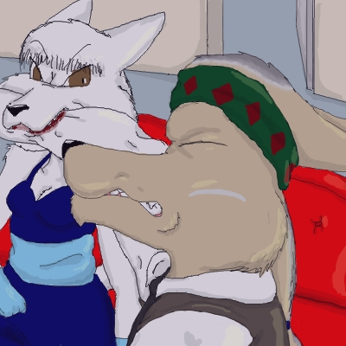
“No fucking way,” he said, and shoved his forearm in her mouth, cutting off her bardic spell. She bit down hard, drawing a lot of blood and evincing a loud yelp from Clyde. He didn’t withdraw his arm, however. Couldn’t risk letting her start again. Instead, he took his other hand and snarled, “Knirhs, bitch.” A small blue ray shot forth from his index finger and disappeared into Jacqueline’s midsection.
In less than a second, the famous comedian and singer was now smaller than an infant’s curled fist. Clyde stuck his bleeding arm in his mouth, clenching his gut to ward off the pain, and he leaned down and scooped up his former date in the other hand just as she was about to dart under the couch. She glared at him and began to sing once again, but he placed his thumb in her mouth, which she once more decided to take a chunk out of with her sharp teeth. By this point, the perimeter of her mouth was soaked red and pink with Clyde’s blood. The jackal wouldn’t let her have her way, however, and made sure to press as firmly as he could. It was like thumb-wrestling a serrated knife.
Bringing his catch up to his face, he told her, “I wasn’t going to do this, since you’re all famous and the like, but I have a little secret I’d like to share with you. Well, it’s not that much of a secret, since you apparently do the same thing to your dates.” Jacqueline gasped a bit (as much as she could with a giant thumb in her mouth) as she saw the enormous muzzle in front of her flick a tongue across its lips and open up. Clyde’s awful breath washed over her face, and she couldn’t help but wonder if she may have been smelling some of his past girlfriends. The idea was silly, of course: They’d all long-since passed through his system, and she’d eaten his last girlfriend, who was the only possible one who could have contributed to what the vixen was gagging on now. One thinks of the strangest things under stress, doesn’t one? Maybe she could use that idea in one of her comedy routines.
“Dnah,” came from the giant mouth in front of her face, and Jacqueline looked left to see a spectral hand about the size of the one currently holding her appear out of thin air. Then she felt Clyde’s hand muscles tense around her, and her world spun a bit as he tossed her small body toward the ghostly appendage, which caught her as professionally as can be. This time her face was buried in the hand’s “flesh,” and she found herself unable to do more than struggle a bit before she was once again tossed in the air, this time caught on the tip of her tail by two fingers, yanking her spinal column and sending a spasm of pain radiating through her body. She couldn’t even struggle, the pain was so excruciating.
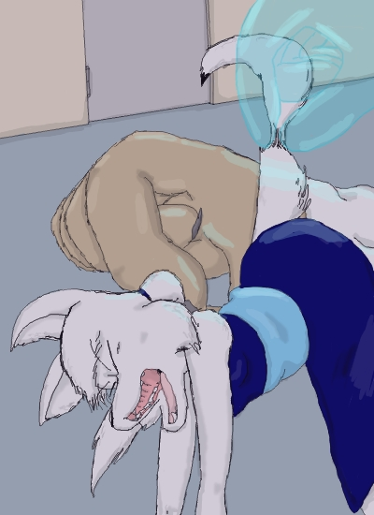
Clyde advanced his claws daintily toward the temporarily paralyzed, shrunken woman, wiggling his fingers just a bit just to piss her off more. Grimacing, Jacqueline managed to spit at him, but was too weak to even come close to her target. The jackal grinned cruelly and attached his index claw to the hem of Jacqueline’s dress, then tugged. It didn’t take much to pull it down past her legs, and only a little more effort to detach it from her tail, leaving her light blue panties exposed. He pulled down just a bit more and the garment and the sash wrapped around it went over the vixen’s head and arms, leaving her body and resting on the intruding gray claw. Clyde took the dress and shoved it in his pocket as a keepsake.
Though still in utter pain, Jacqueline forced herself to start singing. She had to in order to get out of this situation, since she just couldn’t bring her body to dance or anything else. Seeing this, Clyde quickly ran a claw down her back and snapped her bra off, her firm, white breasts flopping down in the process. Quick as a flash, the jackal shoved it halfway down her throat to cut off her singing, then ducked underneath his magical hand and opened his mouth wide, revealing his moistened pink cheeks, long smooth tongue, and treacherous dark throat. His tonsils and uvula pulsed in anticipation, and a bit below them was a small, irregular slap slap slap, like an impatient child throwing a greedy tantrum over some trifle.
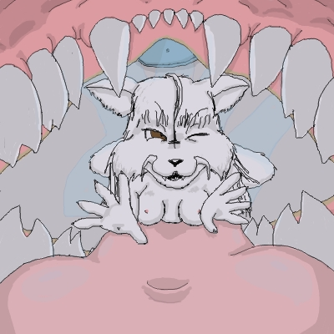
And then the magical hand let go, sending Jacqueline plummeting onto Clyde’s tongue. Her world quickly went dark as he snapped his jaws shut with a clack, sealing the vixen inside. The release of the tension on her tail gave Jacqueline great relief, but she was still in a lot of pain, and now she was pretty damned sure her career, not to mention her life, was over. Still, she wasn’t going to go down without a fight, so she sucked in her breath and started clawing the space between Clyde’s gums and his tongue. Although she tried, hacking up her bra and biting anything seemed to be a futile task, as she couldn’t get a firm grip on anything even with her sharp teeth.
Just then, Clyde smirked and lifted her up, smashing her between his tongue and the roof of his mouth. He’d been through this plenty of times to know how not to get harmed once he’d had someone in his maw’s grasp, and that involved keeping them completely off-balance by swishing them around until he was good and ready to stop fondling ‘em. In the meantime, though…
Jacqueline had never felt more violated than she did right now, even when that one asshole wolf had tried to rape her (may he rest in peace). She felt Clyde’s tongue rubbing up against her all over the place, and in any other circumstance she may have found this extremely kinky. However, the intent made all the difference, and she didn’t intend to allow his intent to go through. The vixen tried to start singing in the hopes she could fascinate and paralyze her date, but she couldn’t perform effectively at all, being tossed around left and right by that slick muscle she rested upon. She kept thinking to herself that the roles should be reversed. He should be in her mouth! This was such bullshit; she’d done this so many times before, but she just had to have picked out a goddamn wizard from the crowd.
And then Clyde pressed her up into the back of his throat, and she knew what came next. She also knew the sheer terror she had inflicted on dozens of other people since she gained enough confidence and ability to get away with it.
Clyde gulped twice. The first pulling her body halfway in, and the next driving it into oblivion.
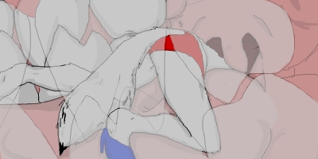
Jacqueline screamed, tickling Clyde’s throat as his muscles escorted her past his little flap and into his constrictive esophagus. He couldn’t help but chuckle a little bit as he felt the small screaming lump push its way downward into his body. The jackal hung his tongue out and let out an “ahhhh…” feeling his prey squish past his collarbone, behind his sternum, and finally losing the feeling of her for a bit when she pushed through his sphincter and plopped into his stomach.
Inside Clyde, Jacqueline splashed into a slimy chamber half-full of digesting meat and vegetables mashed together into an indistinguishable mass of lumpy sludge. Her ears were lambasted by sloshing sounds, heavy breathing, and a dull heartbeat somewhere in the distance. Her nostrils filled with the scent of rot and bile, causing her to retch uncontrollably. She felt the mash working its way into every hair follicle on her body as she was tossed about, and her skin started to tingle unpleasantly. She also couldn’t see a damned thing. On an instinctual level, she knew she should be frightened out of her wits; after all, she was going to die, barring a miracle she did not believe in. However, she couldn’t help but laugh at the situation. This was completely absurd to her, and she felt in a way it was retribution for all she had done in the past.
Clyde could hear Jacqueline’s mad cackling inside him, and he smiled a bit at the break in his prey’s sanity. He’d had others go crazy inside him before as well, but this was the first time he’d had someone bust up laughing. Truly she was memorable in every way. He would definitely keep this encounter in his mind at night. In fact, she was probably his best yet.
Maybe there really is such a thing as justice. Ha! As if. He’s just as nasty as I am…was the arctic vixen’s last thought before she inhaled a lungful of brownish steak-pea-potato-and-acid paste in her demented uproar.
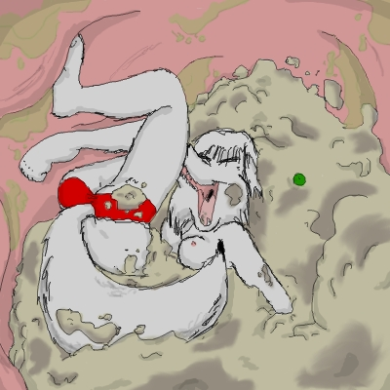
Clyde lounged around for a while on Jacqueline’s sofa, feeling the alien movement inside his belly settle down. He shivered a bit as the thought that she was simply a dessert to garnish his wonderful meal that night. Yes, this was the sort of thrill that excited him so much, and she had provided splendidly. He made a note to thank her when she came out, then looked at his bleeding arm, now bandaged with a white tank-top of hers he’d found on the floor, and decided that perhaps he shouldn’t thank her after all.

About ten minutes later, Clyde hefted himself up from the couch, panting a bit. He checked around the apartment to make sure nothing could incriminate him should an investigation occur. Nothing could beyond tenuous circumstantial evidence (a term he had learned long ago and come to appreciate). Heck, he’d even regained his original height; perhaps the shrinking from her bardic music was only temporary, or perhaps it wore off with the death of the bard herself. Satisfied that all was well, he sauntered toward the door.

As the jackal left the apartment, making sure to close the door gently so as not to make a sound, he thought to himself, Man. If the two of us had teamed up, we could’ve done a lot of damage. Probably a good thing us evil folks are such assholes. We don't make very good allies. His belly sent up a small belch, as though Jacqueline agreed.
