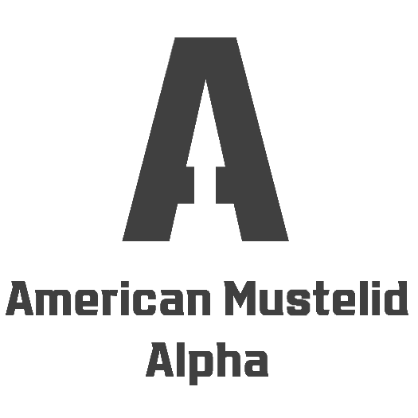
THE CAST (2/3)

#16 Declan
Ferret, Intelligence Research Specialist
Declan McKinney, 34, joins AMA from Chicago, Illinois, where he works as an intelligence research specialist for the Drug Enforcement Administration. McKinney is one of a few contestants coming from a military background: he joined the Army in 2003, at the height of the War on Terror, and made himself a name as a tactical intelligence specialist before being discharged in 2014. He is a solid, no-nonsense individual who likes to blow off steam in the weight room as well on a Brazilian jiu jitsu ring.
#17 Tyler O.
American Mink, Wrestler
Tyler Olson, 25, joins AMA from Los Angeles, California, where he performs as a professional wrestler under the stage name of Tyvar Irontail. A dedicated entertainer and fan of performing since youthhood, Olson got into freestyle wrestling at the age of twelve, winning numerous accolades across the state of California. After missing the cut for the national team in 2014, he decided to move to pro wrestling, lured by the theatrics and the showmanship of it all. His caveman-style gimmick and athletic prowess easily won the love of people and won him a contract in a major league. Despite still being on the fringe of the scene, he hopes AMA can help him get noticed and solidify his status as an athlete.
#18 Toby
North American River Otter, Derrick Operator
Toby Minard, 26, joins AMA from Holt, Michigan, where he works as a rigger and derrick operator. This young lutrine was an All-American football running back in college and still has the body to prove it. After graduating, Minard decided to reconcile with his lifetime passion and got into construction working, soon finding a job thanks to his physical tools and outstanding work ethic. In his free time, he keeps in shape with a training routine that includes weightlifting and swimming.
#19 Greasy Z
Hog Badger, Automobile Mechanic
Zakee “Greasy Z” Armstrong, 29, joins AMA from Porter, Texas, where he works as an automobile mechanic. This native of southeast Texas is known among his friends as “Boss Hog” and “Greasy Z” because of his expertise with repairing cars and other big vehicles, as well as his penchant at getting down and dirty in “Tough Mudders” and other obstacle course races. When he is not working or training with his crew of friends, this mohawked loudmouth can be found motocross riding, snowboarding on the Rockies or playing with his potbellied pigs.
#20 William
Least Weasel, Personal Trainer
William Viera, 34, joins AMA from Orlando, Florida, where he works as a personal trainer at a local gym. The son of Honduran immigrants, Viera grew up in a Latino household and soon got drawn to the idea of mastering his own body and help other furs achieve perfect form. He has been working as a gym instructor and life coach for the past decade, having helped high-profile individuals (including CEOs and music stars) shape up their bodies and find confidence through fitness. He is also proficient in both English and Spanish, has five kids aged from three to twelve and is versed in traditional Honduran cooking.
#21 Julian
Honey Badger, Real Estate Agent
Julian Morton, 42, joins AMA from Fresno, California, where he works as a real estate agent. A father of three, Morton played football and wrestling in high school and college and is the quintessential “sports dad”. His job as a house dealer keeps him away from his family more than he would want, but he never fails to keep up with his gym workout. He thinks he can do well in this show because thanks to his job he is used to take notice of and exploit the weaknesses of people, and he believes he can pull the same trick on his fellow contestants.
#22 Aksel
Beech Marten, Natural Science Teacher
Aksel Rønnow, 31, joins AMA from Carson City, Nevada, where he works as a Grade 8 science teacher. Born in Aalborg, Denmark, Rønnow moved to America at age seven to follow his dad (an employee of the Danish embassy in the U.S.). Despite having earned a summa cum laude degree in Biology, he is most definitely not your average science teacher: this bright, handsome Scandinavian guy enjoys hard rock music, loves to dress in leather, hit the gym, play tennis, and ride horses bareback. He thinks he is going to be successful in this show thanks to his free spirit attitude – an edge he believes it will pull him ahead of his competition.
#23 Scott
Ferret-badger, Engineering Technician
Scott Loubriel, 30, joins AMA from Troy, New York, where he works as an engineering technician at a leading aerospace company. A father of two (three-year old twins Perel and Vince), Loubriel is a blue-collar fur who values his physical shape as much as his friends and family. Other than lifting weight on a regular basis, he is an amateur boxer and kickboxer – physical activity being his way to let off some steam. His main purpose in joining the show is to prove he can hold up with some of the toughest and nastiest mustelids in America.
#24 Michael M.
Wolverine, Blacksmith
Michael Marshall, 35, joins AMA from Whitefish, Montana, where he works as a blacksmith, welder, and metal artisan. Marshall is a rugged, resilient brute whose training regimen involves calisthenics, high-interval intensity training and strongman drills such as slamming tires with a hammer or carrying around sandbags. But the core of his workout is his daily job – 40 hours a week of molding metal have given this wolverine great stamina and an upper body to envy. As much as he does not plan to underestimate his competition, he believes the title of American Mustelid Alpha is his for the taking.
#25 James Sg.
Spotted-necked Otter, Deli Clerk
James Sgambelluri, 40, joins AMA from Hamilton Township, New Jersey, where he prepares, packages and serves deli products at a local eatery. Maine native Sgambelluri was a nationally ranked athlete in rowing, and still enjoys taking part in competitions in his age group. He says that physical activity helps him relax and wind down after a long day behind the counter, be it in a canoe or cycling around the streets of New Jersey. A father of two, he is entering this competition to prove there is still life after fatherhood.
#26 Jeremy
Wolverine, Front Desk Agent
Jeremy Lehto, 33, joins AMA from Wolverine Lake, Michigan, and he works as a front desk agent at a 4-star hotel in Rochester. This tall, friendly Michigander has a bachelor’s degree in Languages and has worked in hospitality for most of his life but isn’t shy to put his physical side into display: other than being a gym junkie, he loves open water swimming and enjoys winter sports such as downhill skiing, ski orienteering and mountaineering. He believes his resourcefulness, competitiveness and “kill ‘em with a smile” approach will help him stand his ground in his quest to the title of American Mustelid Alpha.

#27 Allen
Yellow-throated Marten, Gas Plant Operator
Allen Moore, 35, joins AMA from Holly Springs, North Carolina, where he works at a local refinery as a gas plant operator. This athletic marten comes from a military background, having served in the U.S. Coast Guard for five years – included helping pluck stranded storm victims from rooftops during the hurricane that plagued New Orleans in 2005. After resigning from active duty, Moore experienced several heavy-duty jobs before taking on his actual occupation as a gas plant operator. A rough, redneck personality, Moore hopes to succeed in this show thanks to his perseverance and leadership skills.
#28 Raymond
European Otter, Clerk
Raymond Moreno, 21, joins AMA from Pasadena, California, where he works as a clerk and receptionist at a Toyota car dealer. Moreno is the stereotypical surfer dude, always to be seen at the beach around the vibrant lutrine community populating Huntington Beach. Unsatisfied with his current job as a clerk, he puts most of his energies into working out CrossFit to be primed and ready for surfing season. He thinks his laid-back attitude will not clash too much with the Alpha Mustelid façade he’s all too willing to put on for the show.
#29 Dalton
Zorilla, College Football Player
Dalton Clifton, 22, joins AMA from Monroe, Louisiana, but plays as an offensive linebacker for the Atlanta Tech U college team. A loud and gregarious personality, Clifton brings some much-needed levity to the show – as hard of a competitor as he is on the football field, he knows how to wind down outside the gridiron and motivate others to be their best. That’s not to say he is going to go in underestimated: this college senior never backs down from a challenge and is ready to bring to the fore the experience he built in football.
#30 Eddie
Giant Otter, Demolition Foreman
Eddie Caprio, 32, joins AMA from Garfield, New Jersey, where he works as a demolition foreman. This third-generation Italian and Florida native is an otter of many lives – he is a Navy SEAL veteran, having fought in a peace-keeping mission during the civil war that tore Somalia apart. Since dischargement, he has worked as security professional, fitness instructor and spearfishing guide, before moving to New Jersey and taking on a new career in construction. A weightlifting fanatic, this rugged warrior will stop at nothing to secure the prize that comes with the title of American Mustelid Alpha.

