Sumo Size Me Part 3
By Callum

*****
The Days Leading Up to the Tournament
*****

Zimmer and his band were floating on cloud nine. Their band had been a huge hit at Club Onyx. After the mantrin awoke on the roof of the hotel and managed to bribe a staff member into letting him back in without alerting authorities, he met up with Seth, Jason and Saburo in their room. They briefly considered going to grab Dirk from downstairs, but then Zimmer pointed out that it might be easier to plan out the band’s day without the minotaur interrupting them every five seconds. So they quickly set out a game plan which mainly consisted of them getting dressed, fed, and heading back over to the club to set up and get prepped for their show.

Once everything was in order, Saburo had the hotel staff help them wheel the band’s equipment down to a high end rental truck the zarbon had produced from god knew where. While they loaded up, Zimmer found Dirk in the gym and told him the game plan. The minotaur seemed more than happy to tag along, having found his second calling the night before swinging from the poles. He even pitched in to help carry the equipment after Seth asked if those big muscles of his were just for show or if they could really be put to use. Then they all piled into the truck and rode down to the club.

From there things picked up quickly. Zimmer found his time completely stretched between setting up, managing various modifications to their stage, talking with the club owner, manager, security, and staff who had to shift some of the tables around. Apparently, Saburo had failed to tell them that, being the big, soft, sneaky manager he was, may or may not have put a couple ads out for them around the city.

It would be standing room only tonight at Club Onyx, which the bulging zarbon sheepishly admitted he hadn’t considered when it came to supporting his own heft for the duration of their set. Seth slapped the zarbon on one soft shoulder and had the staff leave an elevated booth open center stage just for Saburo.

“Tit for tat, big guy,” the Kineceleran said, before going off to check his mic.

Six hours of rehearsals and set up later and the band were ready to open. When Club Onyx opened their doors, they were almost inundated by the stream of furs that came to see them. Zimmer was the first to realize quite a few of them were bigger fellas that stood out from the sea of clamoring, cheering bodies. He looked to Saburo who grinned and flashed a thumbs up back.

“Figured Dirk wouldn’t mind a little glimpse of the competition before tomorrow!” he called as he went to mingle with the others.

Shrugging, Zimmer laughed to himself and then turned to Seth. The lead singer stepped up to the microphone and welcomed everyone to the club. A thunderous cheer met him, almost stunning the usually unshakeable Kineceleran for a moment. Grinning hugely, the singer held his hand above his head and called out a “1! 2! 3! 4!” before launching into their first song.

After that, the night simply took off. Zimmer recalled how the previous night, he’d remembered little to nothing about it despite having a great time. Well tonight, he remembered every incredible moment. Furs were dancing to the music he’d helped create. Even Dirk, who was bouncing around and off of the big swollen bellies of his sumo competitors, seemed to be having the time of his life.

It would truly be a night to eclipse all others.

*****
Tournament Day
*****

Dirk knew he was in trouble when he stepped up to the mat to be presented alongside the other sumos in the contest. He’d been hitting the gym for several hours to get some last minute beefing done, but when he saw just how colossal some of these fellas were, even his overconfident mind began to question itself.

As the minotaur pondered his life choices, Zimmer, Seth and Jason found their seats in the stadium.

“Gosh,” the aardvark drummer said as he looked over the massive arena. “Imagine us playing here. It would be insane.”

“Give it a few years,” Seth chuckled. “Or, better yet, a couple months if we stay in Vegas. They loved us last night.”

Zimmer felt a rush of excitement when his friend said that. He hadn’t been the only one riding high from the night before. But he kept his thoughts quiet for the time being as they were there to support Dirk. The mantrin hated to admit it, but the minotaur had been pretty supportive of them during their shows. It seemed only fair they returned the favor now.

“Look at the size of those guys,” the mantrin said as the contestants walked out onto the mats. “Think Dirk will be alright?”

“I guess we’ll have to see,” Seth said, shrugging. He caught the mantrin looking at him. “Hey, he signed up for this. Whatever happens, it’s on him.”

Funnily enough, this was precisely what Coach and Gorilla were thinking back home. They sat side by side, munching on chips and drinking beer while watching with interest.

A couple miles away, Ulysses had also turned the channel to the tournament where he watched alongside Damon and Xavier. While they were a little less invested in Dirk’s performance and more interested to see how the rest of the colossal crop of enormous fatties would compete. Some of them looked like they could barely lift their bellies off the ground.

As each of the competitors stepped out into the arena, a tiny frilled lizard dressed in a referee shirt enthusiastically shouted their name and stats into a mic hanging from the ceiling.

“Up first we haaaaave Cell! Weighing in at almost 1,500 pounds, he’s the android with some serious RAM in that belly! He’s gone 30-0-2 and is looking to be the fan favorite for tonight!” Cell was one of the biggest fellas Dirk had ever seen, with his orange belly practically dragging against the floor as he sloshed out onto the mat.

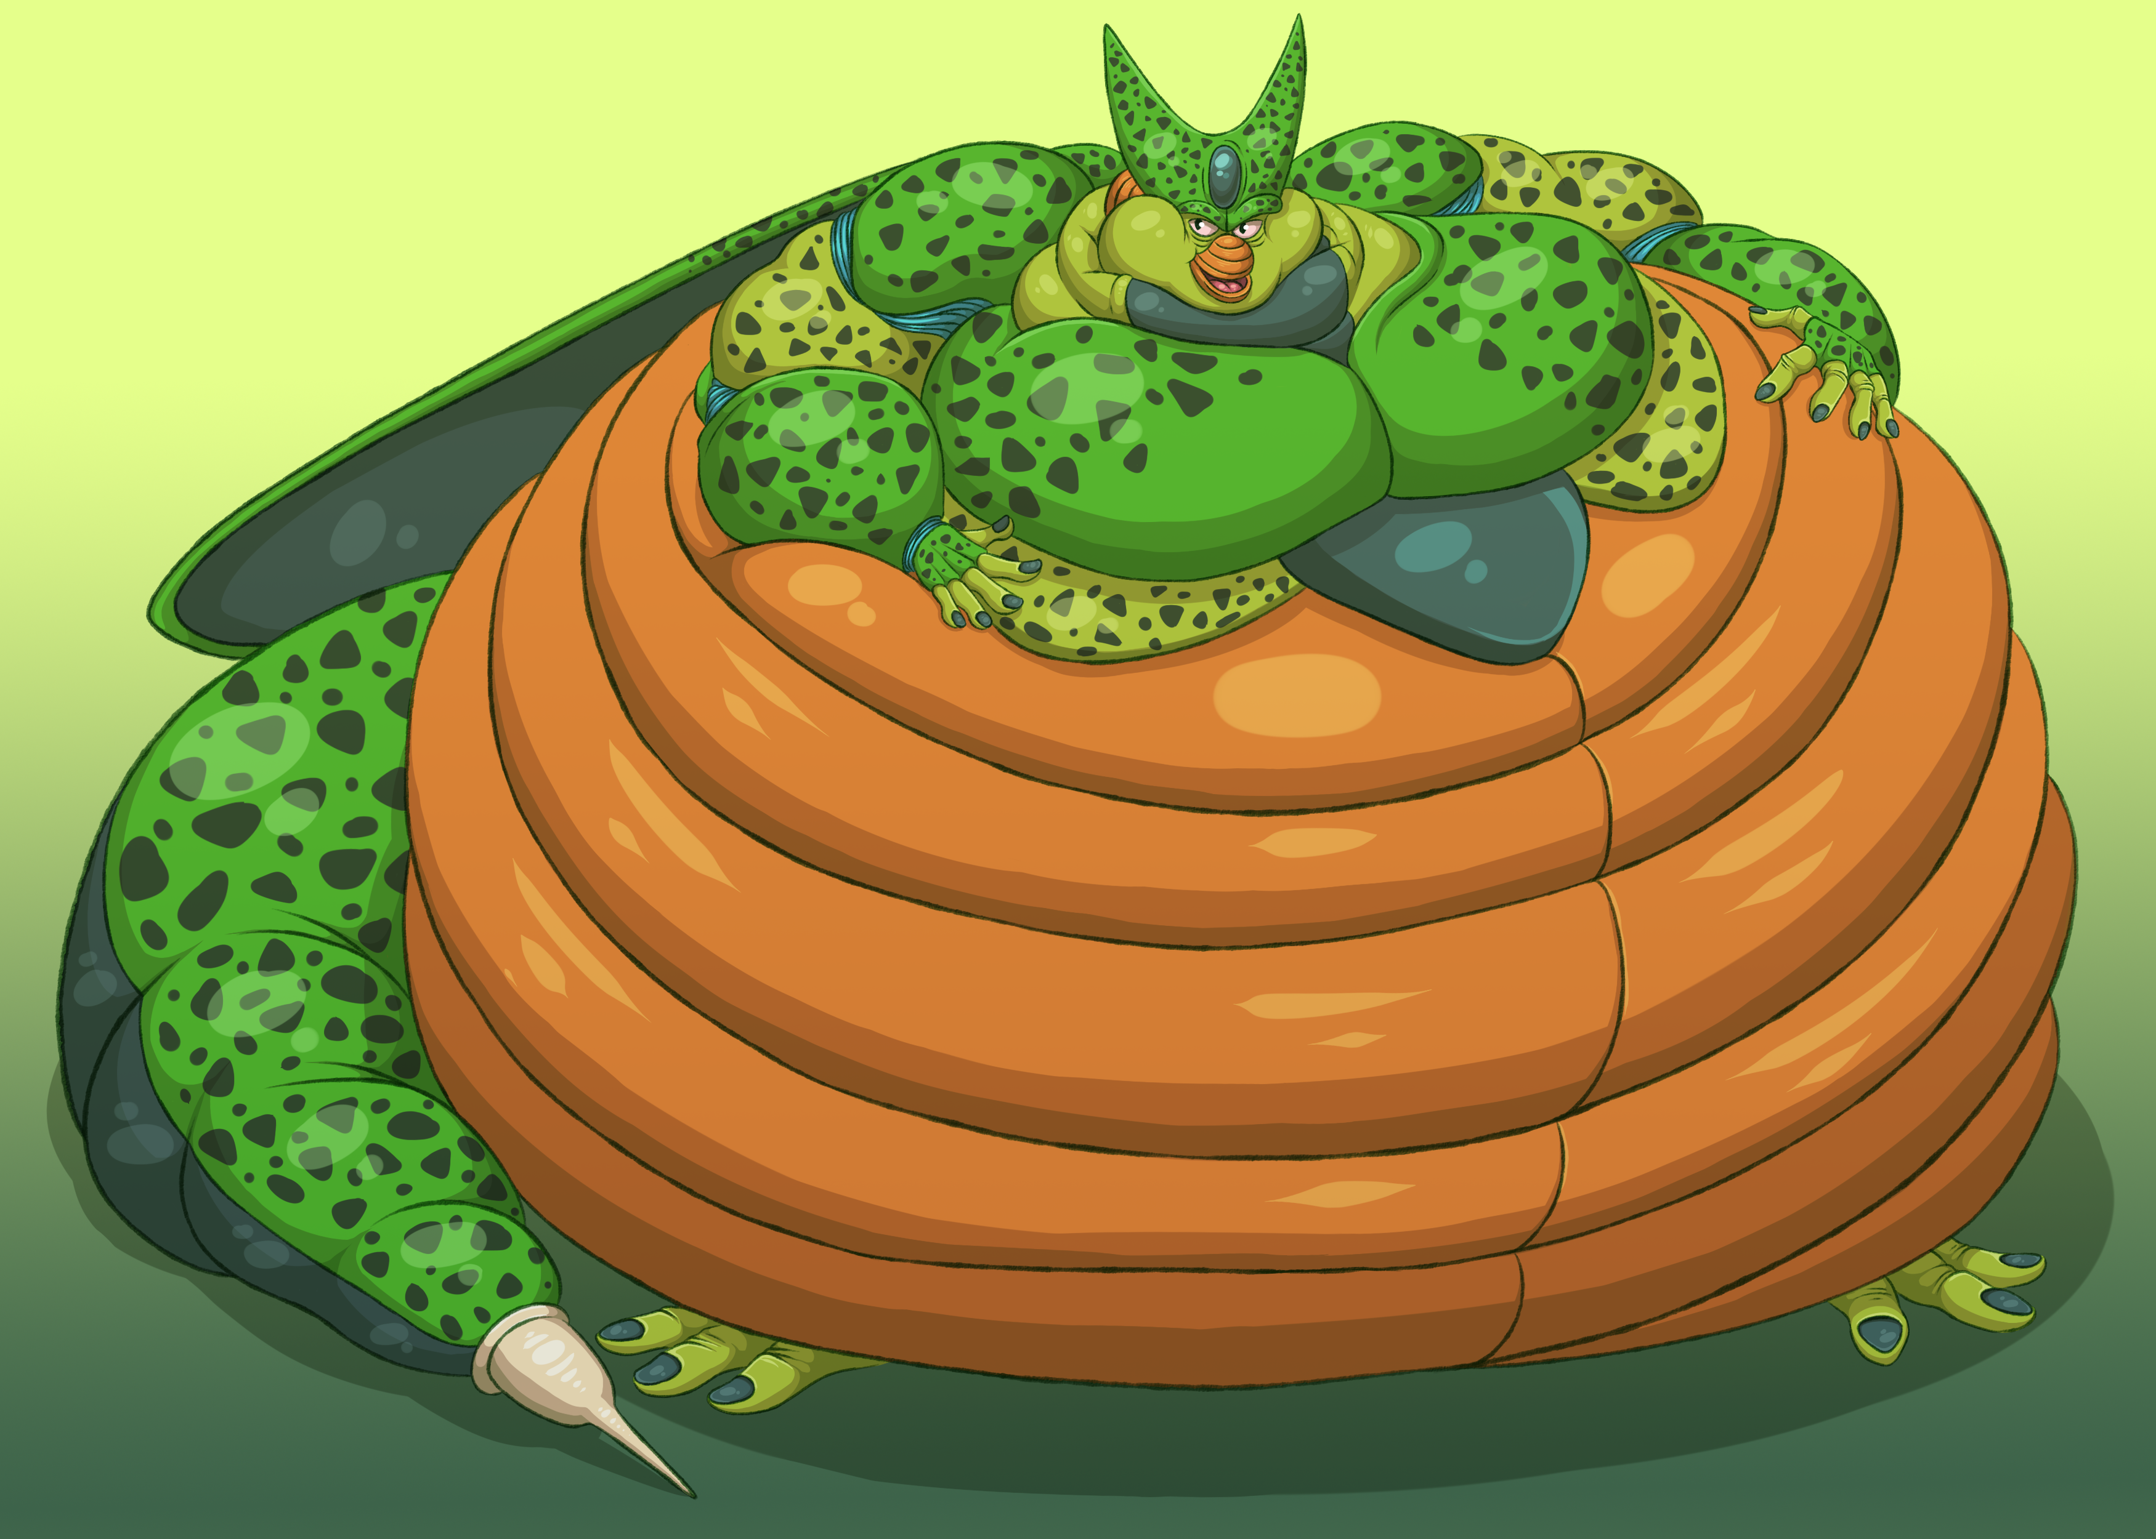

“Next is Sir Master Froug! I’d hate to be a fly on the wall when he’s around! He might weigh a measly 950 pounds, but he’ll make sure you croak!” Froug looked like he’d blimped up on air as he hopped out onto the mats, but Dirk felt confident he could take him. At least until Froug inhaled and his belly bwoomphed out like a catapult to the roar of the crowd.
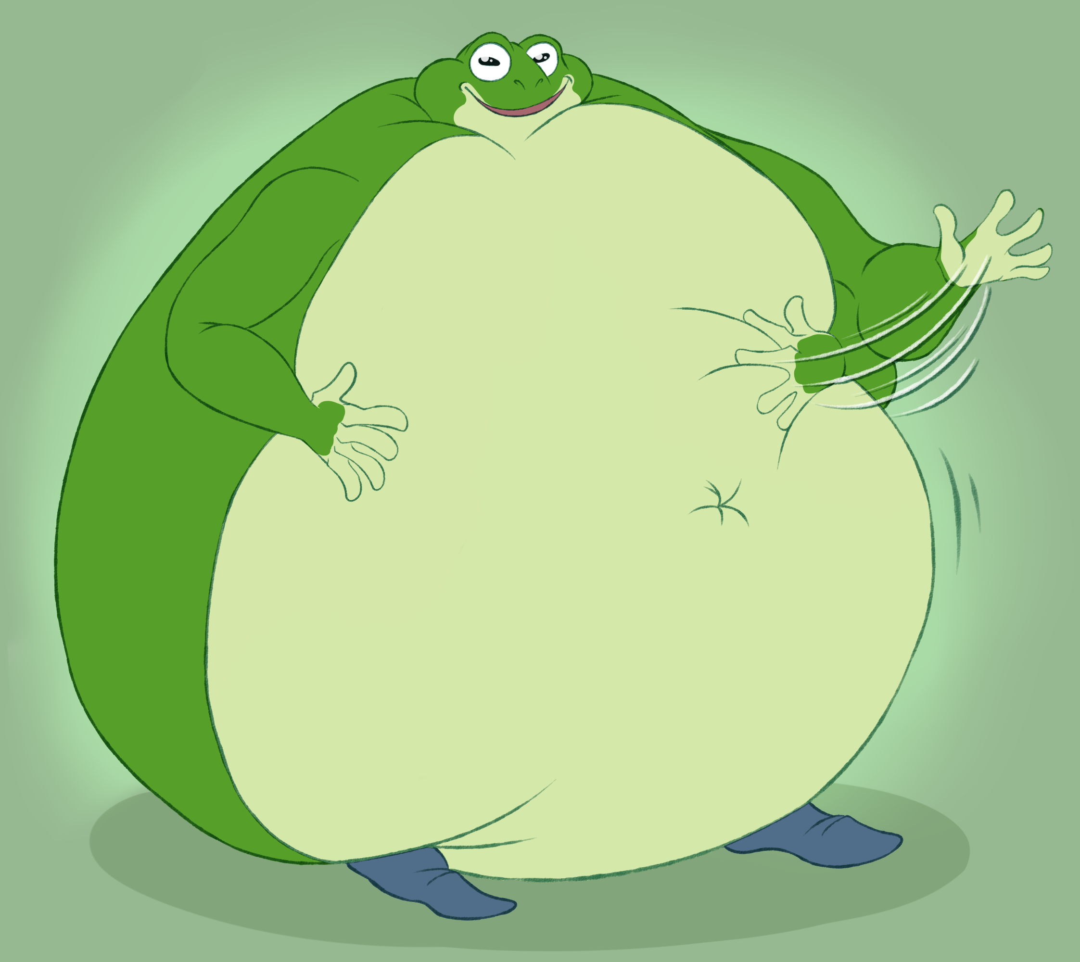

“Up next are brothers Rage and Haze Shenron!” the announcer continued. “Dragons that have to do some serious draggin’ to get those bellies somewhere. Both weigh in at over 1,200 pounds and have identical records of 29-1-4! They’re here, they’re hungry, and they’re ready to devour the competition!” Dirk kept a mental note on their appearances. Rage had a deep purple coloration with a soft, cream colored belly. Haze looked like a cross between a frog and a dragon, though his emerald gut was no less imposing.

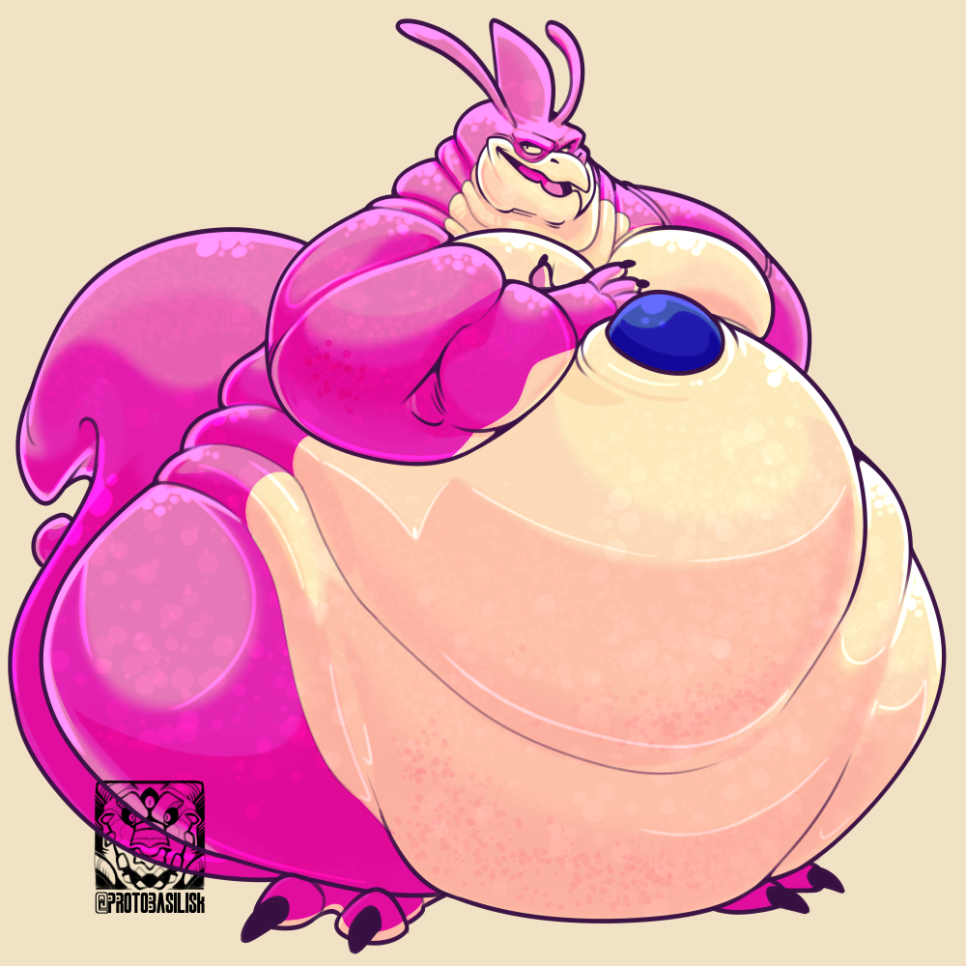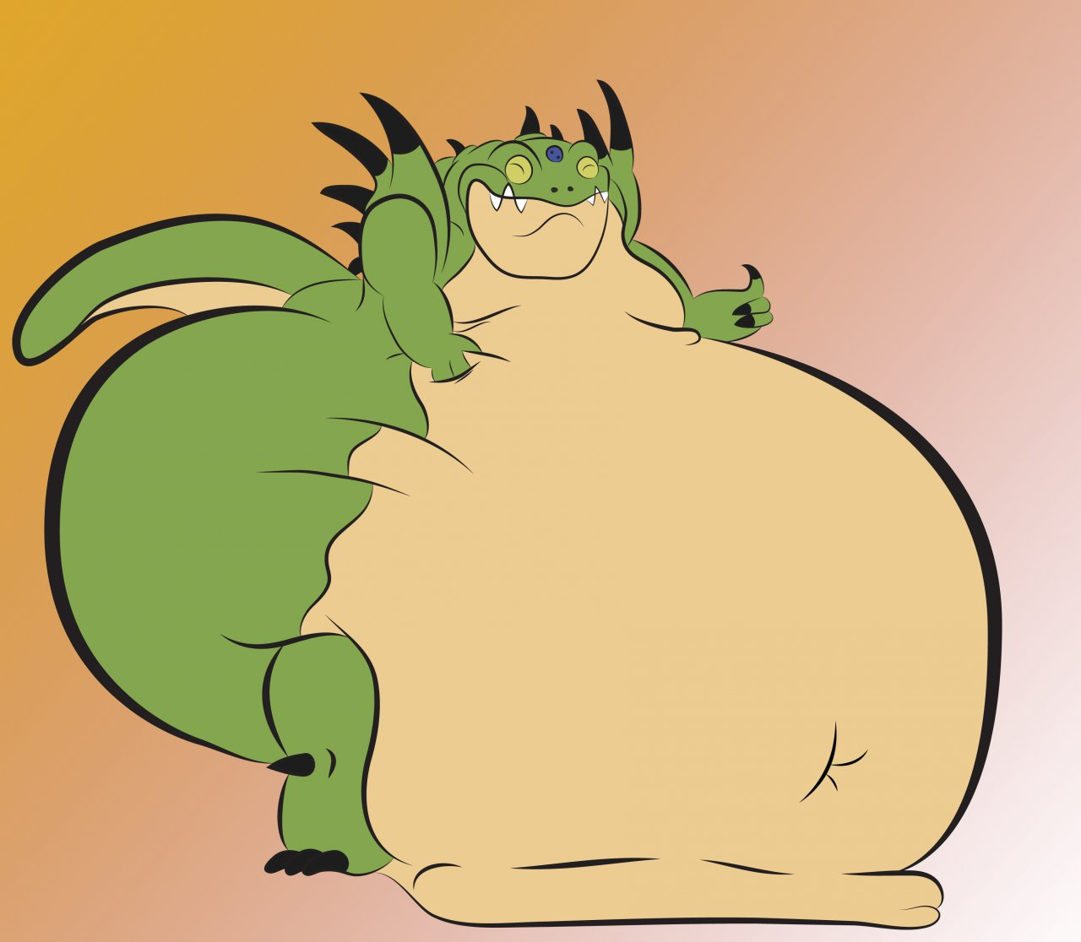

“Following the twins of terror is Yakon!” the announcer continued. “He’s mean and he’s demonic, and his belly will flatten you into the underworld! Coming in at 800 pounds, his speed and agility are better than most, so watch your back!” That got Dirk’s attention. Speed and agility were what he’d been looking for to win this thing, but if this Yakon had 400 pounds on him and was known as a speed demon, then he wasn’t sure what that meant for him.

“Up next we have Giran! An ancient dinosaur beast from the Jurassic era, sent here like the next meteor to conquer this tournament! Weighing in at 1100 pounds and standing at an impressive 14-0-0 record, he might be new to this sport, but never underestimate him!” By this point, Dirk wasn’t sure what to think. Giran was a huge green and blue beast with a belly he was fairly sure he’d bumped into the night before. He wondered what it would be like to bump into it now.

To round off the competition were Cymbal - a big, green dragonoid the size of a blimp; Drum - a huge Namekian that probably could’ve swallowed a bus without a second thought, and Champa - a purple cat who seemed to be the only non-reptilian of the group whose figure resembled a microwaved marshmallow. All had records with very impressive win to loss ratios, but Dirk wasn’t thinking about them any longer. He’d just made the realization that he would be called next.

As he and his friends watched, the frilled lizard opened the minotaur’s info card, paused for a moment, said something to someone off to the side, shrugged and then brought the microphone to his lips.

“And finally!” he called out with a little less enthusiasm. “We have Dirk! Dirk is a newcomer weighing in at 425 pounds and this will be his… first bout ever.” Confusion swirled through the crowds and competitors as a heavily muscled bull with no gut whatsoever padded out into the arena and took his place beside the wall of blubber and bellies in the center of the stadium.

Once there, the minotaur inhaled deeply and relaxed.

Seeming to recover a little, the frilled lizard commenced the announcement by wishing everyone good luck and letting all the sumos save for Froug and Cell file off stage.

Dirk quickly found a seat away from the other sumos to prep himself. Then he watched with interest as Froug and Cell, each a titan with a gut that sloshed to the floor, face off in the ring. The frilled lizard scrambled into the middle, formally read the rules of engagement, backed off to one side and dropped a white piece of cloth to the floor. When it landed, the two charged one another with a belly slam that washed over the stadium.

The tournament had begun.

As Froug and Cell began ramming into one another, Dirk was pulled aside by Saburo.

“We’re going to change things up a little here,” the obese zarbon said. “Originally you were going to go up against Cell in your first round since he’s the favorite to win and he outweighs you by a factor of four. But we decided to put you up against Yakon first. He’s still 800 pounds, but if you can keep on your hooves and be quick, you have a chance of running him out of the ring. After that… well we’ll just have to see.”

Initially, Dirk’s pride wanted to scoff at the downgrade, but then he watched the two beasts in the ring slam into one another. Even from fifty feet away, the minotaur could feel the compression of the airwave wash over him and rustle his ears. “I… umm, thank you, dude. Does anyone else know…?”

Saburo shook his head. “Just me and the director. I like you, man. Try not to get squashed out there, alright? And, if you do survive,” he grinned and pressed his swollen belly up against Dirk’s abs. “Maybe I’ll show you how to bulk up like a proper sumo.”

The minotaur snorted and flexed his biceps. “Well let’s see if these bad boys can’t do the trick, huh? Maybe I could surprise you.”

The zarbon didn’t look convinced, but he knew Dirk’s facade was hanging on by a thread. “Give ‘em hell, buddy.”

With that, the obese humanoid left the buff minotaur to watch the match, which concluded shortly after with Cell using his inhumanly colossal stomach to literally pile drive Froug out of the ring. The amphibian rolled over the white line and onto the secondary pad with a ground-tremoring THUD that sent his gut sloshing and his body rippling while Cell turned to the crowd and jiggled his figure triumphantly. The crowd applauded enthusiastically, with many chanting Cell’s name as he waddled (or bulldozed himself) out of the ring.

Up next would be Cymbal and Giran, then it would be Dirk and Yakon. This would be interesting.

Giran ended up winning the second bout, which made sense given his weight advantage over Cymbal. The dinosaur forced the dragonoid to contend with not only a massive gut to slam and jiggle against, but also the dino’s bold, inventive strategies. Namely, Giran’s use of twisting and waddling out of the way to pull Cymbal off balance. For several minutes, the dino had the dragonoid constantly caught off balance as both titans of tubbiness converged around the ring. Several times their feet came within inches of stepping over the line only for it to be brought back into play.

Cymbal’s downfall came about when Giran feinted to his right, grabbed the fabric of his loincloth, tugged him to the left, spun around and then delivered a truly monumental belly bump that almost knocked the dragonoid clear off the stage. As the mountain of dragon blubber laid there jiggling about, Giran thrust his arms up to a cheering crowd.

Then Dirk realized it was his turn. Being the senior sumo in the tournament, Yakon took the place of honor as the first to be introduced during the bout. A decent amount of cheering rose from the crowd as the demon waddled up the steps and took his place on the far side of the ring.

When Dirk followed, the cheering grew notably quieter with the majority coming from the spot where Zimmer, Jason and Seth sat. The minotaur tried to put it out of his mind, but he’d never felt so many eyes on him before. Tugging on the cloth diaper he’d wrapped around his hips and groin, the minotaur slowly padded up the steps and clopped out onto the rubbery ring. He stopped opposite Yakon and bowed to the bulbous demon, who returned the gesture with a sinister smile. Between them, the tiny frilled lizard scrambled out and went over the rules of the bout. Then he slipped off the stage and hit a giant gong with a mallet, signalling the beginning of the round.

Immediately, the instructions Saburo had given Dirk kicked in. He started circling Yakon, who moved in a mirrored path to the minotaur. His emerald-green stomach bounced and quivered like a salmon jumping from a river, transfixing Dirk’s gaze. The minotaur quickly shook it off though as he waited for Yakon to approach. This was perhaps Dirk’s greatest advantage over the bulging demon: as a rising star, Yakon would be expected to dispatch the minotaur quickly or have his reputation tainted with a slow victory. Dirk was under no such pressure and could move freely around the ring as he pleased, drawing his opponent closer and closer into a spin, dodge or body slam.

The first close call came about a minute and a half into the bout. After getting steadily closer to one another, Yakon suddenly bellowed and charged Dirk. He came within inches of slamming the minotaur with a pillowy wall of fat, but Dirk managed to skip out of the way in the nick of time. Once he gained his balance and said a silent thanks for the Stairmaster at his gym, the muscled bull flashed a grin at his foe and blew them a kiss.

“Yakon has a temper,” Saburo had told him. “Keep your distance and stay away from the gut and you just might win.”

Dirk tried the technique out now by leaning over to poke Yakon’s belly before dancing away in the opposite direction.

It worked.

The demon became suitably enraged as the muscled minotaur dodged his attempts to pin them at the edge of the ring. Had Yakon been bigger or more experienced, he might’ve been able to simply bulldoze his way through. But Dirk had enough leverage behind his muscled frame to parry most of the glancing belly blows elsewhere and to redirect the more head on ones. As Dirk continued to perform surprisingly well, Yakon grew more enraged. The bloated demon was huffing and puffing as he slogged after the minotaur, finding it absolutely infuriating that the officials had let a runt like this in. Being the smallest one of the tournament struck a nerve for the demon. He had plenty to prove and he wasn’t about to be defeated by someone even smaller than him.

At least that was the case until Dirk seemed to find himself back up against the edge of the ring with nowhere to go. Looking around desperately, the minotaur flailed his hands and struggled to keep his balance. A more experienced sumo might’ve waited another moment for the bull to either lose his balance or find it again, but Yakon was too incensed. He bellowed and charged straight for Dirk who suddenly seemed to gain his balance and adopt a ready offensive stance.

As Yakon steamrolled toward him, the minotaur spun off to one side with incredible speed, sank his paws under the bloated rolls of flesh beneath the demon’s arm and shoved him forward. Yakon did everything in his power to stop his momentum, but all those pounds of lard strapped to his frame suddenly became his own worst enemy. With a huge WHUMP! the demon stumbled face first off the area and landed on the lower stage, leaving Dirk to stand alone in the center.

Breathing heavily, the stunned minotaur realized he’d won his first ever bout and thrust his hands into the air. All around him, the arena erupted into an applause, with Seth, Jason and Zimmer cheering the loudest. The frilled lizard came up on stage and grabbed the minotaur’s paw to let him bask in the adoration for a minute longer. Then, after formally announcing his victory, the referee led Dirk off the ring and over to the side of the stadium where an elated Saburo awaited.

“Nice work, dude,” the zarbon said, slapping Dirk on the back. “That was pretty dang impressive.”

“Thanks!” Dirk laughed with genuine pride. “I… I knew I could do it all along, of course.”

Saburo studied him for a moment and seemed to sense the unease behind the minotaur’s eyes. “Sure, bud,” the obese zarbon said, clapping the big bull on the shoulder. “Now why don’t we get some electrolytes in you for your next bout? You have an hour, so you can watch the competition, get a feel for their strategies, make sure you know what you’re doing.”

For once, Dirk’s pride stayed silent. “Sounds good. Any tips for who I might face next?”

“Well it’ll be one of the bigger boys for sure. Like I said, Yakon was sort of a gimme. He’s good, but he’s a feather weight compared to some of these other fellas, so don’t get too cocky, alright?”

“Wouldn’t dream of it.”

“Good.” The sumo-sized zarbon departed to let Dirk digest his victory in peace.

Wide-eyed and still breathless, the buff minotaur watched the other bouts transpire with interest. For the next hour, Dirk got to witness a side of physical prowess he never even knew existed in the fitness world. Sure there were bodybuilders who had more of a barrel shape than perfect muscles and sprinters who were far leaner than he ever wanted to be. But to think that any of the contestants he was watching were actually capable of hefting those massive, doughy bellies around completely befuddled him.

As the bouts slowly passed and the contest pool thinned out, Dirk learned his next opponent would be Rage Shenron - one of the enormous dragon brothers he’d seen at the beginning. Rage had defeated his first foe with ease and that 1200 pound weight bounced around Dirk’s brain like a pinball as he ascended the steps to the ring.

But when time came for Rage to come out, no sign of the obese dragon could be found. Dirk waited patiently while the announcer stalled for time. Murmuring arose from the crowd and everyone began talking and speculating about what might have transpired.

Eventually Saburo entered the arena alongside another official. They had an emergency meeting with the frilled lizard and Dirk managed to overhear a couple words. Things like “drunk” and “buffet” and, most interesting of all, “wedged.” A moment later Saburo came over to Dirk and informed him that Rage had apparently wanted to celebrate his first win a bit too much. He’d ended up consuming a large amount of liquor in a short amount of time, stumbled into a buffet, and gorged himself there in order to “bulk himself up to squish that dumb pretty boy minotaur.” Unfortunately his strategy worked a little too well as he bulked and bulked until his feet no longer touched the ground, his belly was a seething mass of creaking lard and he couldn’t budge an inch. When his team attempted to roll him out of there, they ended up getting him stuck in the door of the restaurant where he was currently awaiting the assistance of a mobile crane and some additional manpower.

Dirk couldn’t help laughing at the thought of his opponent bellowing while bouncing on a gut the size of a car. Saburo cracked a smile as well, but told the minotaur they needed to appear professional. So when the frilled lizard made the announcement that Dirk would be the winner of that bout, the minotaur made sure to look surprised and respectfully delighted. The crowd reacted with a mixture of mutters and silence, and Saburo was quick to guide Dirk off the ring in case he started flexing.

A little while later, Dirk found himself sitting in the locker room once more when Saburo entered with the head of the whole operation in tow. This time, the fat zarbon looked even more stressed.

Fearing it was bad news, Dirk’s ears lowered as he asked outright, “Am I being banned?”

Both Saburo and the head looked confused. “Uh no, man,” the zarbon said. “Opposite, actually. You see… the way this tournament ended up working out. You won both your bouts so far and with things taking a little longer schedule wise, we’re shorting the competition a little. So… in effect…”

“You’ll be one of the final contenders,” the owner said. “Congratulations.”

Dirk looked to Saburo, who nodded affirmingly. “That’s awesome!” the minotaur laughed helplessly. “Who am I facing?”

Even as he asked the question, Dirk seemed to know who it would be. Cell. The 1500 pound monster of an android. Not wanting to dampen his impromptu victory, the minotaur put on a brave smile and accompanied Saburo and the owner out to the ring where Cell already waited, taking up half the stage alone with his colossal belly.

This was going to be one seriously tough match.

As Dirk entered the ring and took up his place opposite the heavy favorite of the tournament, all of Saburo’s information about the android filled his mind. 1500 pounds… twice the weight of Yakon, almost four times his own size. Roughly the same as a compact sedan. Most of that weight appeared to be lining Cell’s colossal belly, which bulged outward in an armored sphere of orange with green plates. At a glance, they looked fairly firm and stiff, but when the android moved around, they jiggled tremulously with fat. Dirk could only wonder how this enormous doughball moved anywhere. Hell, he probably came to Vegas in a cargo ship or a container truck.

Cell smiled wickedly at the buff minotaur, evidently not worried in the least by Dirk’s size. The minotaur was smart enough to know this would be no Yakon. The android could probably just sit there and file his nails while he tried to shove them out of the ring. Once again, Dirk’s advantage would boil down to his speed and novice reputation. But, unlike Yakon, this Cell fella didn’t seem all that troubled by the need to beat him in record time. That was the factor that set Cell apart from the others. At his size, he didn’t need to prove anything.

When the frilled lizard dropped the flag to the floor, the android didn’t charge Dirk like Yakon had. Instead he began taking slow, rolling steps that made his belly roll over the pads like a glacier. Dirk danced on his hooves as that bulging, sloshing mound of android fat closed in on him. The championship had begun.

Immediately, things went wrong for Dirk. To his surprise, Cell seemed to move just fine with all that added girth. His belly produced a continuous “slooooorsh”-ing sound that transfixed the minotaur for some reason. When the android waddled closer, Dirk almost forgot to spin out of the way before the pair of them collided. He did his signature spin off to one side, but this time it felt like he was rolling around the side of a truck fender. The minotaur had to keep on rolling and rolling and rolling, his snout, back and chest bouncing off Cell’s ample tonnage until he came free. And by that point, the white line was mere inches from being under his hooves.

Fortunately, he was able to get out of the way in the nick of time and, as Cell slowly turned his bulk around to face Dirk, the minotaur launched his best two-handed shove into a backside roughly the size of an aircraft carrier. Dirk’s hands sunk in deeper and deeper as Cell’s cheeks enveloped them, each of his muscled forearms disappearing up to the elbow before he met any resistance. Seeming to sense what his foe was doing, the android suddenly whipped his rump around, yanking Dirk off to one side and sending him stumbling to the very edge of the mat.

Yelping and rising on his tippy hooves to keep himself grounded, Dirk didn’t see Cell closing in on him until it was far too late. All of the sudden, the minotaur’s world turned into a sea of orange as the android delivered the full force of his breathtakingly massive belly directly into Dirk’s chest. Dirk was completely smothered in the epicenter of that vast, sloshing gut, his muzzle filled with rippling lard and his limbs locked in place in a prison of pudge. Then he felt Cell take a massive breath that tightened the walls of his colossal midriff and Dirk was propelled backward at fantastic speeds.

FWOOMP! MOOO! WHAM!

Zimmer, Seth, Jason and Saburo all matched the rest of the crowd’s elongated gasp in awe at the amount of hang time Dirk got from Cell’s belly bump. Back home, Ulysses shook his head sadly as he watched on his TV, and Xavier and Damon both laughed at the spectacle. Gorilla and Coach were completely dumbfounded to see their friend thrown through the air like a bowling pin struck by the world’s largest bowling ball. Dirk landed hard on his back some fifteen feet from the android, where he crumpled in a heap.

Immediately, Saburo was by his side, calling for the league medics to come haul the dazed bull out of the ring. After a long silence, the crowd began cheering for Cell who thrust his flabby biceps into the air to bask in their adulation. Wanting to keep things going, the frilled lizard scrambled up the android’s belly and lifted his arm to proclaim him the winner. As the crowd cheered, Saburo guided the medic furs carrying Dirk into a nearby locker room retrofitted into a mobile hospital.

There they laid the minotaur on his back just in time for Zimmer, Jason and Seth to burst in from a side door. Some of the staff tried to keep them out, but Saburo said they were with him.

As they all surrounded Dirk (at a respectful distance) the bull slowly began to wake. The doctor, a world-weary otter with small glasses perched on his nose, monitored the minotaur’s vitals as he came around.

“Everything appears normal,” he told the others. “I doubt anything’s broken due to his excellent physical condition, but he should take it slow and drink plenty of fluids for the next 24 hours.”

“Boom,” Dirk said weakly. “Excellent physical condition, guys. Told yah.”

Everyone laughed a little despite themselves while the otter tapped Dirk’s snout with his stethoscope. “Excellent condition for being thrown through the air like a crash test dummy,” he elaborated. “I don’t know what you were thinking entering a sumo contest like this. Normally, I don’t encourage overeating or weight gain, but you should be at least twice as big as you currently are to be messing around with this lot.”

No one said a word. This had been exactly what Zimmer, Seth, Jason, Saburo and pretty much everyone else had told the minotaur and, as they expected, he seemed completely impervious to logic.

“Ahh, he just got lucky, the tub of lard,” the minotaur grunted as he sat up and flexed a bicep. “Gimme round two in the ring with that walking eclipse and we’ll see who comes out on top.”

Zimmer stepped forward and patted the bull’s giant bicep. “I hope you’ll get it through your head someday that you were almost crushed out there,” the mantrin sighed. “Just because you have some muscle doesn’t mean you’ll win everything. Saburo, Yakon, Cell, hell even my brother, Xavier, would probably beat you in the ring. You have great optimism, big guy, but you need those brain cells of yours to start firing up when you make a dumb decision like participating in a sumo contest.”

Everyone else nodded solemnly while Dirk inevitably dismissed Zimmer’s words of wisdom with a little wave. “You guys worry too much,” he growled. “Cell got lucky. That’s all.”

Shaking their heads at Dirk’s denial, the band members and Saburo filtered out of the locker room and headed back up to their room to go relax. It was obvious Dirk would be fine. With his stubborn headedness, he could probably take a dump truck head on and be fine. As they left, they agreed they all needed to go for a swim with Saburo jokingly offering his belly as a float.

Meanwhile, Dirk began wondering if he had a future in sumo wrestling. He might be a little on the small side, but he could beef up.

This was Vegas after all.

