The Swap: A somewhat personal story dealing with Daniel’s inner struggle.

“Well Daniel, if you really want it so bad you should just get a sex change operation.”
“Yeah, get me the money and I will.”
Daniel and Susan were sitting in a beauty parlor with their paws and feet, or hoofs in Daniel’s case, soaking in some sort of vitalizing liquid. Sue stretched her neck to one side. “Is it really that expensive?” she asked.
“Oh yeah, it is. Believe me when I say I’ve checked.”
Daniel Harris’ was a confused story. He was a young spirited 23 year old stallion, his well groomed fur a bright shiny white in contrast to his harsh electric blue hair to “accentuate his eyes” as he puts it. But the thing about Daniel was he always had wanted to be a girl. Now, don’t get me wrong, he liked certain things that came with being a guy i.e.: simpler emotions, a penis, and things like that. But he always had a certain craving for woman most men don’t have. He didn’t just want to be with them, he wanted to be like them.

Daniel wasn’t too proud of his feelings, even though he had been a very feminine guy all his life. Danny wasn’t too tall, he wasn’t too buff, and he didn’t have a very large jaw. He was very curvy, as his hips were larger than most guys, he was slender, and his face looked very similar to a girl’s, even with large eyelashes. Because of that and his gender neutral clothing, he was often mistaken to be a girl from behind or far away. But Danny didn’t mind too much. In fact, when he was feeling a little down, sometimes he would go to his closet, pull out a hidden box and put on his special clothes. Now, he was not an open cross-dresser, this was a part of his life he wanted to hide, but he felt so damn good
with pink panties on. Daniel also owned some very erotic female clothing; his favorite was this pink half lace up with tall pink hooker boots lat lashed onto the panties. He strutted around in his out fit, thrusting his hips, looking at his ass in the mirror wishing it was “bubblier”. 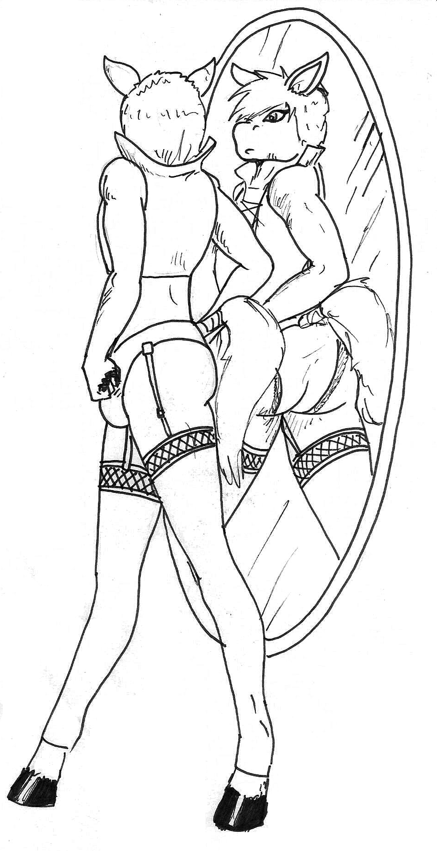

“Hey, what’re you doing after this, Sue? Daniel asked his friend.

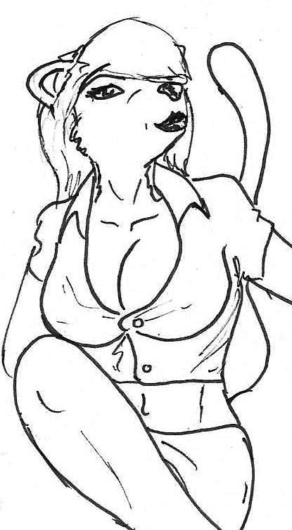

Sue was Daniel’s best and closest friend. She was a very beautiful lioness with jet black hair and fiery orange eyes. She was one of those girls that mocked men by “strutting her stuff” around town. But the kicker was when ever a guy asked for her number she would gladly inform him that she was a lesbian and laugh a little as she saw the disappointment in their eyes.

Now, that might make her look like a horrible person, and in some respects that could be true. But Sue’s controlling, religious parents didn’t look too kindly at a lesbian daughter. Taunting men was just Sue’s was at making sure she was in control. Sue and Danny had met by chance at the very same parlor they were at now and had become very close friends. She didn’t feel threatened at all by Daniel. She didn’t know why but she was glad she wasn’t. She didn’t know about the cross dressing, but she did know Danny was not happy with the body God gave him.
“I wanted to do something with you, but can’t.” Said Sue apologetically, “I have to go meet with some group in my neighborhood who is mad at the herm club that meets in down the street.”
“Herm club?”
“Yeah, you remember Elise? The zebra chick who gave you a ride home that one time we had a block party? It’s the club shi’s in.”
“Shi was a herm?”
“Wow, you really were smashed. Yeah, I’m surprised you two didn’t do it that night. Herms aren’t exactly known for their control over their inhibitions. Anyway, I have to meet with that soon-to-be small angry mob and tell them that the herm club can meet because it’s on private property. I mean this is a free country, why can’t people just leave well enough the fuck alone.”
“I still don’t get why you decided run for neighborhood president. But now you’re stuck with that job until next election.” Danny said splashing the bowl his hands were sitting in.
“Leadership is in my blood, I guess. Hey, I’m sorry again that I have to bail. I know we don’t see each other much and I’ll have to miss our “bi monthly beauty binge” ‘cause I’m going out of town. But I’ll make it up to you.” Sue smiled the gorgeous smile that tugged at so many guys’ hearts. “So what are you doing after this?”
“Meh, I’ll probably just head home after stopping by the gas station for a lottery ticket. I’m feeling lucky today.” Danny and Sue pulled their hands out of the liquid and got up to pay for their bill.
“I don’t like you spending so much money on the stupid lottery.” Sue criticized. “It’s just a big waste of money if you ask me.”
“Well, I didn’t ask you.” Danny retorted, smiling, “And it’s not a waste of money it’s only a buck. I think that’s a fair trade: a dollar for a million, don’t you? Plus, isn’t the lottery up past like 2.3 million or something?”
“Yeah, yeah, yeah, whatever. It’s your money…”
The two paid their bills and went on their separate ways.

Later that evening, Danny walked into his 2nd story apartment. The apartment wasn’t bad, but it wasn’t great. He threw down a bag of groceries and put them away, mindlessly and slowly completing the chore, his mind was else where. He thought of Sue and how he would miss her when she was gone. His mind began to wander as he started to picture his best friend: elegant, with a tight button up on, the buttons squeezing her breasts together. Her ass being held up by the tight fabric of her dress pants, jiggling wile she walks…. whoa! What was he thinking? He couldn’t think of his best friend like that. He tired to shake off the feeling but it was too late. He could feel himself beginning to press up against the fabric of his pants. He walked into his bedroom and loaded the internet. Another thing he liked about being a guy. It was normal to watch porn. He undid his pants and began to pleasure himself to a video of 5 female furs on one lucky cum covered herm dolphin.

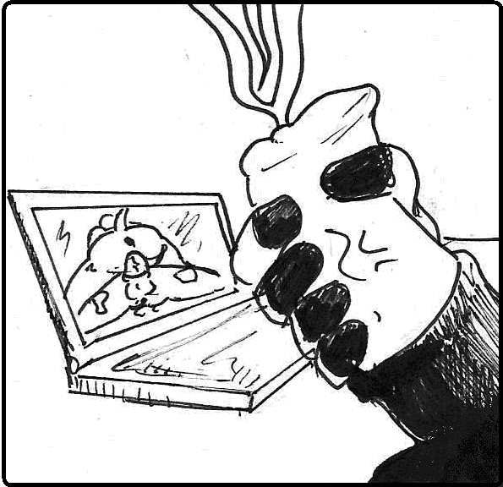

After supper, Dan curled up on the couch, put the lights down low, and began to read a romance novel. As he was reading his lottery ticket from that day fell out of the book. Daniel must have forgotten he had put it in there when he left the gas station! He slowly scratched the ticket. The first number…nothing. The second… nothing. The third…nothi…wait what?

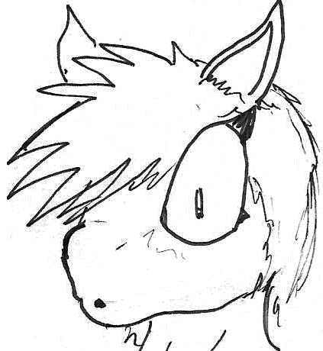

Daniel damn near shit himself. He looked all over the card searching for a thing that told him it was a prank someone was pulling. No it wasn’t! He did it! He finally did it! He won the lottery! He quickly looked up how much the lottery was.
“Oh my fucking GOD!” Danny shouted. The lottery had gone up to $2.9 million! He had won two point nine million fucking dollars!

The next day was even better than the one before. He lost 20% of his money to taxes, but that still means he had $2.38 million! Danny spent the entire day buying things. Food, clothes, he even put his old car up for sale and bought a new one. This was the best day of his life. He had tried several times to reach his friend Sue, but she must’ve been flying or something because she didn’t answer. Then, while Danny was eating lunch at some five-star restaurant, it hit him: he could finally get the operation he always wanted! He could be a girl! Oh this day can’t get any better! Danny thought. A waiter walked up to him, “Your dessert, sir.”
I lied!

“Now this is a very, very serious procedure, Mr. Harris.”
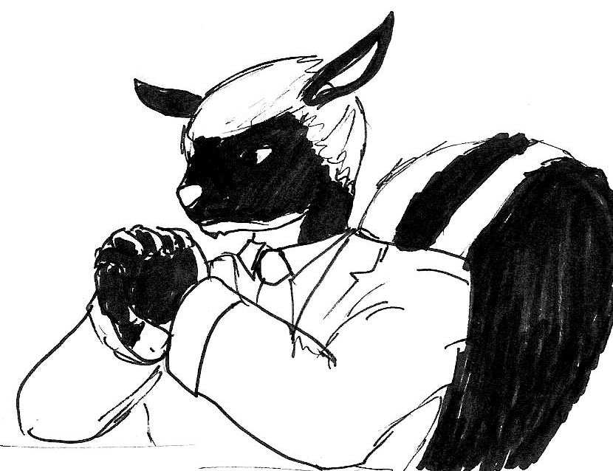

Daniel was sitting in a fancy office on the other end of the doctor’s desk. The skunk, Dr. Francis, was leaning in with his fingers linked together. Around him Daniel could see models of fake breasts, on the wall hung lots of important looking documents. “I mean, I’ll be glad to do it, you couldn’t have come to a better doctor. I’ve had nothing but complete satisfaction from my clients. But I just need you to know what you’re getting into. You did pick some really, uh, large implants.”
“I know doctor, but I’ve been planning this surgery my whole life! This is my chance. I have to go for it.”
“You sound very sincere. That’s a nice change. Most people come in here just to look better. You actually have a good reason for it other than you want to look like the movie stars. It’s a deal Mr. Harris.”
“Hopefully if all goes well, you can call me Ms. Harris!”
“Ha, ha! Yes, I can. Luckily, you’ll get your facial surgery started next…” The doctor looked at his computer, “next…Tuesday? No, two Tuesdays from now.”
“Ok, thanks, Dr. Francis. I’m looking forward to it.

Two Tuesdays later, Daniel sat nervously in the doctor’s office. The last two weeks had been nerve racking. Daniel tried to busy himself with as much stuff as he could. He sold his old car, he rented a new apartment, and bought a whole new wardrobe full of women’s clothes. But for some reason he couldn’t reach Sue. His mind drifted to his best friend as he sat in the office. Sue had recently broken up with her last girlfriend because she was being abusive toward Sue. Not physically but mentally and verbally. It took Daniel four months to get her to break up. Dr. Francis finally entered the room, breaking Daniel’s train of thought.
“Ok, soon to be Ms. Harris, time to get started.” The doctor looked at his chart again. “Now do you have any questions before we start?”
“This is just the facial, breast and rear implant surgery correct?”
“Right, we can’t risk doing it all at the same time with the sex change. You might loose too much blood if something goes wrong. Nothing will go wrong we hope but always plan for the worst.”
“You’re not exactly inspiring confidence, doc.”
“Mr. Harris, you know the risks. Now shall we go?”
Daniel looked down to the floor. Then met the doctor’s gaze.
“Hell yeah I am.”

“Ohhhhhh…….my head…..”

Daniel woke up in a bed somewhere. He was barely conscious but he could tell he was still in the doctor’s building.
“Oh, Daniel! Welcome back to the land of the living!” The skunk doctor walked in the room, carrying yet another chart. “How are we feeling?”
“Oh…I can’t tell if I’m in severe pain, or super high.”
“Well, to be honest: both. Now you can’t take off the bandages for a day or two, but I can tell you the operation was a complete success. You have your breasts, and, well your butt. You won’t be able to sit on it for a while, but just give it time and you’ll look amazing.” Daniel realized his ass wasn’t sitting on anything and his bed was specially made for patients like him. Danny tried to look down at his breasts, but the bandaging around his face kept him from seeing.

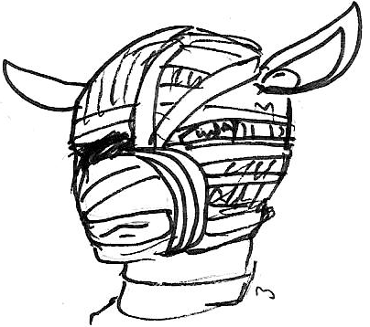

“Same goes with your face,” continued the doctor, “You’ll have to give it time before the swelling goes down. But you are that much closer to your goal. Congratulations, Ms. Harris.” ->
Ms. Harris? Daniel liked the sound of that. He didn’t quite feel like a woman yet, he still had his penis, but he knew to the rest of the world, he looked like a woman. He was a he no longer. He was a she.
The doctor turned and left, but mentioned that a friend of hers was over by the name of Susan, but left a few hours ago. Daniel was surprised. How did Sue know about her operation? How did she know where she went? Will she be back? Daniel could do nothing but sit in her special bed, ponder, and recuperate.

About a week later, the swelling finally went down. Daniel, now Danielle, had almost fully recovered. One morning she woke up walked in to the bathroom and nearly screamed from the face in the mirror. She was beautiful. Daniel’s face was almost gone and Danielle’s was full and beautiful. Her eyes were a deep blue, her cheeks full and rosy, her lips luscious and soft, and her snout cute and pretty. Danielle followed her body down with her eyes. She grabbed the new breasts and squeezed them together. This was amazing! She turned to the side to get another view of the EE beauties.
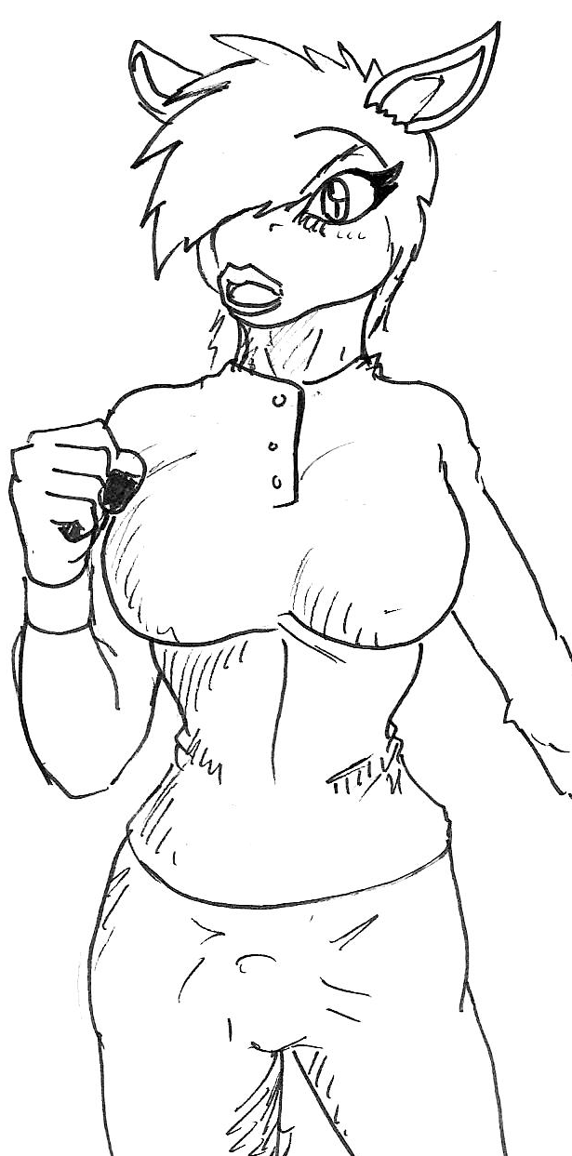

Danielle turned to check out her ass. It was just as round as the best bubble butt she had ever seen. She slapped it and laughed. Danielle pulled down her pants jammies to check on the big blue heart tattoo she just got placed right on her right ass cheek.
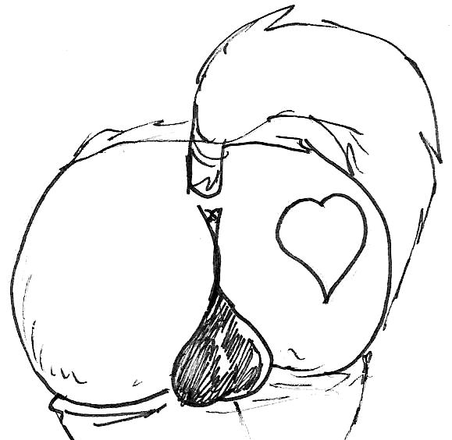

She turned around to face herself in the mirror head on and found the last male part of her sticking out of her jammy bottoms. She laughed as she realized she turned herself on. She thought about the surgery she had planned for next week, and doubts began to fill her head. She liked her dick. She didn’t really want to get rid of it. Just then the phone rang and Danielle bolted out of the bathroom, hoping against hope it was Sue.

“First let me assure you this is not a sales call….” *click*

It wasn’t her. Danielle slammed down the phone and sat on the bed. She hadn’t heard from Sue ever since she left. How Danielle wanted to show her what the new body was like. She wanted to show Susan just how sexy she was. Danielle began to move her hand up and down her shaft, the horse cock stiff and ready for love. She lay back on the bed and began to move faster. Pre began to ooze from the tip of the black and pink member, falling down the sides to lube her up. Danielle pulled her laptop from the nightstand and loaded the site she was looking at the night before. On the video she loaded two herm pandas going at it. Their massive cocks exploding all over the porn movie set. 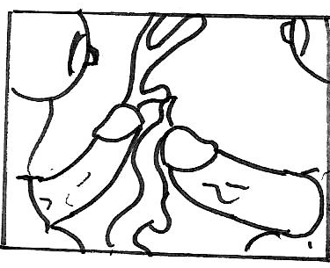

Danielle didn’t care too much for the artificial story then, but just really wanted to see some fucking. One of the pandas had the other panda’s dick in hir mouth and was sucking so fast that the camera had a hard time picking it up. Danielle began to thrust herself into her hand every time it fell down to the base of her cock. She grabbed one of her breasts as she jacked. Just then on the computer screen the two pandas came at the same time, cum flying all over the place, loads of it splashing on the other panda and all over the furniture and floor. Danielle felt her own orgasm building, she watched as the two panda’s traded places the one licking the steamy cum off of the other’s massive two foot cock, hir own two and a half foot cock still gushing with cum. Danielle was a spoogy fan. She was jerking really hard now and gave out a call of ecstasy as her own orgasm exploded on the bed. She trembled as her dick jetted out ropes of cum all over herself and her room. Danielle was a spoogy fan, but not a fan of cleaning it all up.
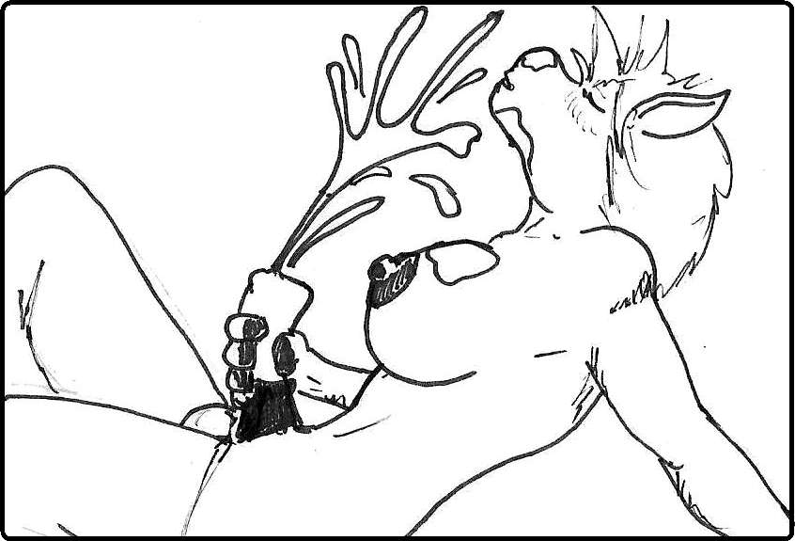

Once her room was finally clean of her orgasm, Danielle got dressed and headed out the door. She swayed her hips as she walked to her car and decided to give passers by a good look when she dropped her car keys, she bent down, propping her ass in the air, her jeans hugging her ass and crack. She got in her car and drove into town. Danielle was determined to find her friend. She checked all over town for Sue. She tried her house, her work, the salon, the restaurant they usually went to, and finally gave up and headed back for one more check at Sue’s house.
As Danielle turned the corner to Sue’s house she saw a zebra walking down a driveway with a bag of garbage in hir hand.
“Hey!” called Danielle, pulling up to the zebra. “Are you Elise?”
“Yeah, how do you know?”
“You were at a Sue’s block party awhile back weren’t you? You gave me a ride home that night.”
“Oh, yeah! Boy, that was a lot of fun.” Elise dropped hir bag in the garbage can and walked over to Danielle in the car. “Whatchya need, hon?” Elise leaned on the door where the window was open. Shi gave Danielle a big smile.
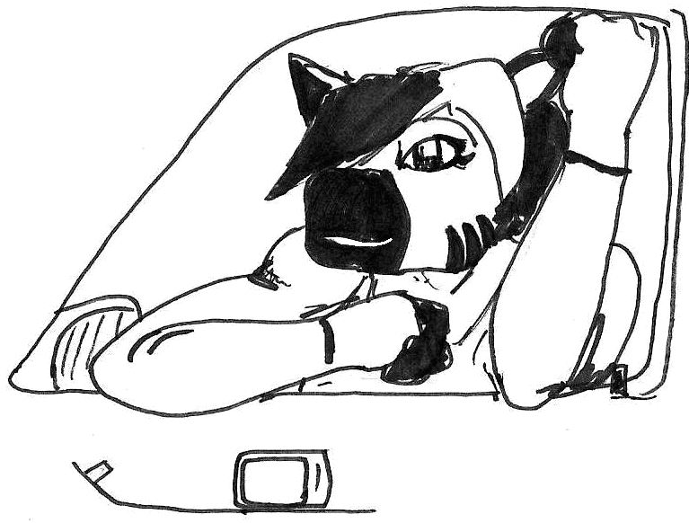

“Do you know where Sue is now? I haven’t been able to reach her in like a month!”
“Oh dear… that’s not good.” Elise looked worried but responded quickly, “You might as well just head on over to her house I guess. But that’s odd… I just said hi to her like, three days ago.”
“Really? Thanks!”
“No prob, cutie!”

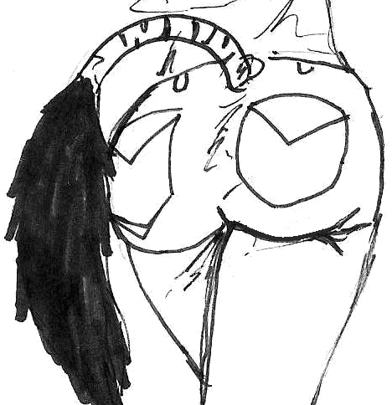

Elise winked and turned around. Danielle’s eyes were captured by the zebra’s swaying hips. Goddamn it! Danny thought, Hir ass is nicer than mine.

When Danielle reached Sue’s house, she saw her car in the driveway! She quickly parted and ran silently up to the door and tried to ring the doorbell calmly.
The door opened. “Ye…” Danielle attacked her friend with a huge hug before she could even say one word.

“Sue! Sue! Sue!” Cried Danny happily. She pulled away and smiled at her lioness friend. “It’s me! Danny!” Sue just stared. Her orange eyes looked almost sad. “W-what’s wrong? Sue? Honey, what’s the matter.”
Sue just stood there.
“Sue, you’re scaring me.”
“WHAT HAPPENED TO DANIEL?!” Sue let out her tears. “WHAT HAPPENED TO MY BEST FRIEND?!”

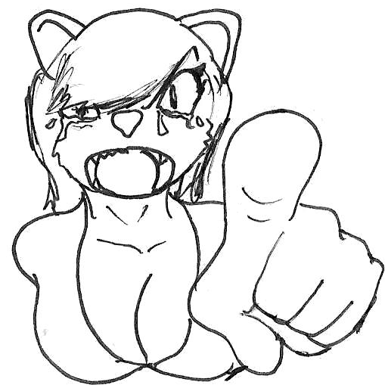

Danny felt her heart sink lower than it ever felt.
“Sue, it’s still me!”
“No it’s not! You’re different!” Sue threw Danny’s arms off her. “I thought I could handle it when I went I heard from one of your co-workers and I went to visit you at the hospital, but when the doctor kept saying “She’ll be alight” or “Her implants worked” or “Ms. Harris” I had to leave. I couldn’t take it!” Sue turned around and walked toward the couch crying.
“Sue!” Danny fallowed begging at Sue. “I may look different, but I thought you approved of it!”
“Yeah, when I knew you couldn’t afford it! But now…” Sue fell on the couch and pulled her legs into her. “You’re not my Danny anymore.”
“Yes I am, Sue! I still am! Look at me!” Sue stared at the floor. “LOOK AT ME!” Sue looked up and into her former best friend’s eyes. “Look at me, Sue! I still am Daniel. This is what Daniel is supposed to be. Look into my eyes it’s still me!” Sue turned away,
“But… you’re just.”
“Fine.” Danielle’s mood changed dramatically. “I see. You can’t accept this and I’m sorry. Just realize my love for you is still here. My body is different but, I’m still the same, and you’re still me best friend.” With out another work, Danielle walked out of Sue’s house, leaving her huddled on the couch.

Later that night, Danielle say in bed staring at the ceiling. Maybe she should’ve just stayed the same. Maybe she could get the breasts taken out. She still had her dick, maybe she could just go back being a guy. No. She made her choice and if Sue didn’t respect her then fuck her! No, Danielle didn’t mean that. She loved her friend more than anything else. Danielle realizes that she loved Sue, more than just a friend. She loved her. She wanted to be with her. She wanted to kiss her, to make love with her. But now, she couldn’t even talk to her. Danielle sat up and walked to the kitchen. She poured herself a drink and sat at the counter, sipping her sorrow. A knock on the door woke her up from her depression. Danielle really didn’t want company. She looked through the keyhole. She saw a zebra and a shark? What was Elise doing here? And who was the shark? Danielle opened the door.
“Elise?” Danielle looked puzzled.
“Sorry to bug you, hon, but we were wondering if you were alright. My mate Monica and I heard all the yelling over at Sue’s house. We tried to talk to her but she wouldn’t answer the door. You want some cookies?” Elise smiled and offered an aluminum foil covered plate of no-bake cookies to Danielle.
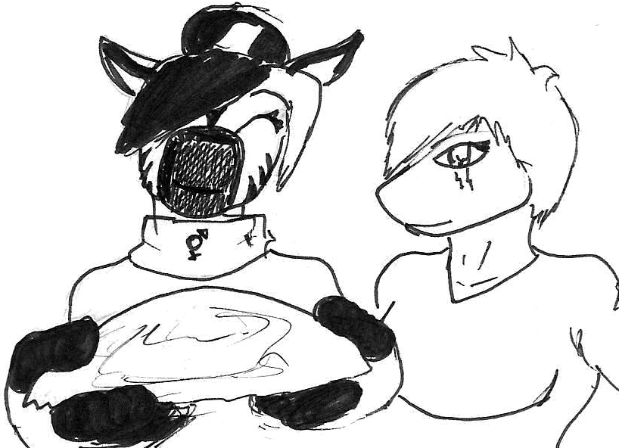

“Sorry if you don’t like them.” Said Monica, “Numb-nuts over here demanded we make these, I think shi just wanted the extras.”
“No I didn’t!” The zebra falsely protested.
“It’s ok,” said Danielle. “I like them. Come on in. You want something to drink?”

The three of them sat at Danielle’s table for about an hour, talking about this and that, eating all of the cookies with some milk.
Elise stood up and adjusted hir pants. Sitting down hir pants had collected around hir bulge. “Danielle, I’m sorry to leave in such a hurry, but Monica and I have to go now. We really expected you not to answer the door either.”
“But we’re glad you did!” Monica said cleaning up the plate and cups.
“Oh, I’ll get the cups, don’t worry about it.” Danielle smiled, “Thanks for visiting. I really needed some company to keep me from just sitting around feeling sorry for myself.”
Danielle walked the two out, and Elise gave her hir card. “Give us a call anytime!”
“Danielle?” Sue walked up to the group.
“Sue!” Danielle was shocked. Susan was the last person she expected to show up.
“We’ll leave you two alone.” Elise said turning around.
“Bye guys.” Said Monica.
“Yeah, bye…” Danielle waved, but kept her eyes on Sue. “C-come on in, Sue.”
“Thanks.”

Sue walked over and sat down on a love seat in the living room. Danielle put the cups in the sink then sat next to her friend. A long moment of silence went by. Then Sue started crying.
“Oh, Sue.” Danielle’s heart sank again. But then Sue dove into her newly gifted friend’s bosom, and started crying her eyes out.
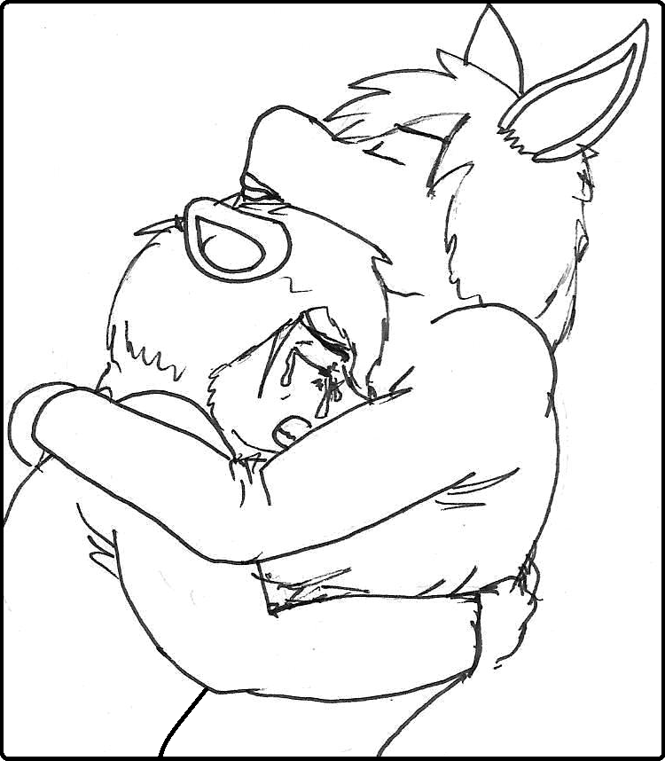

“I’m sorry, Danny!” cried Sue, “I’m so sorry for what I said! I didn’t mean it! I could never give you up! I love you too much, Danny!”
Danielle put her arms around her crying lioness and rested her chin on her head. “It’s ok, Sue, I forgive you. I love you too much to give you up, too!”
Sue looked up at Danielle. “Do you really love me?”
“What?”
“Danny, I may be a lesbian, but there was always something about you. You always made me feel good about myself. Even though you are… were a guy, I still loved you. That’s why when you showed up at my door a girl, I didn’t know what to do. The man I loved was a woman!”
“Well, technically, I still have some of my manliness.” Danielle was frightened and tried to make light of the conversation.
“I know all about it. I talked to Dr. Francis about it all. But what you just said proves it. You still are the horse I love! I need to know…do you feel the same?”
In for a penny, in for a pound.
Danielle leaned in and kissed the lioness smack on the lips. It was like fireworks inside their heads went off as the two began to kiss each other, tongues exploring each other’s mouths. They kissed and kissed, hugging each other tighter as the romance increased. Sue began to move her hands up to Danielle’s breasts, squeezing the new add-ons tightly. Danielle moaned as she felt her manliness begin to rise, pressing on her love’s crotch. The two continued to kiss as they removed each other’s shirts. Sue gasped as she gazed at Danielle’s perfect, perky tits. With out hesitating Sue moved in and started sucking on them. Danielle squeaked as she felt Sue’s tongue dance over her nipples caressing them as if they were a sweet chocolate. Sue moved her hand down and started to rub her pussy through her pants. Danielle grabbed Sue’s hips and stared to grind her bulge against the lioness pussy.

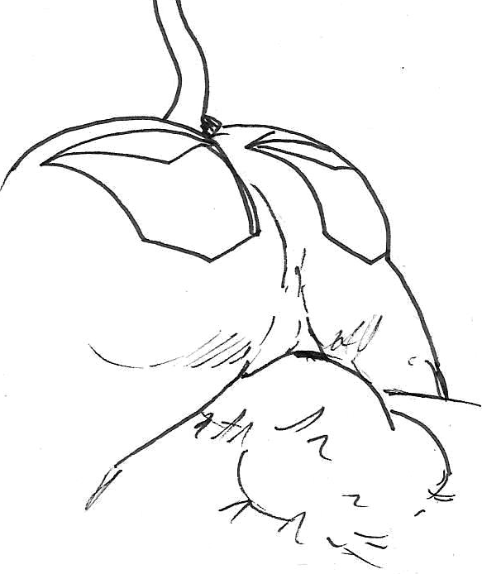

Sue had to move her hand on her couch to keep stable, the other twisting Danielle’s free nipple. The doctor had said to Danielle that it might take awhile for the female hormones to start kicking in so she could lactate, but they seemed to be doing just fine. The free nipple squirted out milk on the couch, as the Sue suckled on the other.
Sue let Danielle’s tits go and slowly moved her hands along Danielle’s belly to reach her pants. She began to undo the belt and zipper as Danielle did the same for her. Like a spring, Danielle’s horse shaft popped out of her pants. Pre leaked
out of the tip. Sue leaned down and licked it off.

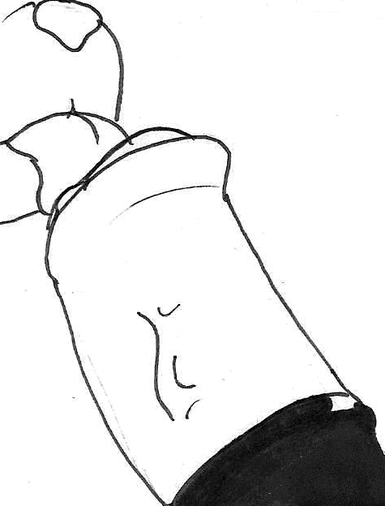

“That was so gross!” Laughed Danielle. “Do it again!”

Sue leaned down again, but this time took more of the long cock into her mouth. She began to suck it all while giving Danielle a very devilish look. For a lesbian, Sue sure as hell knew how to suck dick.
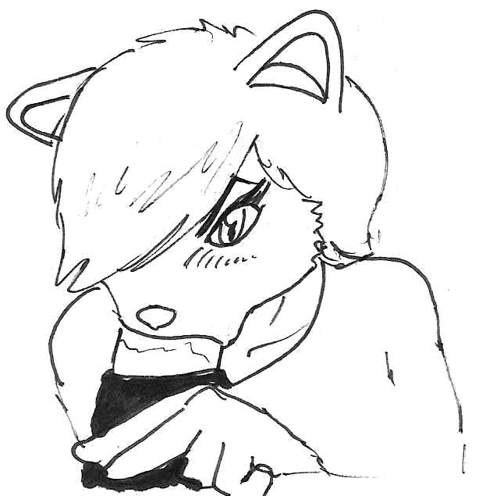

“I don’t want to get off just by you sucking me! Let me up and I’ll be right back.” Danielle got up and walked seductively toward her room, swaying her hips and tail as she walked. Danielle knew she was hot.

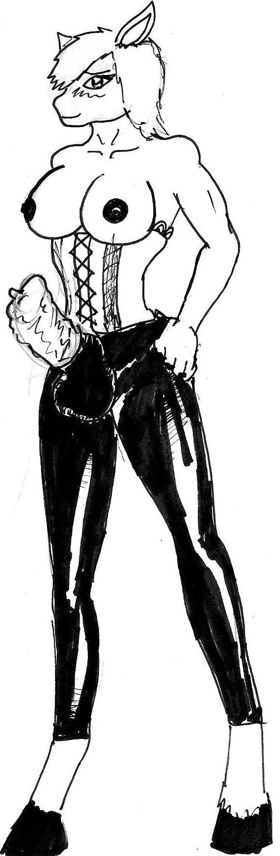

A few minutes later Danielle came back to a fully nude Sue, sitting on the couch with her legs spread and her arm on the back. Danielle was dressed in ass-less chaps and a corset. Her dick was pointing straight up, erect, with a condom wrapped tightly around it. She walked over to Sue who repositioned herself on the couch, with her cunny completely open, with her feet on the arm rests. Danielle moved in and picked Sue up by the hips and thrust her thickness into her. Sue cringed as her first dick rammed far into her. She could feel herself being spread, something in her didn’t want Danielle to do this, but it was quickly shoved out by Danielle’s invading shaft. Danielle began to move in and out of her best friend, groaning with joy. She began to thrust harder as Sue called out her name.

.

Danielle’s tale slashed back and forth, to try to find an outlet to her ecstasy. The warmth of Sue’s insides cradling her cock, the feeling of pushing the walls of Sue’s pussy apart in each thrust, it was all heavenly.

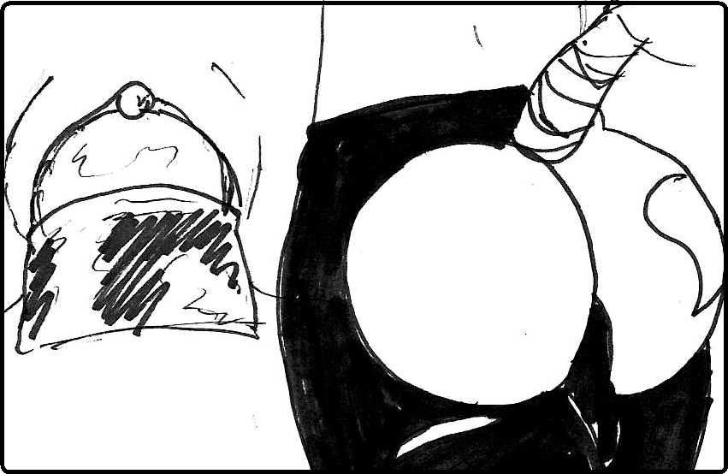

Sue began to pant heavily, grinning with joy as Danielle shoved inch after inch into her, she could feel the horse meat growing inside, stretching her. Sue placed her hand where the two joined, rubbing her clit. Her other hand moved to one of her pierced nipples giving the tit a hardy squeeze.
Danielle’s new ass jiggled with each thrust. Each time the two lovers slapped together felt better than the last. Danielle felt the warmth of Sue’s puss on her cock, the invading head pushing deeper and deeper. The condom was holding an ample amount of pre, Sue could feel it growing inside her.

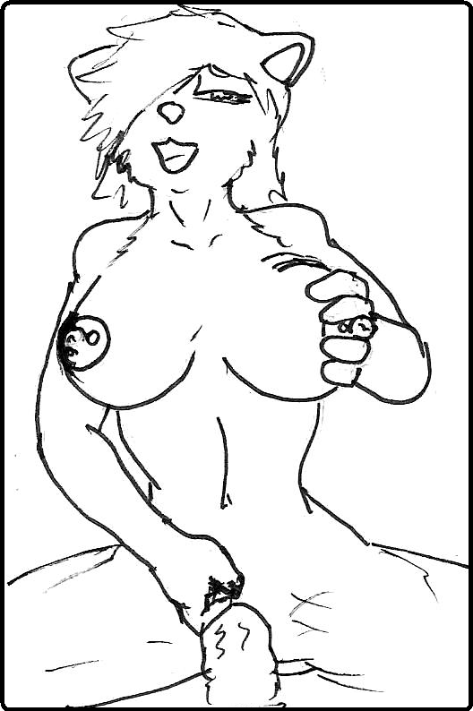

“I’m gonna cum, Sue!” Danielle said through clenched teeth.
The shemale horse let go a flood of cum, dammed back by the condom which was growing fast. Sue pulled off of Danielle while she was still cumming. She took the condom off, threw it on the ground, cum splashing, and let the throbbing, pulsing, dick splatter her face in long ropes of warm horse cum. Sue grabbed Danielle’s rod, took it in her mouth and gave it a good squeeze. Sue swallowed and looked up at Danielle, taking the semi-erect member out of her mouth, letting it ooze cum down her chest.

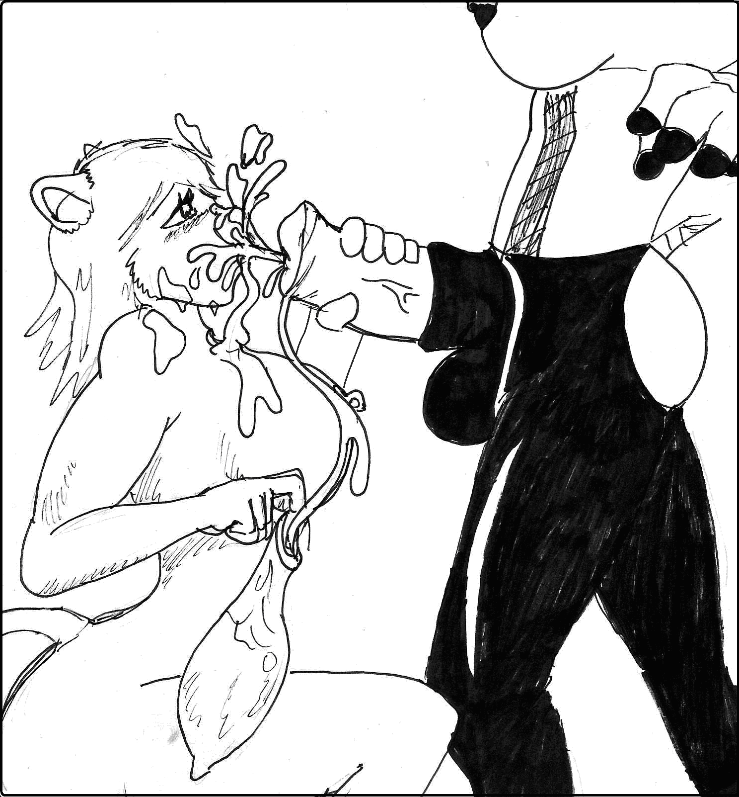

“I may be a lesbian but that doesn’t mean I can’t like cum.” Sue said wickedly. She stood up and grabbed Danielle’s hands. “Now, it’s my turn.” And with that Sue lead Danielle into the bedroom for some more quality best friend fun.
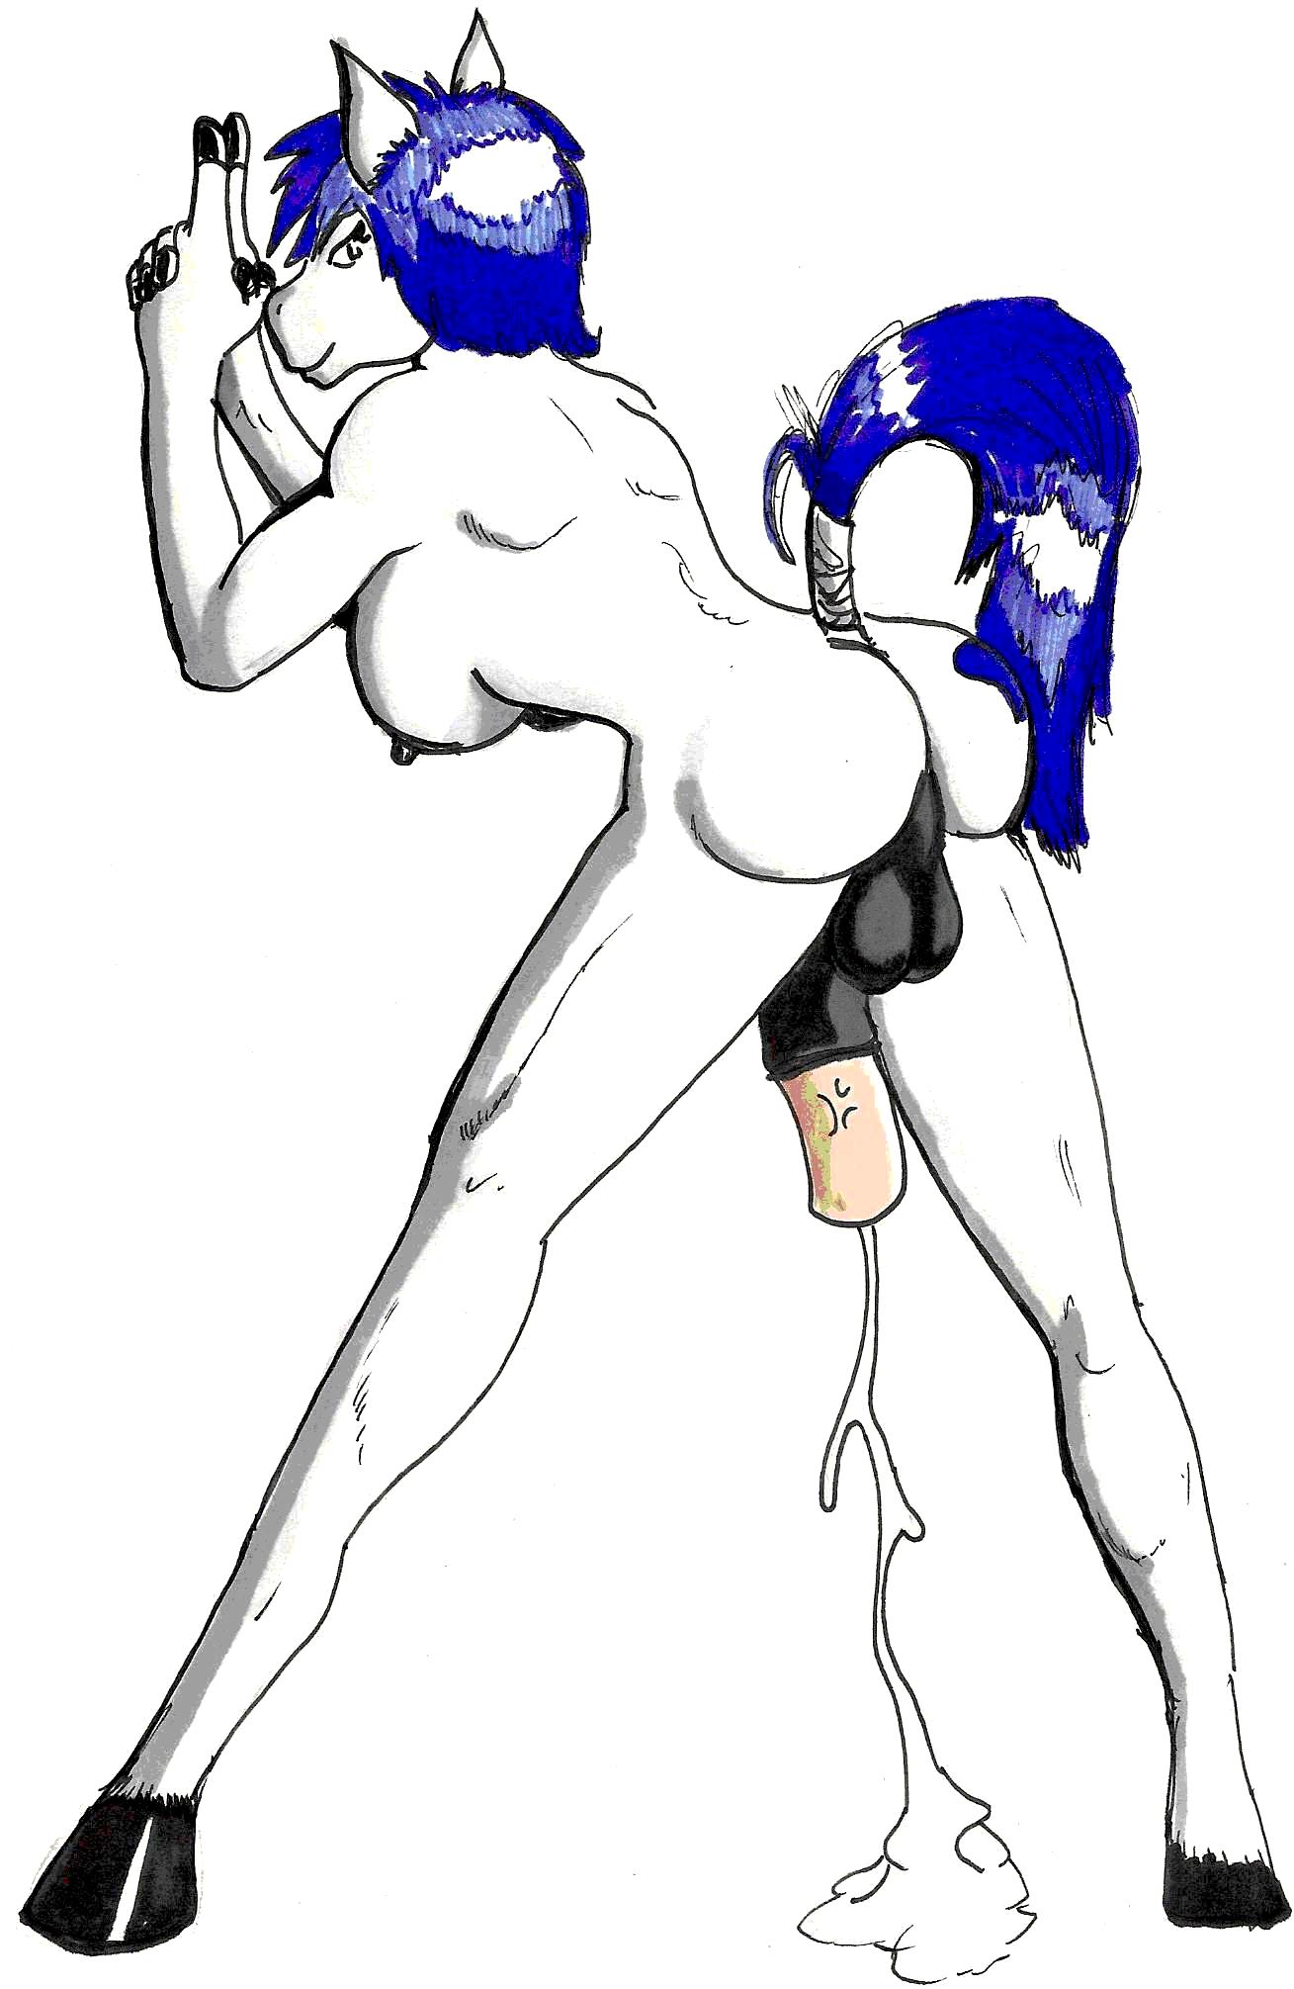
The End (Get it?)

