Darktrunkers 2
By Echoen & Balros
For Blyzzarde, Fortune, Tazel, Lluna, Sigil, Alice/Eclypse, SolarDelton, Ailure, Bun, Rykela, Gao, Nil, Murd, Trip, Min, Kah, Fieron, and Riz and all other corruption addicts who need a fix of ‘phants.

Jon grunted. Felicia’s breasts on his chest were overwhelmingly heavy; he gave a gutteral growl as they swelled heavier, pushing forth from his wolf fur and spurting thickly with milk. His milk. Her milk. The line between feline and lupine blurred, wrapping around her dick he was fervently jerking off, as it too swelled in a surge of growth. Felicia mewl-moaned in his ear; her head on his shoulders pushing his neck further to one side and taking over more of their shared body. No, his body!

Below his huge catcock, below his slightly larger wolfdick, the elephantine cock-trunk larger than both reached up and wrapped around both. All three of them moaned; howling from his wolf-side, wailing from her cat-side, and bellowing from the elephant maw on his crotch. As shi made them all cum, spurting and spraying thick corruptive seed all over, Jon felt the elephant take over even more of his lower body and Felicia’s feline pussy pop open behind his heavy balls. Unf. His now quad of balls, half of them hers. The transformations were accelerating and the wolf fighter could barely will his legs to move, even as his paws flattened out into broad, heavy gray toes.

“Fel… Felicia… we have to… hrrrf… stop this!” Jon growled, his tits spraying milk more firmly as they fattened another two cup sizes.

“Mew… yes, stop being us! Become HIR!” The catwoman mewled, bliss in her glazed eyes as her nose began to gray and push forward. Jon tried to look away but felt his shoulders broaden with elephantine proportions, and Felicia’s massive kittypaws reach up from his lower set of arms to grasp at his belly. Her belly. Hir belly. Rubbing and roaming over the trio’s tummy as it glorped and swelled, filled and fatten, soon kicking with rampantly horny hybrid offspring. Jon shuddered and flexed all his muscles he could, reaching past his tits to grab the trunk-cock between his thighs and-

Cum. Jon came. Gripping and squeezing that sensitive, flexible mix between a huge penis and a strong trunk made all of his dicks erupt with even more seed. A third pair of balls dropped into his sac and Jon knew they were hir balls, not just his and Felicia’s. Rippling orgasms rumbled through all six of his nuts as his gushes of cum grew stronger; his whole shared body shuddered when a second and third pussy popped open and poured with feminine juices. Gods, all three of his wombs ached to give birth as soon as possible!
“This is IMPOSSIBLE!” He roared, arching his back and blasting with potent fluids from his every erogenous area. Felicia joined in too, trumpeting from hir lengthening nose until it to gushed with cum; fat veins bulking alongside her stretching appendage. Jon hated that he could feel it as if it was his own dick - it made his actual cock grow even larger with furious fuckneed. As his rage grew, so did his arousal, and the elephant corruption spread further still.

Swiftly, Jon’s constantly orgasming canine mind was unable to hold back the sensation of Felicia’s constantly orgasming feline identity. The Darkstalker that he had merged with had her own experiences, every bit as euphoric as his. She, too, was endlessly ejaculating from her cock and from the wolf’s angrily throbbing erection, and could feel the elephantine cocks and trunk-dicks of her body as her own as well. Jon could feel her thoughts willingly throwing themselves into the bliss of so many body parts blasting with pleasure, like plunging their shared huge handpaws into the same vat of fluids. Fuck, he could even start to feel an extra pair of thickly muscular Elephant arms erupt from his sides, reaching up to…

Growling, Jon snapped at the huge gray hands that reached for his muzzle. These limbs were not under his control and were coming for his face. His teeth sank into the plump gray flesh, only for those same teeth to transform upon contact - his whole jaw reshaping for great ivory tusks to erupt past his maw. The wolfman’s vision blurred and his arms tugged and pulled at these stronger elephant ones, trying to loosen those gray arms before they p u l l e d…

Felicia mewled in climax for the umpteenth time. The sensation of her wolfy-boy head being gripped and groped, pushed and reshaped into an elephant’s head felt so, so good. Soon her head would look like his, soon to be Hirs. The trunkcock jutting from her somewhat feline face was spreading gray flesh all over her head and body, and it felt wonderful. She wanted it to spread further, spread faster, take over her whole head, her whole body, keep cumming, unload all this p r e s s u r e…

Jon shook hir head, huge ears flapping from side to side and almost slapping hir enlarged eyes. Hir wolfbrain felt soaked in elephant estrus, like hir former male consciousness was giving birth to hir new gender identity. Some inner wolf part of him howled deep inside hir mind, but shi focused instead on the idea of giving birth. Shi wouldn’t even be named Jon for much longer, anyway, and the concept of being pregnant made all of hir and Felicia’s erogenous areas erupt with considerably messy orgasms.

Surprisingly, Felicia’s huge kittypaws were the fastest to clutch at hir shared belly. The feline’s fecundity was a pride point for hir, and now that shi had the properly corruptive genetics to do it, shi could finally fill hir bloated ovaries with everything shi needed. Oversized and white-striped handpaws curled around the swell of hir stomach; Jon’s abs were rapidly covered by layers upon layers of fertile fat. As those gray arms turned to hir own head, Felicia mewled her passion into hir womb and crammed hir corrupted identity into hir offspring.

Lupine and feline influence spread through the rapidly growing elephants bulking within the massively mutated fuckphant’s womb. All three of hir heads blinked in tandem as the burgeoning Elephant within all three minds synchronized. Three sets of nervous systems, three sets of neurons, and three sets of outrageously enthusiastic sexual characteristics that bombarded hir system and defined hir corruptive Elephantine existence.

Flexing the bulging biceps of hir arms, hir thickened thighs, hir aching erections, shi completely took over and fully converted every remaining cell in Jon and Felicia’s formerly merged body. Gray flesh of silky softness covered wherever fur used to be; leaving only the hugeness of hir hands and oversized breadth of hir feet as remnants of the family shi used to be. Shi felt their identities pour down into hir womb; sublimated consciousnesses squirting into hir ovaries and proceeding to blossom within hir belly as shi grew them new bodies. Shi was so fucking fecund; hir elephant trunk-cock from the phanthead at hir crotch had crammed that spunk-spurting trunk into hir sex and washed hir unending eggs with sperm to keep constantly pregnant.

Clutching hir expanding belly as bumps, bulges, and more distinct shapes pressed against the rotund dome, the three-headed hyperherm elephant pushed hirself down into a squatting posture. With two POPS and two KRIKS, hir hips erupted backwards and a second pair of legs thumped to the ground, stabilizing hir on four feet. All six of hir massive testicles swelled until they settled, then beanbagged on the floor, endlessly ejaculating load after load of virile elephant cum. Hir three pussies clenched, and then moaned, as all three mutated into plump-lipped elephant maws; clits becoming slick trunks; labia lips fluttering to moan out with lusty vocalizations; tongues in hir pussies told hir via taste that shi would very soon be giving birth.
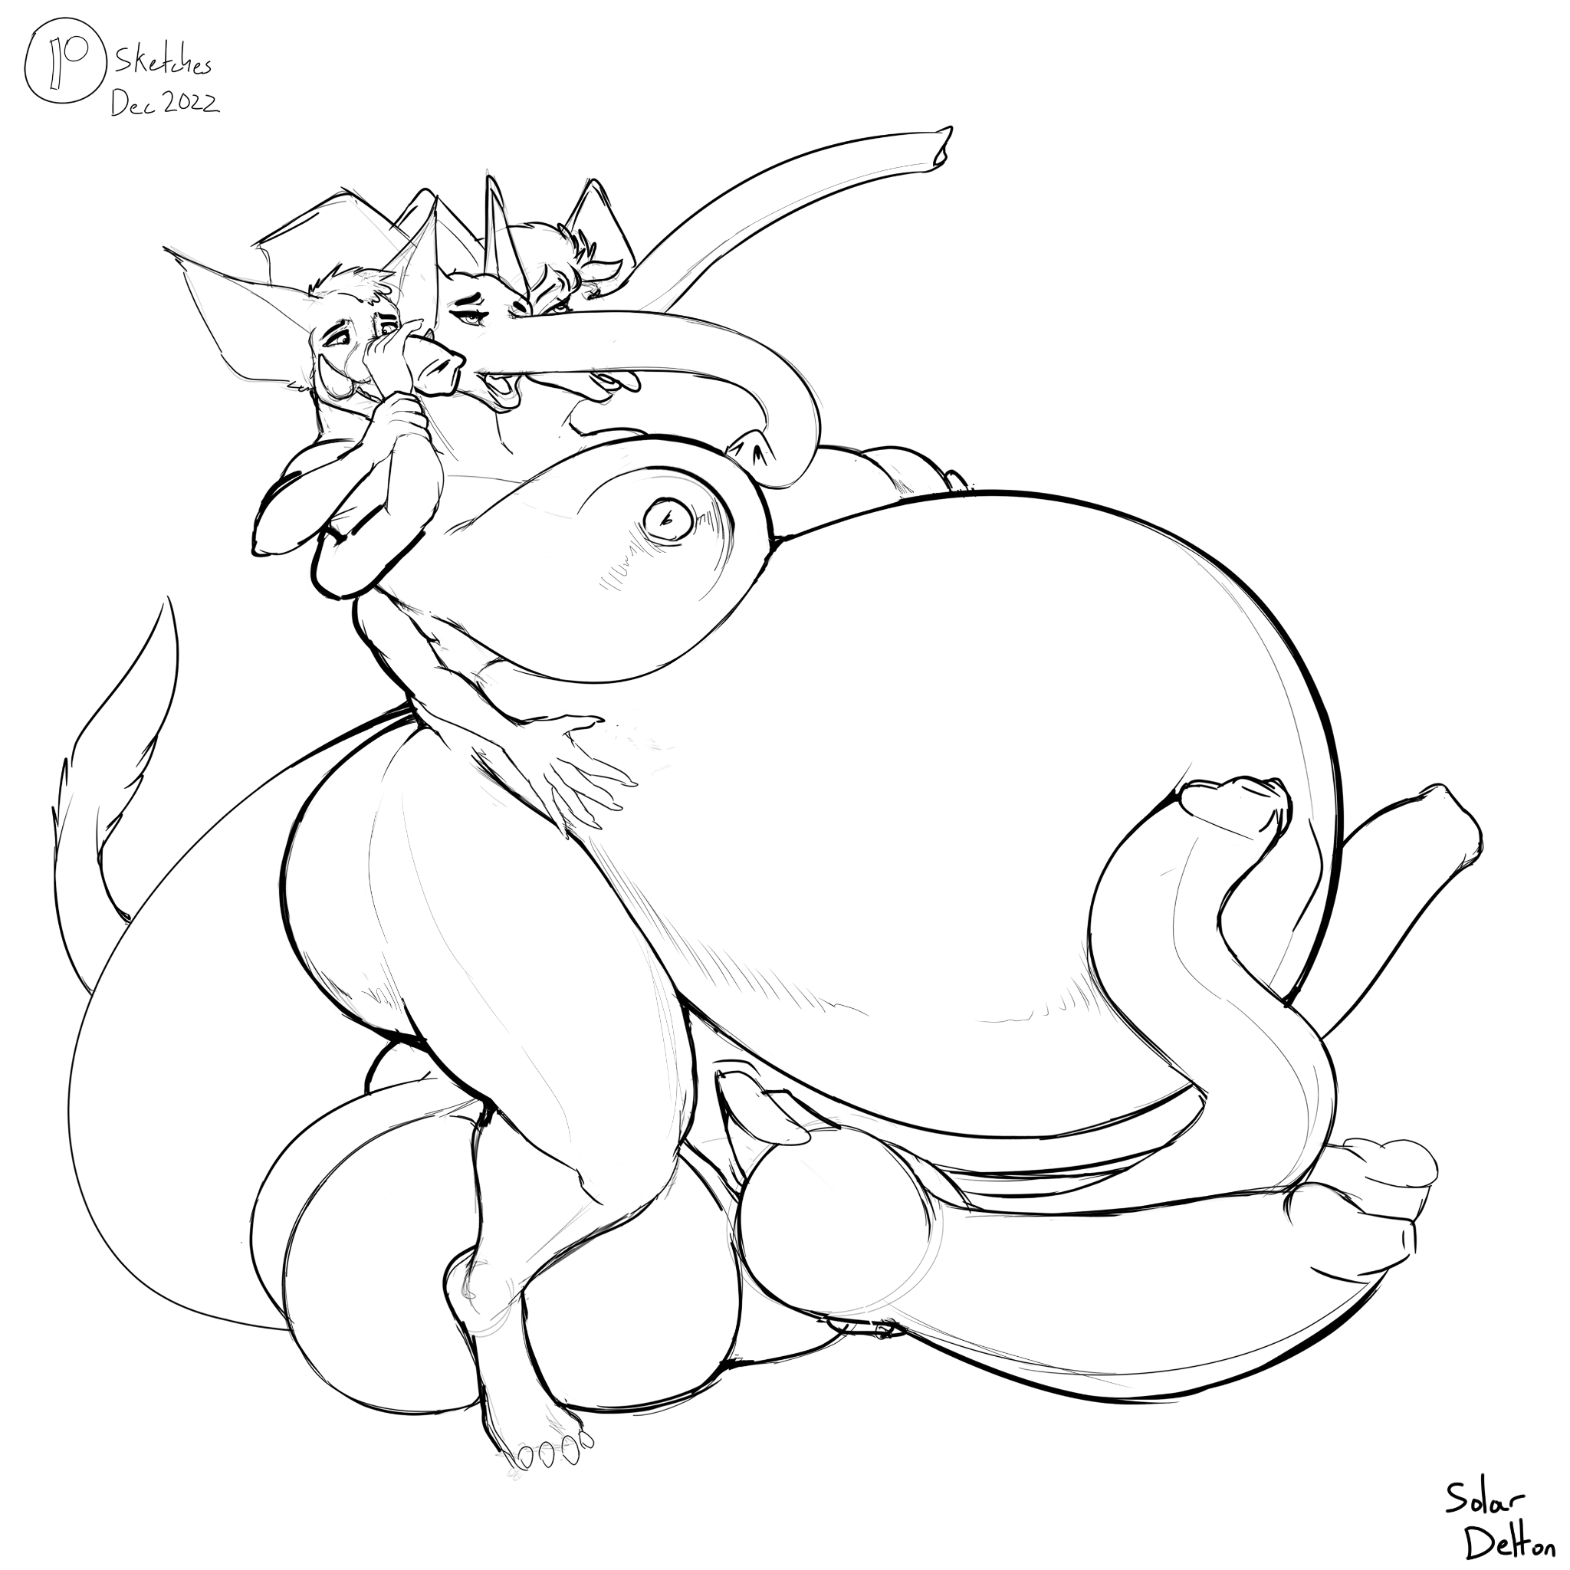

Jon and Felicia felt themselves uncurl. Swelling like two pool toys being bloated with cum, both Darkstalkers bulged with muscle and memory and opened their eyes within their phantmother’s womb. Both felt their pussies penetrated and stretched deeply full of cocks, crammed into them by their busty womb-phant breedsisters growing at an even faster rate than themselves. Though they both had vague hyperherm elephant-like traits, Felicia had regained her paws’s massive sizes and Jon regained his tell-tale tail and fluffy hackles. Neither could resist plunging their elephant trunk-nosecocks into the other’s muzzles, eagerly ejaculating against swelling and emerging pearly tusks.

The elephant mutation corrupted them once again even as they slid out simultaneously from the Mommaphant’s massive womb. By the time they slid from hir sex and slapped to the floor, they were well past their teens in size and feverishly slapping thick gray hips, heaving taller and bigger with each thrust. Their pregnant bellies mashed against each other and both their sets of breasts had lost their fur and spewed only hot phantmilk. One of the Elephant’s heads looked down at them and twisted hir trunk around with theirs, connecting Hir mind with theirs, spreading hir hivemind gestalt self.

Shi gestated within the wombs of both hirselve, hirselves, and those of everyone who heard hir trumpeting cries of bliss. Witnessing the phrenic sound of hypersexualized elephants was enough to smash phantsperm into eggs, or force wombs into where there were none, and bloat a clone within them in seconds. Within the time of hearing or seeing and processing the existence of such pleasure and elephantine bliss was enough to fray the foggy edges of the mind and feel Hir tits, pregnant gut, and aching erection and trunks pushing out of one’s body. Giving birth to Hir was the final step to becoming just like Hir, gray and growing ever girlishly larger.

Jon and Felicia, and every other Darkstalker infected by the plague of elephant corruption, rode out the endless tide of rebirth and refucking, finding each other and their lovers anew millions of times. Climaxing thousands of times before birthing themselves and more elephants into any open space available. Frequently, entire homes were flooded with elephants in a matter of minutes, some births erupting so forcefully and messily that upstairs were flooded before basements. Families, even housepets, detonated in egregious Elephant transformations, and to even write about it was to see one’s fingers thicken and grow gray, erogenous zones burgeoning with pressure and fecund lust.

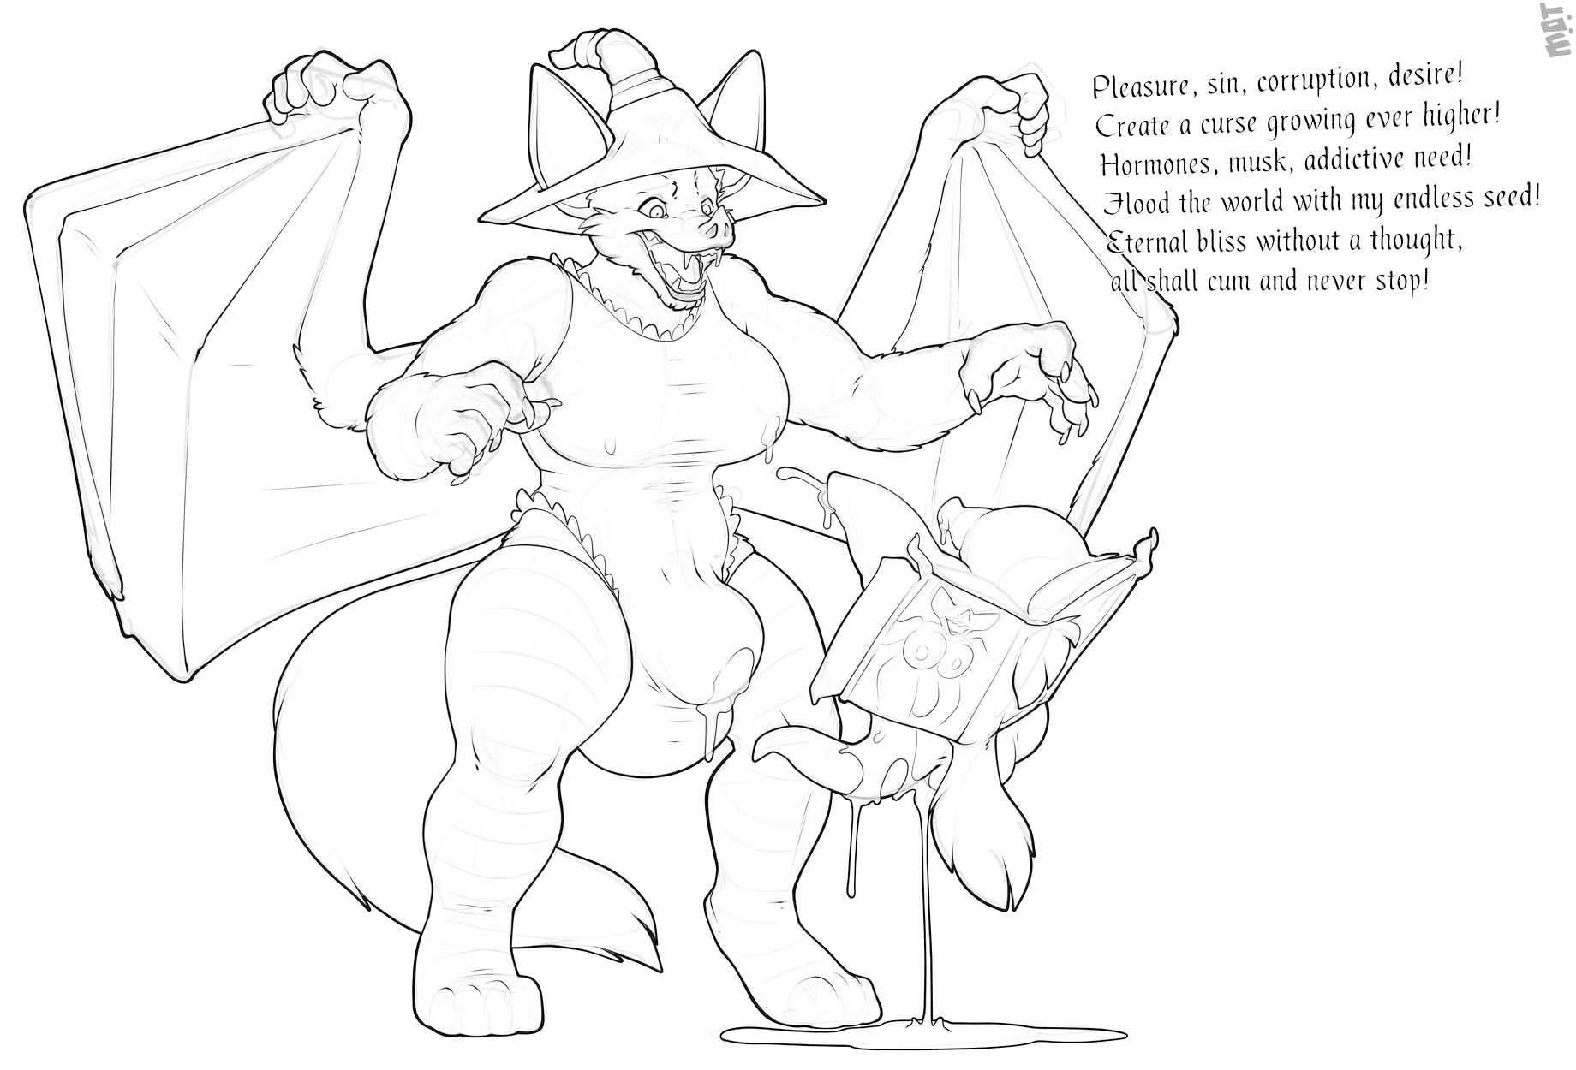
To dare read about the details, is to consult the Echonomicon.

