Tiffany
Art by Anonymous
Text by Echoen

Tiffany could feel hir clothes tightening as hir body slowly, creakingly throbbed bigger. Hir skirt failed to hide the third leg knocking about hir knees as it drooped forward larger by the minute. The shapes within hir sac and shaft became less and less apparent, the mass of those hir cock had consumed adding to hir frame. Tiffany snorted a heavy chuff as hir shirt tightened, breasts fattening fuller, and firmer, as hir bust size increased.
“You’re going in, too, kitten.” The hyperherm horse chuckled, a firm hand on the cub’s shoulder. Hir biceps and arm bulked steadily thicker with muscle and power, hir grip making the young feline whimper. With hir other hand, shi hefted hir skirt, and pressed his face directly to the cum-drenched slab of wrinkled horse dock that jerked a few inches thicker right against his face as soon as he touched it.
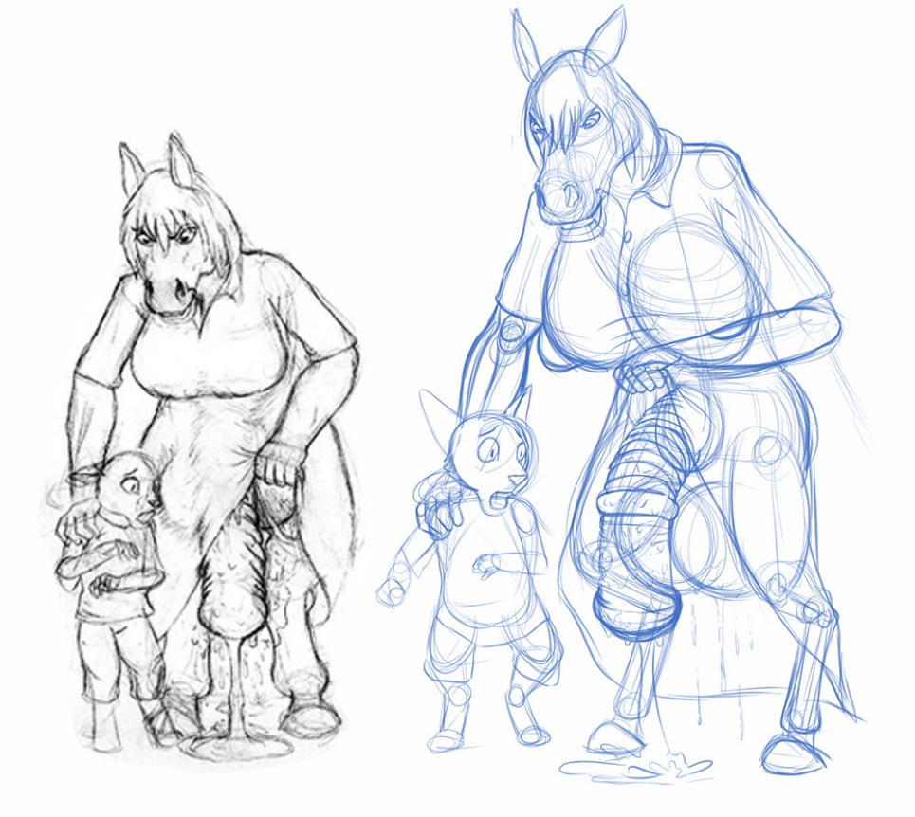
“But first I need to fatten you up, and take a load off. Let’s kill two cats with one bone, eh?” Shi chuckled malevolently. The buttons from his blouse popped off as hir tits surged past hir shirt. The busdriver costume had served its purpose, the driver and all aboard churning within hir body as they served theirs, adding to hir bulk by the minute.
Hefting the helpless cat up with one arm, Tiffany tore off hir clothes as hir body expanded even more. An entire bus of gradeschoolers – Tiffany felt hornier than ever, hir balls gurgling as they bloated in size. Hir ass fattening out, anus bloating past hir cheeks, hir cunt engorged with the mass from those shi unbirthed. Hooves thundering on the pavement, shi brought the kitten to the hood of the bus and slammed him down atop it.
His clothes removed and hir own in tatters, shi bent forward and roughly ploughed hir thickening, greasy pillar of horsecock into the kitten’s fuzzy confines. With a rough jerk of hir hips, the cat held more of Tiffany than his midsection could take, his whole body stretching and deforming around it’s shape.
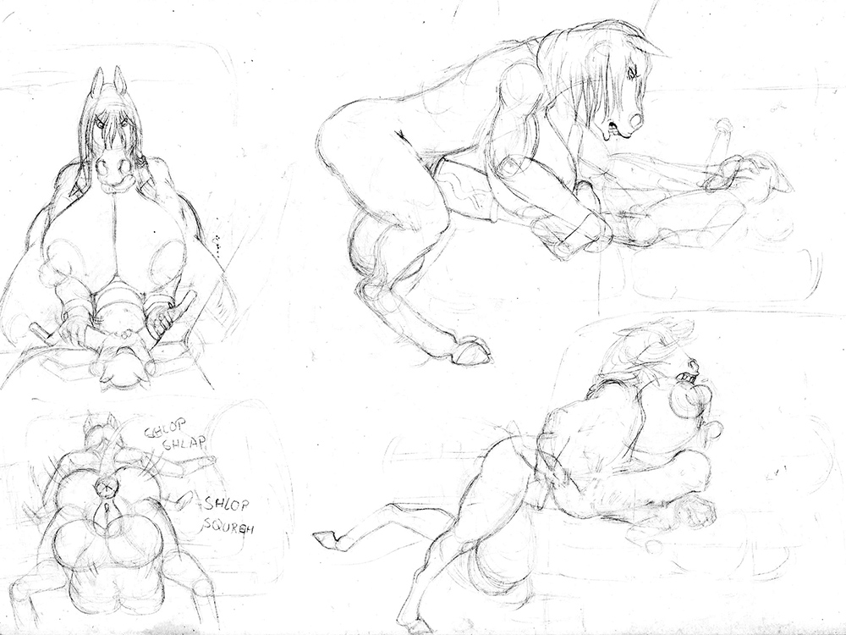
Enthused by the lucky laxticity of hir meal-to-be, Tiffany bent the hood of the bus down as shi fucked into him with no restraint. The bus wheel blew out as hir balls battered the tire, gallons of frothy ejaculate cascading down his thighs and hir nuts as shi spilled into him, and Tiffany’s tits whumped up and down, spraying hot fresh horse milk from hir engorged teats.
Still growing, and recognizing that shi wasn’t really cumming properly yet, Tiffany heaved hir hips for several minutes more, then stood back with the bloated catboy still impaled on hir spire. Snorting, shi walked back into the bus, wrenching the door wider to accommodate hir immense frame.
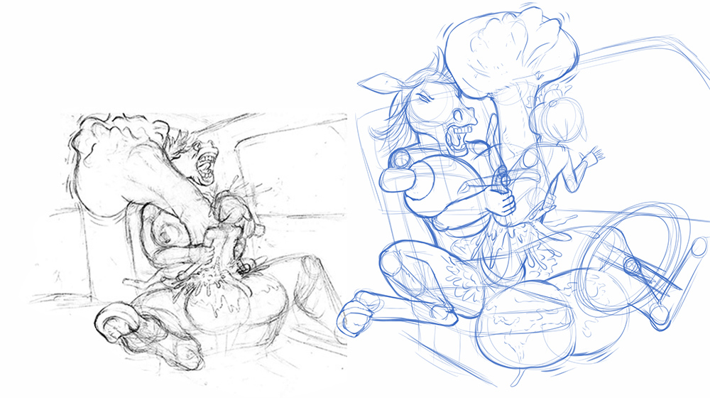

“Still alive, eh? Take this, kitty-condom!” Plopped into the driver’s seat, Tiffany made the entire vehicle shake and screech as shi jerked hir new cat toy up and down with both hands. Hir balls surged bigger and broke the steering wheel. The top of the bus was bashed open as hir still-lengthening cock grew past Tiffany’s head. The yowls and gurgles of the cat boy shi was fucking were drowned out by hir own, unabashed whinnies and screams of pleasure.
Ten minutes later, the entire bus was filled with beyond-bloated kitten belly, sloshing with seed made from the mass of his former friends. Tiffany snorted as shi squeezed one of hir own bloated nipples, kneading and massaging it as shi looked down at the unconscious cat.
“Couldn’t even stay awake to enjoy it.” The witch-horse growled, swiftly pulling back the meters of cock from the overstretched, spunk-slathered hole. Shi placed hir hand on the back of his head and discharged a potent spell to force him awake. The cat jerked and mewled, coughing up a gout of cum.
He was only awake long enough to watch Tiffany’s ass descend upon him, the onrushing wave of growing horse anus flesh smothering him as the bus-sized prolapsed tunnel devoured him whole.

Part 2: Reincarnated

Kass the calico cat jerked awake. He lifted his head from the desk he’d laid his head down on, and blinked down at his book and pen. Had it all been a dream? A nightmare? There had been this horse lady, and some kind of tunnel. He shuddered. His pants felt sticky.
“Immortal, huh? Just the kind of cat I’ve been looking to curse.”
Kass wheeled around to suddenly stare face-to-chest with an immense, familiar pair of equine breasts. A wave of musk blew over his face and Kass’s face was wet as an oversized nipple, as big as his torso, slapped him on the face.

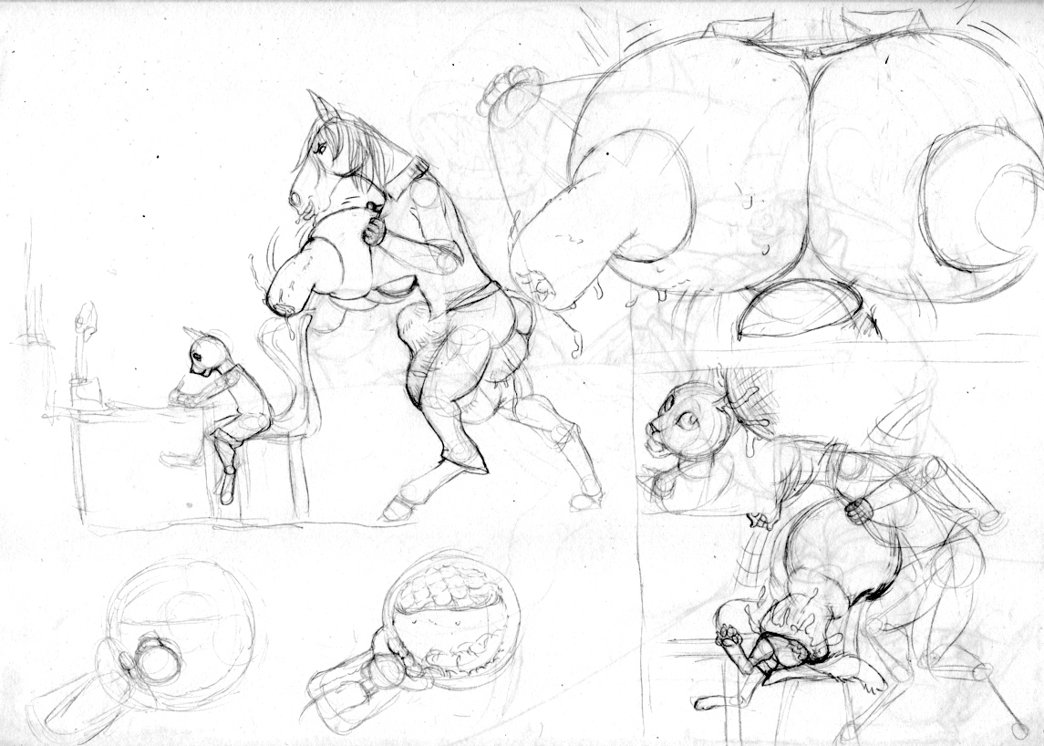
“I came home to make sure your parents wouldn’t miss you. Don’t you like how they look as part of my body?” Tiffany jeered, hir breasts slowly wobbling as they plumped and surged a little bigger. Pushing rudely against Kass. He could hear the fabric of his clothes tearing again.
“Get in there, you! Let’s see how many lives you cats REALLY get!”
“Thirty seconds? THAT’s your respawn time? Pathetic!”
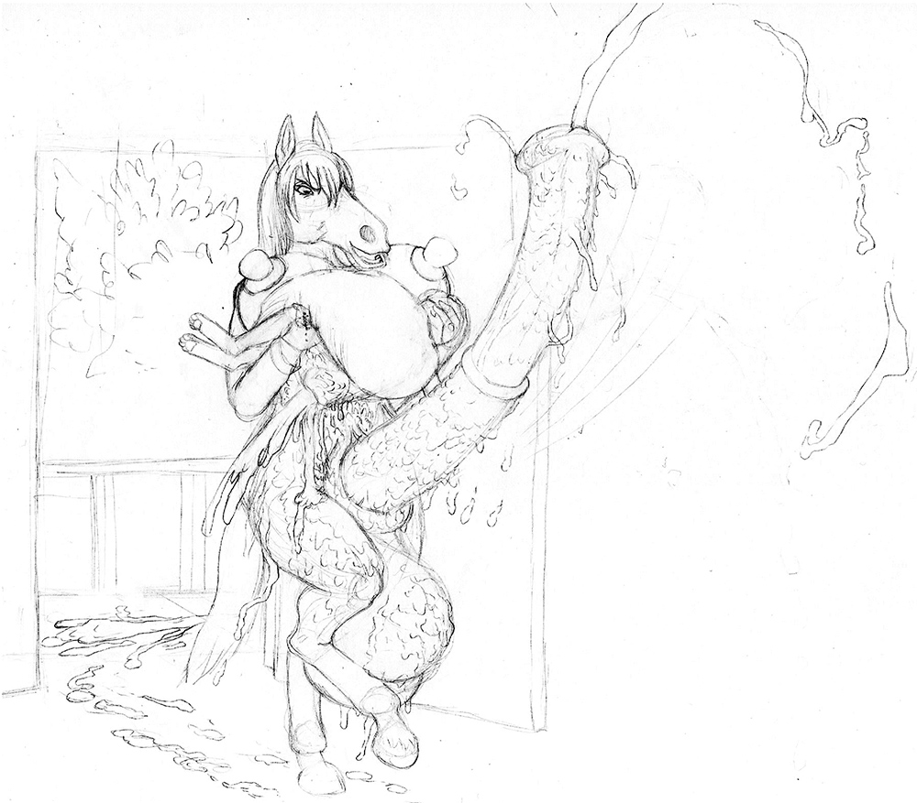
Tiffany’s body was drenched with hir own cum, much of it still pouring out from Kass’s prolapsed behind. Shi was carrying him from his bedroom to the living room, hir jizz painting the walls of the house a sticky white. Hir own engorged anus dragged behind hir for most of the way until, with a grunt, shi sucked hir flesh back into hir own ass and grew two inches taller from the mass of furniture, paintings, and pets shi’d absorbed in hir ass trap.
“Every time I eat you, you reappear a half minute later. I’m a growing girl, so you’re going to have to do a lot better than that!”
Kass gurgled, his face smothered beneath a huge, sweaty breast. A breast he’d been on the inside of more times than he wanted to admit. He could still taste the hot, thick oatmeal-like milk that he’d been forced to drink. It was a taste he carried from incarnation to incarnation, Tiffany’s curse growing more powerful as she fed on him over and over again.

“You need training, Apprentice. Let’s start on the floor of your parent’s bedroom.”
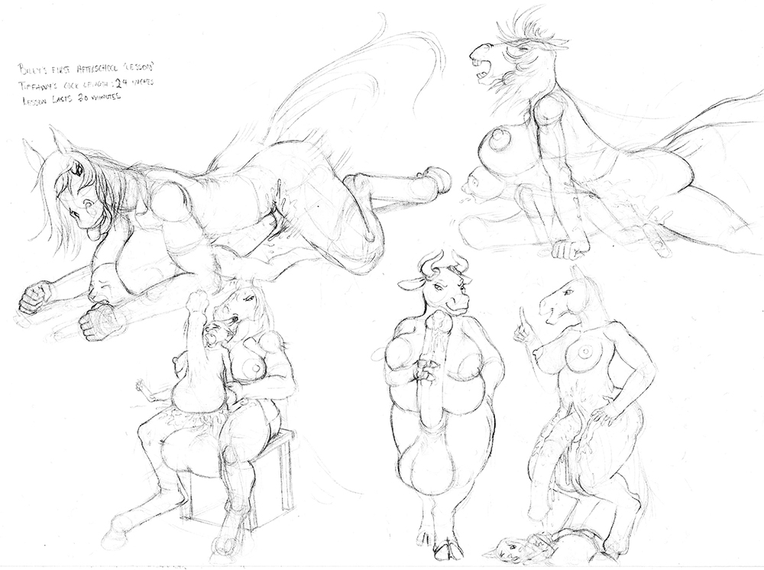
Falling forward heavy enough to break the bedframe, Tiffany ploughed hir cock into Kass’s backside and fucked forward without holding back. The kitten’s mewls, gurgles and squeals were frequently lost in the immense breastflesh that smothered his head, while his belly bulged outwards around the shape of an immense horse dick. Unlike before, Tiffany kept from cumming, and simply fucked and grew into the young cat, making him stretch more and more by the minute.
As the days rolled by, the training sessions for Kass grew longer and more intense, as Tiffany’s body developed new capacity, size and power. Shi could sometimes leave him home to ‘digest’ after a meal of milk or cum, but would frequently stuff him into a body cavity and consume him repeatedly while shi trounced about his neighborhood. His neighbors, household by household, disappeared into hir endlessly growing heft, though when the police finally came calling, Tiffany brought in an bovine friend to help “Herd” them into the proper channels.
By the time Tiffany came back for Kass, her balls were very blue as they dragged behind her that day. That day ended with Kass bloated bigger than the entire first floor of his house, the ceiling to the second floor ruptured to make room for the rest. Tiffany almost looked bored as shi stuffed his immense body into hir pussy.
One day, Kass had had enough. As he kept respawning no matter what, he decided to try to flee. Readying himself, he waited until Tiffany consumed him within hir sheath, and as soon as he popped back into existence nearby, he booked it.
Not knowing where to go in his ruined house, Kass scrambled into the bathroom to hide. He listened for Tiffany’s bulk to follow, but didn’t hear anything. Giving a whimper, he crept to the tub to try and hide in there…

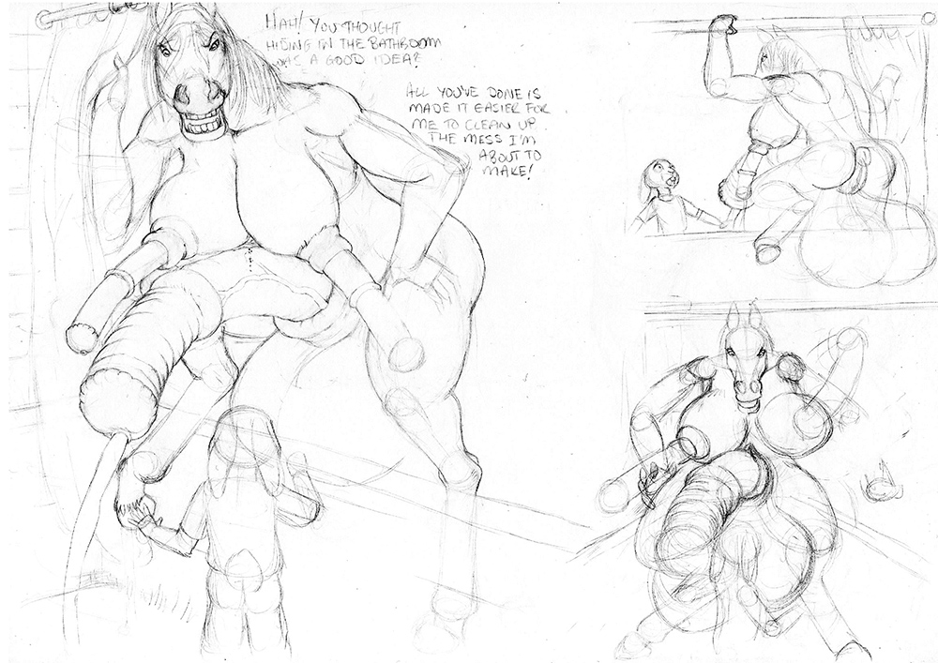

“I’ve been waiting for you to do that for a week! Finally, I’m excited enough that my nipplecocks grew in…” Tiffany chuffed, tearing back the shower curtain to climb out of the tub. Kass’s ears flattened behind his head as he stared up in shock at the huge horse. Shi looked hornier than he had ever seen hir, thick pillars of cockflesh protruding from hir stretched-open nipples. They were as big as hir cock had been when they had first met, and hir main cock now was far larger than his whole body.
“Gods, yes! Run from me more, I can feel myself changing!” Tiffany whinnied as hir shoulders lurched upwards, hir head ramming the bathroom ceiling. “Growing! Flee, so I can grow to chase you!” Hir cock slapped Kass against the door, which he swiftly opened and ran.
It had been three months since Kass escaped. Too scared to tell anyone, he was quickly taken in and adopted by a loving family. Eventually, as Tiffany never reappeared, Kass was able to fall asleep again, though more from exhaustion and always waking up with a curiously sticky set of pajamas.
Late one night, Kass stirred fitfully in his dreams. He could hear the crunch of bone and body of his friends being devoured, the gurgle and creak of expanding flesh being pressed against him. The creaks and gurgles from just outside his bedroom window were blending into his nightmares.
Tiffany grinned as shi slid open the window and began to climb inside. The excitement from mutating had been everything the bat had told hir it would be, and shi’d gone on a vacation to share hir newfound endowments with hir friend. But now shi was back from hir sabbatical, and hir hunger was eager for a fresh new community garnished with hir favorite feline.
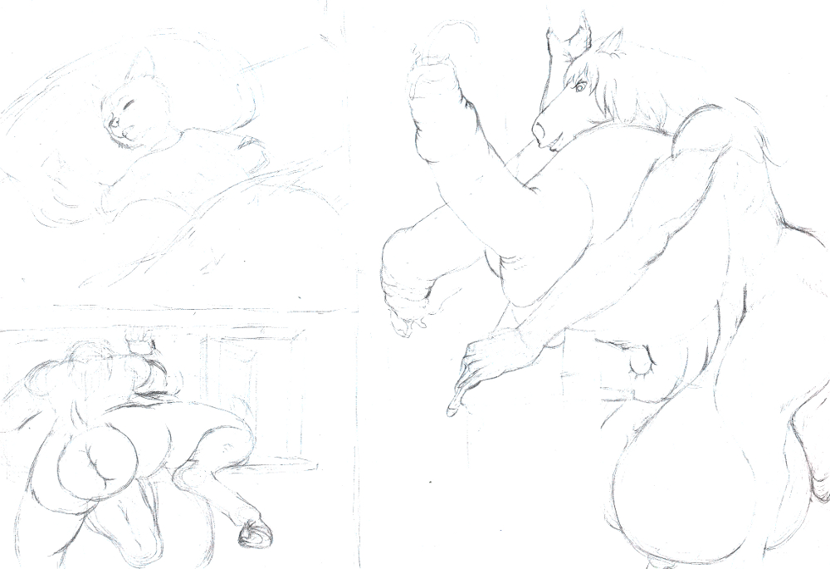

“Wakey wakey, Fancy Feast.”
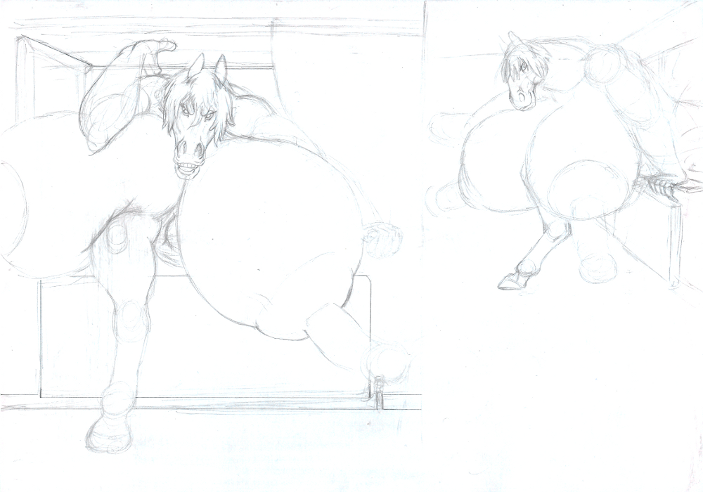
“Like what you see? I grew them just from stuffing you into my tits.” The ceiling and floor creaked as the immensely busty equine witch jammed hirself through the wall, hir huge bulk filling the room as shi stepped inside.
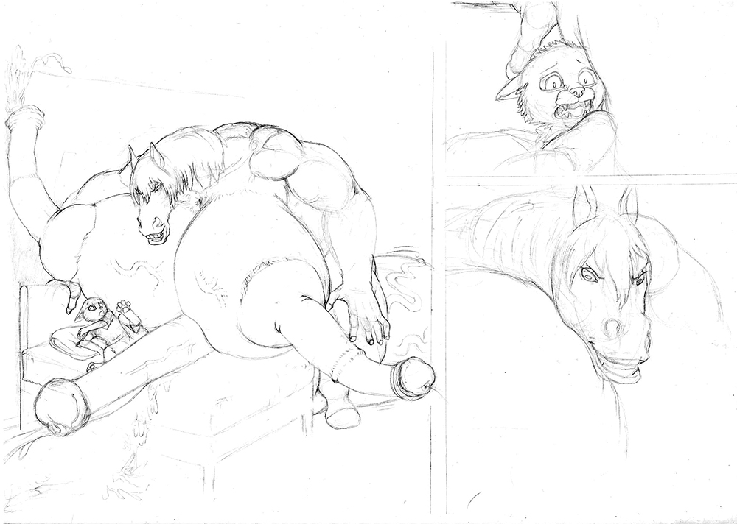
Kass was smothered to the bed by the behemoth horseherm, shoved against throbbing cock and hot, heavy breastflesh. Tiffany relished the terror on his feline face as hir nipples throbbed inexorably bigger in anticipation for what would come next.
“Let’s see if you remember your training. I’ll start you on Easy mode.” Tiffany tore off the kitten’s pajamas much like shi had on the bus, firmly gripping Kass in one powerful hand and hir throbbing nipplecock in the other. Ramming his rump down upon the spurting pillar, Tiffany proceeded to yank Kass up and down, pumping him full of cock once more.
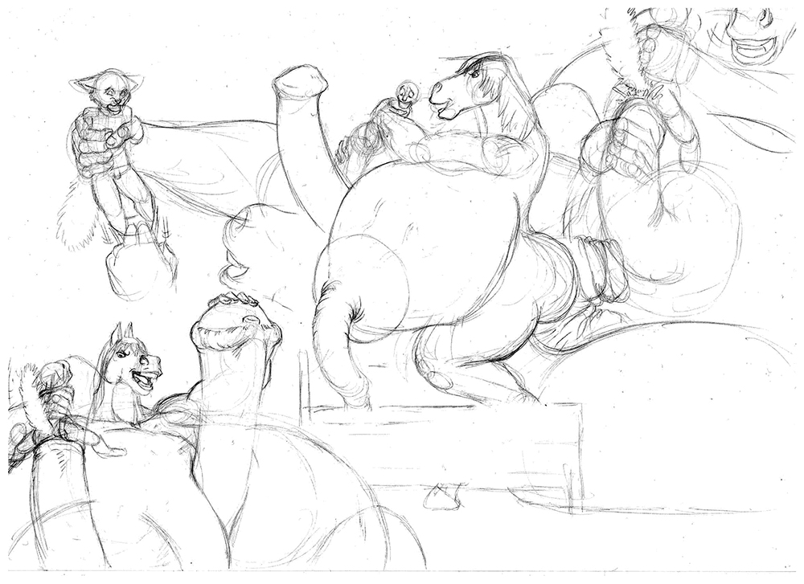
“Look at you, tight as ever! Did you miss this as much as I have?” Tiffany neighed as hir free hand stroked the bulbous tower of hir primary cock, patting the fat flare. “I can’t wait to start growing again, Fancy Feast. You’re going straight in here when you’re done here.”

Tiffany proceeded to devour Kass over and over, unleashing three months of pent up aggression into the small, stretchy feline. Each time shi bloated him full of cum and milk, shi would shove his immense mass deep into an orifice and add his mass to hirs once more.
When his adoptive family came to check on him, Tiffany was sitting on the crushed bed, jackhammering a dozen feet of horse cock into their son’s tight bottom. Their horrified expressions were the last that Kass saw of them as Tiffany scooped them up in one hand and plunged them directly into hir ass, then pressed Kass’s face against hir belly so he could hear the rumbles and crunches of consumption, the creaks and gurgles of growth.
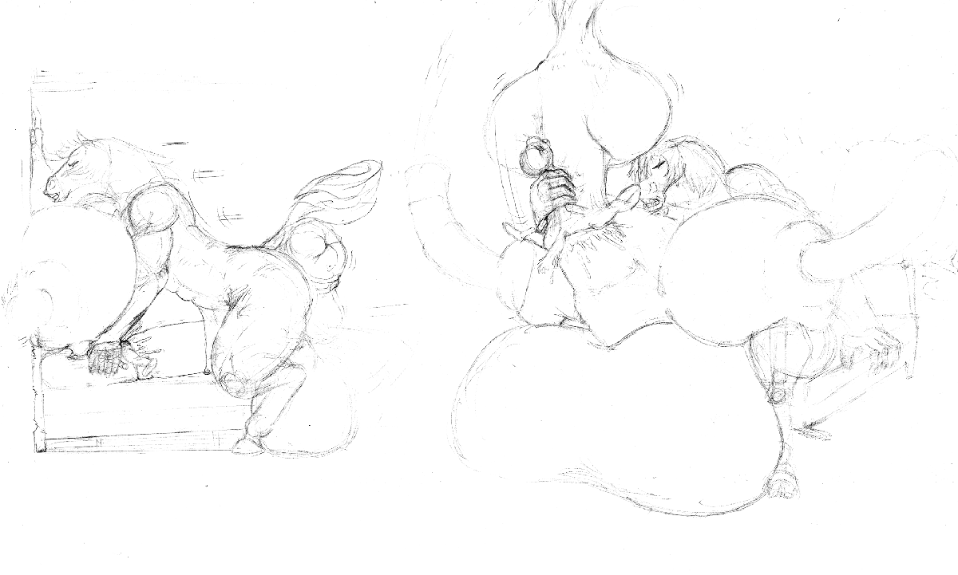
“I should let you run away again.” Tiffany grunted as hir height lurched over twelve feet tall, and hir testes ballooned wider than hir entire frame. Hir shoulders broadened and hir abs thickened bigger than Kass’ entire body. Satisfied, shi shoved him into hir cock.
“Maybe in a month.” Shi grinned, as Kass reappeared a few seconds later, facing an even bigger and hornier herm horse witch. “Hope you find a tasty new school, next time.”

Two months and three cities worth of citizens consumed, Kass would eventually escape once more. Nobody believed his outlandish tale and eventually he was picked up and fostered again. Yet, exactly three months later as he feared, Tiffany arrived once more.
This time, in broad daylight, on a public sidewalk. Kass was turning the corner from school with his friends when one of them, with a hot crunch, was sucked into an engorged equine cock.
“Fancy Feast! I’ve been aching for you. I’m so glad you brought friends, because I’m starving!”
