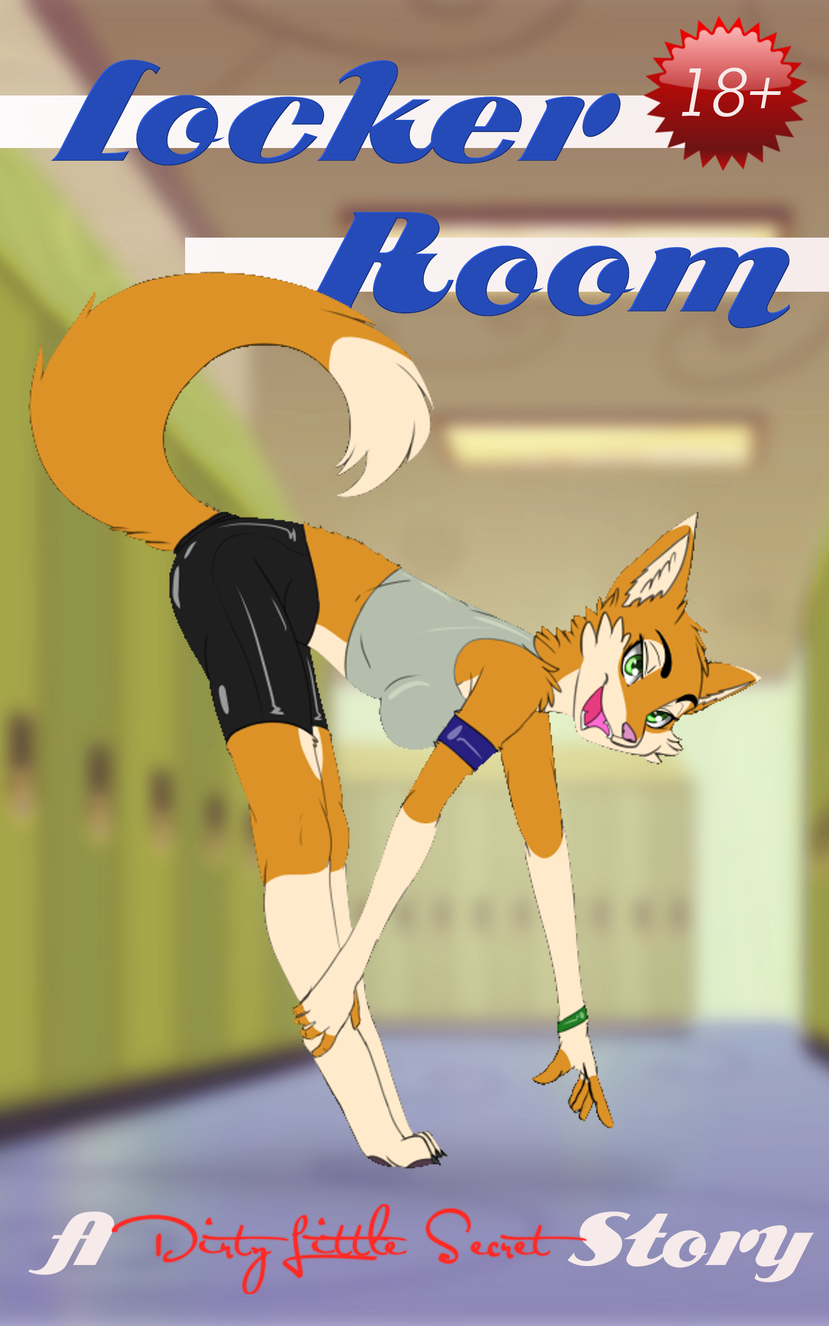

Track practice was the one time that a colt like Rupert could really take his mind off of everything, tune out all the distractions and worries of college, and just let himself be in the zone. When he was running, he didn't have to worry about homework, or bullies, or his roommate's teasing. Here, he could be one with the flow of his hooves against the track and just run.

He leaned slightly into the turn as he rounded the semi-circular end of the track. The soccer field came into view again, though he didn't pay it much mind. Both teams were out there practicing, the men's against the women's, as they usually were during track practice. They never bothered the track team much – occasionally they'd share the track to run some laps, but more often they'd just be doing wind sprints across the field. They were just another thing for him to tune out.

As he neared the end of the strait, Rupert could hear his track coach calling out his teammates' times. “Josh, Four-Fifteen! Travis, Four-Nineteen! ... Nicholas, Four-Thirty-Two! You can do better than that. ... Sammy, Four-Forty! Not great.” He looked up at Rupert, still only halfway down the straight. “What's the hold up, Rupert? Run already!”

Rupert gasped for breath, out of the zone now. Easy for Coach to say – he's a cheetah! Rupert was a horse, as were many of his teammates, but not a very big one, and he was never really all that athletic, not really into sports. Signing up for the track team had only been something to get his basketball-champ roomie to stop hassling him about 'wasted potential'. His side started cramping up in the last dozen meters, and he slowed even more.

He crossed the line just in time to hear “Rupert, Four-Fifty-Five! Even slower than last time!”

Veering off of the track, Rupert draped himself on the chain-link fence and heaved in deep breaths. Finally, it was over!

He wasn't the last across the line, though. That was and would always be Paul, the brown bear lumbering toward them, just now coming around the curve of the track. “Attaboy, Paul!” the Coach called out. “You can do it! You can beat Five-Thirty this time!” Paul never stood a chance of being competitive, but bless his heart for trying so hard. And thank the Goddess that Paul would always be there to distract Coach from the second slowest runner – Rupert himself.

Paul crossed the line and immediately collapsed on the side of the track, panting and sweating.

“Paul, Five-Twenty-Six!” Coach called out. The whole track team cheered for their exhausted comrade, Rupert included. Paul was a mascot of sorts, and his slow progress toward almost being competitive somehow inspired even the fastest runners on the team. The coach turned to the rest of his runners. “Not bad, not bad. Lots of room for improvement, but I saw some good efforts out there. Now take a breather, maybe get a little water. Wind sprints start in ten.” At the groans from his team, he waved them off with a dismissive paw. “Quit your whining – don't sign up for track if you don't want to run.”

A shrill whistle blew out over the soccer field. From the way they were celebrating, it looked like the women's team has just scored the winning goal in their practice match. They looked so happy out there ... it almost made Rupert wish he'd taken more of an interest in team sports. Almost. As much fun as that looked, he couldn't imagine how bad he'd feel if he held back his whole team when they were counting on him. It was the stuff of nightmares.

It looked like the soccer teams were taking a break, too. They were still excitedly chatting with each other.

Rupert watched them – his guilty pleasure of coming to track practice each Tuesday and Thursday. There was no official uniform for practice, but every single girl out there wore skintight shorts and form-fitting tops that were little more than oversized sports bras. How could a young colt help but to stare at all that fur on display?

As the back-patting celebration of their little victory died down, the soccer girls clumped into a few little groups, all of them smiling and chatting.

There was a part of him that felt a bit forlorn, watching them. He was never particularly sociable, and he definitely never had a girlfriend who could talk and laugh with him like that. Sadly, watching from a distance like this was about as good as it ever got for him, and he had come to accept that.

The other studs on the track team were congratulating each other and challenging each other in the upcoming sprints, all primping and posturing ... but they always left Rupert out of it, probably because they knew he'd never be as fast as them. But he didn't mind being left out of that macho-fest. What was the point of all that showing off to each other?

Instead, he just contented himself with watching the soccer girls' happiness from a distance. Well, watching their happiness and watching their tails flick back and forth above tight shorts that left nothing of their highly toned butts to the imagination.

One group of a couple foxes and a cat caught his eye. The cat was pointing straight at him, tapping one of her friends on the shoulder and saying something. The two foxes looked, then they covered their mouths and turned to each other, giggling and constantly glancing back at him.

Though he'd barely recovered from his run, a new wave of heat hit his face when he realized what they must have seen. He glanced down, and sure enough, there was a sizable bulge growing in his crotch, and his own little running shorts didn't leave much to the imagination, either.

He turned around, leaning his chest oh-so-casually against the fence. At least that way, they wouldn't be able to see. He glanced over his shoulder. Were they still looking?

Oh, they definitely were. The grey fox looked at him, elbowed her friend, and then said something. It must have been something outrageous, because both of the others giggled loud enough for him to hear across half the field. The red fox – still laughing – shoved her friend away and vehemently shook her head 'no'. But the cat nodded enthusiastically, and she pushed her toward my side of the field.

I think I knew the fox they were teasing ... she was also in my composition class. Katie, I thought. She walked a couple steps toward me after their push, but then she turned back to them and crossed her arms, telling them off with her tail fluffed out. But they kept on laughing and teasing her.

When Rupert noticed that he was watching Katie's pert rear much too closely, he steadfastly looked away. If he stared much longer, he knew he would pop a full-fledged boner, and there was no way his track shorts were going to cover that up.

For a time, he was able to succeed in calming himself. Nothing more than listening to his fellow runners' pointless banter.

But then their banter took a much different tone. They were all elbowing each other and turning to look at something on the field. Some whispered joke that Rupert couldn't quite hear set them all to laughing, but only for a moment. Then they went back to standing as tall as they could, preening themselves for ... something.

A few quiet, tense moments passed, then someone leaned against the fence next to him. “Hey,” her soft but raspy voice said.

When he dared to look, there was Katie, leaning her back against the fence next to him. The way her arms draped on the fence behind her made her rather spectacular boobs jut outward prominently. She was looking right at him, with a little grin on her white muzzle.

He gulped. Oh Goddess, what should he say? Did she notice him checking out her tits? He should say something, he was sure, but—

“Your name's Rupert, right? I'm Katie, you know, from English one-oh-two.”

“I, uh ... uh...” Oh damn, he already knew he was blowing it. “Um, hi?” Crap! That sounded terrible! He pulled himself a little tighter against the fence.

His fluster only made her giggle. “I saw you running out there. Not bad, huh?”

What? How could she be impressed with that? He was far from the fastest runner out there.

“You know, the boys soccer team could use some good runners. They wouldn’t lose to us so much if they weren't so slow.”

Breathing heavily, Rupert looked away. “I... But I... I've never really, um...”

She gave him a playful punch on the arm. “Come on, I bet you'd be great at it. Why don't you come out and meet me on the field tomorrow after class, and I'll teach you a thing or two?”

“I don't know...” He rubbed the back of his neck, reflexively running his fingers through his mane. He was getting sweaty all over again, he could feel it. “I don't think I'd be very good at, you know, kicking the ball around ... and stuff.”

Leaning a little closer, she said more quietly, “Just come out and give it a try. I'm sure I can show you a thing or two about handling balls.”

The other studs in his track team hooted and hollered when they heard that. One of them laughed and punched Rupert in the shoulder ... really hard.

But he couldn't move, his throat felt too constricted to say anything. What does one say to something like that?

As his awkward silence stretched on, Katie looked back to her friends on the field. She shrugged her shoulders, palms uplifted, shaking her head a little. The gesture couldn’t be clearer: 'What am I supposed to do with this?”

Goddess, her nose was so cute when it scrunched up like that! Rupert had to force himself to look away, so that he could maybe get enough clarity to think this through. But it was so much pressure! And this heat ... when did it get so damn hot out here?

Katie looked at him and sighed a little. “So...?”

It was too much! He could barely breathe. How was he supposed to know what to say when he couldn't even think? All those eyes on him – none of them were making it obvious, but he could tell that all his track teammates were watching him intently, and most of the soccer teams as well. They were all expecting him to do ... what?

“Um, Earth to Rupert!” She touched him on the shoulder.

“I – I need to go!” Leaping free of her reach, he dashed past his teammates, through the gate in the fence and toward the bleachers. Just behind them was the entrance to the men's locker room. He rushed in, bashing his way through the swinging door.

Once in the cooler, dimmer, and safely familiar confines of the locker room, he slipped around the corner and sat himself down on a wooden bench, trying to catch his breath. Stupid, stupid, stupid! That was the worst possible response. But what else could he have done? It felt like this was the only thing that could have saved him. Even now, his breath caught in his throat at the thought of doing ... something else. With Katie.

There was no way that could happen. She was so far out of his league! And yet... A pressure built in his crotch as he thought back to the way her tits had looked as she lounged against the fence next to him. How could a fox so trim and athletic have a rack like that? It wasn't fair ... and he knew that she would be haunting his guilty fantasies for a long time to come.

Gradually, he was able to relax. Yeah, so he blew it. So what? That was pretty normal for him, and after a while, the other guys on the track team would forget about it and stop teasing him.

He could even quit the track team if they went on about it too much. Maybe he should anyway – he obviously wasn't making much progress.

And if he didn't have to come back to practice anymore, he wouldn't have to deal with the constant reminders of—

The locker room door squeaked as it opened again.

What? Nobody should have been coming in here yet. Practice wouldn't be over for another hour and a half! But there were soft footsteps coming ... probably one of his teammates coming to make fun of him.

He opened a locker in front of him, trying to look busy even though it wasn't his locker and it was totally empty.

But when he saw who came in, it wasn't one of his teammates. It wasn't his coach coming in to drag him back to practice.

It was Katie.

“Y-you,” Rupert stuttered. “But, but this is... This is the men's locker room!”

She grinned. “I know.”

“But you can't—”

Katie gestured down at herself. She obviously could come in here. She just did. She sauntered over to the locker right next to his open one, swinging her hips and swishing her tail as she came. “So, done with practice already?” she asked. “Isn't there at least an hour left?”

Rupert stared at her and sputtered. He couldn't manage to form any actual words.

“Yeah, I think I'm done with practice early today, too.” She grabbed the bottom hem of her grey crop top and looked at me. “You don't mind if a girl like me borrows your locker room, do you?”

Without waiting for his reply, she pulled the tight fabric upward.

His eyes went wide and his mouth dropped open as that grey cloth rose and exposed more red and white fur. The hem caught just under her boobs for a moment; she looked him right in the face and smiled ... and then she pulled it up more. One, then the other, they bounced free. They were so round and perfect, just a bit too big to cover up with a hand. The velvety white underbelly fur covering them contrasted sharply against the red fur on her sides and against her starkly pink nipples. They mesmerized Rupert as Katie's effort in getting the sports bra over her head made them jiggle side to side a bit.

She tossed her top on the bench next to her and laughed at him. “What? Never seen a girl's tits before?”

But he was still gaping at her exposed chest, his eyes soaking in the sight and his mind feverishly committing it into memories that he'd never forget.

“Oh wow... You really haven't, have you?” She scooted a little closer. “Wanna touch?”

That made Rupert gasp. “Wha... Really?”

Quite calmly, she reached down and grabbed his right hand,

This is only a 2500-word teaser for the full story, which is 6900 words long.
The full story is available for $2.99 at Excitica or Smashwords.
Or, as always, my Patreon supporters (for just $1 per month) get to read ALL my stories early and free, plus other perks!
Follow my Blog if you want to make sure you're notified whenever a new story comes out!
I take commissions! Check my waiting list/price sheet for details.

