I... was... exhausted. We had not one, not two, but ninety-nine little puppies to look after! Why, there were so many puppies in such a small, London flat, Pongo and I had managed to slip out of the house for almost a week, and Roger and Anita didn't even seem to notice.
It had been a lifesaver of a vacation, and also set my mind at ease. We'd retraced the steps we'd run to save the puppies, making sure to thank each of the dogs, cats, and even cows that had helped us on our way. We could never have saved all ninety-nine without their help.
The five-day trek had led to another realization for me. Pongo was a terrible lover. I don't know if it was inexperience, or a lack of size, or a curse from the pits of Dante's inferno, but the poor ol' chap couldn't even come close to satisfying me. Once, I'd thought that his prowess (or lack thereof) was normal, until I'd met Cobalt. Then, I'd thought that Cobalt was simply Dog's Gift to Bitches. Oh, he was definitely an immaculate lover, but I knew now that he wasn't the only one that could make me squeal.
I needed Cobalt. I hadn't seen him in over three months, what with the pregnancy and the kidnapping and the rescue. And I'd never intended to see him again. I had decided to stay with Pongo, simply because he was my husband, and I truly care about him. I reaffirmed my loyalty to him, and vowed never to betray him again.
What a difference three months of hump, hump, splat could make on a relationship! I worked my claws to the bone helping to care for all the little ones, and Pongo didn't have the decency to make me cum. Not once, in our entire marriage!
Pongo knew I had cheated on him, with Cobalt. He didn't know how much. I spent a full week of my heat moaning beneath Cobalt, until the red-haired Dalmatian was certain my pups would be his, and all his. Pongo thought it had been a one-time fling. When he'd caught us red-handed, I'd felt terrible. Pongo was perfectly nice, and had ended up being a great, loving 'father', and he didn't deserve to find out I needed other dogs to satisfy my lust. I'd hurt him, and felt a terrible guilt. But after three months, I realized the only thing I truly regretted was getting caught.
I'd just have to be more careful - assuming Cobalt would take me back. I'd piled up stone after stone at the front gate, until a two-foot-tall pyramid stood there, signaling that I needed to see him. Would he notice? Would he even walk by? Or had I hurt his own feelings beyond repair? I felt like I would explode if he didn't answer my invitation.
Every night, I watched the backyard for hide or tail of Cobalt, and every night, I left disappointed. Was he even still in the city?
Then, the strangest thing happened.
I knew something was up when I saw our pet, Roger, walking through the door with a bouquet of roses. Cocking my head, I followed him. The human wasn't prone to shows of romance, but his efforts didn't stop there. I watched him grab several glass candles from the top shelf.
"What do you suppose?" I asked Pongo, who had sidled up beside me.
"I haven't the foggiest," he said.
Together, we followed Roger around the house. A metal tray. A bottle of wine. Matches. It all started to come together in their bedroom, as he laid the candles around the room, pouring two glasses of rich, red wine, spreading red petals across the bed.
Pongo perked his ears wonderingly at his pet, and said, "Why, I do believe the old chap is planning a romantic surprise for your Anita," with a light chuckle.
"I didn't know he had it in him!" I exclaimed, tail wagging in amusement.
Roger and Anita had been under a ton of stress recently, dealing with the pups, the press, the royalties from his song, and their efforts to acquire a farmstead for the whole family. Boy, that would be nice. A couple acres to run the pups out of energy each day would be like heaven. I guess I couldn't help but feel a connection to Roger - we both were exhausted and horny, and needed a break. Thankfully for him, he could get that from Anita.
Minutes after the bedroom had been transformed into a rosy, dimly-lit get-a-way, the phone rang. Roger grabbed the phone, holding the bulky, black earpiece up to his head.
"Anita!" he said, positively hopping from foot to foot in excitement.
"What?" he said, balancing awkwardly on one foot.
"Oh...I see. But I thought..." he said, his hand turning white as he clasped the receiver.
"No, no, that's quite all right. I'll...I'll see you tomorrow, then?" As the call ended, he slammed the receiver down, a loud clank! echoing through the small bedroom. His eyes fell on Pongo, and he said, "Bloody hell, Pongo. Well, I guess the evening's off...again." Roger sat heavily on the bed, scattering rose petals everywhere, his head in his hands.
Pongo obediently wandered over to his pet, and soon enough Roger was crooning and petting his old friend. Roger said, "How about...a guy's night? You, me, and the basement, boy? How'd you like that? I'll get the beer."
Pongo just cocked his head at the man, following him closely at his heel. I followed ten feet back, praying the man wouldn't want to trap me in the basement as well. Thankfully, Roger grabbed a six-pack, clomped downstairs with Pongo, and locked the door behind him.
I blinked. Judging by Roger's mood, I had the whole house to myself. For the whole evening... If only Cobalt would come! Hopefully, I ran upstairs, positively panting by the time I made it to the window. I slid the window open, and to my surprise, there he was.
I was stunned. "Cobalt!" I exclaimed, and he looked up at me, his expression a mix of happiness, confusion, and caution. "You finally came!"
My beautiful, red-haired Dalmatian spoke, looking up at me. With a cute, sheepish grin, he said, "When I saw that many rocks piled up outside your house, I wasn't sure I alone would be able to satisfy you."
I laughed, then spoke more seriously. "I've missed you so much, Cobalt. I'm so sorry for hurting you like that. I need you, and I won't turn you away again, not even if Pongo finds out. Come on up here - I have a surprise for you."
Cobalt cocked his head. "Inside the house? What about...?"
I cut him off, saying, "It's a surprise."
He grinned. "How could I ever say 'no' to that face? I'll be right up...in a few minutes. I've a surprise of my own."
What could he mean by that? I didn't dwell on it - I could use a few minutes to make everything 'just so' before Cobalt arrived. "Well, when you're ready, just walk downstairs to the bedroom. I'll be waiting!" I flashed my lover a grin, my heart fluttering at the sheer danger of what I intended. Roger and Pongo were just in the basement...what if he came up to the kitchen and heard something in the bedroom? What if Anita changed her plans and came home early? It didn't matter - I couldn't waste this opportunity.
And so there I was, lying on my back in a bed of rose-petals, holding a long-stemmed rose between my teeth, lit only by eight, yellow candles that shone brilliantly on the two, forgotten glasses of red wine. I watched the door with a smile, spreading my hind legs just so, to give my lover a perfect view as he entered.
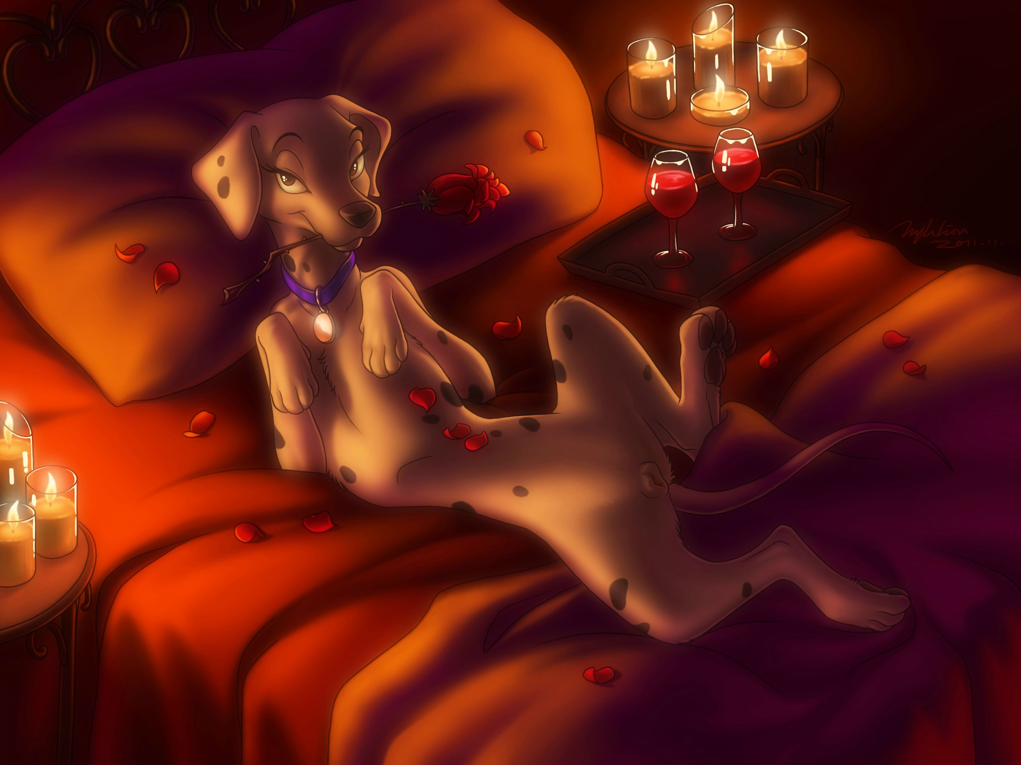
I heard his footsteps on the wooden floor just a few moments before he peeked his head in. Cobalt's jaw dropped at the beauty of the scene...or perhaps simply at my beauty. He gasped, "What a...good...surprise..." licking his chops as his eyes roamed my body hungrily.
I opened my mouth just far enough to speak through the rose in my teeth, saying, "Your turn to surprise me," I challenged, suspecting that he could hardly top mine.
But when Cobalt edged his way inside the room, I caught a flash of movement behind him, and my jaw dropped, the rose falling gracelessly onto the bed in front of me. Cobalt's surprise was the winner.
Behind Cobalt stood an unfamiliar dog, a svelte, strong-looking German Shepherd. Heat rushed to my face as I inadvertently presented myself to the brown-and-tan canine. "Cobalt!" I chided, nervously.
The shepherd took one look at me, his eyes wide, and licked his lips. "You've been keeping this one all to yourself, Cobalt? Shame on you."
Scrambling, I spun onto my belly, looking over my shoulder in shock at the two males. This was certainly not what I expected!
"Perdie, this is Flint, a friend of mine, and -"
Flint interrupted, his tail wagging rapidly, "He's told me a lot about you."
Cobalt glared at his friend and continued, "He's been begging me like a lovesick puppy to meet you, and when I saw that pile of rocks, I thought I might need some...'reinforcements.'"
My ears were still flat, though I tried my best to raise them. Carefully, I walked to the edge of the bed and dropped down in front of Cobalt and his friend. I could tell from the corner of my eye that Flint was staring at me, but I looked away. Voice soft, I said, "Cobalt, I can't..."
"Yes you can," the Dalmatian said, simply.
"I don't even know him," I protested.
Flint lifted a paw toward me, as if to shake, and said with a grin, "Hi, Perdie - I'm Flint."
"You know what I mean -" I started, but Cobalt cut me off.
"You just have to stand there; he'll do the rest," he said, nodding over at Flint.
Flint nodded in agreement, ears erect as he started walking around behind me. I tucked my tail between my legs, dumbfounded. Cobalt really meant to do this! To offer me up as some prize to a friend of his I'd never even met! Was he trying to get back at me for leaving him? I looked into his golden-red eyes, but found only the warm, loving Cobalt I remembered.
Flint walked around me, sniffing, and said, "God, she's beautiful, Cobalt."
I felt his nose sniffing around at my trembling tail, just barely thick enough to hide the glistening mound I'd accidentally presented just seconds before. I looked at Cobalt and whimpered, but the red-haired Dalmatian took a step forward, looking right into my eyes and said, "Trust me."
Ever so slowly, I nodded back, and Cobalt sat down, lifting one of my paws in his. As his strong paws gripped my tiny one, he commanded, "Lift your tail."
Ears still pulled back against my head, I whimpered one last time, but lift my tail I did, never once looking away from the love of my life.
"Oh!" I gasped, as heavy, wet licks slurped up against my trembling mound. I had to struggle to keep my tail straight up. Flint certainly wasn't subtle! I squirmed, but Cobalt held my slender paw reassuringly in his. "Cobalt..." I whined.
"Just relax," he said confidently. "Believe me, this will be a night to remember."
I gave a single, short nod, moaning as Flint's strong, steady tongue slipped inside me. I'd certainly worked myself into a fever, waiting for Cobalt for so many days - I just expected he would be the cure, not some dog I had just met. Still, Cobalt's tongue or not, my aching pussy stretched eagerly apart.
"You're so wonderful, Perdita. I couldn't be so selfish not to share you with the rest of the world," said my love, to the noisy background of slurpsand schlorps. I kept my eyes on Cobalt, pretending his tongue was the one coating my pussy with drool. That helped, though I knew that no universe could be so perfect as to contain two Cobalts.
Now I squirmed for different reasons, as Flint's thick, flexible tongue probed every inch of my aching vagina. I could feel his cold nose expelling warm breath against my tailhole, his muzzle pressed up against my grey spade to help him reach all my deepest spots. I'd be lying if I said German Shepherds didn't appeal to me - I'd spent many days early in my marriage wishing my underwhelming husband were Thunderbolt, the action hero. His pink tongue pounded me, rubbing and squeezing the raised nub inside of me. I moaned, mincing in place, my tiny hindpaws dancing up and down.
"Besides," Cobalt said, grinning, "I want to feel what it's like to fuck you when you're bloated with another dog's cum."
I dropped my jaw, my lady-like sensibilities shocked, but just the thought of what he was suggesting sent me into whining, clenching spasms around Flint's tongue. "Ohhhhh," I whimpered, otherwise speechless.
Flint took this time to pull out of me with a loud smack! He licked his lips, watching my triangular vulva bounce up and down as he said, "Is she ready, Cobalt?"
Cobalt called back, "You tell me."
"Oh yeah, she's ready," he said, his muscles tensing. I tried to move away from him, but Cobalt held my paw firmly. I stayed put.
And then I was mounted by a dog I'd first seen three minutes earlier, to whom I'd never even spoken a word. He'd said, what? Eleven words to me. And now, the muscular German Shepherd was climbing onto my back, just a few dozen feet from where my husband was surely curled up beside Roger in the basement.
I moaned.
Strong paws slid around my slender hips, Flint's scratchy paw-pads brushing roughly against my still slightly-swollen nipples. My dainty hind-legs wobbled under his weight as the shepherd scaled up my body, his white fur mixing almost indistinguishably with mine.
"Good girl," Cobalt said gently. I could see my love's red dick straining out of his sheath as he watched me getting covered by another dog.
It was only when I felt something wet and slimy poking up against my well-lubricated spade that I realized this was really, actually happening! In a mixture of fear and anticipation, I finally said my first words to my new mate: "Oh, Flint!"
"Cobalt," he said, talking past me. "I can never thank you enough for this!" With that, he punched his hips forward and speared my quivering pussy.
My jaw dropped at the feel of Flint's fat cock stretching my y-shaped folds into an obscene, trembling ring. I realized surreally that I'd never even gotten a good look at the throbbing organ before it was plunged inside me while my boyfriend watched. In fact, I'm not sure I could even recognize Flint if I saw him tomorrow on the street. Shivering, I looked over my shoulder at the grunting shepherd. He certainly wouldn't be a stranger by the end of the night!
"She's so tight!" Flint cried, through gritted teeth.
He hammered away at me with none of the loving gentleness I had come to expect from Cobalt. Sure, Cobalt always let me have it right before the end, but Flint humped into me like tonight was his last night on Earth. His eager thrusts quickly hilted inside me, grinding up against my innermost wall. Whining, I couldn't help but rock my hips up and down, my tongue dangling useless from my mouth.
"That's it, Perdie," Cobalt whispered. "This is how Flint says 'I like you'."
I whimpered, but Cobalt lifted a paw to my mouth, tilted my muzzle to his, and kissed me. Our wet tongues embraced sloppily while the German Shepherd watched, his thick, throbbing dick squishing in and out of my soft, tender mound. Flint said jabbing forward to emphasize every other word, "If she were my wife, I'd never let her out of my sight!"
Pongo. I couldn't help but think about him, downstairs, completely oblivious to what was going on upstairs. He'd caught me cheating once, but he had no idea the extent... What would he think if he knew I had two other dogs making up for his inability to do his husbandly duty? I felt a twinge of guilt, but after months of being faithfully unsatisfied, I had made my decision: a girl's got to get her romance and pleasure from somewhere.
I stopped holding back. Why should I sabotage my own fun, just because Flint was a stranger? Any friend of Cobalt's was a friend of mine! I broke the kiss with my love, looked over my shoulder at Flint, spread my hind legs wide and said, "Harder, Flint! Give it to me!"
Tongue lolling from his mouth, the German Shepherd nodded, "Yes, my lady," and pumped even harder. Turns out he'd been holding himself back as well, and now his knot was half-swollen outside of me. He grinded it against my wet folds, his sharp thrusts making a harsh slap! slap! slap!against my rump.
I tensed my muscles and pushed back with all four legs, moaning, while Cobalt watched, saying, "Don't hold back, Flint. Leave her nice and sopping wet for me."
I had to grit my teeth, groaning each time the powerful German Shepherd rammed his knot against my tight pussy. His fat cock slid back and forth in me, making every last inch of my passage squeeze and tingle. I thrashed my hips wildly. God, it felt so good! When Cobalt had first suggested I let Flint fuck me, I'd been resistant. Now, only minutes later, I dropped my jaw and cried, "Knot me, Flint! Make me your bitch!"
"Our bitch," Cobalt clarified, smiling.
Flint launched himself forward, his swelling knot colliding with my aching vulva. He grunted each thrust, saying, "I...can't...get...it...in!" I whined frantically, turned on by his brutish abuse of my raised rump, and both worried that he wouldn't manage to wedge the shiny, red knot into me, and worried that he would. I tried to encourage him, but my voice only came out in high-pitched squeals.
Cobalt gently placed a paw on my shoulders, and then he pushed. Without his help, I doubt I would ever have stretched wide enough for Flint. I had to laugh inside - my boyfriend was literally doing what my husband had only figuratively done: pushing me away onto another dog's knot! Only unlike Pongo, Cobalt would earn my fervent thanks.
With both studs pushing on either side of me, Flint finally managed to wedge part of his bulbus glandis between my stretched-out labia. Despite myself, I howled, only realizing a second later that Roger and Pongo would surely hear the noise. I glanced over at the still-open door to the bedroom, praying that Roger wouldn't bother to investigate. I opened my mouth to warn Cobalt to go shut the bedroom door, but my voice was cut off when Flint banged forward once again, jamming half of his enormous knot into my mound. "Almost...there!" Flint grunted through gritted teeth.
Cobalt timed one last push for Flint's next thrust, and I yelped loudly as the German Shepherd shot into me with a wet pop! Bloody hell! I thought to myself. Now they are sure to come check on me! But a split second later, I simply didn't care anymore.
Flint's full, throbbing cock swelled instantly inside of me, stretching my pussy lips two inches out into an enormous bulge. My straining vulva pulled Flint deeper, until his tip grinded almost painfully against my innermost wall. My slender rump was stuffed completely, in a way my underendowed husband could never accomplish. Flint's gigantic glands tweaked and squished the small, pink nub inside of me that drove me wild. I rocked my hips in short circles, moaning loudly - too loudly.
Flint grunted, holding on for dear life as I shook and squirmed beneath him. He kept up his short, sharp thrusts, his hefty, intact balls slappingnoisily between my legs. Thank goodness I wasn't in heat! What would Pongo say if I gave birth to spotted, brown puppies?
Heat or not, my womb was Flint's to claim. He whined and said, "Here...I...cum!" With that, I felt his balls convulse, his thick cock pulsing, and the steady, hot gush of thick, slimy seed launching into my waiting uterus.
"That's it, Flint," Cobalt said, "Do what you do best: fill her until she's bursting."
That's what he does best? Funny, because he seemed pretty damned good at fucking me so full of cock that I devolved into desperate, gasping humps of ecstasy. But I soon realized that Cobalt had a point: Flint's onslaught seemed never ending! His heavy orbs shot load after load into my puppy chamber, until I felt positively bloated with his cum. I whined, lifting a front paw to slide it to my belly, and my eyes popped open in shock. I didn't just feel bloated, I was! Flint moaned and groaned, pumping me so full that my slender belly began to stick out, stretching me out nearly as far as Cobalt's fifteen puppies had! "Oh, God!" I cried.
Cobalt placed a paw gently on my cheek and said, "I have dozens of friends I'd love to see pounding away at your tight pussy, my love, but I chose Flint for this, his special talent. I want you flooded, well-greased, and dripping with his cum.
"Other...friends?" I whined, clenching down hard around Flint's still-spurting cock.
"Don't worry, they'll get their chance in time."
Flint emphasized each of his words with another bubbling splurt, saying, "Just...glad...I could...be of...service!"
I truly felt like at any moment I would explode, and still Flint kept going, until the pressure built up inside me so far that with a thundering, squeaky squelch! his next explosive load squeezed past his throbbing knot, spraying out everywhere. Hot cum splattered my rump, Flint's legs, the floor - even the covers on the side of Roger and Anita's bed! I was so full I could feel his slimy seed sloshing around inside my bloated belly.
"Oh, Flint," I began, but before I could continue, loud, thudding footsteps rang out from the basement. Roger!
"Close the door!" I yelped at Cobalt, but he only had enough time to turn and see the half-open door before it was too late. The basement door swung open with a high-pitched creeeeeeeeak.
The three of us froze, all staring up at the door. Even if Roger weren't coming to investigate my squeals and moans, he'd have to walk right past the bedroom to get to the rest of the house! Flint clung to my rump, still hopelessly tied - there was no way we could get out of sight quickly or quietly. The jig was up!
Roger walked right on by without a second glance into the busy bedroom. In his left hand, he carried a cardboard four-pack of beer, each bottle empty. Cobalt and Flint and I exchanged glances. He hadn't noticed us at all! But Pongo would, by scent alone! The room must reek with the musky scent of sex.
Yet Pongo didn't follow. He must be waiting obediently for his master in the basement. I heard Roger toss the empty bottles into the trash and open the refrigerator. The clink, clink of glass bottles rang out in the air as Roger's footsteps returned. Again, the three of us held our breaths and watched the door, eyes wide. And again, Roger walked right by the candle-lit room with a fresh box of beer, completely oblivious that his female Dalmatian was entertaining two canine gentlemen inside.
Until, that is, a huge drop of cum dripped out of my bulging pussy and splashed against the wooden floor. Plop!
Roger's footsteps stopped, just a few paces beyond the open door. My heart was pounding like it might escape through my throat, while Flint gritted his teeth, trying desperately to hold back another drop. Roger said, "Huh?" and I heard him take a step back towards the door, beer bottles jingling. I trembled - caught red-knotted.
But he didn't peek inside. Instead, Roger turned back again, and walked swiftly back to the basement door, the lock sliding closed with a metallicclunk.
"Oh, God, that was close!" I exhaled, keeping my voice down.
Flint said, "Thank goodness humans can't smell!"
"They can," Cobalt said, "they're just rubbish at it."
Flint tugged backward, his enormous cock pulling at my stretched, aching vulva. The German Shepherd laughed, "I've never shrunk so fast, I was so afraid of being caught. What would your human do, if he caught a strange dog balls deep inside of you?"
I yipped softly at the sharp, painful yanks. "I don't know," I said, "But we'd better take the rest of the evening upstairs..."
Pop! Flint pulled his knot free, still mounted on my back. All but his tip stayed buried in my sopping pussy. Cobalt walked beside us, glancing beneath Flint at our well-stained rumps. My love said, "Give her a few more good squirts, Flint. Now that your cock's free, she's got a ways to go before you've filled her to the brim."
I whimpered as Flint did just that. He groaned, rolling his hips in circles as his balls tensed, fresh, slimy ropes of cum filling my newly empty vagina until I felt like a creme-filled donut. Flint groaned, and hopped off my back, saying, "I'm going to need a long break after that."
"Suits me just fine," said Cobalt. "Thank you kindly for priming my love." To me, Cobalt turned and said, "Up on the bed. I want to look at you."
I was pretty sure I knew what he wanted to look at, so with a smile, I jumped up onto the bed and rolled onto my back, my tail wagging just off the edge of the bed and my legs splayed, hind paws dangling cutely in the air, to show off every inch of my cum-sopping pussy.
"Beautiful," Cobalt said, taking in Flint's musky scent. He sniffed my sopping folds, but he didn't dare take a lick. He wanted me brimming full for the next step. I gasped as Cobalt leapt onto me, his front paws straddling my slender, bulging belly. He was only half-on the bed, but I could still see his full, throbbing cock beneath him. He crawled forward until his tip rubbed blissfully against my trembling vulva.
"Right here?" I gasped. "But they'll hear!"
"Then you'll just have to be quiet. I can't wait another second."
I whimpered softly, eyes wide as I watched his enormous cock poking and prodding at my well-stuffed entrance. Trembling, I wrapped my paws around my lover's back, wondering how on Earth I would manage to keep myself from howling out while the love of my life stuffed his cock in my Flint-flooded cunt!
I gritted my teeth, trying desperately to hold back my instinctive yip of joy, as Cobalt humped forward. He shoved his throbbing cock deep inside my straining pussy, my over-greased folds offering no resistance. He spread me apart in one, smooth motion with a sharp, squeaky sploosh!Cobalt's enormous cock sent what seemed like gallons of Flint's seed splattering out of me and staining both our hindquarters.
I let out a muffled moan, barely keeping my mouth closed. Cobalt's weight leaned against me, my hind legs splayed out and dangling in the air beside him. My little paws looked so tiny next to my spotted lover's sleek, muscular hips. This was what I had been waiting for! I clenched hard around his cock, hoping to keep him buried deep inside me, but he pulled back with ease, his glistening, red organ basically swimming in a lake of Flint's warm, bubbling cum. Excess semen spilled out of my cunt and dribbled slowly down my elevated rump, running down my abdomen to spill onto the comforter beneath me.
"You're so wet!" Cobalt gasped through gritted teeth, slamming forward again and launching another wet gush of cum into the air. His hefty ballssmacked against my tail hole, resting temporarily on my wagging tail. I could feel his balls churning as the Dalmatian prepared to add his own flood of cum, soon enough. Thank God I'd listened to Cobalt and lifted my tail for Flint, because next to giving birth to Cobalt's beautiful puppies, this was the greatest experience of my young life!
Slosh! Schlorp! Squelch! The cacophony of liquid sounds overwhelmed my ears, and I worried that Roger and Pongo would hear that, if not my muffled squeals. I bucked my hips up against Cobalt's quickening thrusts, my miniscule hind paws dancing along in the air. Finally, I could hold my mouth shut no longer and I opened it with a ragged whisper, "Oh, Cobalt, I love you so much!"
"Glad to have you back," he said gently, smiling down at me as he humped harder. His fat cock slid effortlessly throughout my entire passage, massaging every inch of my trembling pussy faster and faster, until his hips were a blur. I couldn't last much longer, and nor could he! His knot was full and swollen, but even the giant bulge slid in and out of my wet mound with barely a hitch. With Cobalt's hind legs planted firmly on the floor, his engorged cock was enough to lift my rump upward, hind legs trembling. Gravity sent whatever fluids possible into my distended belly, and I wondered for a second what would happen when Cobalt added his own deluge. Would I simply explode? No, of course not.
"Oh...oh God, Cobalt!" I cried, forgetting to keep my voice down. Who cared if Pongo came to investigate? What did it matter? Beneath Cobalt was where I needed to be, where I belonged. Again and again Cobalt's gigantic knot squeezed in and out of me, my vulva spreading several inches wide with each thrust. I clenched hard, trying instinctively to lock him inside of me, but I was so wet that I simply could not hold him. Not that I minded. Each time that knot squelched inside of me, it collided with my raised nub, the source of my bliss. I tried my best, but I simply couldn't outlast my lover.
My whole body began to shudder, hind paws thrashing wildly in the air as ecstasy spread like an explosion throughout my slender body. I dropped my jaw and howled.
"Perdie, hush!" Cobalt said urgently, but I didn't care. Let them hear. This was how a male dog should make his bitch feel. I only howled louder, squeezing and clenching around his full, throbbing cock.
Reaching up with a single paw, Cobalt attempted to silence me, but my mouth was so wide I felt like my jaw would fall off. Resting his belly against mine, Cobalt had to reach up with both paws to hold my mouth shut. I still squealed, shuddering, but at least now the sound was muffled. Cobalt himself was gritting his teeth, trying not to howl. With a muffled grunt, he pounded forward, and this time stayed there, his knot tugging wetly against my stretched out mound. With his balls trembling on my tail, Cobalt said, "Here I come..."
His balls pulsed, and the first, heady gush of cum erupted inside of me. My pregnant-looking belly was already so full that most of his cum simply made Flint's juices splatter out of me, but a good portion shot straight into my straining womb. A warm mixture of both dog's seed began to pulse out of me each time Cobalt's balls squeezed another hefty load, splattering our underbellies and spilling down onto the bed beneath us. I would have screamed for joy, but Cobalt thankfully kept a firm grip on my muzzle. I watched with awe and some fear as my cum-stained abdomen, already bulging from Flint, stretched even farther. Maybe I would explode after all! Oh, but what a way to go!
The pressure kept building and building until my muffled howls turned into whimpers. Cobalt steadily launched his hot, sticky seed into my bulging womb, his seed mixing equally with Flint's, while I shuddered beneath him. Just when I thought I'd reached my final limit, Cobalt pulled back, his knot sliding out of me with a loud, high-pitched pop! He kept the rest of his cock buried and splurting, but with the seal gone, my bloated belly contracted immediately to its earlier, swollen state.
But that rich blend of cum had to go somewhere! Immediately, the bubbling mixture erupted out of me, spraying and drooling everywhere. There was so much cum! Drops went flying everywhere, one splashing up against one of my dangling hind paws, one dribbling down my tail, and I swear, several drops launched so far that they hit the still-open door! But most of the gushing fluid splattered against Cobalt's belly and began dripping down my stomach. I whined in sheer astonishment.
Cobalt was far from done with me, and I swear another three minutes passed before the steady stream of cum pumping into me and leaking out onto the bed and floor was finally over, our chests heaving against each other. Cobalt finally released my mouth, now that I didn't have the energy to make a sound other than ragged panting. Gasping, I curled my hind legs around Cobalt's back, pulling him into a tight, but wet and sticky, embrace. My left hind paw, still sticky with cum, hovered above him, dripping slowly onto his back.
"I don't know what I would do without you," Cobalt managed, with ragged gasps.
"I know what I would do," I gasped. "As much as I wish I could be a good, faithful wife to Pongo, I need more than he can offer. I would take other lovers - but why take other lovers when I can have you?"
Flint, standing near the door, coughed loudly. "And what am I, chopped celery?"
"I didn't mean it that way," I said, flattening my ears. Ew, celery. "I wasn't sure at first, but...any friend of Cobalt is a friend of mine."
"Oh ho!" the German Shepherd replied, smiling. "Then, Cobalt, what say we implement the next stage of your plan?"
"Plan?" I asked, looking from one handsome male to the other.
Cobalt nodded at Flint and said, "Then we'd better take this show upstairs, because there's no way she's going to stay quiet through the next surprise."
"Surprise?" I asked, but Flint and Cobalt were already walking toward the door, ignoring me. Whining softly, I followed them, blushes as my eyes settled beneath their hiked tails at their white-furred, swaying balls. I had difficulty walking with all their cum sloshing around inside me, so I could hardly believe they would be ready for another go. Would I be ready?
Together, they padded up the stairs, taking a right and heading up toward the music room.
Plop!
I looked around, trying to place that sound.
Plop!
I paused, halfway up the stairs, circling in place before I realized what was happening. Heavy droplets of fluids were dripping down my soiled rump and splattering on the steps. Oh, God, Roger's bedroom must be a mess! I was dripping evidence of my infidelity everywhere, but I hardly had time to clean it up now. Cobalt and Flint were already upstairs. Sighing, I had to hope that I'd have time after the two left to clean everything up before Roger and Pongo came upstairs.
I sprinted up the remaining stairs, leaving only three more plops behind.
There, in the music room, I found Cobalt lying on his back on the blue throw rug. His legs were spread and facing me, showing off his balls and his thick, swollen cock. Well, he was obviously ready for another go! My eyes scaled up his spotted body, past his thick chest and muscular forelegs, until I gazed upon his inviting, smiling face, framed by his beautiful red hair and matching collar. Music scores and musical instruments littered the room, but I only had eyes for Cobalt. I didn't even notice Flint standing beside me for several seconds.
"Go ahead," Flint said, gesturing toward Cobalt with a paw.
I didn't have to be told twice. My lover's tail wagged as I scaled his body, placing my slender front paws on his broad ribs. For once, he let me be in control, leaving his paws at his sides. I pulled my sleek hindquarters past his knees, grinning as I lowered my soiled rump toward his waiting, glistening cock. I simply could not wait to feel that throbbing beast buried tightly beneath my tail, stuffed so full I could almost burst!
I was panting and trembling as my soft folds gently brushed against his tip, oblivious to the German Shepherd crouched right behind me, examining every inch of my underside. I held myself there for what seemed like minutes, whimpering wordlessly until I could finally manage to gasp out, "Do it!"
Cobalt shook his head, as if to say, "You first, my lady."
I couldn't take it anymore, pressing my triangular, grey folds down against him. Cobalt lay still, letting me dictate the pace, and though I felt like slamming myself down, I managed to take things slow, having him pierce me a centimeter at a time. My pussy lips dripped with a mix of Cobalt's, Flint's, and my own cum, warm trickles beginning to spill down Cobalt's waiting cock.
My whines drowned out his moans as I felt more and more of him lodging inside of me. A fourth of his cock, then a half, then three-fourths... I was already rocking my hips in a tight circle by the time I squeezed up against his enormous, swollen knot. Thank God I don't have to restrain my yips and moans anymore! While the neighbors could probably hear everything, Roger and Pongo in the basement were probably safely ignorant.
Only now did Cobalt start to hump up against me, groaning as he pounded his knot against my aching entrance, desperate once again to tie himself to me in that most intimate embrace. I rode him hard, in a rather unladylike manner, but I didn't care. I was cheating on my limpdicked husband with not one, but two incredible lovers - the time for behaving like a lady was long since past.
In fact, just as I thought about Flint again, I felt his cold, wet nose in a place that made me yip in shock. He was just beneath my tail in a rather typical canine greeting, but what he did next was rather less formal; even as I bounced up and down on Cobalt's cock, the eager shepherd began to slather his tongue across my tail hole.
"Flint!" I gasped in shock.
He didn't stop, using one paw to hold my thin tail aside as he took another lick. His wet saliva coated my pucker, before he pushed his wide tongue all the way inside, filling every crevasse. I whimpered, my slender rump suddenly filled with two wet, red organs. Never had I felt so full!
"Oh, Flint..." I yelped, not sure whether to ask him to stop, or beg him to continue. In and out his tongue slammed my tail-hole, slurping eagerly. I didn't have the breath or words to ask him why. All I could do was moan and hump my hips. Cobalt just grinned up at me, pounding my pussy while his friend took full advantage of my raised rump.
With a wet smack, Flint pulled his tongue free, leaving me suddenly and woefully empty, dripping with drool. I whimpered, but I couldn't bring myself to beg him to ram his tongue back inside me. Instead, I gasped, "Flint, that was wonderful!"
"Just getting you ready," he said simply.
"Ready for what?" I asked, shuddering.
"Don't look now," Cobalt said.
Confused, I looked over my shoulder to watch the horny German Shepherd climbing up onto my back. It was a little awkward, as I was sitting down on Cobalt's cock at angle, but Flint wrapped his front paws around my chest, grasping me around my elbows. His thick, short fur brushed up against my back, and my tail was pushed aside by his hips. Incredulous, I gasped, "Wait, what? What are you doing?"
He licked the side of my face, shifting his hips to better cover me, and said, "You ain't seen nothin' yet."
He couldn't mean to...he did! I already had one thick spire of dog dick throbbing inside of me, but Flint aimed to double that number. I felt his bony tip against my freshly dripping entrance, and even if I could have separated myself from Cobalt, time was up.Flint's front legs tensed, tugged roughly on me as he humped forward. Just like that, he was in me.
I tossed my head back and howled. I was in the middle of a sex sandwich, and let me tell you - it was delicious. Flint's thick rod joined Cobalt's inside of me, spreading me apart in every direction. They throbbed inside of me, rubbing and grinding against every inch of my most sensitive pleasure centers. Grunting, Flint drilled his way inside of me until I could feel his knot thudding up against my sphincter, desperately seeking entrance. But I already felt like I would explode - what if one or both of them managed to wedge their knot in?
As it turns out, I didn't care. I barked, "Oh please, boys...harder!" Pure lust enveloped my mind, and I wanted nothing more than to let these two ravish me in every possible way for as long as they pleased. My entire body shuddered as I slammed my hindquarters up and down, whimpering pitifully.
This was the moment for which Cobalt had been waiting. With a gleam in his eye, he placed one paw on each of my hips, his muscles exploding beneath me. He pushed and pulled, ramming himself up against my lewdly stretched pussy lips, hammering his knot against me with a slap! slap! slap! Flint joined him, rolling his hips against me faster and faster. All I could do was tremble in his tight embrace, spreading me legs as far as they could go.
Four paws slammed me down, while two knots pushed me up. I could feel my innermost canals slamming up against each other from their forceful thrusts. Can I take them? I wondered idly. I didn't think so, but that wasn't going to stop me (or them) from trying! Our three tails wagged together, blowing music scores around the room. "Oh God..." I gasped. "Oh God...oh God..."
Cobalt chuckled. "Alright, Flint. On three."
My eyes went wide. "Oh...God!"
Flint leaned in to whisper in my ear as his fat cock violated my tail hole. "Oh baby, you're so tight!"
"One," Cobalt announced.
Flint growled, "You'd better get ready," making me shiver.
"Two," the red-haired Dalmatian proclaimed.
"Oh God, oh God..." I groaned, spreading my hind legs and bracing myself. I could feel their knots pressing against my stretched out openings.
Flint said, "Here goes..."
"Three!"
"OH GOD!!!" I yelped as simultaneously, the two dogs pushed down with all their might, even as they humped upward. My tight holes were no match for them, and two loud, simultaneous PLOPS! rang out through the room.
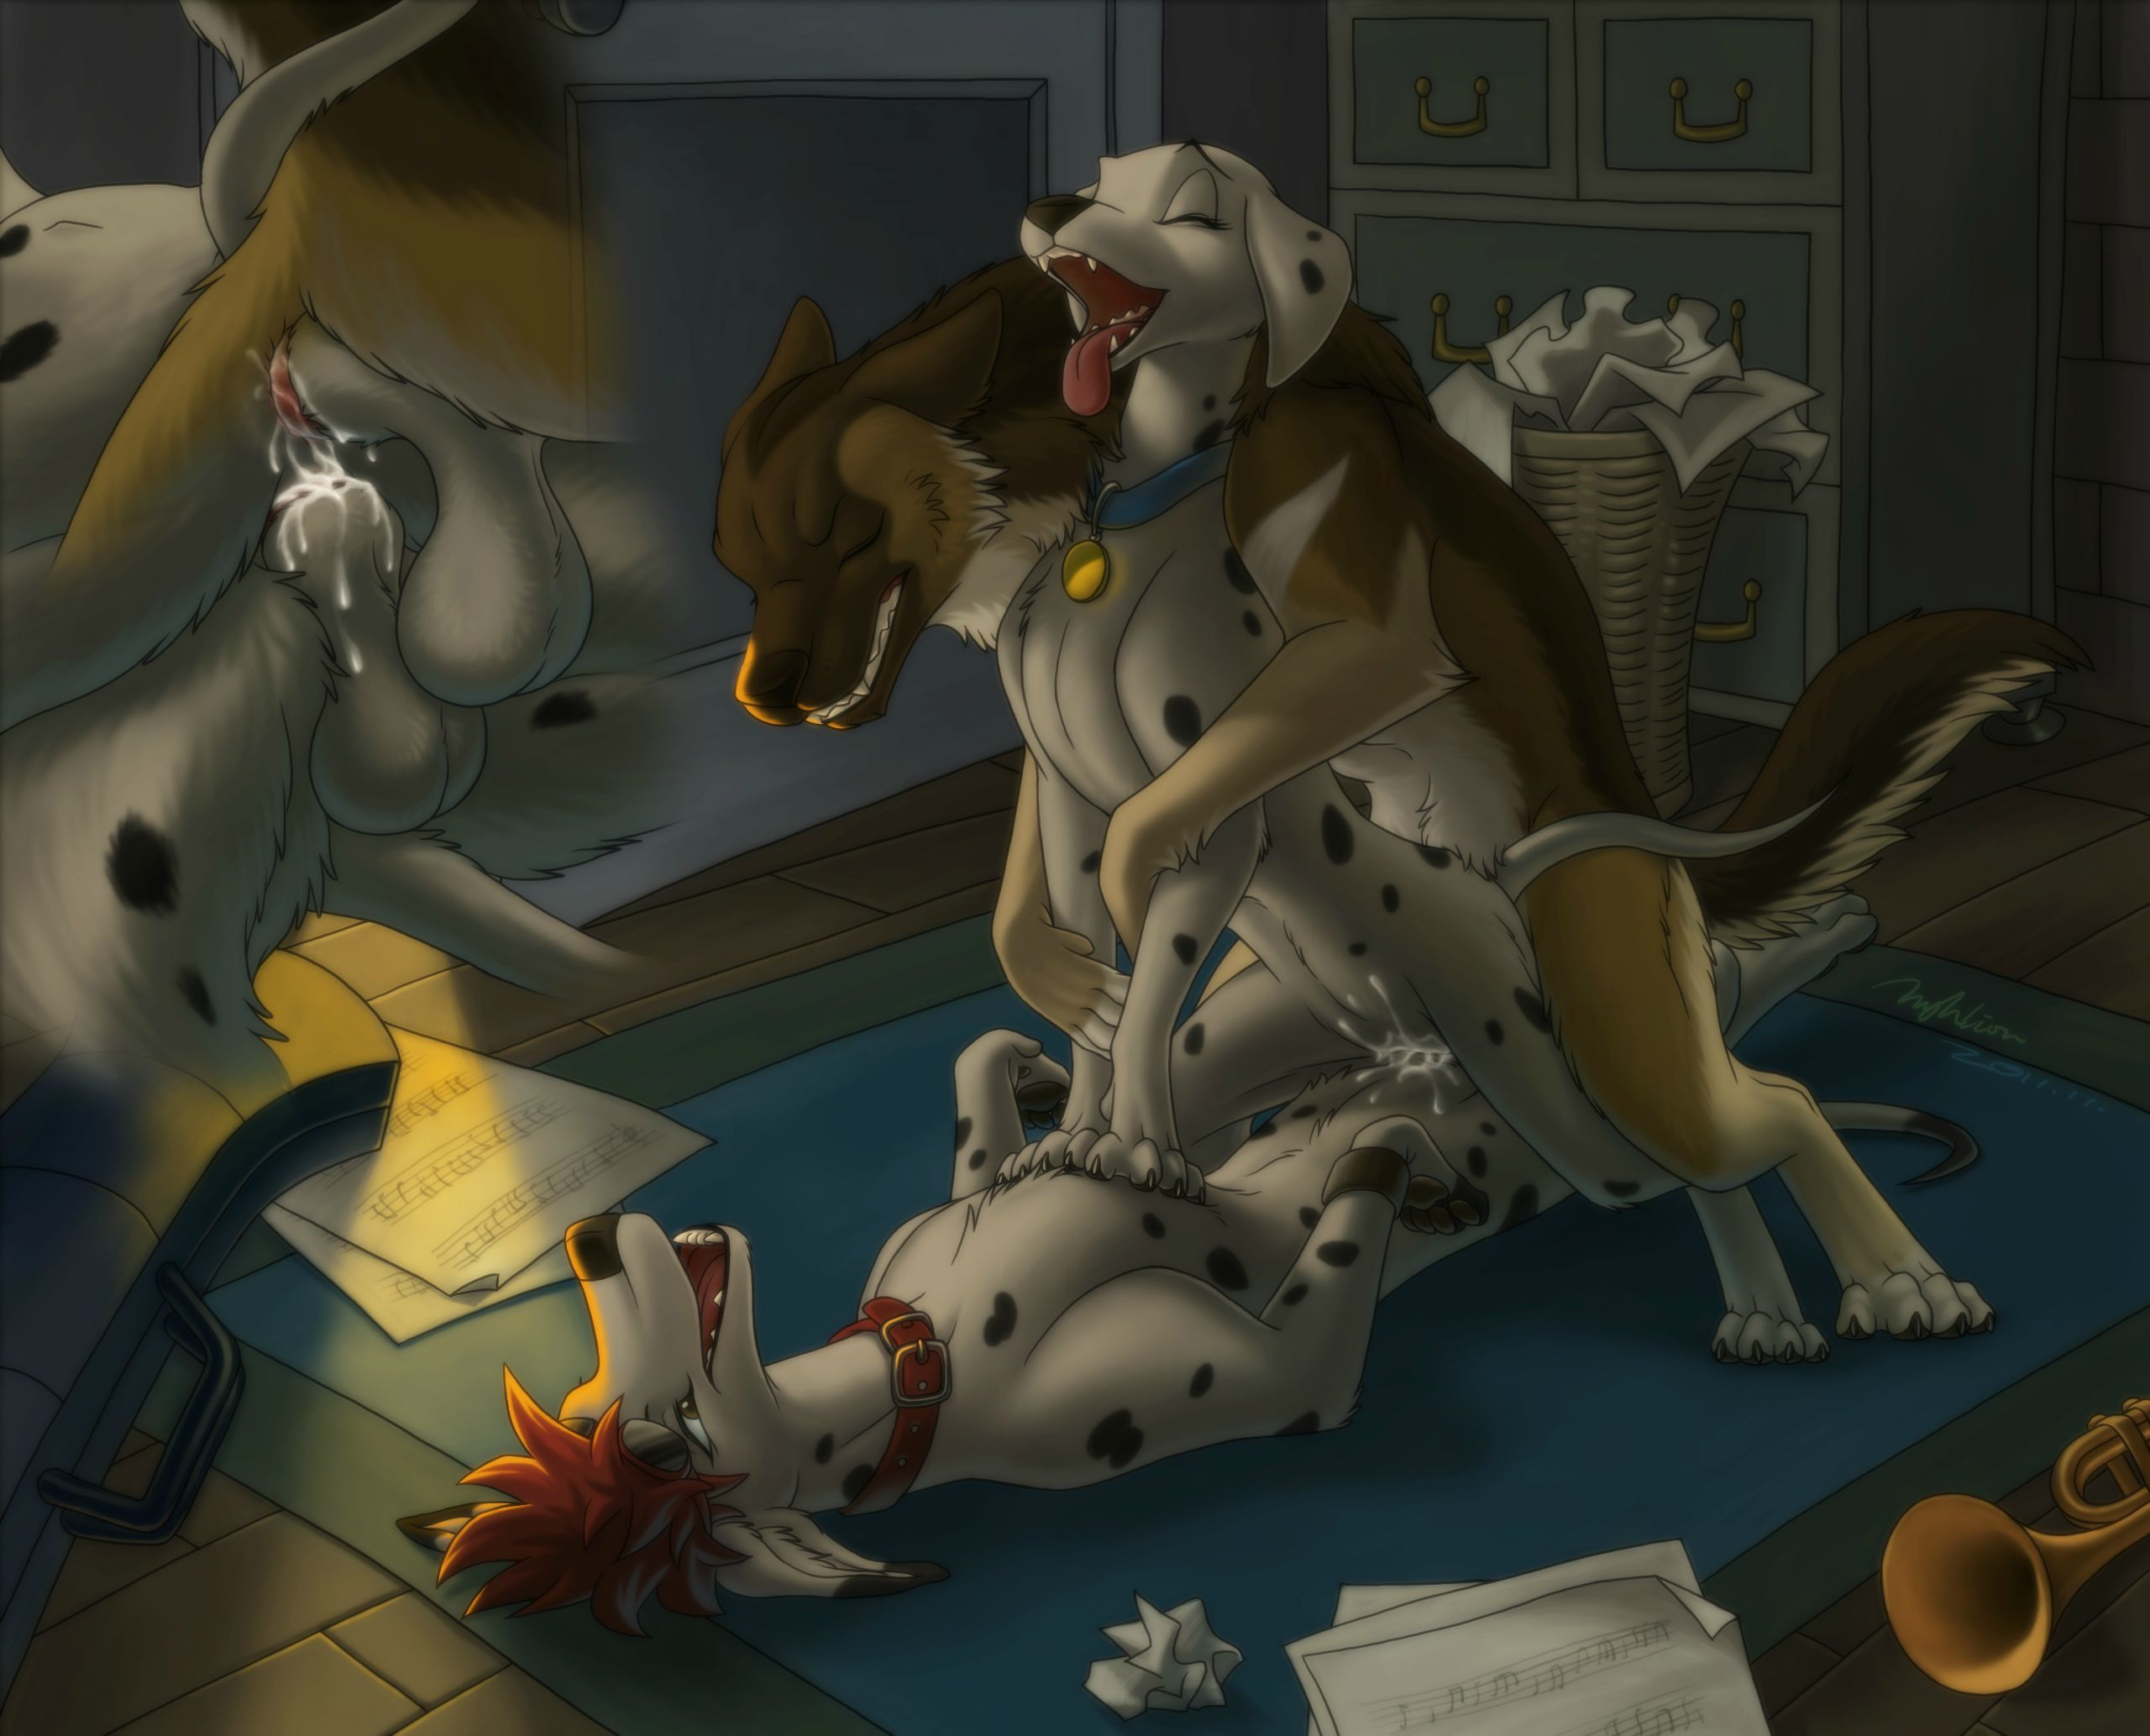
My ass and cunt looked like softballs, the two bulges throbbing up against each other as my slender rump was thoroughly and completely filled. My insides squeezed up together, until their cocks pincered my clitoris between them, sending a violent wave of pure bliss through my small body. My tiny hind paws stretched out against the blue rug, barely managing to hold me in place as Cobalt and Flint used me.
And use me they did. My convulsing passageways clenched powerful around them, and together, they erupted inside of me. Cobalt dropped his jaw and moaned, letting loose with a massive splurt! in my already well-seeded womb. Flint gritted his teeth, grunting and flagging his tail as wave after wave of his cum flooded beneath my tail. I simply took everything they could give me, shuddering and moaning and panting and drooling, my tongue hanging limply out of my mouth. My eyes rolled back in my head, and I swear I could see colors, even though my eyes were clenched shut.
Cobalt moaned, "Oh, Perdita..." as his balls pulsed and clenched, rubbing right up against Flint's own hefty sack.
My sleek stomach stretched visibly from the enormous amount of cum both dogs were pouring into my small body. Every part of me began to feel bloated and full, but still I swung my hips up and down, shuddering around their thick, swollen knots. But even that tight, wet seal wasn't enough for these two; warm, bubbling cum spilled down my rump from both holes, splattering both of their sheaths.
I yelped, "Fill me! Oh God, guys, fuck me ragged!" My howl echoed throughout the house. Thank God we're upstairs!
I could feel their cocks twitching and spurting inside of me, each of their thrusts bumping their dicks together. I had never been stuffed so full, and the sensation was incredible. I swear, I must have cum ten times. My voice was raw, my mouth dry, and my chest heaving by the time they were done with me.
Cobalt lay beneath me, while Flint and I sat above him, and all of us were panting and exhausted. I could still feel the hot gush of their seed as they squeezed a few last loads into me, our crotches already a wet mess of cum. I groaned. "Thank you, Cobalt...thank you, Flint. I really needed that."
Cobalt smiled up at me. "I'm always glad to serve a Goddess such as you."
Flint grinned. "Don't you mean 'service'?"
I gave an experimental tug, but it seemed as though their knots were getting in each other's way. Flint gave me a playful hug and said, "I think we might be here a while."
I knelt down to give Cobalt a big kiss, and said, "Believe me, I don't mind."
Twenty minutes passed before both their knots subsided enough to pull past each other. I sprawled out on the carpet, aching and sore, but absolutely content, shivering as their cum dripped out of me onto the floor. I was positively stuffed.
Cobalt said, "I love you so much, Perdie."
Flint looked around the soiled room and said, "Um...how much time do you think we have? There's a lot of...cleaning to do."
I groaned, wanting to just sleep on the floor with my two lovers, but I knew that Flint was right. If we didn't clean this room, and the steps, and the bed room before Pongo got up, I was dead meat! Groaning, I got to my feet.
That's when we heard the footsteps.
Clonk clonk clonk.
Shoes on hard wood - Roger was out of the basement! Startled, I jumped backwards right into a file cabinet. It thudded against the wall, and as if that weren't bad enough, a trumpet on the top fell down onto the floor with a crash! If Roger wasn't already on his way upstairs, he was now. The footsteps were moving fast!
"Hurry! Out the window!" I yelped, pointed the two dogs to the maid's room, and their escape hatch. Cobalt and Flint ran after me. Roger was already half-way up the stairs, to say nothing of Pongo, who was probably investigating the strange puddles in Roger and Anita's bedroom. I'd have to answer to Pongo for sure, but I didn't know what Roger would do if he found two strange dogs in the house!
Flint went straight out the window with a quick, "See you around," but Cobalt stood on the sill and bent down to me.
My love said, "I'll be back - I promise."
Smiling, I kissed him and said, "I know. Now go!"
I heard the music room door swing open, just as Cobalt leapt down the tiered wall to the backyard below. Taking a big gulp, I turned around.
Time to face the music.

