It had all happened so fast. One day my pet and I were at the park, and it seemed like the next day she was marrying this Roger fellow. Sure, more than a day had passed, but I had taken to understand that marriage was something humans agonized over for years. Anita surely had fallen for Roger. I couldn’t help but feel a little jealous as she paid less attention to me.
Pongo certainly made up for Anita’s lack of attention. The strong Dalmatian looked sporting with two, solid black ears. He had proper English manners and never ceased courting me. Another day I might have lifted my nose and shrugged off his advances, but something told me that his interest was more than prurient - he liked me.
He was polite, and kind, and honest, and we shared a small London flat with our pets and so I married him, on the same day Roger married Anita. I don’t want to sully the romance by mentioning the convenience of marrying the only dog with which you live - the wedding was quite beautiful and touching.
Quite a change from the cold streets of London. How my life would have been different had I never been picked up by the dog-catcher. Anita had found me at the shelter and rescued me from that place, fed me, loved me, taught me good manners...
I couldn’t complain about the course of my life, I suppose. I’d left a good many friends behind, dangling as a pup in the confines of that horrible man’s net. Now I had a good home, with a loving husband, and two human pets just giddy as beavers to consummate their new marriage. Pongo and I watched them with amusement as they stumbled into their bed room, throwing each others’ clothes all about, and slamming the door.
Suddenly I was alone with my new husband. I smiled awkwardly at him, but Pongo was still watching the door to the pet’s bedroom, grinning. The sounds coming through the door were positively scandalous! I whispered, “Oh dear...we probably shouldn’t be hearing this...”
“They’re just pets dear - this is what they do,” he rumbled with his deep, alluring accent.
I couldn’t get over the impropriety of our voyeurism, but what could we do? The door was certainly locked, even if we had hands to turn the knob. “Well, must they be so loud?” I asked.
Pongo laughed and said, “Here, let me show you something.”
A mysterious thing to say on one’s wedding night. The rather handsome Dalmatian dashed up the stairs of our new flat, into the small set of rooms that would soon be occupied by a maid or butler. There stood a grand window overlooking the back yard (small as it was). I followed curiously.
Pongo snuffled around the window, glancing this way and that before saying, “Aha! Look dear, it is just like Roger’s old apartment!” The Dalmatian was positively giddy.
“What’s like it?”
Pongo grinned at me, then pointed down to the window latch with a single, black claw. The window wasn’t closed! Gently, Pongo pushe the window open a creak. I started, “Careful!” Having your husband fall to his death on your wedding day was perhaps the least romantic honeymoon.
“I’m fine, dear. There is a slight terrace just outside. Come on, step to it - carefully now...” Even as my husband spoke, he was backing right out the window onto the roof. I must say I was flabbergasted. Nervous, I bounded up to the window and looked out.
Sure enough, there was plenty of room to walk. The gently sloped roof looked dangerous, but I was able to step out onto the roof with care. But suddenly, the dangerous perch we found ourselves on was the last thing on my mind. The sky was aflame in beautiful yellows, fading into streaks of red marred only by soft clouds, before deepening into a dark purple. A single star shone brightly down from what seemed to be directly above the two of us.
“Oh, Pongo...”
“I know, isn’t it just perfect? Whenever we need to get away while our pets are busy, we can just use this window!”
I blinked. The window? I said, “It’s so beautiful...”
Now it was Pongo’s turn to be surprised. A moment later he realized what I meant. “Oh, the sunset. Yes,” he said lamely. A few seconds later, he turned to her with a bright, open look and said, “Not as beautiful as you, my dear.”
I had to give him credit for salvaging the mood. I smiled and leaned into his warm body, tucking my head under his chin. Together, we watched the sunset, as the yellows faded away, then the reds. As if in an epic game of tug-of-war, the blues and purple grew and forced their way in, until none of the bright colors remained, and the entire sky was black, lit by faintly visible white dots. The cosmic battle was a handy distraction from the nerves building in my slender stomach.
As the last light of the sun finally faded from view, I stood up, meeting Pongo’s gaze. In the heat of the moment, I said, “I love you,” breathlessly. I knew Pongo was about to repeat the same thing to me, but I cut off his words by turning away from him and lifting my tail.
* * * * *
My husband seemed to have enjoyed me a great deal. After I lifted my tail, Pongo leapt onto my back. I was about to say something encouraging, when I suddenly yipped! As soon as he had mounted, he rammed himself inside of me.
He grunted and thrust, probably taking my whimpers for pleasure. It was my first time, and I expect, probably his. Was it supposed to feel good? Perhaps if I were in heat. I felt an odd detachment as he humped me perfunctorily, almost like a machine. Back and forth he went, probably a dozen times - and then...
Splurt! Just as I was starting to adjust to his heavy weight on my back, he groaned deeply and began to fill me up. He did not even oblige me the courtesy of a few more humps before the Dalmatian turned around, leaping off my back and leaving me cold on the roof in the middle of the night. Only our rumps touched, but he continued to moan, and his balls pressed up against my tail, twitching.
Pongo was grinning like an idiot. I did my best to smile for him, as he finally pulled out of me. “Oh, that was wonderful, my dear,” he said properly, curling his body up to lick his softening cock.
I tried to form words, uncertainly how I should respond. “I...uh...”
Pongo smiled, and said, “Speechless?” Affectionately, the black-eared Dalmatian licked my nose, his breath reeking of his own semen. He didn’t notice my grimace before he shivered, and said, “It’s too cold up here. You should clean yourself off and come inside.”
Before he left me, he paused, smiled and said, “I love you, Perdie.”
“I love you too, Pongo,” I replied, though at the moment, the words rang hollow.
With that, he was gone, back inside the warm house.
I sat there stunned for several minutes, alone on the roof. Finally, I curled up and found his sticky, white cum leaking out of me. Tentatively, I tasted it. At least his flavor wasn’t too bad. I lapped it all up, my own tongue providing a tingling affection that had seemed entirely absent from my husband’s lovemaking. Was it my fault? Perhaps I could only feel pleasure while in heat. Would it get better over time, as I grew accustomed?
Clean and confused, I contemplated trying to scale down the house and go for a walk by myself. There was a high wall that tapered slowly to the ground that I could easily reach from the roof. Sighing, I stepped carefully back into the house.
* * * * *
Things didn’t improve. Pongo would proposition me every other day or sooner, with the same results each time. The only conclusion I could draw is that female dogs couldn’t enjoy sex out of season. At least...I silently hoped things would change when I came into heat!
Roger and Anita were so busy with each other they hardly had time for either of us, so my home life was filled with Pongo (and filled by Pongo). As it was, the only points of true enjoyment in my life were our daily walks to the park. Pongo and I would walk side-by-side in front of our owners, gathering complements from passers-by. We certainly made a handsome couple.
Pongo was a true gentleman, and I could only find one fault. Outside of the bedroom, my husband was attentive, smart, and affectionate. When we spoke, we laughed and nuzzled each other. He made me feel very special...until the night came. I couldn’t say anything about it...I couldn’t! How petty would I sound, complaining when Pongo was so perfect in every other area? Besides, I couldn’t know for certain that I wasn’t just placing unreasonably high expectations on the poor boy. Perhaps his methods were just like everyone else’s.
And then everything changed.
We were walking through the park as normal, in mid-afternoon, when one of the dogs we passed (and there were many) made me do a double-take. He was a Dalmatian like me, every bit as strong as Pongo, with a red, leather collar and peculiar shaded glassed sitting on his head. Despite his collar, he was not on a lead - his owner nowhere to be seen. But what really sparked my memory was his tuft of reddish hair at the top of his forehead. I had seen this dog before!
I scanned him quickly, hoping that Pongo wouldn’t see any impropriety in the action. Sure enough, the tips of his ears and tail were black, as well as the digits of his back-left and front-right paws. It couldn’t be a coincidence. It was Cobalt!
But we had soon walked past each other. I craned my neck to follow him with my eyes, and I saw that he did the same for me. Had he recognized me, as well? We hadn’t seen each other since we were pups, living on the streets. I had to speak with him, but doing so in front of Pongo would have been a grave transgression. Certainly I could not brazenly call out to another male he was unacquainted with - it wouldn’t be proper.
I had to think of something quickly, while I still had Cobalt’s gaze. Of course! I jumped over into the grass and buckled my hind legs. Instantly, Pongo and our pets looked away to give me privacy. But I was faking it, anyway. I glanced in Cobalt’s direction, but he too, was looking away!
I had to risk a bark in his direction. I couldn’t change my position, or Pongo and the pets might notice in their peripheral vision. Bark! Thankfully, the red-haired Dalmatian’s ears perked up, and he turned to look at me again. I immediately beckoned him with my right paw to come closer.
Bewildered though he was, he bounded towards me, slowing his steps as I put a paw vertically to my muzzle to shush him, glancing meaningfully at my polite companions. Generally, a tug on the leash would signal when Roger and Anita could continue the walk, but they would become curious if I took much longer. Pongo was facing straight away, allowing Cobalt to walk right up to me.
“Cobalt!” I whispered, when he neared.
He whispered back, his head tilted sideways, “It really is you!”
“My name is Perdita now, but we can’t talk like this in front of my huband.”
Cobalt’s ears suddenly drooped.
I didn’t want to disappoint him. “Can you meet here in the park, tonight?” I said, thinking of the upstairs window.
“Of course,” he said, about to say something else.
I interrupted, saying, “Great! Now go - I’ll see you then!”
He swivelled and padded away, and just in time. I lifted my haunches and looked innocently up at Roger, who had looked down at me, his big eyebrows furrowed. He looked around the ground, but found no evidence. Shaking his head in confusion, he simply walked on, and I rejoined my place next to Pongo, who was none-the-wiser.
* * * * *
I took great care to make sure Pongo was asleep before attempting my little adventure. My husband had, of course, made advances on me, but I told him I had a headache. As soon as his chest was heaving up and down in a regular pattern, I crept out quietly.
My heart was beating in my chest as I climbed the stairs to Roger’s messy music room. It’s not that I was doing anything wrong! Certainly I was only meeting a friend I had thought lost to me, being careful not to allow anyone a thought of impropriety on my part. Still, sneaking off into the night felt wrong.
Sure enough, the window was open a crack, and I was able to slink out onto the roof. I stayed low to the roof as I picked my way over to the tall wall. I was amazed at how easy it would be to travel up and down from the window. I jumped down only a foot onto the narrow wall, walking along to the next drop, which was two feet. Then the wall turned and dropped another two feet, and there I was, standing in the streets of London!
The park was two blocks away, but I wore a bright, blue collar that would protect me should I once again cross paths with the dog-catcher. Walking alone in the night still brought back many memories - some good, some bad. All of these thoughts set me in the right mood to talk to Cobalt.
He was waiting right at the entrance gates to the park, and his eyes widened when he saw me.
“You really came!” He announced.
“I hope I’m not too late. My husband fell only slowly to sleep.”
Cobalt’s whiskers drooped and he said, “Ah, yes. Want to walk?”
“I’d love to,” I smiled.
The park was all but deserted at this hour. Stray dogs generally avoided the place for its lack of available food, and the patterned brick path shone neatly by the three-quarters-moon. Certainly it was beautiful, but I had other things on my mind.
“What have you been doing, all these years?” I asked, curiously, hoping my directness wouldn’t put the other Dalmatian off.
He simply smiled and said, “This and that. Really, every day on the streets brings something new.”
I blinked. “I thought you might have found a human pet, what with your collar.”
Cobalt grinned. “I wear it because it gives the dog-catcher pause. And because it looks so dashing,” he added with a wink.
“That it does,” I agreed. “What about your glasses?”
He looked upward, as if he could see the red sunglasses sitting on top of his head. “It gets bright out,” he shrugged. Then he looked over at me and said, “How’d you...uh, meet your husband?”
My eyebrows raised in surprise. His directness was something I hadn’t heard since I was a pup, and his tone seemed almost to quaver as he spoke. “We met in this park, actually, as did our pets. Roger and Anita really hit it off, and they married just a month ago. Pongo and I followed suit.”
“Where do you live?” Cobalt asked.
I blinked. I describe our nice little flat, but when that left the red-haired Dalmatian visibly unsatisfied, I managed to stutter out the address. He was an old friend...why shouldn’t he know my address?
Cobalt sighed, sitting in the grass beside the path. He looked unashamedly right into my eyes and said, “I’m really happy for you,” with a strained voice. “Pongo is a really lucky guy. I’m envious of both of you.”
“Envious of me? I’m envious of you. Married life is okay, and I know living on the street has its ups and downs. But you have free reign over the entire city. You can live an exciting life of fun and danger, until you find the girl of your dreams from among thousands of possibilities on the street. Pongo was...” I trailed off, realizing I was about to admit that my husband was simply the first and most convenient dog to marry.
Thankfully, Cobalt didn’t seem to notice. He cut me off, saying in a rush of emotion, “But I don’t want any of those dogs.”
He looked genuinely troubled. I said, “How can you know? Surely you haven’t met all the strays in London!”
He spoke softly. “The girl I want isn’t on the streets.”
Oh. He had a particular girl in mind. I felt a twinge of jealously that I quickly suppressed - I wanted Cobalt to be happy. “Who is she?” I asked, “Does she...not return your affection?”
Cobalt looked away, saying quietly, “I don’t know if she does - I haven’t the nerve to ask. She lives in a flat...like you...and I doubt she’d really go for a stray like me.”
“Well, if she holds that against you, she doesn’t deserve you. I know that wouldn’t bother me,” I said, encouragingly. “You should ask her...certainly there is nothing to lose.”
Cobalt looked me in the eyes and said, “Well, the thing is...she’s married.”
Oh. Well that certainly changes things, I thought to myself. Even asking her would impugn her character! He was definitely in a tough spot. Wait a minute...girl, in a flat, married...?
“Cobalt?” I asked, eyes searching his.
Cobalt gulped, a red blush rising to his cheeks. “I’ve...always wanted you, since when we were pups, Perdie.”
Suddenly the entire evening was wrong. I’d secreted away to meet a friend, but now I knew that Cobalt had feelings for me. The shock made my body shiver. Even being here, behind Pongo’s back, was an indiscretion! But I couldn’t leave Cobalt like this. He’d been one of my closest friends before my capture. My best friend.
I had to admit the truth. “I had feelings for you, too, Cobalt. If it weren’t for the dog-catcher...”
Cobalt’s ears perked up, watching me curiously. I continued, “I’d never have met Pongo. He’s great, and nice...but I feel differently about him than I felt about you.”
“Felt?” Cobalt tried, tentatively.
I paused. “Feel,” I admitted, to him and to myself.
Unbidden, he stepped toward me, and licked my nose. I should have been outraged. Pongo would never stand for another dog to take such a liberty with me. But his soft tongue on my nose sent a fire through my body unlike anything Pongo had managed. Without warning, my tail was wagging, and I licked his nose right back.
Our noses almost touched, his breath filling my nostrils and my breath filling his. Electricity filled my body; my heart felt like it was trying to break through my rib cage. I could tell I was having a similar effect on Cobalt.
Still, the red-haired Dalmatian took a step back from me and said, “I wish things had worked out...differently. I would have liked to explore you... Of course, what Pongo doesn’t know can’t hurt him...?” He chuckled lamely.
Cobalt looked down at me, his eyes meeting mine. He was joking, I knew that. He knew as well as I did that I couldn’t go behind my husband’s back with another dog, no matter how much I wanted to. But there was an invitation behind his gaze that belied the truth of his joke. The offer was genuine, as long as I agreed to it. But his whiskers drooped, knowing that I would never accept.
And I wouldn’t have, except that the mere mention of him exploring me sent a shiver down my entire body, finally stopping with a quiver beneath my tail. I clenched my vulva, feeling more aroused than I had in a dozen matings with my husband. Heat rushed to my face as I contemplated Cobalt, eyeing my disconsolate friend.
“You’re right,” I said. Cobalt froze, cocking his head to the side as if he hadn’t heard me clearly. I stepped forward, tucking my head under his and reaching my right paw around the back of his neck in a tight embrace. He was stiff and confused, still unable to comprehend, so I leaned back to look him straight in the eyes again. I didn’t want to leave an inkling of doubt in Cobalt’s mind. I tilted my head and licked his lips, saying huskily, “Pongo isn’t here. You are.”
Cobalt’s jaw dropped, and I took the opportunity to slide my tongue into his muzzle with a wet schlurp. All the tension in his body disappeared at once. He wrapped his forepaws around me, pulling me closer as he explored my tongue with his. I felt awkward kissing him so forcefully, but the heat of the moment brought out a forwardness in me that must have laid dormant for years. I ran my paw down the fur on his back, slurping and licking the inside of his mouth. My body was on fire. Just touching Cobalt made my loins clench and burn with more feeling than Pongo’s most eager thrusts.
“Oh, Perdie...” Cobalt stammered. He looked at me with such awe and love; I felt special. No, I was special to him.
I’d like to say all thoughts of Pongo faded from my mind as my old friend kissed me again. I opened my mouth, allowing him to explore eagerly with his tongue. But as my paw crept lower along Cobalt’s back, I couldn’t stop thinking about how Pongo had never made me feel this way. I felt a rush, knowing that my husband was sleeping ignorantly at the flat, completely unaware that I was consorting with a dog he’d only seen once in passing. I rubbed up against Cobalt, but I wasn’t thinking about Pongo as my paw slid down Cobalt’s flank, sneaking beneath the red-haired Dalmatian until I’d cupped his growing, red, erection.
Cobalt gasped, breaking our kiss to look down at me. He raised an eyebrow until it was almost touching his sunglasses, and said, “Are you sure?”
I brushed my paw pad along his length, never wavering from our shared gaze, and said, “Just lie down.”
He was panting, his tongue dangling out the front of his mouth, but he did as I asked. Rolling onto his back, he looked up and me and shivered, his hind legs splayed below me. I didn’t need words. My look told him everything he needed to know. My eyes widened as I scanned his body, the soft, white fur of his stomach giving way to shorter, sparser fur. There, between his legs, stood his firm, glistening organ, easily as large as Pongo, with still a little more room for growth. I grinned, aware that I was the cause of his throbbing erection. Just beneath that, his white-furred orbs dangled taut against his tail.
Cobalt stared up at me, shivering, his tongue still lolling from his muzzle. His chest heaved as he panted, anxiously waiting as I knelt before him. I placed one paw gently on his right hind leg, reaching my other paw around to grab his waist. I was now mere inches from his stiff erection, which was already well clear of his soft, white sheath.
“Is this real?” Cobalt asked.
I looked into his red-gold eyes, and said simply, “Yes.” With that, I lowered my tongue to the very base of his cock, and slid all the way up his length until I tickled his tip.
He grunted, involuntarily thrusting his hips slightly at my touch. He opened his mouth to speak, but I gave him no reprieve, taking another long lick. His words dissolved into a heavy moan, and he made no more effort to speak. His tail was wagging beneath me as I licked, cupping my flexible tongue around his throbbing cock. His wet cock smelled and tastes so exotic. Just the mere sensation of touching my tongue to his most sensitive organ sent waves of pleasure through my own body. I was more aroused simply inhaling Cobalt’s scent than I had ever been before.
My old friend groaned as I took a detour to caress his balls, though I wasn’t about to stop there! I wrapped my tongue around his tapered, red tip, pulling his erection up and into my muzzle. My licks had made him moan, but now, with his cock buried in my wet muzzle, I watched his eyes roll back into his head. He couldn’t stop thrusting now, pushing his hips up toward my bobbing muzzle. I wrapped my lips around him now, suckling him gently. His thrusts pushed himself deeper into my throat, but I took him eagerly. Extending my tongue, his next push hilted into my muzzle. My dangling tongue tickled his quivering balls.
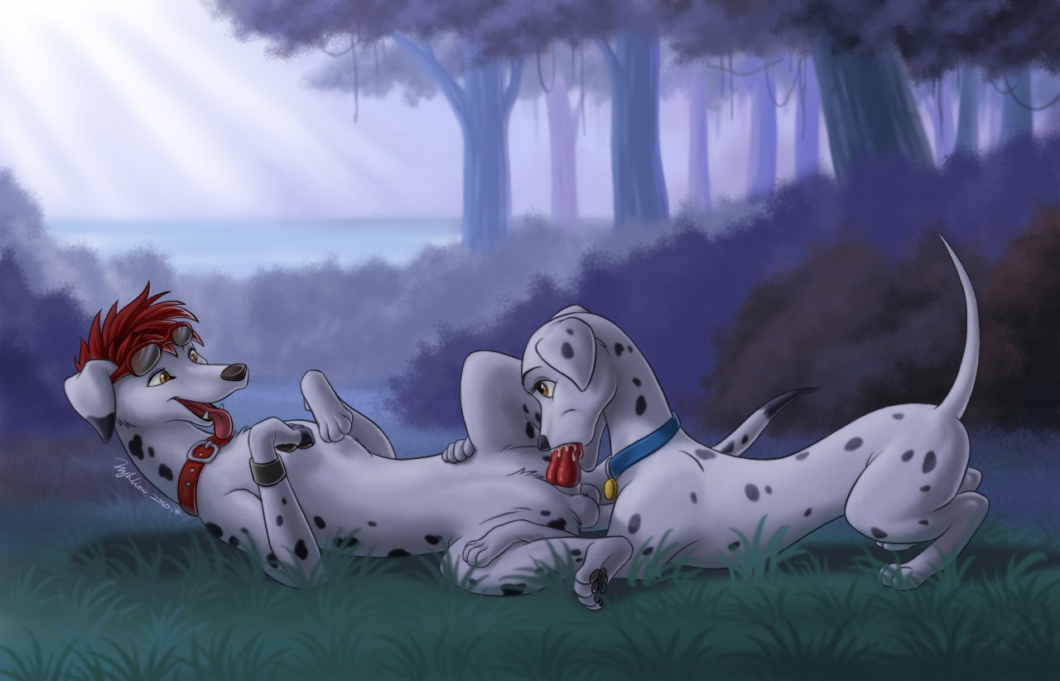
“Ohhhhhhhh...” he groaned again, and I tasted something wet and salty at the back of my throat. I couldn’t look away, my tail wagging as I listened to his pleased moans and whimpers. I was causing that! I sucked harder and was rewarded with a deep, guttural moan.
His knot was swelling at the base of his cock, and I tickled it with the flexible tip of my tongue. I felt another splash of fluid in my mouth, and then another. I knew he was close. Unbidden, I raised my haunches, imaging that his jerking cock was buried beneath my tail, rather than in my mouth. I rocked my hips, clenching my vulva around his imagined cock. Each time he shoved his hips upward, I imagined a forceful thrust between my hindlegs. My entire body was quivering as I humped the air, suckling hard on Cobalt’s spasming cock.
Finally, he could hold back no longer, gritting his teeth. A flood of semen splattered against the back of my throat, and I swallowed as quickly as I could. A large portion dribbled down the sides of my mouth and down my tongue, leaking out of my black lips and coating his slick cock. I hardly cared, because at that precise moment, I was imagining him splattering between my legs. I clenched down at the crisp, night air, flailing my hips wildly as a feeling hit me like I had never felt before! I was no longer in control of my body, heat and pleasure emanating in waves throughout me. I gulped and swallowed everything I could, muffling my high-pitched whine. Sweat caked my paw-pads, and I breathed deep through my nose as my body shuddered. I felt so good my tail forgot to bother wagging! Was this what sex was supposed to feel like? Pongo had never made me feel this way, yet the mere thought of Cobalt sent me into quivering, hot spasms.
Soon, Cobalt lay on his back, panting for breath. I delicately licked up his coated erection, swallowing even more of his illicit seed into my stomach. When I returned to Pongo, he’d have no idea of the infidelity swimming inside of me.
“Wow,” he said.
I smiled down at him, taking another gentle lick of his softening cock. “Did you like that?” I knew the answer, but he still nodded emphatically.
“Let me do something for you,” he begged. He started to get up.
I was amazed to see the growing light of the sun. Had that much time passed? I needed to return home before Pongo or the others awoke! In the heat of the moment, I hadn’t realized how much time was passing - certainly longer than Pongo had ever lasted. I grinned, saying, “You’ve already done more than you know, for me.” I turned away from Cobalt, and took a step home.
“Wait, where are you going?” Cobalt asked, confused.
“I have to get home before the sun rises.”
“Will I see you again?” he asked.
I looked over my shoulder at him, lifting my long, white tail. Warm light from the sunrise made the park glow. I smiled back at him, licking my lips as I watched his gaze fall beneath my tail. My tight vulva was dripping softly with my arousal. If time had not been an issue, I don’t think I would have had the willpower to refuse his advances. His jaw dropped as he gazed upon my wet rump.
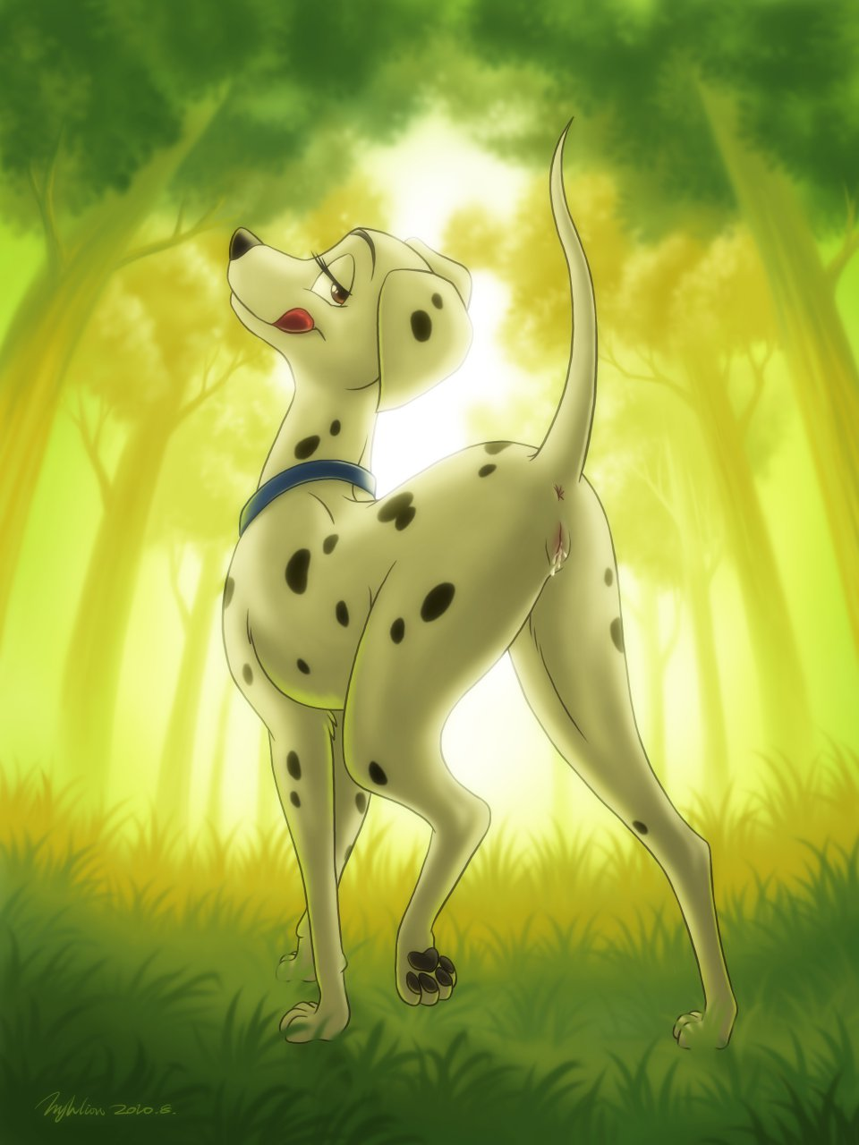
“You know where I live. If I leave a stone in front of the gate, that means I’m going to sneak out to the park that night. To find you.”

