Cobalt came to my house every day, just as the sunset was ending. I peered through the window with my head down, watching, a twinge in my heart whenever I saw his ears droop. It had been a week, and each time the red-haired Dalmatian stopped by, no stone stood conspicuously at the gate.
A rock would have signaled my intent to sneak once more to the park to meet Cobalt clandestinely. Part of me burned to meet him again, but when I had returned from our first indiscretion, my mind was at war with itself. In the heat of the glorious moment I shared with my old friend, I couldn’t have cared less about Pongo, or propriety. But in the morning, when I had kissed my rightful husband awake, I kept thinking about Cobalt’s seed, swimming secretly in my stomach.
I was ashamed. I had never intended things to go so far, and I could find no excuse for my unconscionable behavior. Meeting with Cobalt was entirely out of the question; my place was with my husband. If only I hadn’t told Cobalt where I lived!
Every time I snuck a glance out the window to see my gorgeous suitor, his black-tipped ears dropping in sincere disappointment, it took all of my willpower not to go to him immediately, to reassure him. Today was no exception. He walked away from the gate with stiff legs, more dejected than ever.
“What are you looking at?” a voice came from behind.
I started violently, fur ruffled, a soft cry escaping my lips. My heart raced: had Pongo seen Cobalt? I turned, blood rushing to my face.
Pongo simply cocked his head in confusion. “Perdie?”
I took a deep breath. “Oh! You startled me.”
He smiled gently. “Come, it’s time for bed.”
I nodded slowly, having regained my composure. As I followed quietly behind my husband, he turned to ask, “Are you all right? You’ve seemed distant this past week.”
I gulped, but thankfully he couldn’t tell. I needed a believable excuse, without directly lying to him. I had wronged Pongo enough without deliberately telling untruths! “I think,” I started, my mind racing, “that I may be beginning to go into heat.”
Pongo raised his ears, his eyes widening. I was speaking truly enough...judging by the calendar I was due any day. Pongo dropped his jaw in a ridiculous grin. We reached our room, and he asked the same question he asked every night: “Do you think we might...?”
I had refused every night since my infidelity, with one excuse or another (usually tiredness). I couldn’t keep turning the poor boy down without rousing his suspicions or insulting his prowess. I breathed deep, and nodded. I licked his cheek, stepping in front of Pongo while glancing over my shoulder. Delight covered his face as I raised my tail for him.
“Oh, Perdita,” he said, stepping behind me. He afforded me the barest sniff beneath the tail before I felt his weight upon my back. His firm paws wrapped around my slender hips, and my hind legs buckled to support him. He’d emerged just from his sheath, rocking his hips and slathering the wet, red tip against my tender mound.
I tensed myself for his imminent entry. Doing my duty as a wife had become increasingly tedious as time went on, and I had no reason to expect anything different after a week of delaying. I gritted my teeth; at least the imposition wouldn’t last long.
As I felt his perfunctory prods, however, something strange happened. Unbidden, and to my great shame, Cobalt entered my mind. Suddenly, rather than standing impatiently in our room, I was standing in the dark of the park, my red-haired lover gripping my hips. I whimpered softly, and spread my legs for him.
Easily enough I imagined it was Cobalt claiming me - my heart pounded, my tail thrust aside. Whether Pongo noticed anything amiss, I could not know, but the next moment he had plunged himself into me.
The physical sensation was surely familiar to me, but for the first time my moans came from a sense of pleasure. In my head, my old friend was the one on my back, and my soft mound stretched and folded eagerly around him. I squeezed, gently massaging him as he rocked back and forth, wetly gliding in and out of me. I caught myself - I had been seconds away from calling out, “Cobalt!”
Grunting, I gritted my teeth and pressed my body back against him, rocking my hips madly. I could already feel his giant knot swelling inside of me, making my vulva bulge, but the heat building in my loins was nearly ready for him. I moaned with each thrust, louder, just moments from a howling release, when -
Splurt! I whimpered, feeling my husband spend himself inside of me. He had grown even more efficient in the week since our marriage, now able to finish himself in 5 or 6 solid thrusts. In desperation, I tried to picture Cobalt, waggling my hips against him, with some success. But before I could even half bring myself to climax, Pongo lifted himself off my back, leaving me alone and cold, his tail colliding with mine, stiff and rigid.
Pongo’s grin was even wider, feeling himself quite accomplished, I expect, at making me whimper in pleasure. While I had begun to enjoy myself for the first time, I was all too aware that none of the responsibility was Pongo’s. It took every effort to hide my disappointment. And so, when three days had passed, and my heat finally came upon me, I stood at a crossroads.
Pongo’s interest in me had doubled thanks to my scent, but I continued to delay, saying, “No, I do not feel well at all,” or “I will be ready in a day or two.” Could I truly offer my first heat to yet another emotionless, mechanical copulation? I was certain now that Pongo was the problem, and not some quirk of biology. But surely I could not seek anyone else to quell the fire growing between my legs. Betrayal aside, such an encounter would as likely as not put with me with pups.
I saw Cobalt again, looking disappointedly at the stone-less gate. Something stirred within me; desire, yes, but also regret. I couldn’t keep stringing him along. My place was with Pongo. Unfortunately, the only way I could bring the sad message to my old friend was to meet him again, at night. Quietly, I snuck out to the gate, and rolled over a large rock I had placed aside for just this purpose, propping it up against the gate.
That evening, I watched the red-haired Dalmatian literally leap for joy. I certainly felt ill to be delivering him such unwelcome news after so long a delay. I would have to never see my old friend again, and settle for life with my husband. I dreaded the coming night.
I waited for Pongo to sleep. Instead, as Roger and Anita retired for the night, my husband came to me, his whiskers drooping. He said, “Are you...ready?”
I was a week into my heat, already several days past when I had promised I would oblige my husband. My first instinct was to delay once more, but I had already made my decision. I was Pongo’s. I’d vowed once - and now again - to spend my life with him, and to bear his puppies. Why hold back now?
But when I tried to will myself to kindly lift my tail for him, I couldn’t. I itched and burned between my legs, but instead, I said, “One more day, I promise.”
Pongo nodded slowly, his tail down. With a heavy plop, he flopped onto the ground, watching me with sad eyes. Why hadn’t I just agreed?
Not wanting to waste any time, as soon as my husband finally slept, I crept out of the room on my belly, sneaking upstairs through the music room, out the window, and down the wall to the street. The unpleasant task ahead of me wouldn’t grow any more pleasant with time!
The moon was full, casting a glowing, blue light upon the park, and illuminating long, dark shadows. I took a deep breath, entering the park.
“Hi!”
I jumped, every fur on my body standing at end. Gasping for breath, I looked over to see Cobalt, having hidden behind the gate. He laughed at my reaction, but he said, “Sorry,” with a sheepish grin.
“Oof,” I began, and couldn’t help but chuckle softly. “That’s not how to greet a lady!”
His tail quivering, he said, “You finally came!”
Little did he know how ineffective Pongo was at arousing that reaction from me... “I’m sorry for the delay, but I -”
He cut me off. “Let’s walk,” his boundless energy making him bounce in place.
I nodded my head slowly, and we took off down the cobble path, padding gently into the dark, empty park. I had been about to tell him the bad news, but now I found bringing it up impossible. My tongue would simply not form the words.
“You’re even more beautiful than ever, Perdie.”
I sighed, though the compliment made my heart flutter. “Thank you, but I -”
He interrupted again, “I’ve been really looking forward to seeing you again.”
Could he be suspecting what I was trying to say? There was an undertone of urgency to his voice. “I’m glad to see you, too, Cobalt. It’s a wonderful night.”
He cocked his head, smiling softly. “Isn’t it? Look, the fountain is even still going.” Just ahead on the path, the stone fountain was running, eight jets of water rotating, rising, and falling, each droplet reflecting silver in the moonlight. I was breathless.
Cobalt leaned next to me, his slowly filling chest brushing against mine. I stiffened. His touch sent flames through my eager body, but the gesture could not be mistaken. If Pongo had seen, he’d be furious.
The red-haired Dalmatian couldn’t help but feel my reluctance. He gulped, looking at me nervously. I tried a third time, “I’ve really missed you, but I -”
I waited for him to break in, but he didn’t. “But I can’t see you anymore.”
All the energy drained from his body, his ears laid back, tail drooping between his legs. “I - I know...” he stammered. “I just hoped...”
I sighed.
Cobalt said, “It’s okay, I understand. I won’t bother you again - just, can I have one, small favor, before you go?”
His expression was so down-trodden, how could I refuse. “Anything,” I said, foolishly, trying to clamp my mouth shut at the last second. Too late! What if he asked for a repeat of last time’s indiscretion?
His eyes brightened, and he said, “Then, let me return the favor...from last time.”
I blinked, heat rushing to my face. His request wasn’t as bad as I’d thought; all he wanted to do was please me. Still...I couldn’t! I dropped my jaw and stammered, “No, no, I couldn’t allow that...”
“But, you promised!” he protested, even as I took a step back from him.
“I can’t! I - I’m in heat!”
He cocked his head. “I know...but it’s not like I’m going to -”
“Cobalt!” I cried, turning away from him, toward the park exit. He had a point...it seemed silly to be squeamish when just two weeks ago I had wrapped my muzzle around his cock. I tensed my legs to leave, but something stopped me.
That was all the delay Cobalt needed, and suddenly I felt something warm and wet beneath my tail. I yipped, and yelped again, “Cobalt! What are you doing!?” I looked over my shoulder to see my old friend snuffling beneath my tail, his agile tongue teasing at my mound. I was about to shout again, but my cry of “Cobalt!” melted into a low, husky moan.
I tried to resist, but the feel of his tongue slathering my most sensitive spot made me arch my back, spread my legs, and lift my tail. Cobalt wasted no time taking advantage of this greater access, pushing forward and plunging his tongue deep between my swollen lips. The only sound I could form was a long, plaintive whine.
His firm, steady licks violated me, but the sensation was anything but unpleasant. My husband had never even considered doing what Cobalt was doing. His wet, red organ filled my aching entrance, his hot breath washing over me. Whimpering, I couldn’t stop myself: I rocked my hips, pushing hard against his muzzle.
He only lapped harder at this evidence of my pleasure. What could I do? His tongue felt unlike anything I had ever experienced, sending shockwaves of pleasure through my slender body. Every time I tried to protest, my words faded into moans. A low dread filled my gut... What if he ignored my wishes and didn’t stop with simply eager licks? I was deep in heat...could I really trust him? A low howl growing in my throat, my eyes popped open as a new thought popped into my head: Could I trust myself?
“S-stop!” I managed to plead, my fear finally lending voice to my thoughts. Either he ignored me, or he didn’t hear, because he kept his tongue buried inside my hot, clenching passageway. I moaned as the tip of his tongue tickled that incredible spot just inside of me, thrusting frantically in desperation.
I felt a warmth building inside of me that I’d only felt once before - the last time I’d been with Cobalt. The sheer joy of pleasuring the red-haired Dalmatian had brought me to fits of ecstasy, but what I felt now was an order of magnitude better. Slurp! Slurp! Slurp! His steady, relentless licks spread my tender lips lewdly apart.
I panted loudly, my tongue dangling uselessly from my mouth. “Oh...Cobalt!” I cried, bucking my hips faster and faster, a dark red blush on my cheeks. The park was deserted at midnight, but we was standing out in the middle of the path, plain to see. Headlights from the few cars out this late illuminated the road to our left, and I couldn’t help but wonder if any of the drivers glanced into the park to see two, startling white-and-black figures, caught in a most indecorous act. Wait...had that car stopped by the side of the road to watch?
The wet smacks continued unabated as Cobalt mercilessly guzzled at my soft, trembling sex. All my reluctance had gone by this point, and Cobalt stepped forward. I felt one of his paws at the small of my back, and I gasped, certain that he would mount me, then and there.
Instead, he tucked his arm around my right hind leg, and pulled me back towards him. I yelped, my eyes flew open as I felt the very end of Cobalt’s mouth compress my swollen lips, pushing harder and harder until, to my disbelief, his nose wedged inside of me. My puffy sex ached and strained apart! I yipped again, helpless as my burning loins clenched eagerly around his muzzle. When he dropped his jaw - still inside of me - and shoved his tongue deeper than anything I’d ever felt, I moaned and writhed, overwhelmed.
Mmph! My tail wagged. Unnhh! My hips rocked. Ohhhh! I clenched down around him, all thoughts forced from my mind as I reeled. It was all too much, and I tossed my head back and howled, my jaw straining all the way open. My insides began to pulse and gush, sticky wet fluids flooding my passageway.
Gulp! Gulp! Cobalt swallowed greedily, his tongue in the perfect place to lap up all of my juices. I worried absently that he might run out of air and pass out, but his tongue kept up its steady rhythm. My knees buckled and I pressed my hips back against him, whimpering and gasping for breath.
My rush of ecstasy lasted for an eternity, though the moon had hardly moved from it location high in the sky. Finaly, I could handle it no more, my whimpers fading into a high-pitched whine as I stepped forward, pulling myself off of Cobalt’s snout. I looked back at him in shock, not sure what to say.
Cobalt panted noisily, licking his lips to clean his splattered muzzle, before giving my a wry, sheepish grin. “Sorry,” he said. “I couldn’t help myself.”
My chest heaved, and I was breathless. A full minute passed before I could speak, but I never once moved from my spot, several paces in front of Cobalt with my tail raised. He stole several glances at my dripping vulva, and said, “I’m sorry...” He was worried he had forced himself upon me.
I finally found my words, and I smiled. “Fuck me.”
Cobalt blinked three times in rapid succession. “What?” he said, cocking his head.
I spread my legs, right where I stood, holding my tail rigidly to the side. “Do it, Cobalt...right here, right now.” The car was still parked at the side of the road, headlights glowing, but none of that mattered now.
“Are you sure?” he asked, his red tuft of hair waving in the gentle, night breeze. “But you’re in heat!”
I swallowed. I needed Cobalt more than anything ever before. My loins were burning, screaming to feel him inside of me. Was my heat confusing me? The sheer joy of my recent climax? I didn’t care. All that mattered was Cobalt, and we had a whole, long night ahead of us. “My husband already took care of that,” I lied. “I need to know what I’m missing!”
Cobalt didn’t need much convincing. He took a deep breath, inhaling the scent that surely had filled his nostrils when his nose had been buried inside of me. Too late for any decency, I glanced back between his legs, licking my lips to see his glistening erection, wet and already dripping white fluid onto the smooth brick beneath us. Just beyond that dangled his light-furred, white orbs. My jaw dropped, realizing exactly what I was planning as I watching his hefty sack bouncing.
I stayed put.
“Oh, Perdie, you’re so beautiful...” he said, stepping up behind me. I shivered at his touch, as the large Dalmatian placed his paws on my back, mounting me. I watched over my shoulder, whimpering wordlessly. I knew exactly where his white-tipped cock was going, but my only response was to hold my tail more firmly to the side.
His paws slipped around my waist, but unlike my husband, Cobalt took great care not to dig his claws into me. I felt his belly fur covered my back, my legs buckling under his weight. His hot breath washed over the back of my neck. I whined, my voice ragged, no longer able to see his throbbing organ. But I could feel it: his tip brushed gently up against my oversensitive lips, leaving a sticky, wet trail. I spread my legs, dropping my jaw as I waited anxiously.
“Oh God, Perdie,” Cobalt cried, his body trembling.
My triangular mound bounced up and down, desperate to be filled. The feeling of lust and anticipation was so unlike anything I’d ever felt with Pongo. Guilt flooded my mind, but all the guilt in the world wouldn’t have stopped me from allowing Cobalt to claim me. Breathless, I gasped, “Do it!”
With a grunt, he did. My tingling loins engulfed his probing cock with a wet schlurp! I moaned incomprehensibly. Cobalt’s tongue had been one thing, but though the sensation was similar, this time I knew that his glistening, dripping erection was buried inside of me. That carnal knowledge made all the difference. We were mating! I, deep in my heat, was letting another dog fill me up! Oh, if Pongo only knew...
His gentle thrusts pounded steadily deeper inside of me, and I shuddered and moaned, pressing back with all my strength. Cobalt kept a firm grip on my hips, his moist breath buffeting my face as I looked back at him. His eyes were closed, his lips drawn back in ecstasy. Together, our tails wagged in harmony.
My eyes went wide at the utter thrill of the moment, gasping for breath. Cobalt’s swollen, throbbing cock spread me with each, vigorous hump of his hips, a gentle wet slapping sound punctuated by tiny splurts that could only be waves of his fluids...like a scouting party to make way for his inevitable, explosive invasion. His massive orbs swung back and forth, colliding between my quivering hind legs, all the more telling about the likely consequences of my hot and clouded decision.
What was I doing? This was wrong on so many levels, but I just moaned and clenched down around him, my tight passage wetly massaging him, milking him. Just beyond the fountain, I noticed a dark silhouette - a man, watching us. The parked car still waited to our left, and, if I didn’t know better, I’d have sworn the chattering squirrels in the trees were chattering about us. I bucked my hips and moaned.
“Harder!” I panted, my cheeks a brilliant red, tongue wobbling in the air.
Cobalt’s slow, steady thrusts increased in pace until his hips were a blur. In and out his glistening cock glided, well-lubricated by our combined fluids. I felt his swollen knot smashing into my tender vulva. He yipped, “Perdie...I’ve wanted you for so long!”
The smells of our mating were wafting around us, further clouding my mind. He rammed into me, and I whimpered, “Then take me! I may be Pongo’s wife, but I’m your bitch!”
This spurred my lover to even greater urgency, his wide cock pumping me like a piston. Panting for air, I turned my head to lick the side of Cobalt’s face affectionately. Eyes still closed, he blindly turned his mouth, his tongue twirling wetly around mine. He probed my mouth with as much force as he probed my twitching passageway.
My moans were muffled by his wide tongue. I humped my hips mindlessly, tail whapping into his right hind leg so hard I wouldn’t be surprised if he bruised. Drip! I dug my claws into the brick below us, pushing back against his swollen knot. Drop! Cobalt shoved his knot forward, smashing it against my tight lips, slowly stretching wider. Drip, drop, splash! I looked back, tilted my head to find the source of that sound, whimpering when I found it. Drops of white fluid dripped steadily from between my legs into a puddle on the ground, proof that Cobalt had already unleashed a torrent of precum at my fertile womb - so much that I was already overflowing!
The time for second thoughts had come and passed. I broke our kiss, dropped my jaw, and howled plaintively at the moon. Cobalt’s voice joined mine shortly after, his hammering thrusts finally beginning to wedge his knot beyond my tight, clenching lips.
Squish! Splish! I squealed as each thrust split me half-an-inch wider, spreading painfully around Cobalt’s four-inch knot. Schlish! “I need you inside of me, Cobalt! All of you!”
Tensing his muscles, he leapt against me. The force of his thrust lifted my hind legs off the ground and sent his knot hammering inside of me. Squelch! My moist, tender vulva stretched lewdly around his entire cock, an apple-sized bulge stretching out from my slender rump. As if that weren’t enough, his full cock shuddered to a halt inside of me, filling me completely. I could feel his sharp tip burrowing into my cervix, and I felt his pre-cum splash out of me, coating my inner thighs.
I knew that Cobalt was larger than Pongo, but I had no idea he was this much larger! His throbbing cock stretched and made my entire vagina tingle in spasming ecstasy. His massive knot ground up against my pink nub, sending waves of pleasure through my slender body. I laid my ears flat and moaned, eyes rolling backwards in my head.
His short, jabbing thrusts rocked my entire hindquarters back and forth. I yipped and whined, finally able to form the words to beg, “Fill me, Cobalt! Shoot me full of your puppies!”
Cobalt blinked, hesitating, leaning in to my ear to ask, “But I thought you and Pongo...”
I looked back at him with wide eyes, realizing I’d given away the ruse. I stammered wordlessly.
The news that he was the first to claim my womb made my old friend grin, tongue dangling. He said, “I love you, Perdie!” before groaning, “Oh God, here I come!”
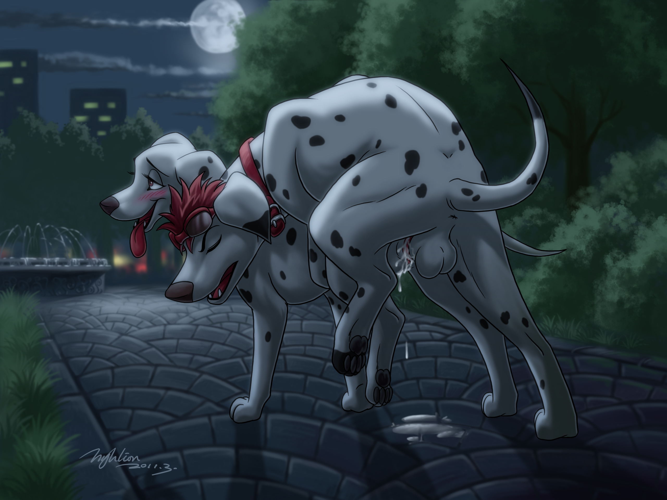
I braced myself as he gritted his teeth, and then he erupted inside of me! I felt rope after rope of sticky cum splattering against my cervix, Cobalt’s soft balls pumping fiercely. Splash! Splish! Splash! sounded out four times a second as he spent himself inside of me. The wet fluid drenched my clitoris, and I could hold myself back no longer, dropping my jaw and howling as my body devolved into spasming leaps and shudders.
His knot formed a tight seal with my aching, stretched vulva, keeping his fluids trapped inside my overfull pussy. Each new spurt build up the pressure inside of me, until I felt like I was going to explode! Squelch! One more spurt was all it took, and my cervix was forced open, the building flow of Cobalt’s dog seed rushing into my waiting, fertile womb as if ejected from a popped water balloon. Hot, sticky, wet cum coated my most sacred chamber, by all rights belonging to Pongo, but claimed instead by my secret lover. I squealed, knowing there was no taking back what we had just done.
But I didn’t care.
I yelped and shuddered, bucking my hips helplessly as Cobalt held on to my hindquarters for dear life, still spurting deep inside me. His knot’s seal failed next, cum spilling from the stretched lips of my vulva and splattering our legs and his dangling, quivering balls. I tried to shout his name, but all that came out were squeaky whines and endless squeals of delight.
He was a never-ending torrent, squeezing load after load into my hot, defenseless womb, far and beyond more productive than my husband had ever managed. All four of my legs shook with the effort to remain standing while Cobalt continued to breed me mercilessly, my pussy milking him eagerly for all he was worth. Just when I thought he was about to finish, he tossed his head back and howled, starting another long series of short thrusts and deep-planted ejaculations. I dropped my jaw, moaning between desperate gasps for breath, vaguely aware that the two of us had long since attracted a veritable crowd of humans and animals, watching with awe.
“Oh, Perdie!” he cried again, still not stopping his copious contributions. The splatter on the brick beneath us grew into a puddle, and then a pool, until I could finally keep my feet no longer, collapsing in exhaustion despite his powerful grip on my hindquarters. Still knotted and spasming inside of me, my collapse pulled Cobalt down with me. We landed on our sides, though I took the brunt of the puddle, coating my hips. Even after this, Cobalt humped into me, until I lay stunned, whimpering like a puppy.
I said through deep, ragged gasps, “That...was...incredible!” Looking down between my legs, I saw the massive bulge of his knot buried in my vulva and the pool of cum below me, and I blushed. “I love you, too, Cobalt,” I said, without hesitation. I couldn’t imagine a better way to live than to be connected at the genitals with my new lover.
“You are something else,” Cobalt said softly, groaning as I gently squeezed his sensitive cock. “But...but you’re in heat! What on earth are you going to tell Pongo?”
“I’ll give him his shot in the morning,” I said, making up my mind as I spoke. “As far as anyone knows, the puppies will be his. What he doesn’t know can’t hurt him!”
Cobalt’s whiskers drooped and he said, “You’re...going back to him?”
I sighed. “Anita lives with him...I can’t leave him. But I can take plenty of midnight strolls.” I added, eying Cobalt with a grin.
His ears perked up again. “Fine by me!” he exclaimed, his tail thudding against the ground.
Looking around, I noticed that most of our audience was clearing away now that the action was over. My cheeks were on fire, now that the heat of the moment had passed. Howling and breeding openly in the park? I should be ashamed! However, if anything, I found the experience all the more thrilling for it.
We lay there quite a while, until Cobalt’s knot finally subsided and he managed to pull himself painfully off of me. I yipped, but then smiled reassuringly at him, licking his cheek. I was exhausted, lying on my back in a pool of Cobalt’s seed, which had once again begun leaking from my stretched and sopping vulva. The red-haired Dalmatian looked down at me, grinning. “You are the most beautiful creature in the world, Perdita.”
My jaw dropped at the compliment, and I shyly replied, “Then you are the perfect mate for me, Cobalt.” I looked myself over, an absolute mess. Chagrined, I said, “But I had better clean myself up; not even Pongo could miss this!”
My old friend looked down at me, licking his lips. “So soon? The night is just starting.”
My eyes widened. He couldn’t possibly mean... I could barely stand! My jaw dropped, and he chuckled, adding, “Don’t worry, I’ll do all the work.”
“Oh, Cobalt,” I said. I had to admit, the thought of continuing our fun was appealing. I glanced around and saw that the man by the fountain was still watching, as well as a ring of particularly eager squirrels. “I would...but we’re being watched.”
“Let them watch,” he declared loudly, standing over me.
My eyes dropped to his glistening, white-coated cock, already standing full and hard for me. My empty pussy burned to be filled by him again, but ultimately, I whimpered and stammered, “But...but...”
I started to get up, but Cobalt put a paw to my mouth, stopping me. He said, simply, “Stay,” and I obeyed. He walked forward until his nose was touching mine, even as I lay on my back below him. I looked up at him, my tongue dangling from my mouth, torn between love and lust, and blushing embarrassment at our audience. The latter feeling vanished, however, as Cobalt opened his mouth and kissed me.
His tongue swept over mine, and all concerns vanished as I reached a paw around his neck to pull him closer. The ring of watchers had already seen quite a lot, and if our love-making drew new observers, so be it. All that mattered was Cobalt.
My lover’s paws roamed all over my body, brushing and rubbing against my rows of tender teats. I moaned, listening only to the wet smacks of our kissing. I took deep gasps for breath whenever I could, loathe to let anything interrupt the feel of his tongue against mine. Cobalt’s paws roamed lower and lower as we kissed, brushing through the light fur of my abdomen. Squirp! I cried out, trembling as he finally pressed his paw up against my drenched and dripping mound.
I moaned and writhed beneath him, Cobalt watching with a diminutive smile. He swirled his paw, further smearing my cum-stained vulva, before pushing gently between my folds. He slid easily into my heat-swollen pussy, and I dropped my jaw, mindlessly thrusting my hips against the tips of his digits.
Cobalt eyed my pussy, still drenched with his fertile seed, with wide eyes. “Oh, Perdie...”
I couldn’t take it any longer. In a high-pitched whine, I said, “I’m ready...just fuck me, already!”
“Hmm,” Cobalt said, deliberating. He pushed his paw deeper into me, my stretched lips engulfing him with a squelch I could barely hear over my own squeals. “I will...on two conditions.”
I waited for my moan to die down before I could stammer, “C-condit-ions?”
He flexed his paw, triggering the source of my most intense pleasure “First, you’re going to return to the park tomorrow night...and every night.”
“Yes!” I agreed, in a desperate whimper, waiting to hear his next demand. I rocked my hips around him, completely under his control.
Cobalt smiled, and continued, “Second, you’re going to refuse Pongo’s advances for a week. I don’t care what excuse you make. I want to know exactly who the father of your puppies is.”
I paused, mid-thrust. My heat might not last another week! If I agreed with Cobalt’s demand, my scent might fade before Pongo had a chance. My husband would know for sure something was wrong when my belly swelled, anyway. I gasped, “That’s too long! How about three days?”
Cobalt shook his head, spreading his digits deep inside of me. I writhed, whimpering helplessly as he reiterated, “A week, no sooner.”
“Yes! Okay!” I yelped, knowing that I’d agree to anything if he’d just end his teasing.
With a satisfied, half-grin, Cobalt pulled his paw free. I lay there panting below him, trembling in sheer anticipation. But Cobalt took his time, reaching his coated paw out to me. I set to cleaning it immediately, whimpering. Broad strokes sent my tongue across his pads, lapping up our juices without a second thought.
I was too busy thinking about the promise I’d just made. I was not the sort of dog who would go back on her word - at least, not normally - so I would have to delay a full week. Hopefully, my heat would last long enough, but if it didn’t... That wasn’t an option. Maybe if I-
My thoughts were interrupted as Cobalt once again stepped over me, our noses touching. I’d finished cleaning his paw absent-mindedly, and the time had finally come. I tried and failed to suppress a high-pitched squeal of delight, deciding I would worry about my promise later.
My eyes were locked on the glistening tip of Cobalt’s cock, slowly descending between my splayed legs. I can find no words to describe how much I wanted - no, needed - to feel him bury that massive organ deep inside my fertile sex. To think, I’d come to the park intending to break it off with Cobalt, now I was spreading my legs and whimpering for him to cream me a second time, fully planning to return every night for a week!
I trembled as his tip slipped between by wet folds, only for Cobalt to shift his feet, crouching lower. A thin rope of cum connected my waiting pussy with his throbbing cock, guiding my secret lover straight toward his target. Well, secret to Pongo, anyway. After tonight there would be plenty of people and animals who had witnessed our carnal acts.
I looked to the side, gazing with wide eyes at the squirrels and birds and even raccoons watching from the trees. I didn’t care any more; I smiled at them, my tongue spilling out of my mouth onto the cool brick. There was no place I’d rather be, and if our voyeurs were feeling anything about us, they were feeling envy.
I felt Cobalt’s paws underneath my rump, pulling my hindquarters upward. “You’re my beautiful bitch,” he said, adding, “Let me go ahead and take care of this.” For emphasis, he pointed at my heat-swollen mound. His paws were busy, so he pointed with the only thing available, his tapered tip brushing up against me.
I whimpered, clenching down around him as if I could engulf his tip and pull him deeper inside. “Do it! Breed me, Cobalt!” I screamed.
Finally, he obliged my burning lust. Squelch! With one, sharp thrust, he plunged himself deep, and the whole world changed. I lost all control of my body, yipping and whining, shuddering as I clenched down around his delicious cock. I squirmed side-to-side and my hips wiggled up and down, hind legs splaying apart until every muscle ached. My head was up and eyes were locked on his erection, pumping back and forth into me, grinding his beautiful, swollen knot against my aching pussy. The rest of his penis slid into and out of me with loud, ringing schlorps, but I whined wordlessly in my desire to feel his bulbis glandis fill me yet again.
“Harder!” I tried to say, but it came out in an unintelligible jumble. He grunted, humping smoothly into my sopping vagina, his pointed tip aimed straight for my unprotected womb. “Harder!” I tried once more to moan, to no effect. As if out of mercy, Cobalt leaned forward and filled my mouth with his tongue, cutting off my desperate cries.
Muffled moans were all I could voice while Cobalt pressed himself down against me, ramming his knot again and again against my trembling sex. To my dismay, he made no effort to wedge himself all the way inside of me. I whined, picturing his entire cock completely filling me, his tip grinding once more against my burning uterus before erupting inside of me.
Not that his long, broad strokes weren’t satisfying! He dragged his throbbing erection a full five inches out before slamming it back in, filling the oh so temporary void inside of me with a wet pop! His glistening organ slid heavily against my spasming nub, sending echoing waves of pleasure throughout my small body, unlike anything I’d ever felt with my husband. Pongo didn’t deserve to father my puppies, and he wasn’t going to. I might be forced to live with him, but Cobalt owned my womb. I managed to pull my tongue away from Cobalt just long enough to cry, “I’m your bitch! Fill me!” The last word was long and drawn out, fading slowly into a low moan.
Cobalt trembled, crying, “Oh, Perdie, you’ve no idea how long I’ve wanted to hear that!” Then, he dropped his jaw and howled, launching himself forward.
I felt his bulging knot collide with my pussy, pressing painfully down on my folds, but even the immense force of his thrust wasn’t enough to bury him all the way inside of me. It didn’t matter. I felt the heady rush of his warm seed coating my insides with several loud splurts. Humping back, I lost all control, whimpering, my shuddering passageway clenching hard around him. He was doing it again, filling my fertile womb with his seed, mixing deep with his first, massive load.
His next spurt sent the excess seed shooting out of my unsealed vulva, splattering his knot before dribbling slowly down by abdomen to join the pool of cum beneath me. I could barely think through the incoherent cloud of pure bliss that had descended on my mind. Then, without warning, Cobalt pulled himself out of me, standing over me as he continued to spray his seed.
I gaped, still shuddering in ecstasy, watching Cobalt’s throbbing cock launch volley after volley on top of me. I lay back, groaning and thrusting my hips vainly against the air, warm splatters of his seed striking me everywhere on my thighs, my belly, my chest. One particularly forceful shot splashed against my nose, and in my eagerness, I lapped it down immediately.
He was like a machine, more and more cum drenching my quivering body. I couldn’t help but realize: this was his second load, this much and more of his seed must have poured straight into my womb from our first coupling! Even if the handsome Dalmatian had knotted with me, it would be no use. I was certain my deepest chamber was already full and bloated with his semen.
I writhed like this for several minutes, each new drop of cum seeming to send my body into another, slightly weaker orgasm, until finally I lay in a heap, panting desperately for air. Pools and rivers of cum covered my underside, one particularly long string drooping from his tip down to touch my quivering vulva. Cobalt groaned and said, “How was that, my beautiful bitch?”
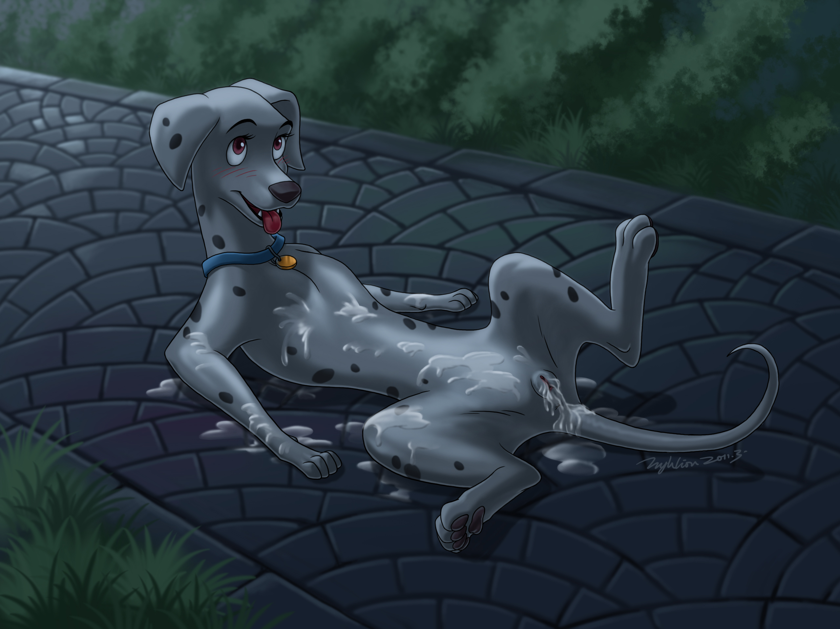
I blushed red, looking up at him with eager eyes. “Say that again.”
Grinning, the red-haired Dalmatian said, “My beautiful, sexy, fertile bitch.”
I murred softly, running my paws across my belly to feel his slippery cum coating and claiming me. Daintily, I sniffed my wet paw, and suddenly, I was licking it. His salty seed slid smoothly down my throat. The mere thought of whose cum this was was turning me on. Without another word, I began lapping at myself, gulping and slurping at the pools on my stomach. Cobalt watched, stunned, as I eagerly cleaned myself.
Drinking his cum down took far longer than spraying me with it had. By the time I lowered my snout to the last refuge of sticky seed - my leaking pussy - Cobalt was erect again and rubbing himself. I lapped deep and slowly, revelling in our combined flavor. My mound trembled under my steady licks, burning for something more substantial than my tongue. Looking up, I saw a very suitable replacement.
Finally clean, I decided to undo all my work the best way I knew how. I clambered to my feet, shoved my rump in Cobalt’s face, and raised my tail. He wasn’t about to turn down such an offer.
We only had time for one more glorious fuck before the night sky began to lighten. For a moment, I considered staying with him, and trying some lame excuse to Pongo and our pets, but caution finally got the better of me. Instead, I licked Cobalt’s grinning face and said, “Tomorrow night. And the next night. And the next.”
He wagged and said, “I cannot wait, my beautiful bitch.”

