WHAT’S OCCURRED ANOTHER…
FATAL ERROR TF/FtM TG/MC/PC/Possession

It was another boring day for a severely tired but meek woman named Fiona Elliott, she opens the doors to a tech-themed convenience store as she yawns and then sighs…

“Today’s gonna be another typical workday for me…”

Fiona said as she then gets into her typical working routine such as picking up cables, and stocking more analog TVs and old Computers that seemed like an endless pawn shop…

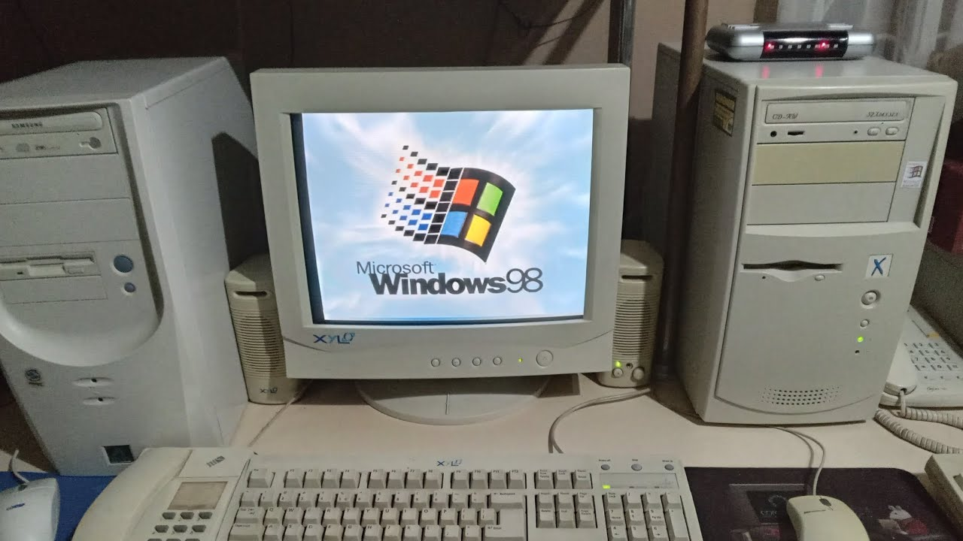

After getting offered coffee during another working so hard, Fiona then started to reminiscence her childhood and what things could’ve been, upon working on her computer…she noticed a game application of Sonic & Knuckles collection on the Windows 9x PC…

“Hey, I remember that game when I was a kid!”

Said Fiona. Fortunately, it was the end of her shift, giving her a much-needed break time.

“Maybe, people say that that there was a copy of this game that contains viruses in it in this computer. Maybe it’s just a rumor to me, one game time wouldn’t hurt a bit…”

Fiona said to herself, wondering what could go wrong…

Upon playing Sonic & Knuckles Collection at first just like her childhood days, she clicked on Sonic 3 to start here first. When starting Sonic 3 on the PC once again just like when she a kid, she noticed that the title looks strangely different…

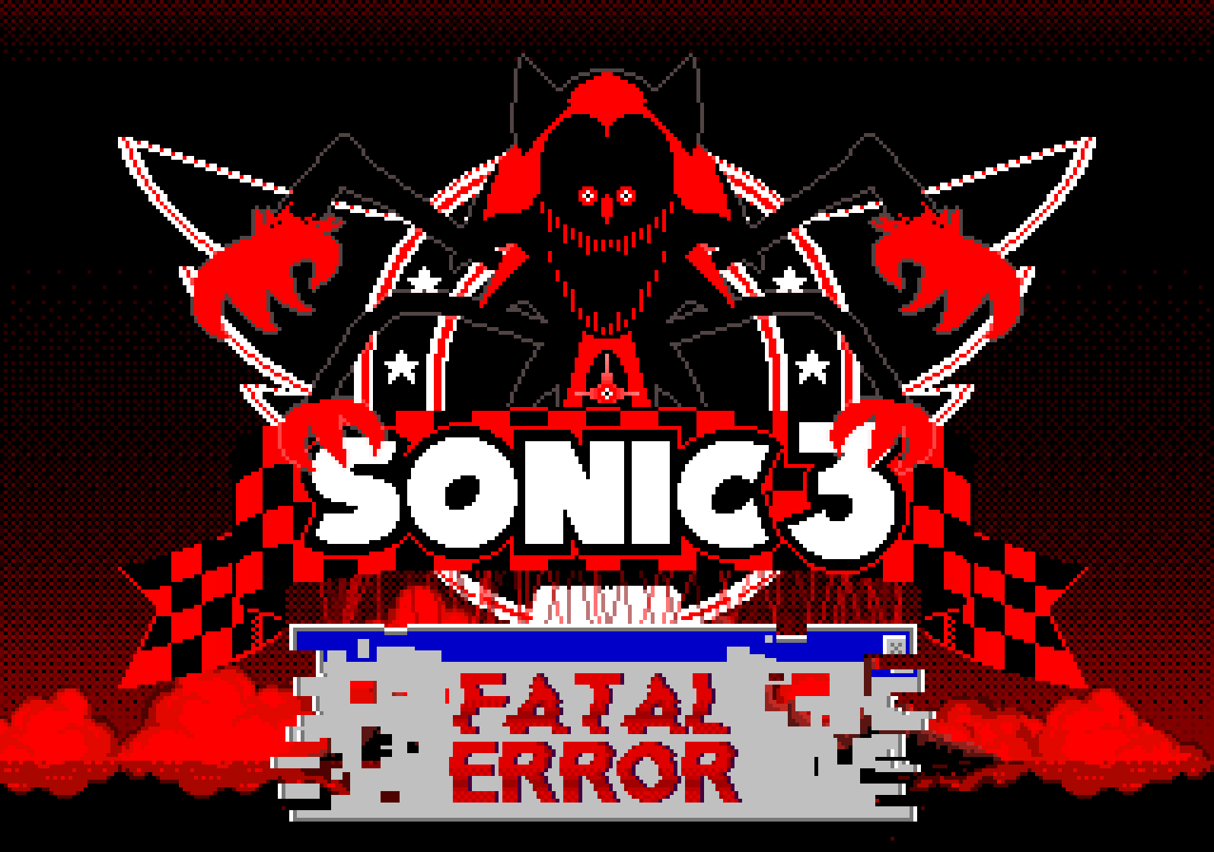

“What the…?” Fiona Eliott said, looking stunned and confused. “What’s with the scary red and black Sonic with four arms? And I don’t get what a “Fatal Error” means…”

Out of confusion, she just simply starts the game, trying to ignore the situation. However, when she clicked on an empty save data to start the game, the opening cutscene started normally, but something’s wrong…

In the cutscene, the skies turn dark red, and the ocean becomes bloody red, Tails’ body looks lifeless, nothing but red and black with red puppet strings above him. Then, there was NOT Sonic…

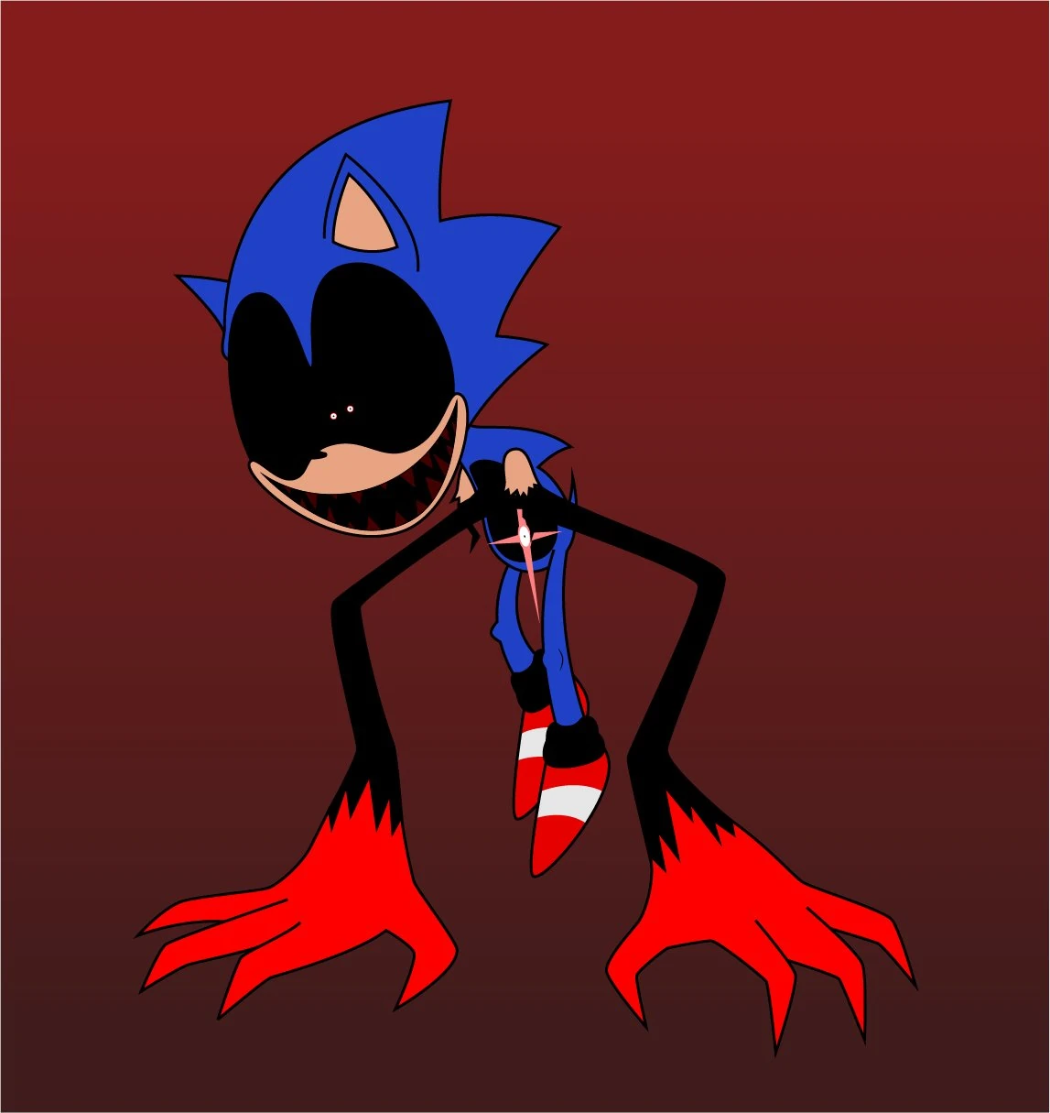

To Fiona’s vary eyes, what appears be two black arms with half of red hands coming out of his black, hollowed, armless body of “Sonic” with a light red, shining eye on it. He stares at Fiona menacingly and creepily; His eyes are pitch black with red pupils and black irises on them with a creepy smile and dark red, sharp teeth.

“What’s going on with this game…?”

Fiona said, looking petrified and confused at the same time, she doesn’t know what’s going on or why there might be a virus inside the game…

Then, a voice, that sounds like Microsoft SAM, but deeper and raspy, spoke…

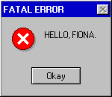

“What the hell?!” Fiona said in shock as if she was jumpscared…

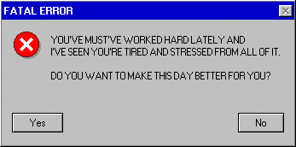

Nervous, trying to be as noninvasive as possible, she naively clicks on “Yes” …a little did she know that one pop-up’s choice would change everything for Fiona…

The Sonic vessel went frozen, eyes turning static as under the hollowed vessel comes out the true form of nothing other than Fatal Error. Shocked, Fiona felt two red claws and black arms rising out from the screen. Thinking this must be a nightmare, Fiona tried to run. But one of the arms coming from the ground grabbed her by the ankle, reality started distorting into red and blackness.

Fiona tried restraining herself, but felt his presence RISING slowly in front of her with a menacing and monstrous grin on his face…

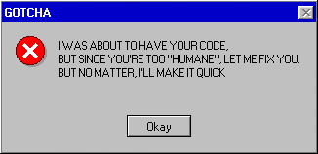

As the error box closes again after finishing his speech, Fatal Error soon goes inside of Fiona’s hapless body as she blacked out…

A few moments later, Fiona woke up, inside of nothing but a black and red void…when she got up, she ends up finding herself in the body of Fatal Error’s Rodent/Sonic vessel. She attempted to leave the vessel, but she couldn’t get out…

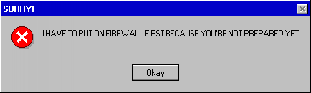

“What the fuck?! We had a deal and this is the thanks I get?! You’d better let me out of here, you red freak! I—”

Fiona demanded Fatal Error as she tried resisting as she yelled…to no avail. Her demand and resistance stopped when Fiona started feeling a sharp pain from the inside of her body, as she glitched.

“AAAAAAAAAGGGHH!!”

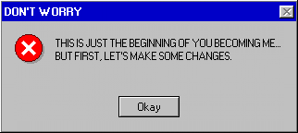

Fiona felt like her body was on fire, as her transformation was about to commence…

Fiona felt her hands turning peach-toned to red, they've started growing sharper into masculine claws as her arms grew longer and black as she watched in horror…

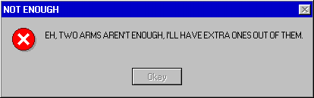

Just as she felt her growing arms and claws, she felt monstrous pain coming out of both sides of her torso, two additional red claws and black arms spontaneously appear from both sides under, tearing out her shirt. Fiona then looked at all four of her arms…

“W-What the?! What is all this--?”

Fiona said to herself in shock as she felt her spine arching and her shoulders broadening, the redness and the blackness were reaching her torso, her chest started twitching.

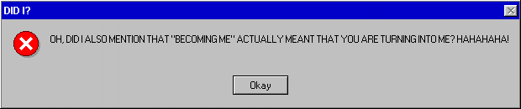

Fatal’s voice spoke as Fiona’s breasts started receding in a matter of seconds until they became completely flattened and masculine, her waist cracked and became less curvy. Her shirt grew a little tight…and uncomfortable…

“I-If I can keep control of myself, maybe he’ll—”

Fiona said before Fatal Error interrupts her speech…

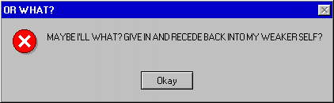

He said as Fiona felt her hips receding and becoming less feminine, she started growing taller, her clothes becoming tighter as her leg started getting a little longer. Half of her legs turned black

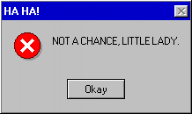

He said as Fiona felt a cramp coming from her shoes as she felt her feet growing bigger but more monstrous.

“N-No…”

Fiona said to herself as her shoes suddenly exploded in the process, both of her feet became black and monstrous with her toes becoming nothing but monstrous red claw-like toes.

“AAGGHHH!!”

Fiona screamed in pain as the transformation kept going, the redness then appeared on her neck, growing longer and crooked. Her short, messy dark beige hair becomes fully black with red edges as they quickly grew to a long length, with two devil-like horns appearing out of her head.

"I-I can't stop him; he's already taken so much. What should I do?!"

Fiona said to herself, trying to figure out as she felt a painful sensation happening next to her face while she felt her crotch started burning…

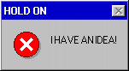

Fatal said as Fiona felt her face distorting while she felt a strange sensation that’s growing outwards from her crotch.

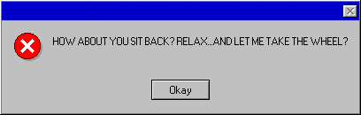

He said as Fiona groaned in agony and arousal, her hormones and reproductive system becoming an opposite sex as her XX Chromosomes become XY. During that time, her face becomes more monstrous but masculine, her entire face becoming red with her ears and nose vanishing, her teeth grew sharper, half of her eye blue eyes becomes black with a red iris and a white pupil with the left of her eye vanishing and separating into many holes on one side. During her pained groans and moans, her feminine voice lowers and turns masculine from the inside of her neck, sounding more of a glitched, deep, and raspy tone of Microsoft Sam.

Then, her mind was soon corrupted by Fatal Error as he puts on the finishing touches to the takeover of Fiona’s former body, he takes over her mind completely as she felt a migraine coming from her head, her past memories of being once Human was replaced by Fatal Error’s causing her mind and her body to fully restart like a Computer once the takeover’s finished installation.

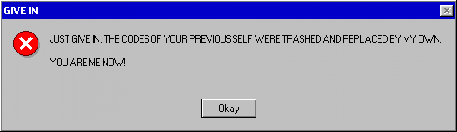

He said as Fiona then passed out from the finished transformation…

Following the restart, he rebooted up as he got up from the transformation and had looked at his new, masculine body.

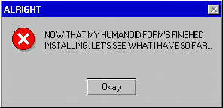

He noticed how tall he grew more than he usually, slouched 5'0ft height, and looked at his entire skin and looked at how black and red he has become.

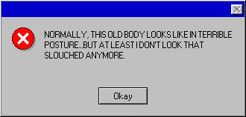

He then looks at his arms and moves them in his amusement, and then...he noticed his legs, but separate from each other and he has grown black, monstrous like feet with red claws as he wiggled his toes, as he takes every step…

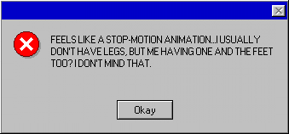

Fatal Error then saw his new pecs coming from his tight shirt, the old bra of his is making him uncomfortable for his chest…

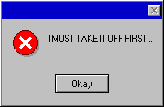

He said as he managed to delete his old bra from his Humanoid form’s files, his flat chest needed to breathe out.
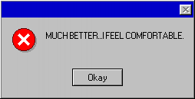

He said as he breathes heavily, as he then touches and feels his flat chest, it felt very good for him.

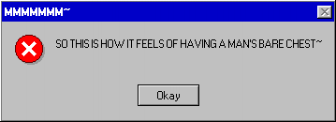

He then feels his completely masculine and monstrous face, as he stroked his new, long-length, black hair, twirling it and feeling his devil-like horns.

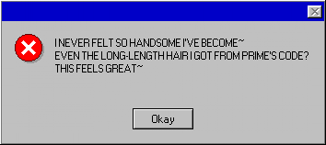

Fatal Error then noticed and almost forgot that he felt something fully grown from under his pants.

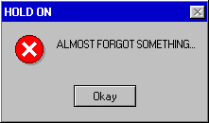

He then said to himself as he placed one of his hands on a grown bulge from his crotch and had felt that his womanhood was 100% deleted and manhood is 100% installed.

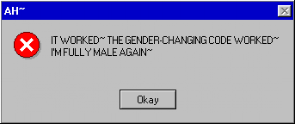

He then said, growing flustered at his new, mannish body. Suddenly he realized that he had taken over a former Human Female’s vessel and with improvements by changing it into a Male Humanoid and he succeeded in it. He’s no longer a tired, stressed, and meek worker named Fiona Elliott anymore, but a powerful and malicious Virus codenamed…

FATAL ERROR.

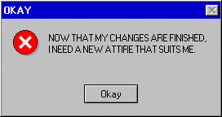

He said as he started reworking on his old clothes’ code. His old, untucked collared shirt becomes white and well-tucked in, and clean, with his red tie becoming entirely black with a blue clip with a white "X" on the red circle. His dark blue jacket was fully zipped in and red with red sleeves fitting four of his arms and a spine and ribs appeared on his torso. His tight, dark blue jeans become a black, well-dressed and comfortable pants with red edges with his pair of panties becoming a pair of "Blue Screen of Death"-printed Boxer shorts from underneath. His open torn shoes were morphed into a pair of knee-high black boots that suit his feet, with white laces, red buttons with white "X"'s on the sides, red soles, and neon blue high heels.

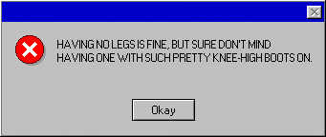

He chuckles as he stands up on his knee-high boots, and to his surprise, he was taller with his boots on. He then takes out a red hairtie as an extra and ties his very long-length hair all the way up to a ponytail. Fatal Error smiled at himself and his new look and said to himself…

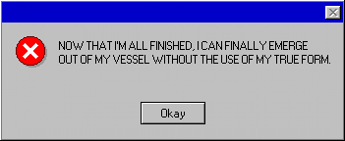

Just then, Fatal Error and his new, Humanoid form finally emerged out of his Rodent/Sonic Vessel, giving him some fresh air in the digital world he's finally in, as he takes a deep breath and lets it all out.

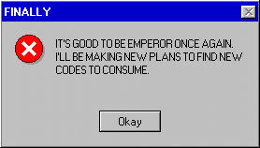

Fatal Error then said to himself to his pride, as he sits down on the error box and smiles, planning on searching for new codes to consume and new applications and game worlds to corrupt and take over.
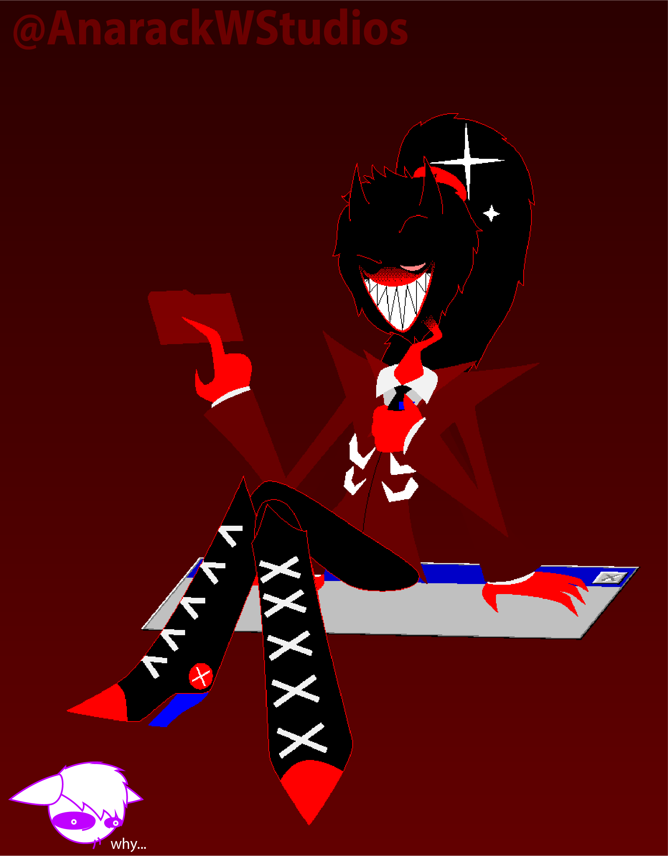
THE END.

