Maledicted
Curse (The Curse Of X) TF/Female to Transmasc (Transgender Male) TG/MC/PC

(TW: Mentions of Gender Dysphoria (Not Meant for Normalization/Romanticization), Implied Transphobia (Not meant for Normalization/Romanticization), Themes of Bullying, Stalking, Some Angst)

Things aren’t going well for Cora…She’s been suffering from Gender Dysphoria and has struggles with her med bills and her journey to transitioning into a guy, ever since she was taunted and teased for trying to fit in the in-crowds with the other boys and usually doing skateboarding together with them back when she was in Elementary School.

She’s been a shut-in and a loner for an entire life in her apartment; she’s been suffering from the consequences of communication issues and how her former peers didn’t accept her as a Transgender Man. The Girls, especially when she used to be at school, teased her the most.

Cora has it even worse, she had an ex-friend who's been stalking her, bullying her, harassing her, deadnaming her, basically getting under her skin on purpose.

Her mediocre daily life and cycles of the mistreatment she’s gone through seems endless…that was until another day came for Cora that would change everything when she got home…

“*Sniff* This is the worst day I had in my entire life…And it’s ALL because of my stupid ex-friend and my peers who laughed at me again…!”

Cora sniffled as she went into her room, slammed the door shut, and fell her face into her bed, sobbing.

“My life is such a fucking Curse…Why can’t I let anyone accept my transition and be loved by all…?!”

She said in a sad tone, tears falling on her pillow.

“You know what…?”

Cora said as she sniffled

“I wish for something greater in my life, something that’ll help with my transition so that’ll be prouder of myself…as a Man…”

Just then, Cora noticed what appears to be a pair of red, fluffy boots with bandages and thicker black and grey thigh high socks along with two pairs of ripped gloves.

“Reminds me of a certain blue blur…” Cora said to herself as she thought “I wonder if those help me with my transition??” She said as Cora then picked the gloves from off the bed and put them on.

“Hmmmm, they feel kinda loose and worn out…,” said Cora.

Just then, she felt a tingling sensation coming from both of her hands, feeling like pins and needles.

“Huh? My hands feel funny…”

Cora said to herself as she felt both of her hands growing darker tones of blue fur, and a bit masculine as she felt beans forming on her palms and black claws growing out of her nails, making her gloves suddenly fit to her surprise!

Soon, it started to spread on her peach-toned Skin, starting with dark brown fur forming and spreading on her arms with deep cuts on them.

“That’s new…”

Cora then said to herself as she felt her new hands and her new, growing fur.

“On second thought, there’s something going on with my chest…”

Cora said as she felt a tingling sensation coming from both of her breasts.

As the dark blue and dark brown patches of fur spread on her shoulders and torso as two spines grew out of her back, her breasts suddenly sank their way back to her chest as she watched them vanish. A small chest of fur appeared in the front, once her breasts shrunk down and become flat-chested, Cora then felt a sharp pain coming both sides of her chest. She then takes off her dysphoria hoodie and then her shirt, only to find both of Mastectomy Scars forming from under her chest.

“Guess I won’t be needing a Binder nor paying for Top Surgery anymore.”

Said Cora as she noticed her new top-surgery scars as the fur from the torso went down to her waist.

Cora then noticed the thicker black and grey thigh high socks along with bandages and two pair of fluffy red and white boots from behind her.

“About time for phase two…”

Cora said as she takes both off her shoes and her short socks and puts on the thigh-high that reveals both of her toes and heels. The dark blue patches of fur then started forming on her feet as her Humanlike feet grew and her toes merged into three, her feet suddenly became two darker blue paws that fits her socks with beans appearing from under her feet as she wiggled her new toes.

Cora then puts the bandages in and then the boots that soon fit her new paws. The fur then started spreading from above her legs. The wounds then soon started appearing on her legs from under her bandages and socks much to her pain. The dark blue and dark brown fur then spread on her waist and hips; scars appeared from above her legs. Then, her butt and thighs started tingling as the dark blue and dark brown patches of fur started growing on them.

“Mmmmmmph~ I can feel it happening to my ass~”

BWOMPH~!

JIGGLE~

Cora moaned as she felt her butt and thighs swell up a little, as she jiggles them, a big, floofy Hedgehog tail pops out of her pants. It then stopped; her pants weren’t even fitting anymore. Cora then takes off her pants to reveal her fluffy, Mobian Hedgehog hips and thighs as she wagged her tail.

“Hmmmmmm, there’s one more left…”

Cora then noticed to see gold earrings and an ear cuff on her desk, as she then pierces the on to her ears.

“Here it comes…”

said Cora as patches of darker blue fur start forming on her ears, her ears have turned pointy that they've both grown into bigger, fluffy hedgehog ears with the insides becoming darker brown. Her long-length hair shortened and hardened, becoming slightly messy quills. As the dark blue fur reaches her neck and the darker brown reaches half of her face, her nose becomes black and animalistic as she grows a muzzle. Her tongue and teeth also turned black with her mouth forced into a black, empty wide smile, her eyes then become black with her irises turning red and her pupils becoming black, tar-like substance leaked out of her eyes as her feminine voice deepened, starting to sound masculine as a lump then finally formed from the inside of her throat.

“Is it…Is it over?”

Cora then said in his new, masculine tone that sounded like Sonic. He then reaches to the mirror reflection and then saw…his new self.

Cora then noticed that he has grown tall and lanky rather than a normal girl's height. He then feels his fully grown fur on his arms and looks at his new hands and his gloves, he then takes off his boots, revealing his paws as he wiggled the toes of them and feels them, and then puts them back on. He then feels his thick thighs along with his fluffy tails. He turns around his back to reflection as he jiggled and shakes his butt and thighs and wagged his tail. He turns back in front of the mirror and feels his ears and quills, and then his new masculine face. He noticed his top surgery scars and his flat chest and then touched them with his new paws by himself.

“I can’t believe this, my wish’s been fulfilled…but I also feel cute and all but…who am I…?”

Cora then said to himself as he questioned about his new identity…just then, he felt his mind started changing, his old previous memories fading and replaced by his newer self.

"Wait a second, I have found myself...After all of this times during my struggles, I've founded my transition into a male. I wasn't even a gender dysphoric, introverted, loner, and a shut-in named "Cora" anymore, I am a redeemed Hedgehog who was once the Sonic in the universe. Despite my slightly scary look, I'm actually very kind, almost dangerously, always courteous, understanding, and sweet. However, I'm very hesitant to make new connects all because of my trauma and sometimes I feel kindness given to me is insincere. I have the Time Eater scythe I wielded as part of the Time Eater, I'm Bisexual and taken in a Polyamorous relationship, I'm a Transgender Man because this is me, the real me…I am Curse!"

Curse said as he finally embraced his new self, soon, after the transformation following his mind change, Curse started to feel very sleepy. Before he passed out from the changes, he took off his boots, revealing his paws, and went to bed.

A few moments after the transformation, Curse woke up to a bright blue glow as he got up out of his bed, waking up to a new world as he put on his boots.

“Is that…my scythe?”

Curse said as he found a Time Eater Scythe next to him, as he grabbed said Scythe, a blue, crystalized chain formed on the left of his wrist.

“Guess it’s back to work for me. I wonder what message and reason of death do they sent next? Haven't executed such a dead in a moment…”

Said Curse as he goes out of his room with his Time Eater Scythe again, continuing his work. Though he’s proud of his transition thanks to the transformation and how he’s forgotten his past as a struggling Human girl, it looks like things have gotten better for Curse recently…

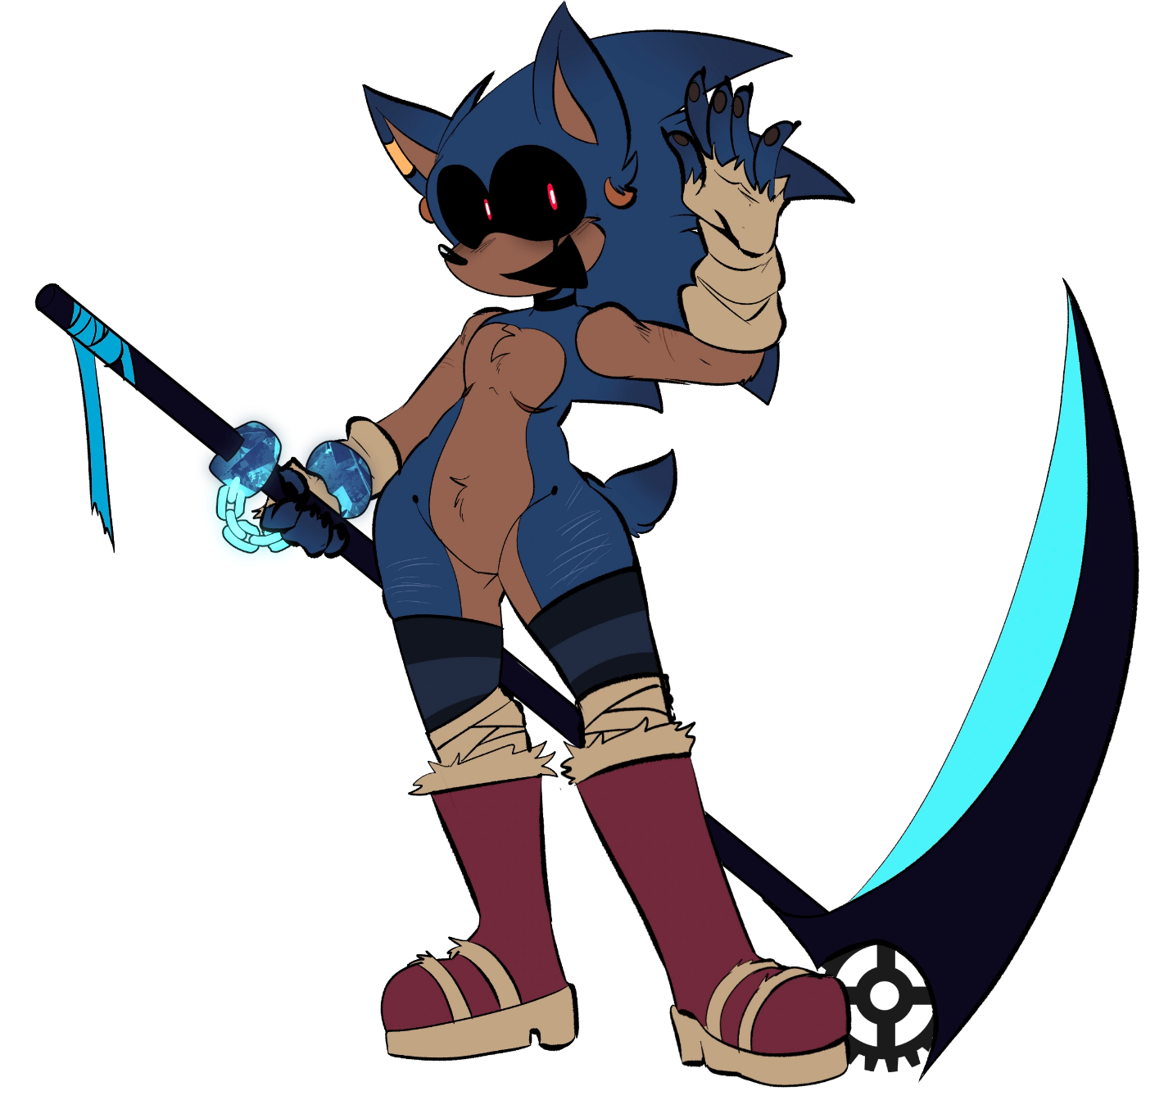
THE END.

