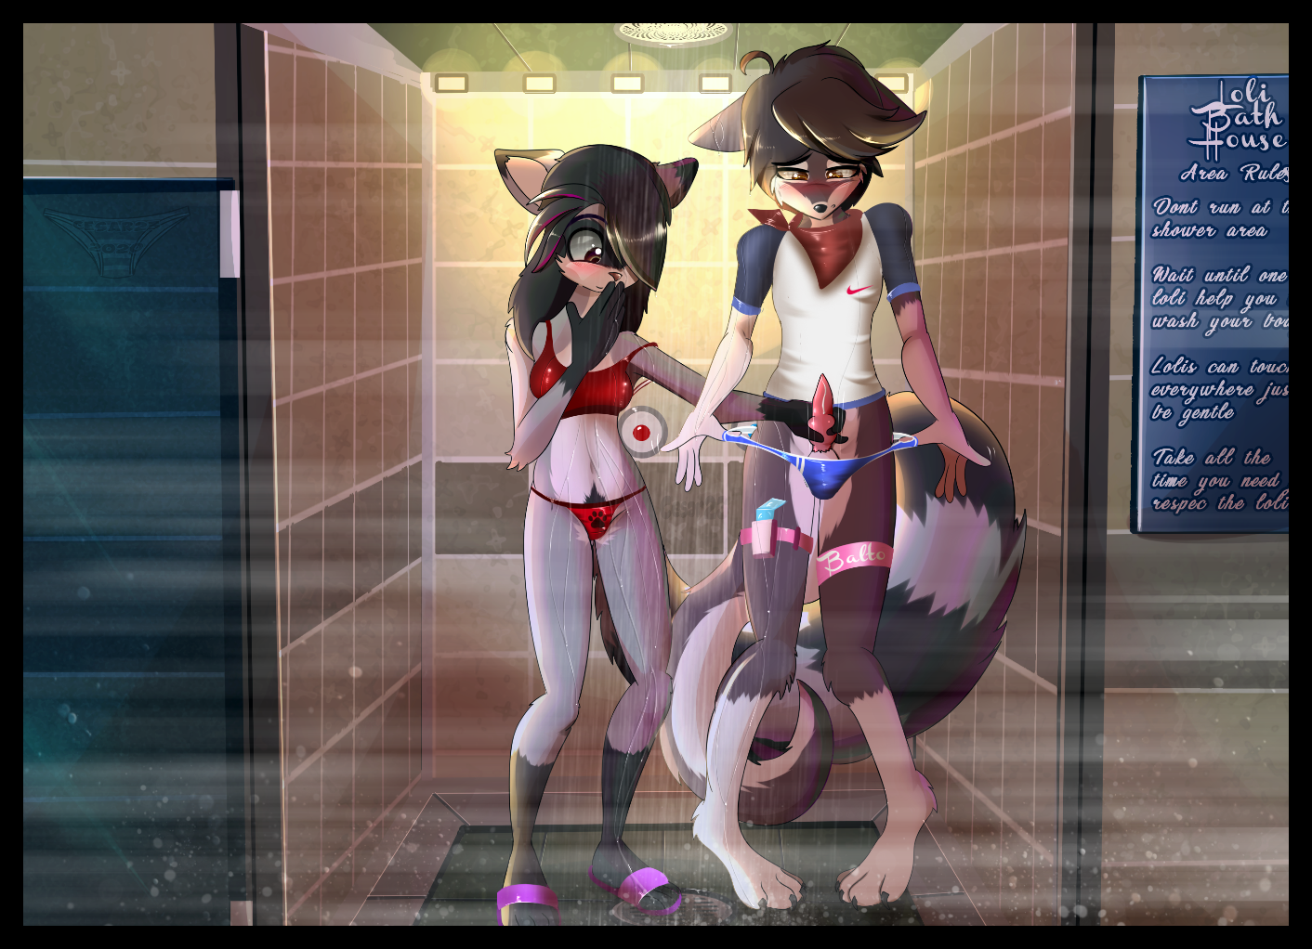

Loli Bubbly Bathhouse

A new Video game came out a few days ago, and I really, really wanted to have it. Every kid in school talked about. But Mom said it is too expensive for her in the moment, so I either have to wait, or I earn the money myself somehow. Well, was worth a try. I asked the Neighbors, if I can help them around the house, cut the lawn, wash their car or anything else, but no one wanted to hire me. I would be too young. I do that at home all the time, why should I be too young for it?
I heard from a bathhouse in school, were they hire young girls for all kind of jobs. Rumors were around that these included, well, let us call them special jobs. Mom always told me to not believe so much in rumors. Some made pretty dirty jokes about the place too, mostly the older boys.
Since I love swimming, and I thought the jobs there would be mostly cleaning things or offer services like, I don’t know, bring people drinks, I wanted to give it at least a try and look what they had to offer.

I turned on my computer, as I came home from school. The bathhouse offered a job during the holidays on their website, it was called “Special Service Maid”.
I looked everywhere on the site, but I simply couldn’t find any more information about the job in this offer. Just the address, phone number and what they would pay for one or two weeks of work. It was quite a lot for, what I thought, easy work.
Mom wasn’t home yet, so I called them right away. The Manager took my call himself, his name is Mister Tonalix. He was quite surprised, that a boy asked him for a job, since, as he said, normally only girls work for him there.
He told me to come to his office and speak in person with him. We made out a time for Saturday. He told me we will speak a little, he will show me the place and explain what I am supposed to do there. He ended the call, after he told me when I was supposed to be there.

Saturday

It was a sunny day, so I decided to take my bike to go there. The place actually isn’t so far away from our house, what was kind of surprising for me. Maybe I never recognized it, since it looks not that special from outside.

I stored my bike in the bicycle rack and walked into the bathhouse. I looked around a little. I spotted a group of girls walking around in sexy, but pretty tight looking uniforms. After a short while, they walked out of my sight. A young raccoon girl saw me standing there, and waved with her paw. Shy as I am, I only waved back, without really looking at her. She giggled, before she followed the other girls.

I moved over to the Information Desk, to ask the girl there, if Mr. Tonalix is here, since he wanted me to come here for a job interview. She asked me for my name, then she told me to wait a moment.
I looked into the pool area, since I hoped to see the girls again. My thoughts must have driven away a little, I didn’t hear this man coming closer to me.

“Hi there!”

I startled.

“Oh sorry young man, I did not mean to scare you. I am Mr. Tonalix, the owner of this place. I am glad that you could make it. As I see, you have already looked around a little.
Well, follow me, I want to talk with you in my office, before I show you the rest of the place and introduce you to some of the girls.”

I looked around a little more, as we were on our way to his office on the first floor of the building. I saw a few photos of girls on the wall, with their names written under them. I looked for this cute raccoon girl, and shortly before the office, I finally found her.
Winie, 13 years.

I giggled.
I looked at the photo of her for a few moments, before Mr. Tonalix turned around and saw it.

“Winie is one of our best girls here my boy, but be careful, since she is a raccoon, she can be pretty wild”
I had to think for a second. “Can be wild? What does he mean? Wild like Erin? No, that can’t be. He could be her father…”
I wasn’t sure anymore, if that was such a good idea. The adult asked me to come into his office and offered me a chair in front of his desk.
I sat down and looked at him. He saw how nervous I was in that moment.
“Calm down boy, no one will eat you. Well, at least not yet…”
He giggled after that, while I was shaking a little. I took all my courage together and started to talk:
“I have seen your Job offer on the website, The one for the Special Service Maid. I think I can do that. But can you tell me what a Special Service Maid is actually supposed to do? Your Add didn’t tell anything about this”

Mr. Tonalix looked at me without saying a word. A few moments of silence later, he finally answered me:

“Well boy, A Special Service Maid is here to support the guests, make them feel good, and to fulfill their wishes. But also for maintenance, like cleaning the rooms. You already saw some of the Girls running around, before I joined you?”

I just nodded.

“Then you have already seen the Uniforms the girls usually wear during their shift. You seem to have just the right body for it. Well, we just need bigger panties for you, since, well, you have a little more down there than the girls. I think you will look good in it. And since you are the only boy, it could be that many customers will pic you as their maid. As you might have seen it, the uniforms are pretty tight. I hope that this is no problem for you, Balto”

“No sir, its fine. Well, I guess so.”

I looked on the ground, after I said that.
“I understand you Balto, don’t worry. I say one thing clear. If you don’t want to do something, you don’t have to. No one can force you to do anything. If someone tries that, we will throw him out. I will give you a wristband, to show that touching you is forbidden. You can wear it, or take it off, if you feel like doing that. The only thing you have to do is to help the other girls, assist them as good as you can. Do you understand that?”

I smiled a little. What a relief, that I don’t have to touch anyone. I told him: “Yes, I understand”

He continued:

“Well, since everything seems to be clear, let us go downstairs. I will show you around, and then show you some examples of what a Special Service Maid is doing here for our customers. Oh, and before I forget this, did you ever had Sex? I am just curious.”

I was silent for a longer moment, looked to the ground and answered silently:
“Ye… Yes, I had. But only once, with a cute bunny-girl. Her name is Erin. It was not long ago”

Mr. Tonalix was thinking for a moment, before he replied to me.
“Well, that sounds good. Bunnies are fun to play with. Have you ever played with a cock, beside your own?”
I was getting a little nervous again, but I told him anyway:

“No sir, but I am watching some gay porn-streams from time to time. They are hot!”

He smiled, turned around, and we began to walk through the bathhouse. He showed me the pools, sauna, the massage rooms, and also some girls doing, well, their special services.
I must have looked pretty dumb every time, since they always smiled and laughed at me.
Mr. Tonalix explained to me, that the first goal of the Bathhouse is to help the customers to relief stress, and give them a good time. He repeated, that we never had to do anything we wouldn’t like to do. He showed be the Rules, which were hanging in big letters on most of the doors. We finally reached the coworker’s locker-room. He told me to wait outside for a moment, he wanted to go in and check, if everything is clear inside.
I was standing there a little lost in front of the door. Some girls passed by. They giggled, as they saw me. Nervous, the tail pinched between my legs.
One seemed to be a little older than the others, and also bigger. A bunny, who came directly to me.

“Hey there, wolf-boy.
My name is Bary. I am the group leader here. I hope you will be a good boy, while you are here. I will keep my eyes on you!”

She walked away, before I was able to answer her. The door of the locker room opened moments after this, and Mr. Tonalix asked me to come in. I walked in very slowly, but as I saw Winie standing there, I had to wag my tail a little.

“Balto, I think you remember Winie from the photo before. She will take care of you from here, give you your uniform and she will make sure that everyone is nice to you. Just do what she tells you to do, and welcome aboard. If you need something, feel free to come to me or Bary. Oh and Winie, give him a “Don’t touch” Wristband”

Winie answered:
“Sure boss! I will take good care of the nervous little puppy”

Mr. Tonalix away. I had to think about this bunny from before.
“Yeah right, Bary. She would rather eat me than help me…”

Winie came closer to me and, her cute voice interrupted my thoughts:

“Here you have your uniform. Try it on, but I think this size here should fit. You are a little bigger then we are, but it should be just fine!”

I looked at the uniform, the Panties, and a strange little thing with a rubber band on it. I looked at Winie and asked her, what that thing is. Her answer was:

“That is your Condom Dispenser! Safety is the first and most important rule here. And now try on your uniform, I want to see how it fits!”

I looked at the girl, asking her for a changing room. She just shook her head and giggled.

“We will work together doggy, you will see me naked soon enough, and I want to see my new partner too. And now, follow orders, strip little doggy!”

Shyly I took off my shirt and my pants. I still had my underpants on me, as I wanted to take the Uniform. But Winie quickly took it away.
“No doggy, the underpants too! Not part of the uniform!”

I pulled them down, while I tried to cover my sheath with my tail. Winie laughed.

“Cute doggy, don’t be ashamed. I have seen enough nude boys here. But never a doggy like you. Do you have a knot? Don’t be shy! I show you my boobies, if you show me what you have down there.”

I looked at her. She lifted her shirt, and showed me her little boobs. She even took it of completely. So I let her look at my sheath, what made her smile. This girl seems to not know any form of shame, because she came closer, and touched me. I stepped back, she followed, touched me again.

“Winie, I am really not sure if you should do that”
“Come on doggy, I want to see your dick! Get it out! Please, show me!”

She came closer again, this time she even pulled my sheath down a little, so my tip came out. She gently strokes it, and even if I was nervous as hell, my cock slowly grow, till is stood fully erected in the hand of this naughty little raccoon.
Winie didn’t stop there, she now began to squeeze my cock gently, while she massaged my balls. I gave up my resistance, this felt so nice, that I wouldn’t want her to stop. She rubbed my cock faster, even spit on it, as it was a little too dry. I only moaned and humped her hand a little, my knot slowly got bigger. Winie touched it carefully, even sat down in front of me, and began to lick it, while she continued to rub my cock. I was about to cum, wanted to move away from her. She only fastened her grip on my member.

“Not going away before you cum doggy, Winie’s rule!”

She took my hard dich into her mouth, and began to suck on it, till I couldn’t hold it anymore, and filled her mouth my cum. She swallowed it and smiled. I was just panting hard.

The girl licked her hand clean, while she looked at me.

“Good doggy. Now we can start work. Get in your uniform, Customers are waiting!”

This will be an interesting time here……

Orange: Mr. Tonalix
Red: Balto
Green: Winie
Purple: Bery

