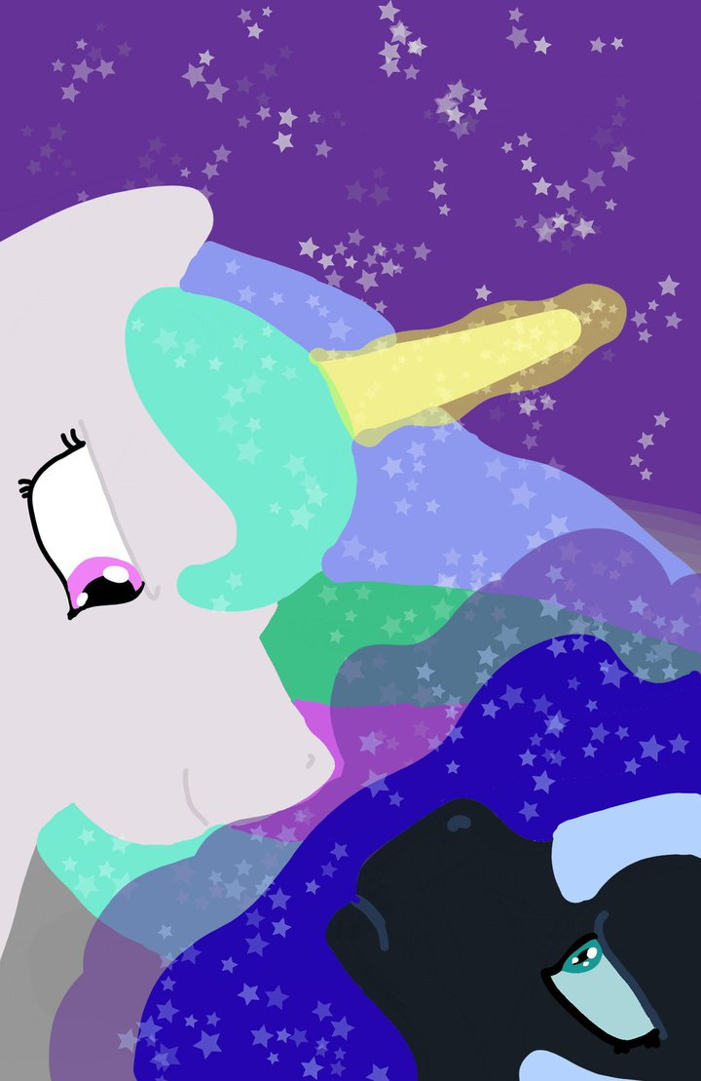
Short summary: Nightmare Moon tries to persuade Celestia to let her off the moon.

Long summary: It’s time for a routine check up on Nightmare Moon. Celestia removes all potential means of escape to make sure the captive stays put. Despite her busy schedule and the memory of her sister still fresh in her mind, the alicorn in mourning finds it in her heart to talk to the condemned pony on the moon.

Rating: Teen

Tags: Gore, Dark, Drama, Horror, Thriller, Tragedy

Celestia Visits Nightmare Moon

Fear of Heights

Fear of Heights

You bring out the best in me, Celtor. Your trust enforces my own belief in myself. It gives rise to everything that is good within my soul. A coal-gray pebble slid upwards toward an ash-gray rock. Both of them were pressed against a big boulder. I wish to stay by your side forever, dear brother. When I am with you, I feel whole.

That’s how sibling relationships ought to be experienced, sweet Nightshade. And fear not, my dearest; nothing could ever tear us apart. Joining our forces makes both of us stronger. We can overcome any obstacle that the world may throw at us. Together, we can transcend it. The big rock slid down a hoof length to join with the pebble.

Oh, my valiant booster. I always feel at ease around you because you know me so well. It is almost as if we are connected with our souls… No! Our bond is even stronger than that. It almost feels as if we are one.

It’s easy to know someone fair Nightshade. One must only stop and pay attention. That’s all there is to it.

The pebble pressed hard against the stone. I would be lost were it not for thee, courageous pathfinder. You hear me out when I express my fears, and then you shoo them away. Without your caring support, I would not even dare to dream of a trip over this big mountain.

It goes both ways, supportive brother. You’re not as bad as you think you are. Know that I have great need of you in my life. You compliment me like no one else could, my dear soulmate.

You are so good to me, Celtor. Yet, I sometimes dread the thought of what our relationship could have been like. The pebble slid down a little.

There is no reason to be distressed by a mere thought, graceful Nightshade. The true friendship, we share, has brought us nothing but joy. Why would our relationship be anything other than the harmony we nurtured between us?

You could have dismissed all my ideas as bad and scold me whenever I would bring about a concern. I could try hiding the parts that displease you. All my pain could just be festering within me instead of being exposed to your judgment. You could find fault in each of my actions, suffocating my resolve little by little.

Why would I ever do any of those things?

I do not know! A massive ball of salty water splashed between the pebble and stone.

My sibling, even if that were to occur, you could not have pretended forever. Sooner or later your accumulated hurt would burst out in full force. The results of that would be devastating.

I know! More tears splashed on the askew side of the boulder. One of them brushed the pebble. As it soaked the liquid, its shade turned darker.

A shadow passed the boulder. The pebble and stone froze in place.

The ever-present silence broke as a whooshing sound emanated all around. Dust rose up from the ground as the air cocoon forced itself down.

Luna inhaled. The smells from Equestria filled her nostrils so strongly that she could almost taste them; freshly baked bread from the castle’s kitchen and a hint of roses from the Royal Garden. And there were many more smells in the background, bringing the fading memories of her past life back to the surface. Even clues to the climate condition down at Canterlot could be sensed in the mixture. A tinge of looming moistness hinted on a storm in the making.

The stooped mare curled her upper lip as she sniffed at the air. Ears perked up and her breathing ceased when she heard the sound of approaching hooves. The hair all over her body stood up as a haughty tone boomed from behind her, “Nightmare Moon, what are you scheming this time?”

A large shadow encroached upon the smaller silhouette at the boulder. The pebble and stone fell from Luna’s shaking hooves. Her ears twitched, disturbed from a long wait in the silence of space. “Cel—estia…” The tongue struggled to keep up with the word. It laid dormant for so long, almost forgetting how to dance to the mutterings of sound from the vocal cords.

Celestia neighed. “Do not let little old me keep you from your depravities, defiler.”

“‘Tis alright; I was merely trying to pass the time, somehow.” Not daring to look back, Luna bowed her head. Her ears flipped down as she watched her shadow being enveloped by Celestia’s.

“I wish to bear witness to your indecencies, deviant. Keep it up, pervert.”

“I would rather not. You are bound to mock me for it…”

“I insist!” Celestia thundered, stomping at the ground with a hoof. “I wish to see it, strumpet!”

Luna gulped. “Um… Okay…” She picked up her props and slid the pebble in her left hoof closer to the stone in her right one. Her cheeks turned red as she spoke, “Celtor, this wall is slippery…”

“Celtor?” Celestia smirked.

“Celtor is represented by this stone.” Luna raised it with her right hoof. “He is the brother of Nightshade.” She lifted the pebble in her left hoof.

“I see twisted Nightmare Moon is fantasizing about stallions.”

“No! That has nothing to do with this.” Luna dropped her figurines and stood up.

“I bet that boulder is not the only vista those stallions explored, wanker.” With a grin showing on her face, Celestia slid a hoof between Luna’s hind legs.

“No, sister!” Luna clenched her teeth and gazed into the distance. More tears were forming in the corners of her eyes. When she bowed her head, two balls of wetness rolled down her snout. “It is not like that at all!”

“Who are you calling a sister, Nightmare Moon? I do not have a sister anymore.”

Gasping, Luna turned to face the white alicorn behind her. “I am your sister!”

“There was a time when I did, in actuality, have a sister. We lived in concordance until a certain monster appeared, consuming my sweet Luna where she stood.”

“Celly, please! Listen. It is me—your sibling.”

“You foul monstrosity! You know very well that I am without my precious Luna. Her good name is blemished when you speak it.”

“But ‘tis my name…”

“Nightmare Moon! Was murdering her not enough for thee? Must you also taunt me by pretending to be her? Reminding me of her absence is like pouring salt onto my wound. Have I not suffered enough because of thee, violator?”

“Can you not see your own sister before your eyes? You have not lost me. It is still me, just like it has always been me. The only difference is that you can now see me plainly with no guise.”

Celestia’s lips tightened, revealing clenched teeth behind them. She was snorting through her nostrils as her body tensed up.

“If there is anything I am truly guilty of, it is trying to please you too much. Having a troubled sister was not acceptable for thee, so I pretended. You wanted me to be fine, so I took upon myself the role that you envisioned for me. Yet, despite skillfully acting the part, I was not okay. All along, I was hurting. Badly!”

“Lies! You may resemble my sister at a glance, yet you are anything but her! Luna was simple minded enough, and I could read her like a book. She only got confused on occasions, and even then, I always saw it in time. By nudging her back to the proper path, the little ill behavior she exhibited had invariably been promptly corrected.”

“You forced what you wanted to see, without noticing the real Luna. All along, I was hiding behind the facade that you molded with your emphatic expectations.”

“Nightmare Moon! How dare you even imply such a thing, disruptor‽”

Luna shuddered.

“I knew my sister perfectly well, deceiver. She stood by me since I was little. You are the one who does not know Luna, outcast. She was consumed by your terror before you even introduced yourself to her, desecrator.”

“You do not understand. I am not the corruption you see me as. At the same time, I am not Luna you knew. She was merely a mask I used in an attempt to make you happy. However, it was not the real me that you saw. All along I was trapped by the thick cover of false decency, afraid to show my true self.”

“Luna was nothing like you, impostor.”
“Are you even listening to me? There has never been a Nightmare Moon intrusion. I am as much Luna now as I was before.”

“Luna was a proper pony, and I shan’t let thee blemish her image, libertine!”

“Image… That is what you always put on the pedestal. It is the reason why I concealed myself from your judging eyes for so long.”

Celestia narrowed her eyelids as she gazed at Luna.

“Despite hiding all the bad, I still had not been good enough by your impossible standards.” Luna lowered her eyes. “It came to the point when I could no longer cope with the pretense. I was raging inside and could not stand the insincerity of it all. At the same time, I could not let myself be dismissed again. I needed you to see the real me. It was my hope that you would realize the state I was in. You did not…”

“I grow weary of your delusions, fabricator.”

“Please, for once in your life; pay attention!”

“Enough of your stalling, trickster! You know very well why I am here.”

“Oh, no…” Luna gulped “I beg you; not that!” Trembling, she pushed herself backward on the dusty surface of the moon. “It is not needed yet. My wings are still nothing but ineffectual stumps. As for my horn, it is not even closed up on the top, let alone be functional for weaving magic.”

“Lies! I can already see a making of a feather on your left appendage, spawn of darkness.”

“You know I cannot fly with a mere feather on a stump, Celestia. Please! It is too early for it. I am still broken and in pain from the last ordeal. Despite being an alicorn, I can not recover from such vicious treatment that rapidly.”

“You are a typical sociopath, Nightmare Moon. All you ever think about is yourself.”

“Just hear me out. You can trust that I am all better now. Above all else, I am very sorry for my actions…”

“—You are sorry that you lost, annihilator.”

“No! You don’t understand.” Luna wiped a tear with a hoof. “I honestly regret facing you that dreaded day. If I could turn back time, I would do anything and give everything to make things right again.”

“Indeed, you would, wrath. Sacrificing anything and everything is what you are good at, spiteful foulness. You would stop at nothing to achieve your devious ploys, degenerate. Had I not put you in your place, you would have ended me too, assassin.”

“No!” Luna sobbed. “Look… I see the error of my ways. I should never have opposed you. You were right all along. About everything. I beg you; have mercy.”

“Flattering me will not get the job done, craven spook.” She pointed a hoof at the ground. “Lay down, troublemaker, or I will put you down!”

Clenching her teeth, Luna obeyed. She only dared to whisper, “Please! Not this…”

“Unfold your cursed wing, taint.”

“Observe it more carefully, Celestia.” Luna raised a stump in the air as she lay on the side. “Only a fraction of the muscle structures are formed. It is going to take a lot more—Ah!”

Celestia’s hoof hit it.

“Aah!”

The walloping leg immediately lifted up for another strike.

Luna twitched in response to the ensuing hoof bombardment. ”No, no, please! Aah!”

The crackling of the bones sounded under the blows. Celestia raised the hoof for a decisive bash.

“Nnn—Aaaah!” The bone snapped in half, leaving Luna breathless. Her mouth was wide open, and the need to scream was even stronger than the instinct to breathe in. Yet, not a squeak passed her lips. One cannot utter sounds with empty lungs.

The broken wing swung back and forth from Luna’s back, only holding on by its skin.

“Are you ready, evildoer?” Celestia opened her mouth and bit on the shattered remains.

“Gah! Wait.” She gasped. “Just wa—Aaaah!”

The sound of tearing skin pierced through Luna’s ears as Celestia pulled on the stump with all her might.

“Au!” Luna shook her head, spraying her tears in long arcs.

“Ptuy!” Celestia spit the torn remains out of her mouth. “One down.”

“Nngh! Hurts…”

Celestia walked around Luna. “Unfold it, creep.”

“No, it is okay as it is. I cannot fly with just one wing. There is no need for more of this madness.”

“You know what is even harder than flying with one feathered wing, cretin?”

Luna’s mouth was agape as she faced Celestia. She leaned her head to the side and opened her eyes to their full extent.

“Flying without one.” Celestia grinned.

“Both endeavors are equally impossible! You know this!”

“Spread it, fleer!” She kicked Luna with full force, rolling her onto the other side.

“Au!” Luna whimpered and coughed as she slid on the dusty surface of the moon. “Please… It is not necessary,” She whispered, but obeyed. Despite her disinclination, she extended it. “Aaa!”

Celestia repeatedly struck on the wing. The sounds of hooves striking at the fragile bones resembled a drum solo. Despite dreading the silence of the soundless vacuum, Luna hated the unyielding audible vibrations even more.

“Ah! Aaah! Stop, I beg you!” she howled in pain. “Stop! I can not take it anymore. Aaaah!”

Celestia hoofed at the sensitive appendage until the wing bones were nothing but shattered pieces wrapped in skin. “Ready, weakling?” She said as she bit on the extant remains.

Luna panted through her teeth. “Nnnnnnn. Nnnnn?”

The moment Luna glanced over the broken wing, Celestia glared back and pulled without breaking eye contact.

“Aaaaaa!”

“Hmm, perhaps Nightmare Moon is capable of learning, after all. You are not giving me as much trouble as you did the last time, transgressor. I may even be early for the tea party this evening.

“Ugh!”

“I am hosting it within Luna’s quarters in her honor. She would be so proud, knowing that justice was served today.”

“I—need… Moment!” Luna’s body swayed. Her eyes were darting all around.

“We are almost done, failure. You will have plenty of time to wallow in your selfish, self-righteous self-pity afterwards. At this time, however, I expect you to bow before me, disgrace.”

“Ngh… No need. The horn… It heals slower.” She gasped for air. “And even if it were to regenerate… I only know of one appropriate spell. It could bring me back to Equestria. Yet, not without precisely aligned star formation. It is of no relevance. Such alignment would not embellish the night sky for a millennium to come!”

Celestia raised her head, looking about.

“I only have a base of a horn, and even that is still split open from the last time. It can wait. It can! Please!” She extended a foreleg toward her sister, in desperation.

Celestia ignored her plea as she levitated a rock from some distance away. “This one will do nicely.”

“My horn is still broken!” Luna screamed, but no ears would acknowledge her invocation. It was as useless as shouting at a boulder would be.

The yellow aura faded, and the rock dropped under Luna’s head. “Lay down your horn, aggressor.” Celestia said monotonically.

“This is pointless!” Luna hit her hoof on the ground in frustration.

“Take your medicine for the disease you beget, sicko. You planted this contempt within me; now reap what you sowed, tormentor!”

“Medicine is meant to improve your condition, not worsen it!”

“This treatment is working without fault, murderer.” Celestia half closed her eyes. “Seeing you pay for your crimes is undeniably beneficial. It gives me consolation for my terrible loss that I have suffered when you unleashed your terror.”

“But…”

“Sadly, I was not able to protect my sister then, but it is still not too late for me to express the discernment I had for her. I shall make up for my lack of resolve when you invaded her. If I make sure the perpetrator of my sister’s death does not go unpunished, I am bound to get some peace of mind eventually.”

“I never killed anypony!”

“I was there, slayer! I saw it all. Luna was getting more pesky than usual that day, but it was still her. Suddenly, you took her place, demon! And then, you lashed out at me! My sister would never dare to do such a thing. She loved me.”

“I still do…” Luna whispered.

“Nightmare Moon, do not defy me further!” Celestia exclaimed firmly.

Luna shook. Rolling to her haunches, she lay her horn stump on the rock. Her mouth was agape, but she didn’t say another word.

The white alicorn towered above her head and raised a hoof. “You ready, skank?” she asked and brought it down with half of her body weight backing up the strike.

“Aaa!” Luna twitched as a small piece of the horn flew off. Yet, the majority of the stump still remained intact.

The tensed foreleg rose up for another strike. Grains of sand were tinkling as they fell on the boney outgrowth, as if they were marking the target. The rattling was replaced by a whooshing sound, as a hoof cut down through the air.

“Aaaaa!” A crack spread from the horn’s opening down to Luna’s skull. “Ghh-gh—Cel…”

“Hush, cryfilly!” Celestia stood on her hind legs.

“Tia… Why with hooves? Ngh… Hurts!” Luna’s eyes were darting sporadically.

Celestia dropped down with full force.

“Aaa!” The top of the stump shattered to pieces as the crack leading into the skull spread out.

“Whew.” Celestia breathed out, deeply. “That took some effort.” She wiped the sweat from her forehead.

Luna spasmed uncontrollably.

Celestia stomped on the bony remains and ground them. “I fixed you up good, scourge.”

The black lump of misery on the ground shook and gasped.

Sliding a forehoof under Luna’s head, she gazed into her eyes. “Until next time, evil Nightmare Moon.” She dropped it and jerkily turned around.

“Nnn… Tia!” Luna cried out behind her.

Celestia pawed at the ground with forelegs. “Ugh!” She grimaced as she glanced back. “Why does filth call out to me?”

“This…” Luna tensed her muscles “How much more of this? Ngh!” She pressed a hoof on her wobbly head. “How long must I endure the moon? It has already been weeks since…” Her voice suddenly dissipated, along with the bubble of atmosphere around her.

Celestia grinned and flew off.

