The parents of Aspen Alabaster were about to go out on a cruise. Before they leave, they must find someone to take care of Aspen since he is far too young to take care of himself so they invite Fig Newton to watch him for the time they are gone since he's a friend of theirs but little do they know that he has such a lust for cubs. Aspen was far too young to have been taught not to let someone touch his body in an intimate way but Fig was going to teach him how much better it would be to be touched and mated. Fig arrived and the parents left. Aspen lied calmly in his crib comfortably while Fig watched over him and he looked back. 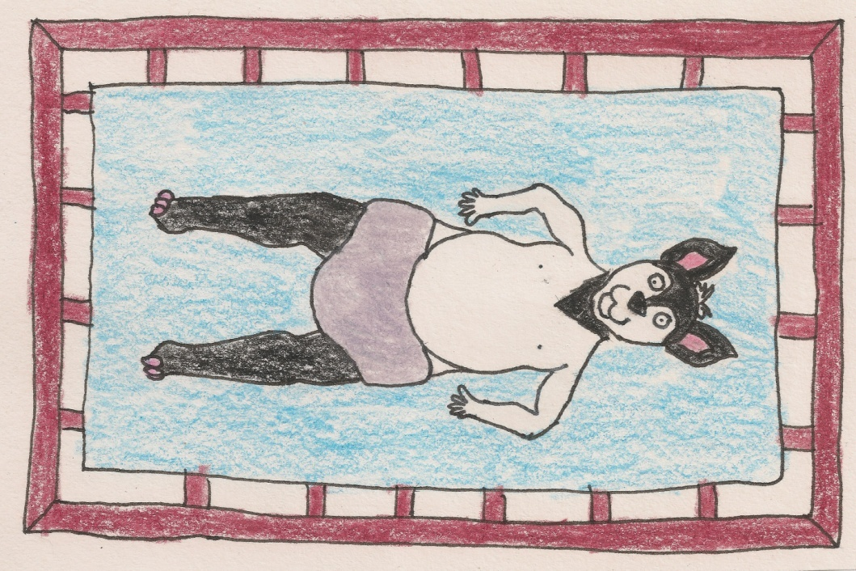They spent about ten minutes looking at each other when Fig decided to pick him up and hold him in his arms. Aspen enjoyed the feeling of Fig's warm paws on his body as he was a bit cold, Fig knew he would enjoy a nice warm cuddle in his arms under the blanket so he took Aspen over to the guest room where he would sleep while babysitting. Fig laid Aspen on the bed and removed his loincloth then removed Aspen's diaper. "What a delicious looking body he has." Fig thought to himself.
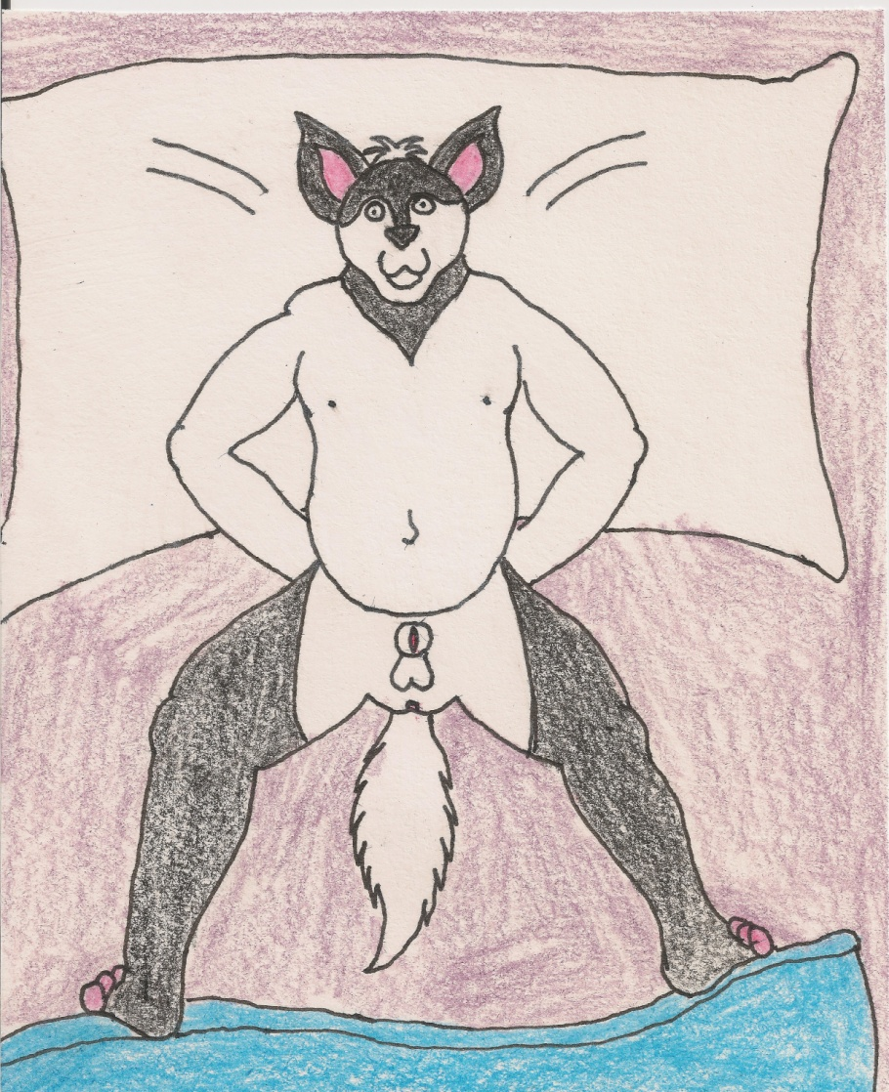 The site of Aspen naked on the bed with him was really turning him on and Fig lied next to him and pulled him up to his belly and pulled the covers over sealing in the heat and began to rub Aspen's belly. Aspen and Fig closed their eyes and lied in bed with each other for the next hour. Aspen was fully asleep while Fig was still awake. Fig began to get an erection to the thought of touching Aspen's body in an intimate way and thought now would be a good time to start.

