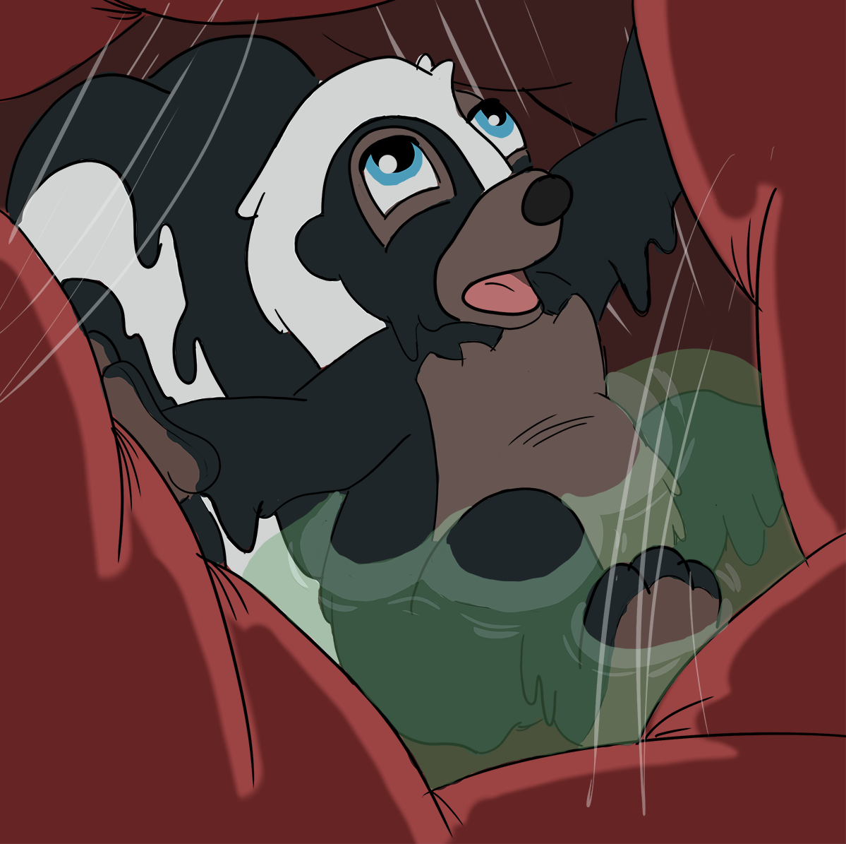

Flower whimpered, this couldn’t be the end.

His little skunk body squirmed and wriggled about as much as it could in the squishy confines of this meaty prison, the soft pads of his stinging paws kicking into the belly walls hoping something would give. This was it. He’d really, genuinely been eaten up just like his mother had always warned him could happen if he wasn’t careful.

“Flower if you don’t watch the ground carefully you could wonder right into a bear’s mouth!” she had said with a careful tone “If you get the slightest whiff of predator run as fast as you can, unless you want to end up festering in its belly.”

If only he had listened, for now the skunk was just that, a piece of slowly melting meat in a pred’s tummy. His striped tail wet with juices, already starting to lose some of its natural sheen and replaced instead by a gooey green slime. The white stripe melting down, running into the blacker fur around it like paint.

“h-hey!” Flower called out, panting in the humid prison “it’s g-getting really hot in here....p-please don’t d-d-digest me....”

But the only response that Flower got was the slow gurgle of a belly happy to meet him. Delighted to have such a sweet, innocent skunk to spend some quality time processing. the heavy stink of digestion hanging in the thick air as he squeezed, squashed about, the calm before the storm as it were.

gurggggllelle squlllrrrcchhh

For soon the belly began to churn and boil in earnest, getting hotter and hotter, more unbearable with each horrible moment. "help!!" Flower called out, half submerged in boiling, slimy juices that clung to every inch of his little body "Bambi!!! HELP!!!"

He didn't want to be someone’s food, to spend the final hour of his life surrounded by the stink of past dinners. Hot, wet, bothered, his body melting under the digestive onslaught.

But unfortunately for Flower such was his lot, and there was only the deep chuckle of a happy pred and the gurgles of the belly to comfort him as he went out.

Some animals became twitterpatted and led long, healthy lives with many kids to play with. Others ended their time as a melting piece of meat inside a pred's belly. Flower was the second of those two, doomed to be a creamy layer of fat upon this predator's tummy.

The pool of slimy acids rose higher, Flower panted, and pushed against the belly walls again. His little paws barely making even so much as a dent on the outside of the pred’s belly, and eventually loosened up enough gas to lead to....

URRRRPPPPPP-BURAPPPP

The belly clenched suddenly and Flower let out a strained “oof” of indignation, digestive juices covering his mouth for a terrible, panic inducing moment as the entire meaty prison he was inside of shook with a wrathful thunder. Hot gas, smelling deeply of his own digesting musk, surged past and exited out of the pred’s mouth in a nasty, deliciously skunky burp.

“Stinks” Flower heard the muffled reply of the pred as the belly finally loosened enough for him to breath again “glorified rats, that’s all you are. Damned tasty, however...”
He would have responded, perhaps in anger or perhaps out of feverish desperation, but Flower got no chance. Before he could say another word the belly finally kicked things up a notch. That burp had awakened it fully, the air became more humid and Flower began to panic yet again.

“unf” he panted, squirmed again “he-mmmmmppplllgurgggglllle!!”
The pool of digestive juices urged upwards right up near the sphincter and Flower found himself floating, suspended in a sac filled with boiling, hot, stinging juices, every atom of that liquid burrowing down into his skin. Dissolving his soft body into fat for this cruel, hungry pred.

Opening his mouth to cry was a mistake, and if the belly were to be made transparent at that moment someone looking from the outside in would have seen Flower’s eyes open in shock and terror, and then watch as the bubbles of his air rose up becoming thinner and thinner with ever breathless gasp. He writhed around, every limb pushing against the onslaught of the belly in one final but ultimately fruitless attack. Visibly dissolving at an advanced rate, his fur slipping off, melting away into nothing.

And then with one final twitch it was over, Flower’s eyes rolled into the back of his head and he went still, his lifeless body now at the complete mercy of this pred. The same pred who, in time, would belch out a black and white hairball, pat it’s belly with a grin and then sniff the air, eager to have a go at that delicious bunny that the skunk had hung around with. And perhaps even the deer, if they were lucky. Already beginning to forget the delicous skunk that now lay as a half melted, sludgy piece of festering meat in their well trained, happily gurgling stomach.

