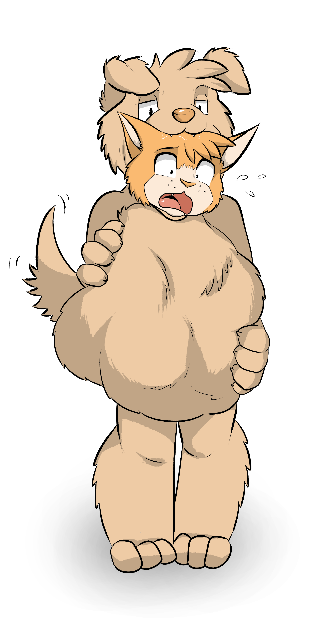

When Marvin awoke that morning he hadn’t expected a number of things. For one he didn’t expect that the February morning would be so beautiful, the sun outside showering down its golden warmth. He hadn’t expected that his dad would have suddenly flown up-state for work, leaving little more than an explanatory note taped to the fridge, and he hadn’t expected that his stash of catnip that he kept for such occasions would be so disappointingly depleted.

And he certainly hadn’t expected his brother to walk into the kitchen soon after, check the pantry to find that his own secret stash of dog snacks was also running low, proceed to smell the beefy air that his feline companion was giving off. And then proceed to have him as a snack!

Honestly Marv was so high on the catnip that he’d barely noticed Tiger at all. And when the dog came so close that even the feline’s sedated mind stood to attention Marvin merely groaned in acknowledgement, leaned back and flexed his claws in case to warn off Tiger, lest the dog take the opportunity to sniff his butt or something else that Marv found improper.

But it wasn’t the cat’s butt that Tiger was interested in, or not just the butt at least. Tiger was interested in all of him and had been for so long, and now that Dad was gone for the weekend and Marvin was zoned out on catnip now was the perfect time to finally strike.

“heeeeyy Marv....”
The cat groaned again, eyes half lidded as the joint in his mouth sagged between his front teeth. He was listening, mostly.

“You know I've been reading a lot lately”
This time Marvin turned to look at him with some more acknowledgement in his eyes. Tiger, reading? Really? He wasn’t the scholarly type at all unless it had to do with pizza. It probably had to do with pizza.

“Yeah, been reading a lot how cats and dogs used to get along, before humans and everything moved in. And I was thinking....remember all those times you stood by and let all of those cats and other animals make fun of my name?”
Marvin raised and eyebrow and took the catnip out of his mouth, snuffing it out on the ashtray nearby. “This again man? You need to get over that shit, and what’s that gotta do with humans? They never said anything to you.”
Pursing his lips now and with a devious, but angry grin flickering onto his face, Tiger continued. “You’re an asshole Marv, that’s what i’m getting at. All of you cats are and we dogs used to have a way of dealing with prissy little felines like you. Before the humans came along.”

Thinking that his brother was just being over-dramatic and getting really peeved off at how close the stinky hound was standing near him, Marvin reached out to take another puff of the catnip before he attempted to claw Tiger’s face off. But before he could Tiger finally made his move with one final declaration.

“Hope you taste as good as you smell, bro.”

---

Tiger had himself been surprised by a number of things about this experience. For one, he hadn’t expected the claws to be such an easy obstacle to overcome. Every single website that he’d run across during his research had warned that cat’s claws were so problematic, always getting snagged on things as they went down and causing major indigestion. But honestly Tiger hadn’t made any attempt to tie up Marvin’s paws and he was doing just fine. Maybe it was the shock of being eaten or maybe it was simply the fact that, at the end of it all, Tiger was his brother and he would never claw at him with the intention of really hurting him. But regardless of the reason Marvin didn’t use his claws to defend himself once.

The second, and more pressing matter, was how hard it was to swallow up an entire 4’4, living, breathing tomcat whole. Tiger had started from the feet as they seemed like an easier target that trying to gobble up the wide dome of his brother’s head in one go. It was smooth sailing for the most part after that. Tiger ignored his brother’s confused questions and proceed to gulp those heavy paws into his gullet, sliding up the furry masts of meaty cat legs and arriving at the knees. By that point Marvin had caught on that this situation was more serious than he had thought, put the catnip back and proceeded to wriggle violently and kick up a hell of a fuss. But again no clawing, just a few tense warnings and commands to stop lest Marvin tell dad all about this.

Tiger didn’t care of course, all he wanted was his annoying brother digesting in his belly, filling him up nice and good and finally putting an end to all those taunts he’d endured over the years of being a dog with a cat’s name. Tiger, Tiger, wouldn’t be so funny now, would it?

But the dog had bitten off more than he could chew, quite literally as he would soon find out. Once the knees were done being licked at and gnawed on Tiger slurped down more and more of Marv into his belly, the cat’s feet touching the pit of his stomach and beginning to curl up into a tight ball. “Don’t you fucking dare” Came a warning from the cat as he looked down and noticed his entire lower half bulging out Tiger’s gullet, the dog’s tongue at his crotch and that wet nose at the base of his tail.

The predator’s grin widened and, with the addition of a sly movement from his tongue, sniffed in deep and long. Hot breaths sucking in and then puffing out right at the entrance to Marvin’s furry butt.

“ugggggh, you’re an animal!” The cat hissed, lifting down two paws to his waist to try and pry himself free “I swear when you drop me i’m going to piss over everything you ow-”
gulllllppppp slurrrrrrp

The next few movements happened so fast Marv barely had time to comprehend them. With one more sly lick between his legs his butt, crotch and both of his paws were trapped behind thick dog maw, Tiger standing up now and pulling Marvin right off the chair and into thin air. He waddled, not a tall dog to begin with and now filled with half of a cat taller than he, and rested two paws on his swollen belly. The fattened organ bulging out with imprints of toes and knees and letting out an ominous gurgle as it got to work.

Truth be told, Tiger was starting to feel queasy and he wasn’t sure if the noises in his stomach were a good or a bad thing. The websites had told him to practice on rats and raccoons and smaller creatures before attempting something as hefty as Marvin was, but he hadn’t listened. Maybe that had been a mistake.

Not one to be deterred and past the point of no return anyway Tiger continued his conquest of the cat. Gulping up that delicious belly, surprisingly beefy and padded out for such a lean cat, and then with one hesitant, panting swallow, that fluffy chest joined the rest of Marvin’s ingested body.

“hurrrrgggg” Tiger groaned, closing his eyes to steady himself, something that didn’t go unnoticed by his victim.

“hah, what’s the problem mutt? Too big for you?” Marvin chuckled, his terrified eyes tinged with mischief now, believing that he was finally winning. “Who the hell told you to eat an entire cat anyway? C’mon Tiger, just spit me out, i’ll get cleaned up and we can talk properly about this.”
The words were tender and well meant, sincere. Marvin still loved his brother even if he was currently trying to turn him into fuel for a pooper scooper. And if there was any way they could work this out in anyway that didn’t end with Marvin as fat around Tiger’s belly, that was something they could work towards.

Gulllllppp

bloooorrrrrp

Tiger’s let out such a loud groan that both him and Marvin stopped, only the cat’s head protruding now from those jaws while the rest of him bawled up within already being kneaded and slopped around inside of his brother. “C-can’t eat....” Tiger groaned out, barely able to get the words out through his full maws “anymore. Too much, food.”
“I’m not....oh you know what fuck it, fine, I am food,. Are you happy now?” Marvin cried out in a panicked cry, his body feeling strange and still trapped inside of Tiger’s hot form “For the love of pridelands, let me go. You can’t finish me off, and m-my, oh fuck, I can feel my pawpads dissolving.....”

But there was no getting Marvin even if Tiger had wanted that to happen. Eating someone was hard enough, as the dog was discovering, but trying to extract them at this point would be fatal for at least one if not both participants. The prey was already digesting, and even extraction in the early periods like this usually meant surgery at best, and for the pred it meant almost certain internal damage. No. Marvin was going inside of him one way or the other.

Gulp

Nothing moved

slurrrpp
Nothing, Marvin’s head, ears and anguished face still stuck out under those folded ears.
This was stupid, and concerning. If Tiger couldn’t get him in then he was just as doomed as Marvin was.
“I’m, i’m digesting you moron, my paws are stuck in....ugh, horrible sticky slime, c’mon man, you have to get me out now before I start properly melting.”
This time Tiger did tune in and remembered a story he’d read on one of those predator forums. One regular poster, a wolf, would often describe how he’d often eat up his favoured prey (mice and deer) about halfway then let his belly start digesting before slurping up the rest once the lower half was good and melted.
Could he do the same? He didn’t really have much of a choice but to try.
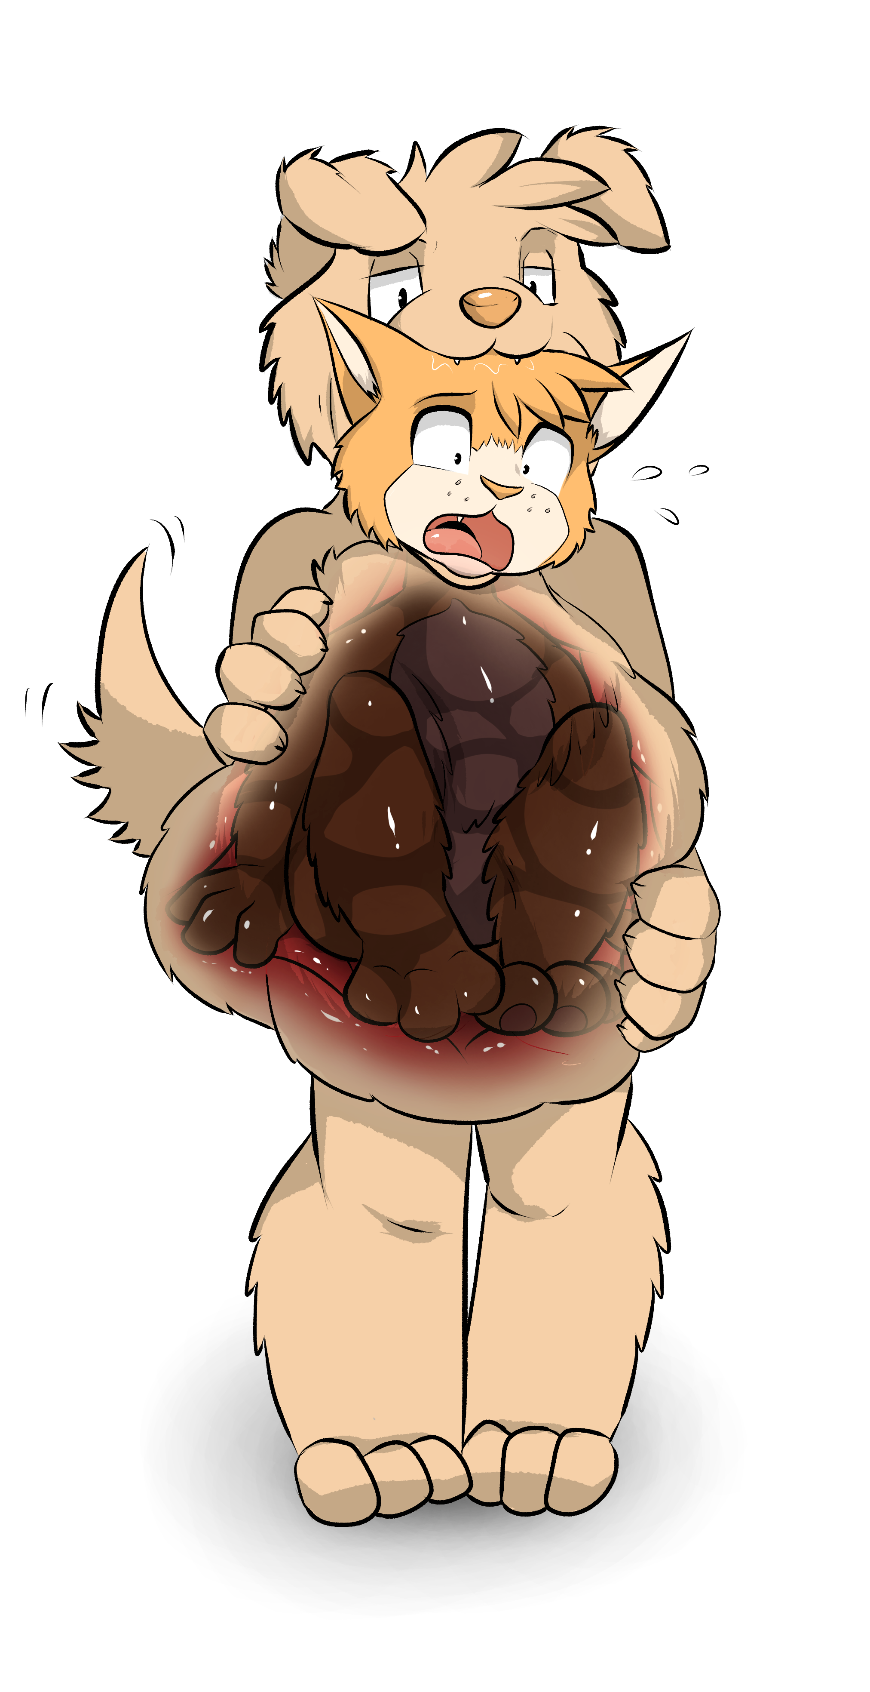

---
Another thing that had surprised Tiger was just how long it took to digest Marvin.

Of course the websites and forums had warned him of this too and it made sense, a cat like Marvin had many layers of bone, meat and fur to get through, but even then Tiger hadn’t bet on just how long it would take. How long he would be sitting upon that couch in the living room too fat to move, wishing he could reach the TV remote.

He waddled over inch by inch as soon as his plan to digest whatever he could before trying to swallow that bulbous head again. Sprawling out on the couch as his brother wriggled up a storm and cursed him the whole way through. So much so that Tiger considered chewing on more than one occasion.

“You rat bastard! You sick fuck! You’re eating me, I'm digesting!”

All of this and more came pouring out of the cat’s mouth as he hung from the dog’s. His paws pushing against the gooey innards of the belly, bulging out large enough for Marvin himself to see. “Those, those are my paws....oh gods....”

It could have been entertaining and certainly the wolf poster on that forum would have loved it, but Tiger was less than thrilled with the experience. Sure it felt great to have a full bodied cat wriggling around inside of him but the struggle to breath and the queasiness he felt from all that movement inside was off putting. Every single wriggle or attempt to pull himself back out caused the digestive prison around Marvin to lurch and groan discontentedly, stretched to its limits and even further considering that an entire portion of Marvin still rested in the gullet and hadn’t even begun to be processed yet.

Tiger did, however, enjoy the parts of his brother that were being processed.

He’d often feel around his fattened, full belly as Marvin cried and screamed bloody murder a him. Touching the bulges of those softened paws pushing out against hard muscle, twirling his fingers along the imprints of broken off claw and melting paw-pad, making a mental assessment of how far they’d come along every time he returned to touch them.

“Stop, you’re making it worse!!”

Tiger ignored the protests and once in his digestive daze lifted a paw up to stroke at Marvin’s head and scratch at his ears as he’d seen dad do many times before. It was affectionate to a point, an appreciation of just how much Marv was filling him up and how good the cat had tasted, although it did little to calm the feline down.

All in all it took about three hours of rubbing, kneading and gurgling to finally finish Marvin off. The cat crying out as his pawpads and claws dissolved, then his legs began to lose their fur, the sticky and stinging liquid inside slowly rising to encompass his knees, crotch, butt and stomach while his upper half rested in the gullet and maw.

“feels so weird...” he mumbled at one point, dazed now as Tiger’s probing paws scratched again at his left ear “feels so....”
He groaned and then, with one more twitch, his head went limp and his tongue lolled out, he would never awaken again.

With a chuckle the dog moved both hands to his belly and felt where the sides of his butt, the meatiest part of Marvin, was.

“Alright, Marv” Tiger thought and tugged playfully at the ears to make sure the cat was dead “time to put you away for good....”
Crunnnnnccchhh!
With all of the strength in his body Tiger pushed his palms together and crushed whatever was left of Marvin within him into a much more digestible package. Bones cracked, Sinews felt apart and his tummy let out a thankful gurgle in response. Tiger couldn’t have done this when Marvin was still alive because one, it would have been too cruel and secondly the movements of the still alive cat may have caused one of the bones to poke right through and injure the dog. Better to wait until all of that bone and muscle was softened, forming into a digestive stew of half melted cat meat and fear before forcibly scrunching it all up.

Cracccck!

With that done, Tiger placed a hand on the corpse’s head, and finally swallowed the last remnant of his brother that still remained outside.

“ahhhhh” He groaned, gulping to help the top half of the cat slip into the digestive soup formed from his bottom half “Goodnight Marv....”

---

“You think WHAT?”

Fox slumped back in the chair and raised a hand to his face. “Gods Fido, You can’t be serious. I knew Marv....”
“I’m sorry to be the one to tell you” the older, muscular dog replied carefully “but that’s how all the evidence lines up. We’re dealing with a murder here, not just a disappearance. And the murder weapon, well, let’s just say when we find our murderer we’ll find the murder weapon right with them.”
The husky looked up and, his eyes still wide in shock, raised an eyebrow.

“What do you mean? You think it was a feral attack, claws and all?”
“Sort of”
“Gods Fido, just tell me know. You know I can take it.”
Fido drank from his flask, then leaned in. “Marvin” he chose his next words carefully “was eaten.”

“w-what? e...”
“Yeah, that’s where all the evidence points anyway.” Fido took another swig of his flask, he’d been doing that a lot today. “Vanishing into thin air, saliva all over the kitchen, hasn’t been tested yet but it seems to be canine in origin, the smell of...digestion in the air.”
“You don’t think the wolves could have done it?”

“I’m trying to be sensitive about this, we don’t need this to cause anymore friction than we know it already will. If we just go and blame the wolves it could destroy this whole town.”
Fox had to concede that he was right. Gods Marvin, the cat had been eaten...
“Does anyone know?”
“no, I sent a team out to search the wood for...you know”
Fox didn’t know and his face told Fido that, the police chief sighed.

“For leavings. What goes in, must come out.”
Fox felt sick, this was all so surreal and disgusting. This wasn’t meant to happen in a civilised world.

“So his brother still think’s he’s missi-”
The phone rang and Fido picked it up. “alright” he knodded “send him in.”
Putting down the phone he turned back to Fox. “Tiger is on his way in, we’re gonna need to ask him about what he saw that day. You alright to help out here? Remember, he doesn’t need to know what we think happened yet.”
Fox knodded and went quiet after that, thinking about Marvin still, and how horrible his last moments must have been.

Who would do such a thing?

---

“Tiger...”
“Wha?”
The dog turned around with the biscuit still in his mouth, and almost sprayed crumbs over Fido. “oh” he gulped the rest of it down “sorry.”
Fox would have laughed were this a normal situation. But the dog’s brother had been missing for nearly three days now and they had reason to suspect that he was eaten, but of course Tiger didn’t know that. He must have still thought Marvin was hiding out somewhere, and that was why he was nonchalant about the whole thing.

“Just tell me where you were the day Marvin went missing.

“Oh, well...” Tiger thought deeply and for the first time in a few days Fox noticed just how fat he had gotten recently, even for him. That pudgy pug belly had been replaced by a full blown pouch of thick fur and even thicker lard. His butt was huge and his cheeks were round as two pigs. Strange, he must have been stress eating since Marv had gone. Honestly Marv was probably the only that had kept him from eating himself to death.

“Well, let’s see. Hard to remember” Tiger went to take another biscuit but Fido stopped him. #

“Tiger, you’re hiding something from us, and we need to know what or else we might not find Marvin. He could be in danger Tiger, ok?”
Tiger looked at him, and knodded. “OK, well I was hanging out at King’s house in the morning and...”
King?

Why would Tiger be staying at King’s house? They weren’t close at all. Something was up.

“And um” the dog’s stomach let out an ominous gurgle and his face dropped “Can I be excused?”

This time it was Fox that responded.

“No, you’ll stay here and tell us what you’re hiding.”

Tiger’s went green, and his stomach gurgled even more.

“No really, I need to-BBBBURRRRAAAAPPPPPP”

Before he could say anything else a massive belch came rippling out of Tiger’s maw and the two other dogs held their noses at the immediate stink. The low, broiling odour of digested meat filling the room, vaguely familiar in it’s form and heavy set. Accusatory.

“oh i’m sorry i-URK”

Fearing that another disgusting expulsion of gas was imminent Fox pulled his police shirt over his muzzle. But instead of a burp something else came flying out of Tiger’s maw: A small, orange bundle covered in stomach juices and saliva.

Fido and Fox silently looked as the bundle undid itself right on the police chief’s desk. Falling apart to open and reveal orange fur, enamel stripped fangs, small collar bones and most damningly a purple cat collar. Half digested, stinking and stained with digestive acid and long vanquished meat.

It was undoubtedly Marvin.

They turned to look at the fat dog, his hands over his mouth in both shock and guilt.

“heh.....April fools?”

