Pandora’s Box – Kahu Sub-Species - Eeyra
Eeyra (Ottercat) Warriors/Pleasure Slaves

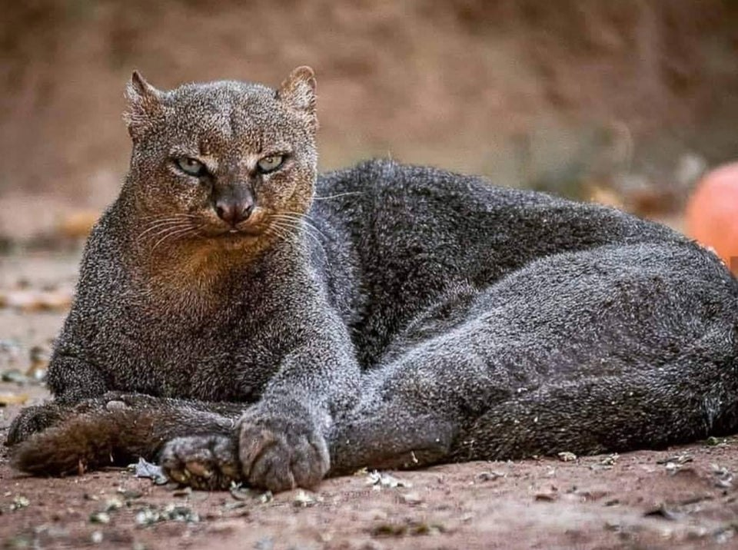

The last Kahu that the humans created was around halfway through the Kahu War. The Eeyra was designed to be a lethal and stealthy slave species, however, early in the development of the warrior/assassin slaves, it was discovered that the Eeyra had an extremely high male to female reproduction rate with a females losing their lives to males, either through mating or fighting. After a couple of years the first generation of the Eeyra species died out, whether from disease, infighting or genocide, no records exist as to the cause of the first generation to become extinct. The next few generations of Eeyra sub-species was limited to 3-4 birth cycles with genetic samples taken from individuals that showed desired traits for future trial runs. Eventually it came down to genetic coding that the preferred warrior/assassin Eeyra species came to be. Genetic encoding also determined a male or female’s place in their society would be once they reached puberty (warriors, nursing, assassin, leader, breeder, pleasure slave etc).
Most Eeyra fur coloring ranges from black to brown to dark brown with other colors denoting their caste (orange, red, beige, tan, yellow, white and mottled), their adult eye colors vary depending on fur color. Male Eeyra’s height ranges between 4’5 and 5’3, and female Eeyra’s height ranges between 4’9 to 5’10, the kittens will usually attain adult height at around two years before adulthood, newborn kittens are 12” long and slowly grow to 24” in their first three years, it is at the age of 4 that the kittens go through a growth spurt as they hit puberty where they grow to their adult height. It is difficult to differentiate males from females as they have the same muscular build and their fur covers all identifying parts. Only nursing and breeding females have visible breasts all other females don’t have visible breasts. Eeyra kittens are a uniform grey with black, white and brown spots and kitten blue eyes. All Eeyra are born with eidetic memory and a strong sense of direction.
The average lifespan for most male and female Eeyra is 45 – 50 years, others are 60-65 years save for those in the Pleasure Caste as their average lifespan is 80 years. To the Eeyra, those in the Pleasure Caste are the lowest of the lows as not being able to bear or sire kittens is a fate worse than death. Eeyra are weaned from their mothers after 3-5 months and are full mature adults at 7 years of age.
The Eeyra are very militaristic, living in a ridged society where laws and rules dictate their place in their society, what they can and can’t do. Their society structure consists of a family group that has 10-20 individuals with one male and female leading them, answering to their clan leaders. A Clan consists of 20-25 family groups with two males and females leading them, answering to their territory leaders. Territories consist of 35-40 clans with six males and females leading them, answering to their nation leaders. There are four nations with twelve males and females leading them.
The Eeyra are the protectors of Thera and her star system. Each star system in the Deadlands (a five hundred light year sphere) has their own Eeyra protectors. The Eeyra do not interfere with the other Kahu’s lives or societies, they trade and barter with them.

Fur Coloration, Caste System and Integration

As stated earlier, fur coloration determines one’s place in society. The humans who created the Eeyra inserted a code that activates genetic codes a few months before the kitten hits puberty after they have been weaned from milk to solid foods. When the young Eeyra’s fur starts changing from kitten to adult colors, they are taken to camps to start their basic training and getting tested genetically to confirm their caste. Fur coloration and caste is as follows:
- Black Fur (Both male and female) – Breeders, Assassin, Ranger, Maintenance and Grunt.
- Brown or Fur (Both male and female) – Breeders, Ranger, Grunt, Maintenance or Intelligence.
- Dark Brown Fur (Both male and female) – Breeders, Intelligence, Infantry, Maintenance or Sniper.
- Red or Russet Fur (female) – Breeders, Nursing, Hospitality, Supply and Personnel.
- Orange Fur (female) – Food Service, Communications, and Personnel.
- Mottled or Torte Shell (Both male and female) – Ambassadorial (post war).
- Grey Fur (Both male and female) – Family, Clan, Territorial and Nation leaders.
- Yellow or Cream Fur (males) – Kitten sitters, house keepers, Pleasure Slaves and post war Pleasure Males.
- Beige or Tan Fur (females) – Kitten sitters, house keepers, Pleasure Slaves and post war Pleasure Females.
- Albino (male and female) – Kitten sitters, house keepers, Pleasure Slaves and post war Pleasure providers and personal servants to the Grey furs. Albinos are naturally sterile and docile.

Genetic testing is only to confirm the individual’s place in society. Those that are in the Pleasure Caste are sterilized and declawed after puberty before getting sent off to the elder Pleasure males and females for their final training after recovering from their surgeries. The few males and females in the Pleasure Caste that want to become warriors after their declawing and sterilization, have to prove themselves to their family, clan and territorial leaders in three 2 hour paw to paw combat sessions. If they succeed, they are marked by claw branding to signify that they have proved their worth to become warriors, if they fail and are lucky (or unlucky) enough to survive they are banished, never to return to their clans or society. Banished Eeyra or those that flee because they don’t like their lot in life or desert usually settle in villages as honorable members of society doing what they want to do, some to become mercenaries on their own terms.
The breeders earn the right to sire and birth kittens after 15 years of military service (if they survive), the only females guaranteed to become breeders are those in the Nursing, Supply and Hospitality castes. The breeding females hold ultimate power over all Eeyra by refusing to mate if males and females are overly abusive to those in the lower castes.
Those in the Pleasure caste have a mandatory five year military service that they have to serve once they have completed their other training. Unless one from the Pleasure caste has earned the right to be a warrior, they are kept in secure areas behind lines. After those in the Pleasure caste have been declawed, they are issued special 'gloves' that they are trained to use if attacked, these gloves are attached at the wrist with two finger rings for the three fingers and thumb and equipped with nano blade claws.
Eeyra kittens stay with their birth mother for 2-3 weeks after birth before nursing females take over feeding and caring for them, those in the pleasure caste also take care of the kittens until they are sent off to boot camp at the age of 7. The kittens learn from a young age the rules and laws of their society even to reporting kittens and adults they suspect are breaking laws.
Honor is everything in the Eeyra society, mindset and teachings no matter what caste one is born into. Crime of any sort is virtually nonexistent due to punishment for anyone violating society laws is put to death. There are no infirm Eeyra, any kitten born with birth defects or is discovered to have mental defects is immediately eliminated.
Albino Eeyra are rare, and when one is born it will never see military service save for boot camp after declawing. Albino Eeyra are assigned to the Grey Furs after they complete boot camp and will serve for no more than 10 years before getting sent to kitten sit. Albinos are the only Eeyra that is held in high regard and it’s a crime to harm or abuse them in anyway.

