On Stage
By: Ainoko Ironrose
A Thursday Prompt exercise

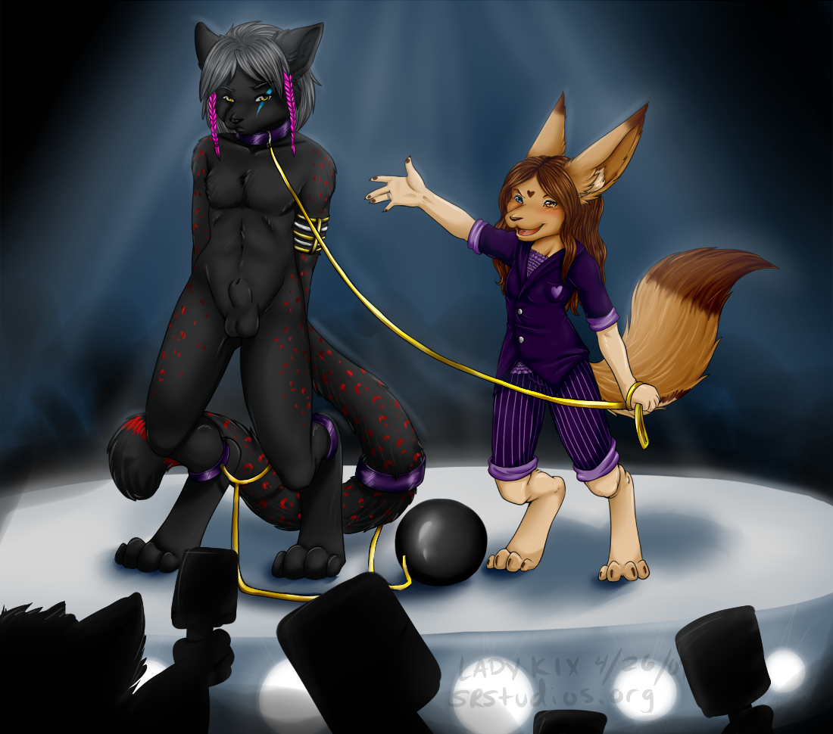

Deep in thought, Magistrate Nystra Hunnydhew nearly jumped in fright when his data center chimed indicating that he had an important message. Opening it, he sat up in shock from seeing who the sender was.

Magistrate Hunnydhew,
I know the cause of your problem and can fix it very quickly. All you need to do is one thing and your worries will be over. There is an object I desire, and I have included instructions for locating the desired object, and where you are to display it so that I can get it legally. I am giving you three weeks to obtain the object and store it in the location I have specified. I am watching and will know when you have acquired what I am seeking at that time, and will keep my end of the bargain.

Deagon

Looking at the details the mysterious Deagon sent, Nystra once again felt the faint pangs of regret for making deals with Daemons, and wondered what would happen if he refused to do this little ‘chore’. Deciding that it wasn’t worth the risk, he started working on the job at paw. “Aiton!” He called to one of his most trusted aides, “I need you to begin searching for this.” He said handing him a piece of paper. “You are to get this via any means possible that won’t result in damage to the any person or property, let alone to the item in question. Once you have the item in your possession, take it here, and give this data pad to our contact there, they will know what to do after that.”

After Aiton left, the Magistrate began sobbing, knowing that after tonight some lives were going to change forever because of his cowardice. “May the Gods and Daemons forgive me for this.” He prayed.

***************

“GET UP!”
Looking at the blurred image looming over him, Ainoko
Struggled to get up off the floor where he found himself, angry at having his sleep disturbed.
“GET UP!” Came the voice again, and was immediately followed by a well placed bucket full of ice-cold water was splashed onto his face.
Getting on his paws and stumbling to the rear of the small, bare, featureless room that he was in, he tried to figure out when and how he found himself in this strange situation. The black and red furred Cheolf (wolf/cheetah hybrid)shivered from his sudden immersion in water. Water was dripping off his pink braids and leaving wet splotches on the wrinkled and somewhat dirty clothes he was wearing. He looked up just in time for another bucket of freezing water was thrown at him, soaking him to the bone.
“I’m up! I’m up!” He yelped in shock from the cold water hitting him.
“Now that you’re up,” Said the voice, “You need to get yourself cleaned up and presentable. You are going to have to look your best to your prospective Master or Mistress, but first you have new adornments that those in your position are required to wear.”
Before he had a chance to protest, three large imposing furs, two black and white badgers and a white polar bear, entered his room and firmly, yet forcibly, removed all his clothing and jewelry. He struggled in anger, as his dignity was repeatedly violated. He felt degraded and ashamed, like he was nothing but a piece of property. Then as two of them held him motionless, the third approached and clamped a gold and silver band around his left arm, before attaching a metal collar around his neck, metal shackles around his feet, and another shackle with a ball on it onto his tail. No sooner than the band was clamped to his arm, a sensation like something digging through his arm began. At first it was mildly painful, before starting to feel pleasant, then sending ripples of pleasure through his body. This lasted for the length of time it took the three furs to attach his restraints.
Once they were done with that, they took him to a room that contained a shallow tub, where they chained his collar to a peg hanging from the ceiling. Then they began to thoroughly clean him from head to toe, shampooing his fur with something that smelled like vanilla, making sure that his fur was clean and silky. He was surprised and annoyed when he heard himself purr from the warm, soapy water raining down on him, not to mention the hard scrubbing from the three furs. It was after the brutes were finished drying off his fur and brushing him down, he heard a low chuckle from behind him.
“I am glad to see that you are starting to enjoy your preparations, but unfortunately we have some business to conduct. Now Ainoko” Came the voice once again, this time next to him. There stood a femme; her fur was dark and light brown like the finest cocoas you would find in the markets, with a brown heart mark just above her and between her eyes, she was wearing a purple suit with lighter purple stripes and highlights, like something from a carnival gypsy. She was about two heads shorter than him, holding a set of gold chains, and very intimidating. “All you have to do right now is do what I tell you and nothing else.” She said as she clipped the chains to his collar. It was then that he noticed his shackles change color from a dull grey to a bright, lively purple, nearly matching what she was wearing. “As of today, the life that you have known is no more, you are now a salve, to be the property of someone else for their pleasures.” Looking at her in shock and dismay, he began to protest in anger, but she continued before he could say anything. “You are now my property for the moment and will be auctioned off to the highest bidder in fifteen minutes. Just to let you know, my name is Lady Kix. You may only address me as Mistress Kix and nothing else until after the auction and your new owner pays for you. While we are on the stage, you are not to move for any reason during the process, not even if and when your prospective Master or Mistress comes on stage to get a better look and feel of you. Now, Ainoko, do you understand what I have just told you?”
“No Ma-, I mean Mistress Kix, I do not understand.” He said, before angrily continuing, “Just how in the holiest of the eternal hells did I wind up here? I am a free fur, not no cursed slave.”
Chuckling softly, Lady Kix produced a data pad, with which she began reciting information. “You, Ainoko Ironrose, being found guilty of the offense of living beyond your means and being in debt, you are hereby ordered into debtor prison. Upon further consideration, you will to be handed over to the slave market to be sold into slavery, and what you are sold for will be split three ways. 15% will go to you, 15% will go to the slave market as payment for your sale, and the rest will go to pay off your debts. If by any chance you are sold for more than what you owe, the difference will go to you. Once sold, you will be used in any way that your new owner desires. Nystra Hunnydhew, city Magistrate. What this means Ainoko, is that You have no chance of ever regaining your freedom.”
Closing the pad she continued on, “Now you know why you are here being auctioned off as a slave. One more thing, there is a band that was put on your arm. This band is now a permanent part of your body, and cannot be removed without seriously harming or killing you. It’s composed of a living metal, and when it was placed on your arm it began to form a lattice inside your body to keep it sitting from where it’s at. It generally takes the metal three days to fully embed itself into your arm, at times it will be mildly painful or extremely pleasurable until it is completely embedded. The metal helps your Master or Mistress keep you healthy, both physically and emotionally. The band also acts as leash, it will allow you to roam your new owners home and the immediate property, but you won’t be able to stray farther then that, or not far from your owner when they take you where-ever they go.”
“B-b-b-but this is ridiculous!” He stammered angrily as he reached with his right paw to see if he could try and pull it free, “I have never lived beyond my means or have EVER been deep in debt! I am a respected member of this city. I want to know who did this to me! I demand to be released!”
“Ainoko” Lady Kix said harshly, “I am not the one to file a grievance with only you can do that; however that is no longer your concern. According to Magistrate Hunnydhew, your freedom is no more. I am not the one who sentenced you to be a slave for the rest of your life. You had the chance to appeal the decision when you first came here, but didn’t make the claim.” Looking back down at her data pad for some information, she continued. “From our records, you have been here three days, that means you had plenty of time to make your appeal but didn’t.”
“B-B-But I just woke up a couple of hours ago!” He exclaimed in anger. “How can I file an appeal if I am unconscious during the past three days that say that I have supposedly been here? I haven’t had a chance to exercise my rights and you know it!”
“Look at this, and tell what you see.” Kix said as she pulled up vids of the past few days. “See this? This is you, in your room talking to your legate about you charges, you sure don’t look unconscious there. Here is Justice Aiton bringing you in, your were quite awake then, fighting him as he brought you in.”
“I-I-I-I can’t explain that.” He said in protest. “I must have been drugged or under a spell, there is no way that I would have accepted this without a fight!”
“Ainoko, you had your chances to appeal this and you didn’t. I’m sorry, but you are now a fur with no rights or privileges. Accept it. Now, we have to get out on to the auction block, you are the last one on the docket to be sold today.”
“Mark my words Mistress Kix,” He said vehemently, “By all that is holy, I will find out who did this to me and make them pay dearly. Whoever buys me, I will make sure that their lives are a living hell. They will regret ever getting me.”
“You go ahead and do that Ainoko, but remember this, eventually you will come to accept your new role in life and come to enjoy it. As Magistrate Hunnydhew stated, your days as a freefur are over. Even if your auction nets enough gold to pay off your debts, you can never be free again.” She said as she urged him onto the small round stage. “Remember, you are not to move at anytime during the auction, unless I say otherwise. Failure to obey will not be tolerated and you will be punished accordingly”
At that, Kix activated a switch on her data pad, which turned on a set of lights on the outside ring of the stage turn on. A few seconds later, the stage began to rise slowly off the floor towards what seemed to be a small ring of light. At first it was quiet in the tunnel, but soon sounds began to drift down to the slowly ascending stage. Early on the noise was just a rumble, but the level of the sound increased in volume the nearer they came to the light. In no time the indistinct voices began to separate into different tones. There was laughter, protests, and yelling from the furs bidding for the slaves that they wanted, as well as the wailing of children being ripped from their mother’s arms as they were sent to ones who bought them. Then, before the stage was to rise through the hole above them, the stage stopped. After that all lights save for those on the stage went out.
“Ok Ainoko.” Kix said excitedly as she made sure that both of them were properly groomed and ready for the last time. She then turned off all the lights on the stage, save for those on the outer ring and the ones under their paws. “Get ready, we are going up into the arena right about now.” At that, the stage began a slow but steady climb up and through the hole above them, into a circular pit ringed with intense bright lights.
“And now my fellow furs… here comes our latest addition to the auction! He was just delivered a few days ago and is the last item on today’s auction!” Boomed a voice from over the stage as it began to rise up from the floor. Ainoko cringed inwardly as he was greeted by what seemed to be a physical wave of cheers, catcalls and whistling. ”He is young! He is wild! He is untrained, unbroken, and outspoken ready to be used any way you like. He will be the perfect addition to your harems, stables or as a valuable member of your breeding stock! Now without further ado, here he is with his handler, Mistress Kix!”
“Good evening my fellow furs! I am Lady Kix, and tonight I present for your bidding pleasure, Ainoko Ironrose!” She said right as the stage came to a stop in the midst of the bidding arena. “As you can see he is a young wolf/cheetah hybrid called a Cheolf and is extremely rare. I can tell you that he is attracted to males, so those of you who have females can be assured they will be safe from him, however, males might be a temptation for him until he is properly trained. He does have other talents that may make him a valuable asset to your slave stables, he knows his way around a kitchen and is an excellent cook as well. He is also good with cubs and can be very protective of your cubs. Before the bidding begins, feel free to come down and check him out.”
“Ainoko, will you please walk around the stage so that the audience can get a better view of what they are bidding on?” Doing as he was asked, Ainoko began walking around the stage, only stopping when someone came on the stage to get a closer look at him. He growled silently to himself, embarrassed about being paraded in naked front of hundreds of strangers, as well as finding himself being forced into slavery.
“Now, let’s start the bidding at 150,000 Gold… Ainoko, please go back to the center stage now that the auction can begin” Doing as he was told, Ainoko stared angrily at a spot on the stage in front of him, trying avoid looking into the assorted furs for fear of seeing familiar faces. ‘I will find out who did this to me, and make them tell me why I am here.’ He thought to himself as the auction began and went into high gear.

